SECR 2033 Computer Organization and Architecture 2019/2020-2
Programming 6: CONDITIONAL STRUCTURES

HAM JING YI A19EC0048 SECTION 2

Part A – Programming review

- Block-Structured IF Statements

Assembly language programmers can easily translate logical statements written in C++/Java into assembly language
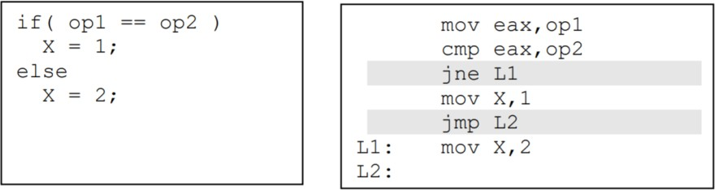

Compound Expressions

Logical AND Operator
When implementing the logical AND and OR operator, consider that high-level languages compilers for Java, C, and C++ use short-circuit evaluation for efficiency reasons.
The second expression is not evaluated if the first expression is false. (early exit)

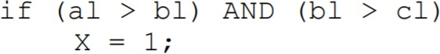 | 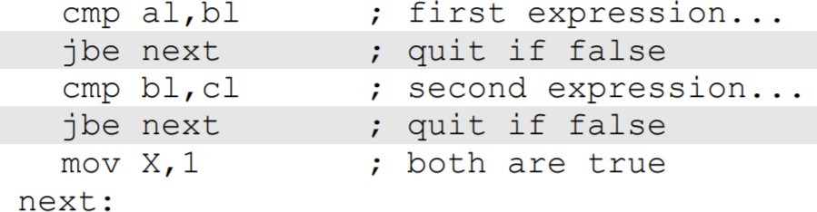

Logical OR Operator

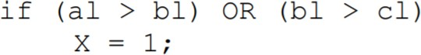 | 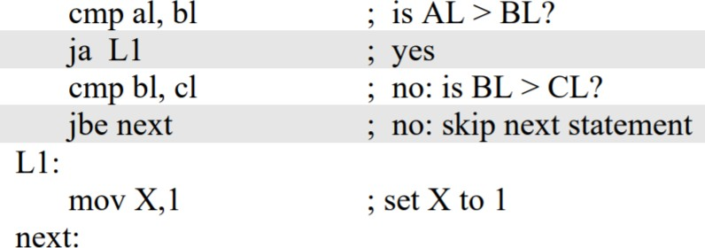

WHILE Loops

The WHILE structure tests a condition first before performing a block of statement. As long as the loop condition remains true, the statement is repeated.

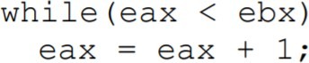 | 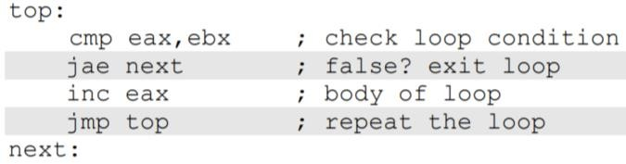

Assembly Code

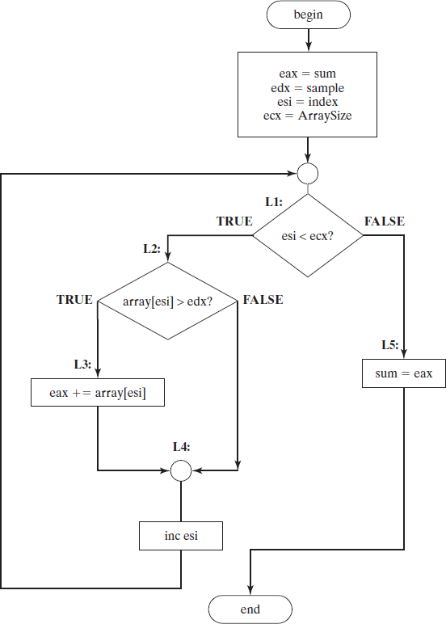
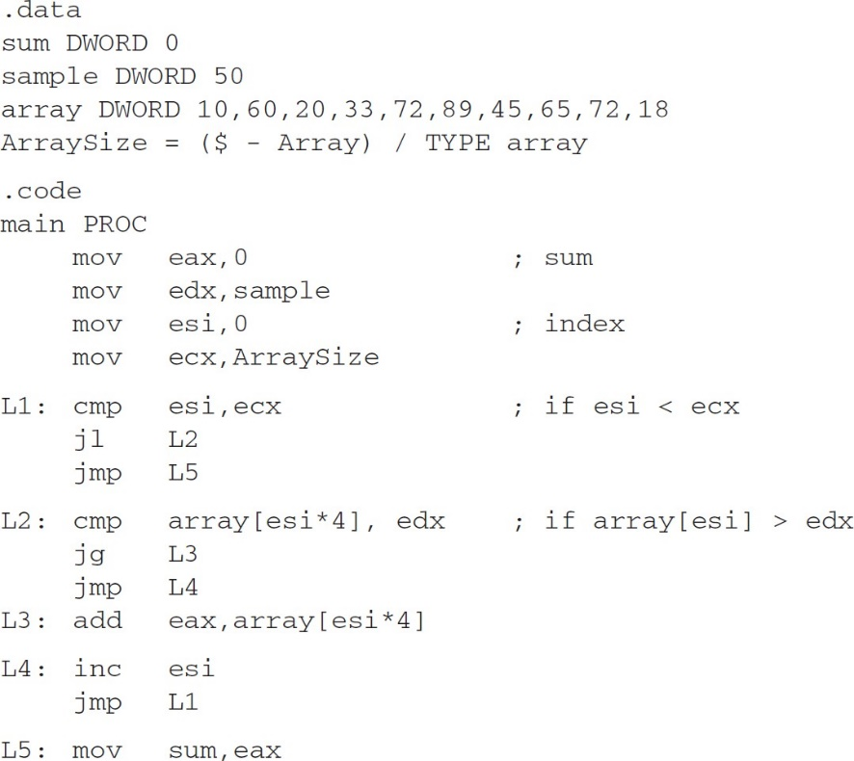
The easiest way to generate the assembly code from a flowchart is to implement the code for each shape. Note the direct correlation between the flowchart labels and the labels used in the source code.

Part B – Let’s do a little programming on your own

  - Implement the following pseudocode in assembly language, using unsigned values. Please use short-circuit evaluation in your code.
IF (MY_MONEY < YOUR_MONEY) YOU_DONATE = 20;
ELSE
{
YOU_DONATE = 10;
I_DONATE = 10;
}

ANSWER:
mov eax, MY_MONEY
cmp eax, YOUR_MONEY
jb L1
mov YOU_DONATE, 10
mov I_DONATE, 10
jmp L2

L1: mov YOU_DONATE,20
L2:

  - Implement the following pseudocode in assembly language, using unsigned values. Please use short-circuit evaluation in your code.
IF (EBX > ECX && ECX <= EDX)
{
EAX = 9;
EDX = 10;
}

ANSWER:
cmp ebx, ecx
jbe next
cmp ecx, edx
ja next
mov eax, 9
mov edx, 10
next :

  - Implement the following loop, using unsigned 32-bit integers. Please use the reverse condition to make the code shorter.
WHILE (MINE <= MIN_CONTRIBUTION)
{
VAR++;
PRINTF(“Sorry your contribution is not enough.”);
}
PRINTF(“Thank you for your generous contribution.”);

ANSWER:

.data
MINE DWORD ?
MIN_CONTRIBUTION DWORD ?
VAR DWORD ?
str1 BYTE "Sorry your contribution is not enough.",0
str2 BYTE "Thank you for your generous contribution.",0

.code
main PROC

top :
mov eax, MINE
cmp eax, MIN_CONTRIBUTION
ja next
inc VAR
mov edx,OFFSET str1
call WriteString
call crlf
jmp top

next :
mov edx,OFFSET str2
call WriteString
call crlf

  - Rewrite the code from section (D) so it is functionally equivalent but uses fewer instructions.

ANSWER:

.data
sum DWORD 0
sample DWORD 50
array DWORD 10,60,20,33,72,89,45,65,72,18
ArraySize = ( $ - Array)/ TYPE array

.code
main PROC
mov eax, 0
mov edx, sample
mov esi, 0
mov ecx, ArraySize

L1: cmp esi,ecx
jge L5
cmp array[esi * 4], edx
jle L4
add eax, array[esi * 4]

L4: inc esi
jmp L1

L5: mov sum, eax

  - Suppose a student wants to decide to go home or stay in UTM during online teaching & learning phase. Two criteria are used to determine whether the student will go home or not:
    - First is the student’s hometown current zone, whether it is in green or red zone.
    - Second is the internet speed in the student’s hometown. The speed must at least be 2MBps to have a decent teaching & learning experience.

- Draw a flowchart of the program.
End
Print “go home”
ebx=speed
ecx=zone
ANSWER:
Begin

Green zone =1, red zone=2, other =3

Print “stay in UTM”
ecx==1 && ebx>=2
L1 :
FALSE

TRUE

- Write an assembly language program that ask the user to enter the inputs and suggest a decision to the student.

ANSWER:

TITLE MASM Template (main.asm)

; Description:
;
; Revision date:

INCLUDE Irvine32.inc

.data
str1 BYTE "Please enter your hometown current zone (green=1, red=2, other=3): ",0
str2 BYTE "Please enter your internet speed in your hometown (MBps) : ",0
str3 BYTE "Decision : GO HOME",0
str4 BYTE "Decision : STAY IN UTM",0

.code
main PROC

mov edx,OFFSET str1
call WriteString
call ReadDec
mov ecx,eax
mov edx,OFFSET str2
call WriteString
call ReadDec
mov ebx, eax
cmp ecx,1
jne L1
cmp ebx,2
jb L1

mov edx,OFFSET str3
call WriteString
call crlf
jmp outt

L1 :
mov edx,OFFSET str4
call WriteString
call crlf

outt:
exit
main ENDP

END main

