Philosophy and Current Issues
UHIS 1022
Submitted by

Name | Matric no
Toya Lazmi Khan | A20EC0284
Tanshiba Naorin Prapti | A20EC4051
Rahim Rehnuma Tahsin | A20EC5001
Ibtesham Ahmed Promit | A20EC4027
Zhu YiChen | A20EC0285
Fariduzzaman | A20EC4016

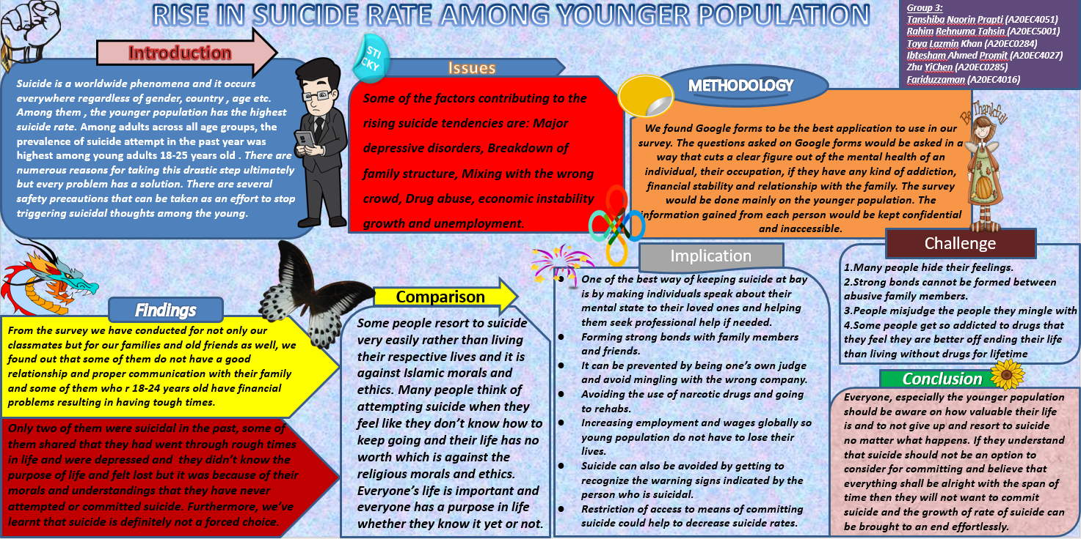

Video Link

https://youtu.be/F3mKkJTBS18

Rise of suicide rate among younger population

Introduction

Having heard of someone committing suicide is nothing common these days. These days we get to hear about it through person to person and media and it has significantly increased in younger population. Suicide is a worldwide phenomenon and it occurs everywhere regardless of gender, country, age etc. Among them, the younger population has the highest suicide rate. Suicide is a major issue in many developed and developing countries. While suicide rates have been reported as constant or dropping in many developed countries, a rising tendency of youth suicide has been observed over the last couple of decades. In 21 of the 30 countries in the World Health Organization (WHO) European region, suicide rates in males aged 15-19 rose between 1979 and 1996. As for females, suicide rates rose less noticeably in 18 of the 30 countries studied.
According to many surveys and research it has been concluded that young suicide has been increasing day by day.
In one such survey they found this:
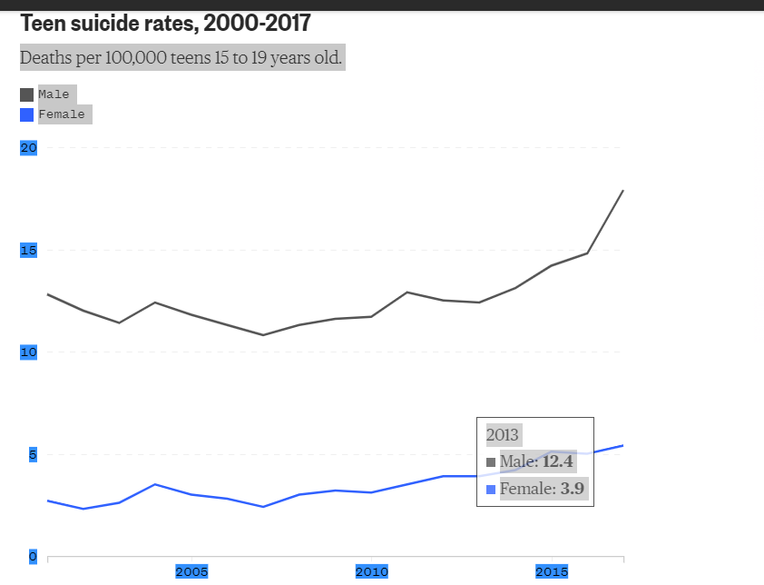
It clearly says that suicide rate increased from 2000s. The survey was done between 2000 to 2017 from the Centers for Disease Control and Prevention. They emphasized on teens and young adults between 15 and 24.
They found that in 2017, the suicide rates for this age group reached their highest levels since 2000. That includes an increase of 8 percent among girls aged 15-19 dying by suicide from 2016 to 2017, according to the new research.
These can have various reasons and backstories. A person does not take their life just because they were bored of life. They are many dark secrets and reasons behind it. According to many researches the reasons for suicide among the young population are losing employment, having severed relations with family, mingling with bad company, getting bullied etc. We will be discussing about these causes and then find solutions throughout this report regarding this increased suicide rate and how to diminish it.
Issues
Suicide is a major concern in many developed and developing countries. According to WHO (World Health Organization) close to 800 000 people die due to suicide every year. And 79% of global suicides occur in low- and middle-income countries.
While suicide rates have been reported as constant or dropping in many developed countries, a rising tendency of youth suicide has been observed over the last couple of decades. Again WHO tells us that suicide is the third leading cause of death in 15-19 year-olds. In 21 of the 30 countries in the World Health Organization (WHO) European region, suicide rates in males aged 15-19 rose between 1979 and 1996. As for females, suicide rates rose less noticeably in 18 of the 30 countries studied.
A recent survey by an international survey agency revealed that almost a quarter of 1,027 Malaysians polled experienced suicidal thoughts, and it was especially prevalent among youths.
There are several issues behind the rise in the suicide rate. Some of the factors contributing to the rising suicide tendencies are:
- Major depressive disorders.
- Mental health problem or mental illness.
- Breakdown of family structure.
- Traumatic Stress.
- Academic failure.
- Bullying, shaming, or humiliation, including cyber-bullying.
- End of a close friendship or romantic relationship.
- Financial problems.
- Mixing with the wrong crowd.
- Economic instability growth and unemployment.

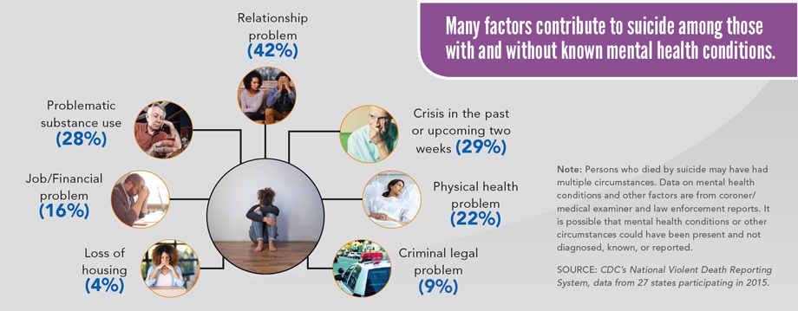

Suicide rising across the US

Challenges
We have to face many challenges to reduce suicide cases. It's very challenging to prevent suicide because people who have attempted suicide or thinking of taking their own life are not seeking help. Therefore they are not getting the help they need. So the main problem is people are not asking for help. Here is a chart that shows why Malaysian people don't seek help.
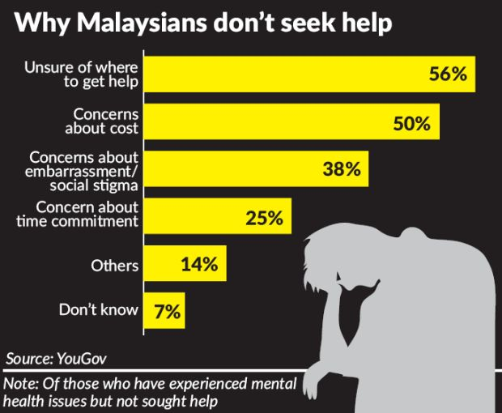

Youths toyed with self-harm

Then there are people who are reluctant to talk to anyone. It's quite impossible to help such persons. Another challenging situation is when someone has abusive family members in his/her family. In that case, seeking help from family, sharing problems, or having a strong bond with the family is totally impossible.

Sometimes there are so many bullies in school or college that it becomes impossible for the victim to save himself/herself from bullying. Also, many of the people don't have such close friends to share their problems with. Such peoples don't have friends to help them with their needs.

Some people do not have the capability of judging between good and bad company. Thus they mix up with bad companies which lead them to different kinds of illegal works. Afterward, it leads them to frustration and finally suicide.

It is often seen that young people don't have the emotional maturity. So after failing in love they go through an emotional breakdown and sometimes commit suicide.
Some people get so addicted to drugs that they feel they are better off ending their life than living without drugs for lifetime.

Objectives:

Research Solution Goals/Implication
Every grim problem comes with a solution and bringing down the suicidal rates among the young generation is feasible if we work accordingly and use preventive measures.

One of the effective ways to prevent suicide is to let teenagers tell their loved ones and those they depend on and believe in their mental state, and help them seek professional help if necessary. As people who have no suicidal thoughts, they need patience to listen when they find suicidal people confiding in themselves, while analyzing their confidences is secondary and the most important thing is listening. When comforting people who want to commit suicide, many people always say "think too much" and "don't be so sad, think of something happy". Although it may be kind, it is often powerless and even easy to worsen the relationship for sensitive people who want to commit suicide. Pay more attention to listening during the conversation, and help them find professional and reliable institutions and people to enlighten them when they realize that their mental state is too heavy to understand.

Meanwhile, establishing a strong relationship with family and friends can also effectively avoid Compared with other groups, teenagers are simpler. They are impulsive and easily influenced by external things and thoughts before their values are completely molded. If they are exposed to society alone, they will easily cause many uneasy phenomena, because many setbacks in the society will easily hit teenagers with less experience seriously, and many bad thoughts will bring teenagers incorrect values and lead them astray, which will cause many irreversible vicious influences over time, which will easily lead to teenagers' suicide. Therefore, for sensitive and inexperienced teenagers, it is extremely important to keep good communication and stable and close positive relationships with family and reliable friends, with the emphasis on positive relationships. As family members, after keenly perceiving the emotional changes of teenagers at home, don't neglect, care for and understand them, so that teenagers can truly feel the warmth and reliability of their home, and so can friends. Compared with family members, friends have fewer blood ties, but they are easier to understand their peers' thoughts.

In addition, adolescent suicide can be prevented by self-judgment and indirectly avoiding contact with the wrong person. It is extremely important for teenagers to choose their friends. As mentioned earlier, good friends can bring positive influence to them, while some are completely opposite. If you meet a so-called friend who can't bring positive or even more negative effects to yourself in your life, you should not continue to deepen and maintain this relationship, and try to make the relationship between them gradually weaken.

In order to prevent people who paralyze themselves with drugs from getting worse, they should avoid using drugs and seek help from rehabilitation centers. Drugs can escape temporary pain and keep these desperate people alive, but escaping will only make the problems bigger and bigger. Drug taking is against human reason and law. As a professional institution, the rehabilitation center will analyze the patient's psychology from the root, to have a greater chance to solve the suicide problem.

In addition, based on some people's consideration of suicide caused by economic problems, increasing employment and wages on a global scale, so that young people don't have to lose their lives will be a direct way for them to avoid suicide by having a job.

Methodology

We found Google forms to be the best application to use in our survey. So we put all the questions we wanted to ask people in the google forms and requested people from different societies, places including our friends and family to answer and it. This helped us ensure what people’s mental state is with regard to different occupation, financial stability and relationship with the family. We did this survey on younger population only since we were only targeting this group of people. We only included people who are between 18 to 28.
In the end, we ensured all our survey takers that the information revealed by them will be completely confidential. We also did not ask them their names in google form so the survey done stays completely anonymous.

The question we asked all our survey takers were:

- How old are you?
- What is your occupation?
- How is your relationship with your family?
- Have you ever been depressed? Suicidal? Why?
- Are you financially sound?
- Why do people attempt suicide in your opinion?
- In your opinion is suicide a voluntary choice or a forced choice?

Then after collecting all the answers to the questions we read them out and analysed the data, enough to reach a conclusion . At first we took into account the percentage of young people who are suicidal and then we tried to find the reasons for it. Since, we asked some personal questions about finances, family relations, mental state, and finally why exactly they are depressed and drug addiction , we tried to figure out what makes them suicidal. These made us reach conclusions and find solutions to the problems.

Findings
We have conducted a survey using Google Form, for finding the answers to the questions we have listed previously in methodology, as shown in the images below:
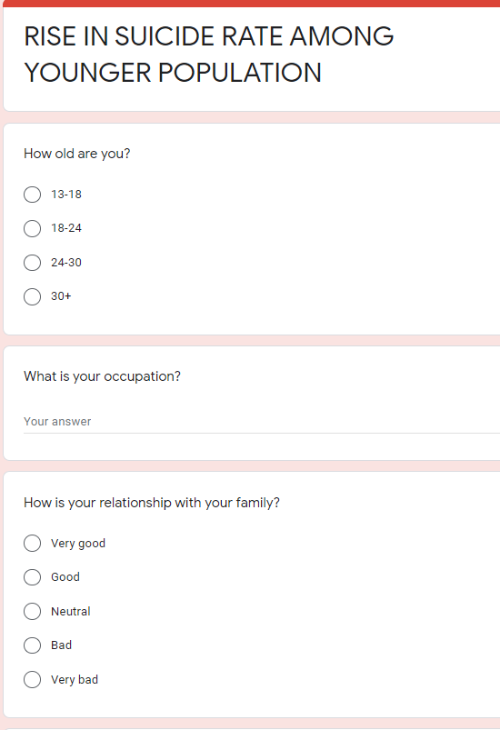
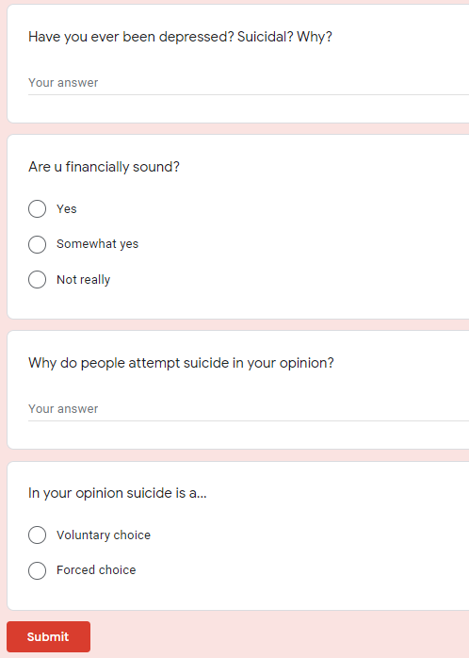

This survey was conducted to get an insight of what people around us think about suicide and whether they are personally familiar with this issue or not. It was conducted for not only our classmates but for our family members and old friends as well. Pictures below shows all our findings from the survey.
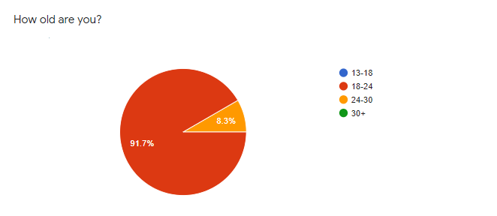
Picture 1: Respondent’s age range in pie chart
Picture 2: Occupation
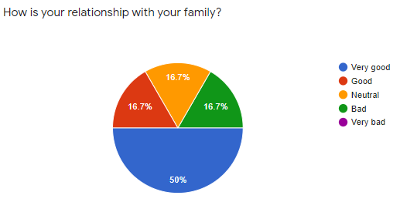
Picture 3: Relationship with their family
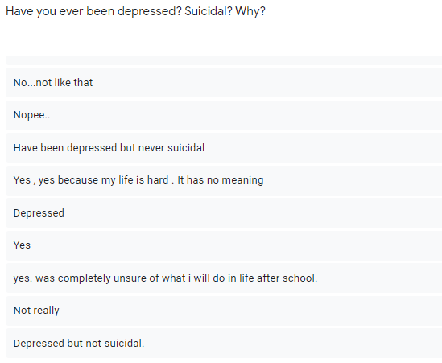
Picture 4: Have they ever been depressed? Suicidal? Why?
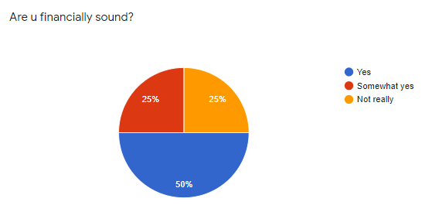
Picture 5: Financial status
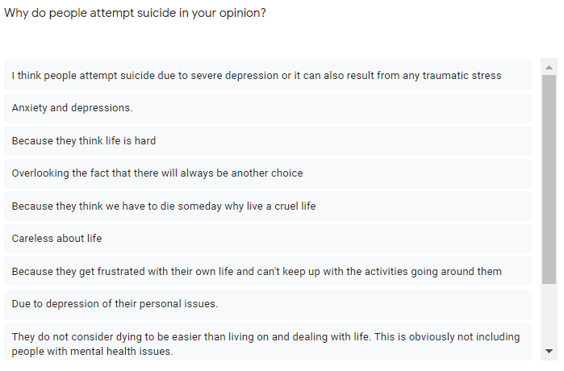
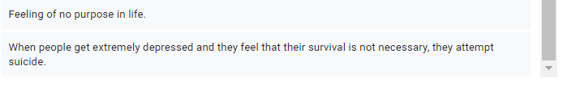
Picture 6: Opinion on why people attempt suicide
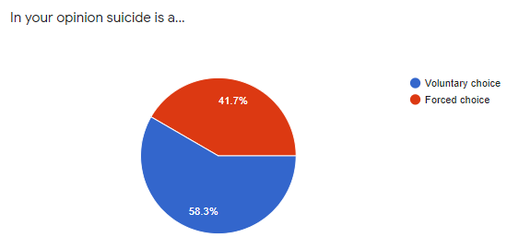
Picture 7: Is suicide a voluntary choice or a forced choice?

Reflection on Findings
According to the answers we have received in this survey, 91.7% of respondents are 18-24 years old and the other 8.3% of them are 24-30 years old (Picture 1). We have asked what their occupation is and we have received the result that most of them are students and few are researchers and bankers (Picture 2). Then they were asked about their relationship with their family and the result displays that 50% of them have very good relationship, 16.7% of them have good relationship, another 16.7% have neutral relationship and the rest 16.7% or them have bad relationship with their family (Picture 3). As for when they were asked if they ever were depressed and/or suicidal or not and why (Picture 4), one-third of them said they were not, one-fourth have said they were only depressed but never suicidal and the rest one-fourth have said they were both depressed and suicidal. This one-fourth of people who were depressed and suicidal are among the 16.7% of them who have bad relationship with their family. One of the respondents, who are or were depressed as well as suicidal, said he/she is suicidal because life is hard and it has no meaning. Another person stating to be depressed and suicidal has said that he/she was completely unsure of what to do in life after school which tells us that this person is a student of age within 18-24 years. As shown in Picture 5, when they were asked if they are financially sound, 50% of them responded that yes, they are, 25% of them said they are somewhat financially sound so their answer lies in between yes and no and the remaining 25% said not really. Among these 25% of people who are not really financially sound, some had gone through depression although they were not suicidal.

The next question asked in the survey was for the respondents’ opinion on why do people attempt suicide (Picture 6). To that question, the respondents have mentioned severe depression, anxiety, traumatic stress, difficult life, carelessness about life, being frustrated with their own life, the feeling of having no purpose in life, and the fact that they will always be someone else’s second choice or is easily replaceable from another’s life, are the main reasons for why people attempt suicide. As for the last question on the survey, they were asked whether suicide in their opinion is a voluntary choice or a forced choice and to that, 58.3% respondents said suicide is a voluntary choice and the remaining 41.7% said it is a forced choice (Picture 7).

Based on all the findings from this survey, after analyzing all the results, we can say that people who don’t know or can’t determine the importance of their life are mostly the ones who become suicidal or attempt and/or commit suicide. From what majority of the respondents of our survey believe, Suicide is definitely not a forced choice and with proper communication with loved ones and morals on life, people can get through tough times instead of resorting to suicide.
Conclusion
The race of life is not so easy to deal with. There may be good or bad times in different phases of life. Failure or incapability to handle things in tough situations provokes the young generation and thus suicidal ideation tip off their mind.
Suicide is a voluntary choice and anyone can overcome severe depression, anxiety and difficulties in life if they know how important their life is and understand the morals of life. If they mentally suffer too much to an extend that they don’t feel like living anymore, then they should open up and talk about it to an elder and seek help from professionals. Having good relationship and communication with family can be one of the ways that can help them understand the morals of life. Everyone, especially the younger population should be aware on how valuable their life is and to not give up and resort to suicide no matter what happens. If they understand that suicide should not be an option to consider for committing and believe that everything shall be alright with the span of time then they will not want to commit suicide and the growth of rate of suicide can be brought to an end effortlessly.

References
1.Edwards, E. (2019, June 18). Suicide rates among young people reach their highest level since 2000. Retrieved January 13, 2021, from https://www.nbcnews.com/health/kids-health/suicide-rates-among-young-people-reach-their-highest-level-2000-n1018376
2.Suicide. (n.d.). Retrieved January 13, 2021, from https://www.who.int/news-room/fact-sheets/detail/suicide
3. D;, R. (n.d.). Trends in adolescent suicide mortality in the WHO European Region. Retrieved January 13, 2021, from https://pubmed.ncbi.nlm.nih.gov/15490280/
4. Lai, M. (2019, November 28). Youths toyed with self-harm. Retrieved January 13, 2021, from https://www.thestar.com.my/news/nation/2019/06/20/youths-toyed-with-selfharm
5. Suicide rising across the US. (2018, June 07). Retrieved January 13, 2021, from https://www.cdc.gov/vitalsigns/suicide/index.html
6.What interventions help teens and young adults prevent and ... (n.d.). Retrieved January 12, 2021, from https://academyhealth.org/sites/default/files/Rapid_Evidence_Review_Behavioral_HealthJan2018.pdf
7.Crisis Intervention with Youth at Risk for Suicide. (n.d.). Retrieved January 12, 2021, from https://www.sccgov.org/sites/bhd-p/Training/Documents/2018/OCT%202018/crisis-intervention-with-youth-at-risk-for-suicide.pdf

Thank you

