Question 1
a. True
b. False
c. True
d. True
e. True

Question 2
a.0
b.1
c.1
d.0
e.1

Question 3
a. correct
b. incorrect
c. incorrect
d. correct
e. correct

Question 4
a. not False
b. number greater or equal to 200.0 and 22.0
c. true or false
d. 22 equal to 200
e. character R is in between N and Z

Question 5
a. sale <= 1000 || !( hours_worked <100)
b. temp < freezing && wind_Speed > 30kmh
c. year divisible by 4 || !( divisible by 100)
d. 1 <= cent <= 100

Question 6
- If ( -x <num <+x)
Cout “True”;
Else
Cout “False”;

- If (letter == lowercase)
Cout “True”;
Else
Cout “False”;

- If ( ch == 0 to 9)
Cout “True”;
Else
Cout “False”;

- If ( ch == ‘+,-,*,/,%)
Cout “True”;
Else
Cout “False”;

Question 7
If (test_score >= 90)
{
cout << “Excellent.” << endl;
}

Test_score >= 90

Yes

Print “Excellent”

NO

8.if(purchases>200)
Bonus_points=bonus*10;

Purchases>=200

True

Bonus_points=bonus_points*10

9.
Value>9

true

Print”Not a valid digit”

Question 9
If (0 =< x =< 9)
Cout << “Valid digit” << endl

10.
If(num>20 &&num<50)
Cout<<”Valid number.Proceed to next input”<endl;
Num<=20&&Num<50

True

Valid number proceed to next input

11.a.to give the grades according to the marks
c. if ((mark<80)&&(mark>=50)) “outcome congratulations , you passed”
b.
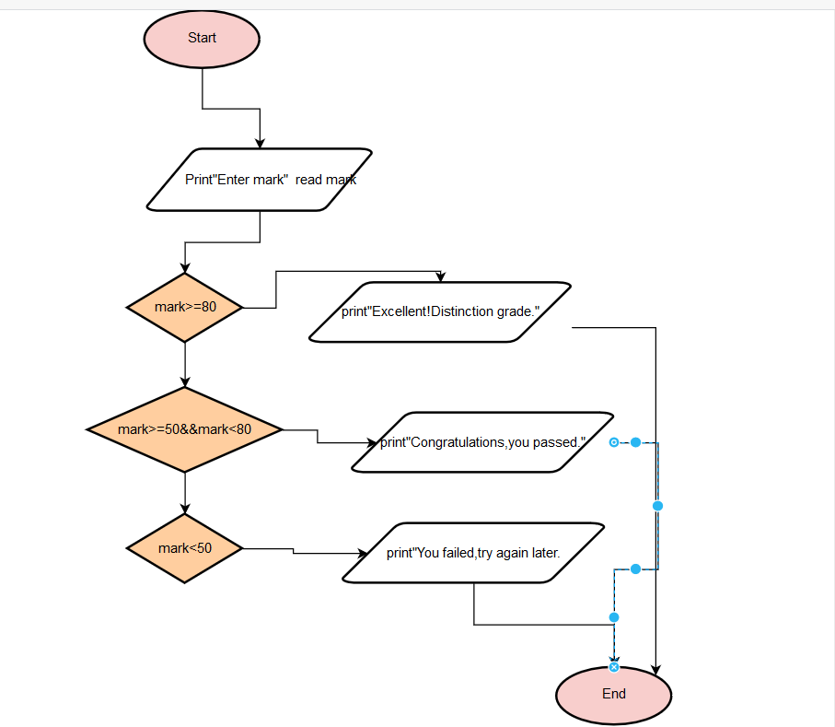

12.
If(area>=0)
Side=sqrt(area);
Else
Cout<<”Error:Negative area”<<endl;

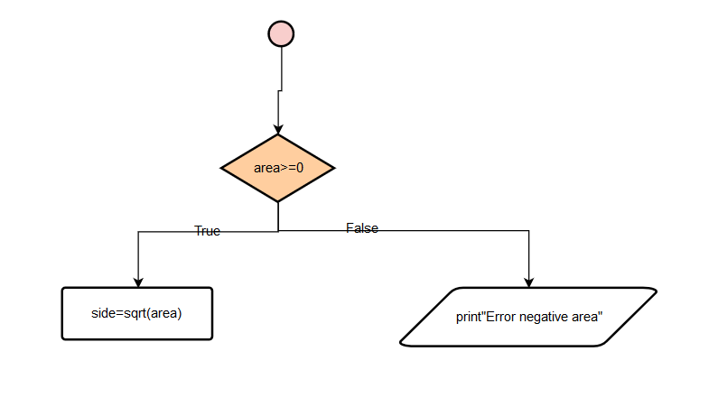

13
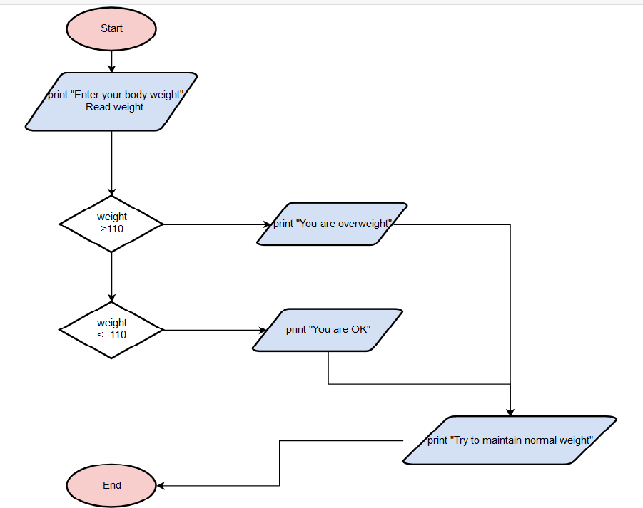
a) To determine the status of our body weight
true
true
False

b.
if((weight>110)
cout<<”You are overweight”;
else
cout”You are OK”’;

c.
if and if
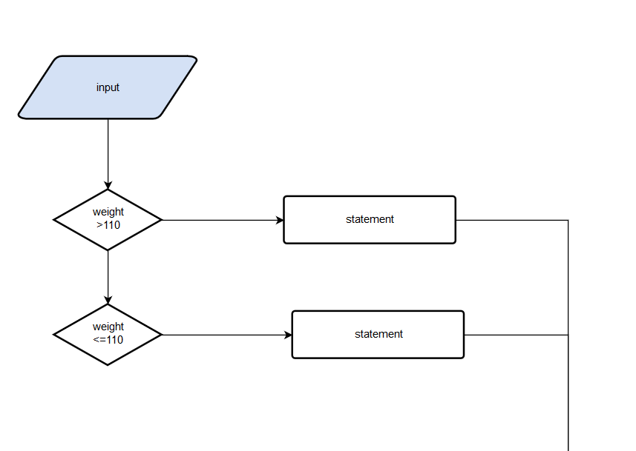
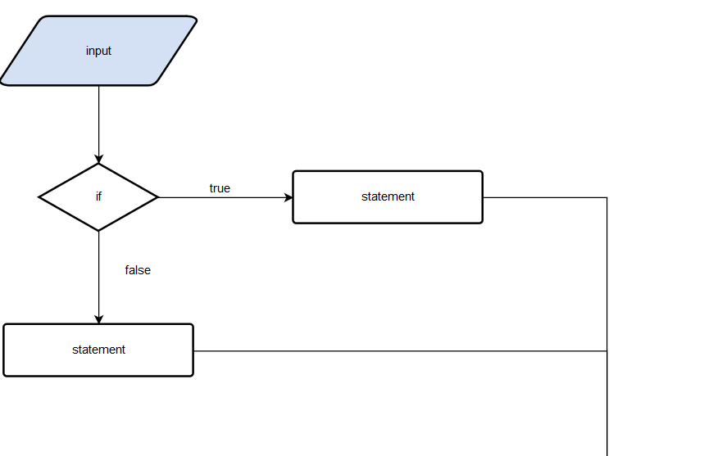
true
true
False

If and else

14.
a.
If(first >=second)
Cout>> largest =first;
Else
Cout>> largest =second;
b.
if((minute<0)&&(minute>59)
cout<<”Sorry,invalid”;
else
cout<<”OK,valid”;

15
a.cout<< (application_status==1)? “Congratulatons!\nReport for duty on the 1st.\n”:”Sorry,you are not qualified”
b.
val=(val%2==0?even++(val>10?val+5:val-3):odd++)

16.
a.input=1
output=Single
#include <iostream>
using namespace std;
int main() {
int filling_status;

cout<<"Enter your ta filling status";
cin>>filling_status;
if(filling_status==1)
cout<<"Single"<<endl;
else if(filling_status==2)
cout<<"Married-filling jointly"<<endl;
else if(filling_status==3)
cout<<"Married-filling separately"<<endl;
else if(filling_status==4)
cout<<"Head of household"<<endl;
else if(filling_status<0)
cout<<"Error in filling status"<<endl;
else if(filling_status>4)
cout<<"Error in filling status"<<endl;

return 0;
}
17.
a.
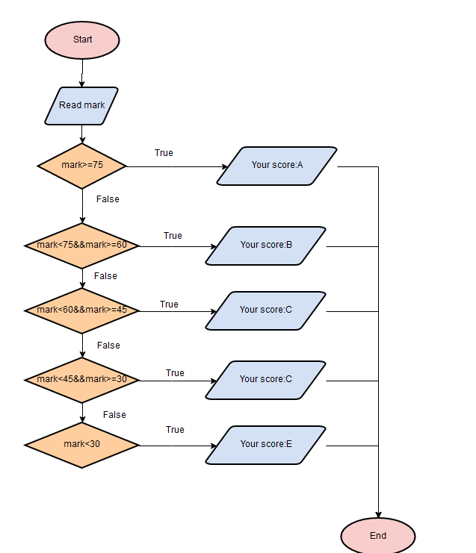
b.
line11
Your score:A
c.
The difference two if else and if that if the first if is true(line 10), all of the other else ifs won't be executed, even if they do evaluate to true. If they were individual ifs, however, all of the ifs will be executed if they evaluate to true

18.

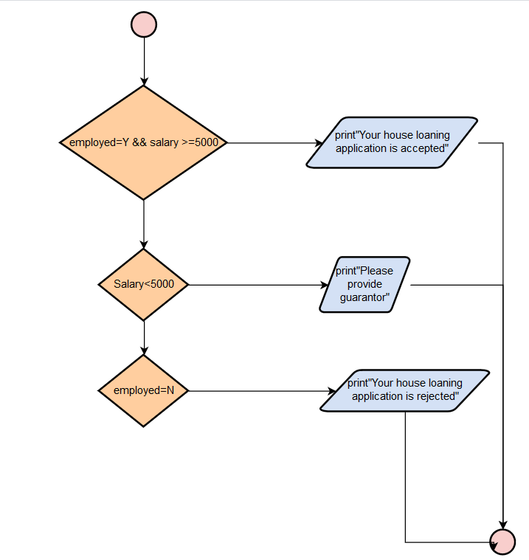

1.Q1 until Q6 Wei Hong
2.Q7 until Q12 Ragu
3.Q13 until Q18 Jeggean

