CHAPTER 5: SYSTEM UNIT

INTRODUCTION

In this digital age, it is almost impossible to do work without a computer. One of the most important parts in a computer is the system unit, which contains all the main components of the computer. Have you ever wondered what problems might arise if the system unit did not exist? In this project, we are required to work on creating a system unit, hence, it is assumed that the system unit still does not exist in our world, and the current computers have all the necessary components to function, except it is without a system chassis. In other words, the current computer does not have a casing to store all its important components together into one device (system unit), instead, the current computer has all its components connected separately and not all put together in a single device. Hence, we are required to come up with the solution of creating a system unit using the concept of design thinking in order to solve all the problems that arise without its existence.
There are 5 different phases in the whole process of design thinking, they are “empathize”, “define”, “ideate”, “prototype”, and lastly “test”. These phases will be nicely connected and transitioned between each phase in a logical manner, and also with a good flow of thought in order to show their underlying relations with each other. These phases of design thinking are necessary and important to lead and educate students to being able to design and come up with the implementation of their own creative solutions to solve any given problems.
Without further or due, let us look at the next part of the report, in which we will discuss about the details of the steps and descriptions in each phase of our design thinking process.

DESIGN THINKING PROCESS

- EMPATHIZE
As stated in the introduction, there are 5 phases in the whole process of design thinking. Let us dive into the first phase, which is empathize. In the empathize phase, students are required to carry out interviews with people who are related to the field of study in order to get some responses about the issues that they are currently facing within the specific field of study, which gives the students a sense of direction about the problems that they should be looking to solve with their final product.
For our design thinking project, we are tasked with creating a system unit. Hence it is assumed that the system unit had not yet been invented. With this in mind, we have come up with some possible questions to ask our interviewees for the empathize phase before we carried out the interview. Some of the possible questions are:
- Are you currently facing any problems related to the computer in terms of its boot up (power on) process?
- Are you currently facing any problems related to the computer in terms of its portability?
- Do you find any problems in the current computer in terms of the safety of each of its individual parts (peripheral devices)?
We have also anticipated some of the possible answers to our questions, they are:
- Yes. I am facing a problem with booting up the computer. Because since all the parts are not put together as one device, I have to power up each of the computer parts one-by-one whenever I want to boot up my computer and it takes me a very long time to do so. Thus, it is a big problem for me.
- Yes. The portability of the current computer is a big problem to me because the computer parts are not all put together into one device. So, whenever I want to move my computer, I have to move each of the separate computer parts one by one to another location and it is very inconvenient to me.
- Yes. Since the computer parts are separated, they are in great risk of being damaged easily because they are too exposed to the environment. Hence, it is a big problem to me because I have to constantly worry about my computer parts being damaged.

We interviewed three students who are currently studying Software Engineering in Universiti Teknologi Malaysia, who are namely Brandon, Weng, and Jing Xuan. These interviewees are qualified to be interviewed for our design thinking project because our topic about the system unit is related to their field of studies. It has been confirmed beforehand that they are studying courses related to computers, which includes our topic, the system unit. We have also compiled all of our possible questions into a single question for our interview: The current computer has all its parts separated, do you find this to be a problem?
The interview had been conducted to learn the problems of the current computer through each of their experiences. Their answers are recorded in the table below:
Interviewee | Answer
Brandon | Currently, I’m experiencing a problem where I have to plug in the components separately. It takes quite a long time for me to plug it all in, so I find it quite troublesome.
Weng | I think its quite complicated for me because whenever I want to move my computer o have to unplug all the parts and move them one by one, so I think it wastes quite a lot of my time and it is not very convenient for me.
Jing Xuan | I have a habit of having a cup of coffee whenever I use my computer, and also, I live on the first floor. So, whenever the cars or vehicles pass by, my computer parts will be very exposed to dust and it is very annoying to clean the dust off my computer.

As expected, their answers were as anticipated. Hence, this marks the end of the empathize phase. Next, we have to transition into the define phase.

2)DEFINE
In this phase, we are required to clearly define the problems faced by each of the interviewees and also state the solutions to solve their problems. After analysing the interviewee’s answers thoroughly, we took note on three of the different problems faced by them. Besides, we have also listed three solutions to solve these problems after a lengthy group discussion. These problems and solutions are as listed in the picture below:
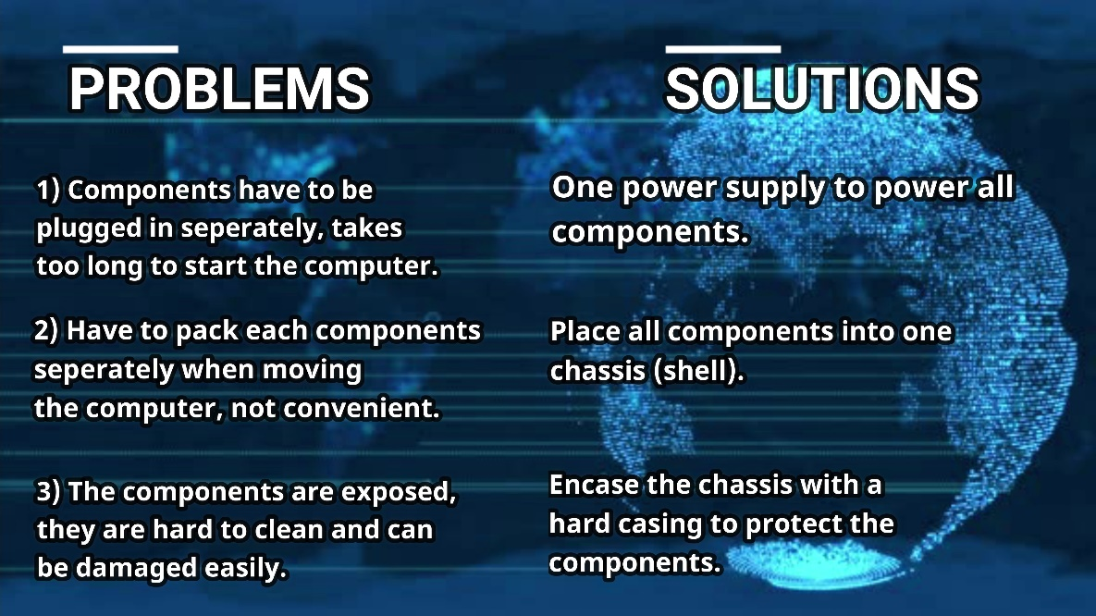
Hence, this marks the end of the define phase. The next phase is ideate where we have to think creatively about the ways to implement our solution into an actual device.

3)IDEATE
For this phase, we are required to think creatively to determine some of the possible ways to integrate the solutions determined in the previous phase into a workable device. In order for us to do that, we must first determine what are the parts that are included in the current computer in order for it to function properly. The current computer consists of the motherboard, which contains the CPU as its brain, the RAM as a volatile (temporary) memory, the expansion slots, and the bus lines to connect additional devices to the computer. Outside of the motherboard, there are the hard disk as a secondary long-term storage, the CD-ROM to read external disks, and also the ports that connects to the expansion slots.
All these different parts are currently separated to allow the computer to function, this causes the problems that our interviewees are having to arise. Hence, in order to integrate all our solutions into one, we have decided to arrange all these parts into a single system chassis as shown below:
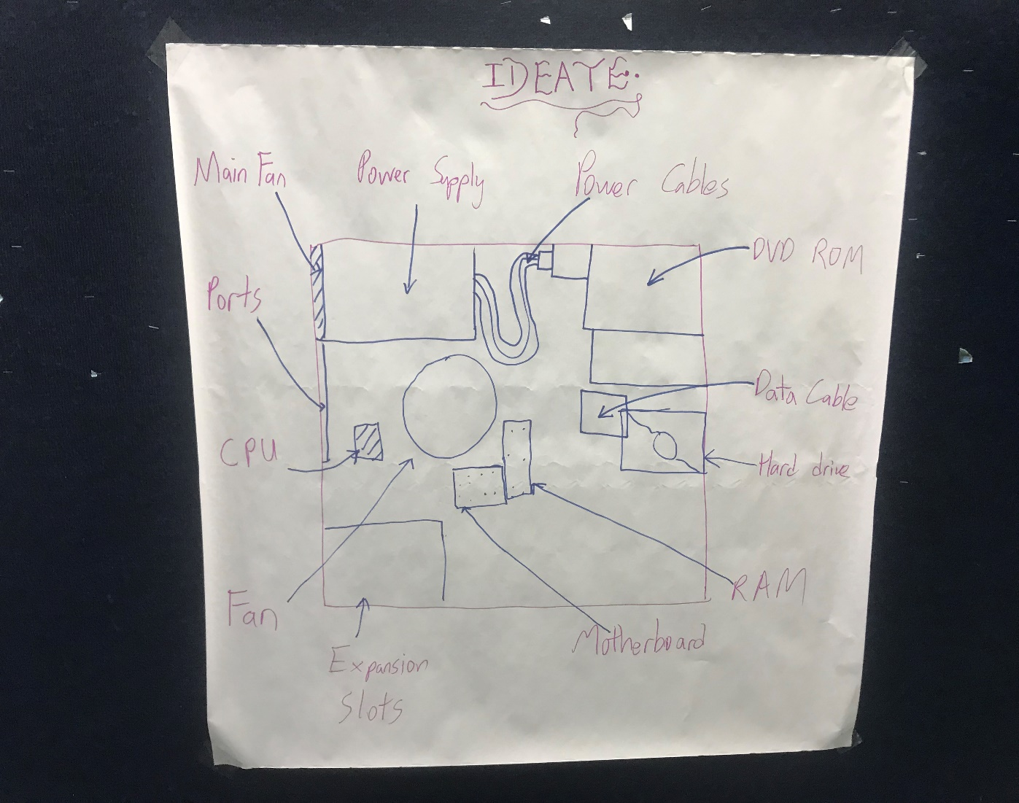
According to the picture above, all the different computer parts are connected and put together into a single casing in order to protect all the parts from damage. Apart from that, since all the parts are put into a single casing, they can be carried around easily, which solves the portability problem. Lastly, the parts are all interconnected and can all be powered up by a single power supply, which solves the problem of taking too long to power up the computer. This whole chassis of computer parts has been named as the system unit. This marks the end of the ideate phase, the next phase will be the prototype phase, in which we are required to create a real physical device based on our plan above.

4)PROTOYPE

In this phase, we are required to create real physical copies of our idea from the previous phase. We have successfully created the system unit using cardboards, tape, scissors, and also glue. The end product was almost similar to our idea as discussed in the previous phase;

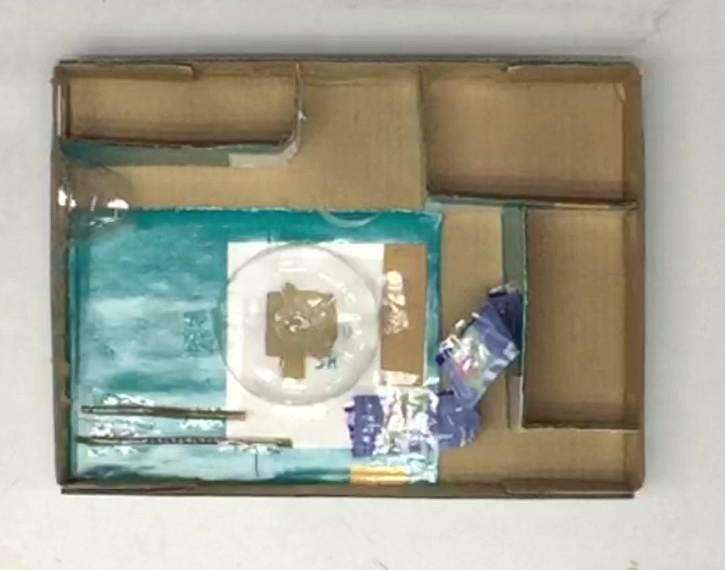

Hence, our prototype should be able to function to provide a solution for the needs of our interviewed users. The prototype must be tested in the next phase, which is the test phase.

5)TEST

In the test phase, we have allowed our interviewees to use our prototype as testing to check if our prototype is able to solve their problems. The video clips of the demo for the testing of our prototype has been posted online on YouTube. The contents of our video consist of our whole design thinking process including the demo for our testing phase. The link to the video is https://youtu.be/7VdWqqbq1h4, which currently already has more than 100 viewers globally.
After the test phase, we have interviewed the same people from out empathize phase to get their answers on whether or not our prototype helped them in solving their problems with the current computer. All of their feedbacks were positive and hence, it has been concluded that our project to create a system unit is a success.

REFLECTION

- What is your goal/ dream with regard to your course/ program?
For all of the members in Group 2, our dreams are to one day be successful software engineers with the necessary skills to solve many real-world problems to make the world a better place.

- How does this design thinking impact your goal/dream with regard to your program?
This design thinking project allows us to learn and improve our teamworking, problem solving, analysis, communication, creativity, and also leadership skills. Hence, we will be able to learn and improve on all these skills through this project and be better prospects as future software engineers.

- What is the action/ improvement/ plan necessary for you to improve your potential in the industry?
We strongly believe that we have to focus more on mastering our ability to not just code well, but also to be able to be a great team leader who can lead a team to handle and overcome any problems that might arise. This is all a part of being a great software engineer.

TASKS

- CHEONG CHIEN LI (A19EC0186)
        - Providing ideas for video editing.
        - Extracting problems from interview for define phase.
        - Providing ideas in ideate phase.
        - Filming parts of the video.
        - Building parts of the prototype.
        - Interviewing people for empathize phase.
        - Completing the report.
        - Preparing the necessary tools and materials for the prototype.
        - Preparing slides for the presentation.
        - Setting up meetings to complete the whole assignment.
        - Planning the presentation.
        - Uploading the video to YouTube.
- MUHAMMAD KHAIRUL AMIRIN BIN KHAIRIL (A19EC0100)
        - Editing the video completely.
        - Providing ideas in ideate phase.
        - Extracting problems from the interviews for define phase.
        - Provide some solutions to solve the problems.
        - Helping to build parts of the prototype.
        - Acting in the test phase of the video.
        - Providing ideas while filming the video.
- ALUGE OSEI-AMAKA ELINOR (A19EC4005)
        - Helping to film some parts of the video.
        - Extracting problems from the interviews for define phase.
        - Provide some solutions to solve the problems.
        - Helping to write some parts of the report.
        - Helping to build some parts of the prototype.
        - Acting in the test phase of the video.
        - Providing some materials for define phase.
- SYAFA ILYAS AL MUZANI (A19EC0288)
        - Extracting problems from the interviews for define phase.
        - Providing some solutions to solve the problems.
        - Helping to build some parts of the prototype.
        - Acting in some parts of the video.
        - Providing some tools for the prototype phase.

