INDUSTRIAL TALK 1 – MDEC

Names:Nurul Hana Binti Azam
Matric no:A18CS0219
Section:06
Lecturer:Nor Bahiah Binti Hj. Ahmad

INDUSTRIAL TALK BY MDEC e-REZEKI
To:Dr Nor Bahiah Ahmad
On 25 September 2018,A talk was present by MDEC in e-Rezeki programme .A speaker of the talk was En Ihsanuddin Johari who is a full time freelance .A bit introduce about what is freelance is a person who is self-employed. Freelance workers sometimes represented by a company for temporary agency that resells freelance labor to clients. They work in independent that can do a lot of things using IT such as photography ,ICT service & consultant, project manager,education and also graphic designer. E-rezeki was a local platform that provide accommodation for people to make them easy to do somethings by saving their time also. A few example for this platform is Grab,FoodPanda and MakeEasy.There are 3 things under MDEC programme which is E-Usahawan,E-Rezeki,Global.E-Rezeki is a program that enables to help people especially in low-income groups to generate additional income by doing digital assingments via online platform.Many kinds of job in e-rezeki which is digital micro task,digital works and digitally enabled works.In talk , a few example of people that give inspired to us were Jeff Bazos( Amazon.com), Jack Ma Yun(AlibabaGroup),Mark Z.Berg(Facebook),Garret Camp(Uber),Brian Chesky(airbnb).
Why they inspired us? because they have their aims on how to get more profit by their own way with keep going,consistent ,and think out of the box.Jack Ma described himself as”like a blind man riding on the back of a blind tiger”.Since he founded a technology company without anything about computers. "Believe in your dreams, find good people, and make sure the customer is happy," Ma said. Nothing impossible if we have our confidence in ourself.They also generous to charitable purposes likes Mark Zuckerberg,the co-founder and chief executive of facebook. He and his wife would give 99 percent of their Facebook shares “during our lives” — holdings currently worth more than $45 billion — to charitable purposes .Through this talk, three things found to expand their effort is by sharing economy,share under-utilized assets and also transfer with platform digital.First,sharing economy devided by three points which is skill, space and staff.Within skill,they will increasing number of freelance.Upwork is the largest global freelancing website which can emerging skills as an indication of hot freelance job market trend. By using space by applications such as trivago and airbnb would provide citizens accommodation where people want to go for holiday or business trip likes hotel ,chalet or villa.Staff like Grab and Uber synonym with nowadays that help citizens go anywhere without need to think hard about transportation as they will provide transport to go anywhere and easy to fetch up in a few minutes.
E-rezeki may also a website that earn income from working online.There are three sites of e-rezeki which are digital micro task,digital works,digitally enabled task.Digital micro task is a simple task that involve data entry,processing images,or any actions that required non-specific high level skills to perform.within a few minutes the task completed and can be performed.The task need in digital micro task are data entry of online forms,removing duplicated data,photo image review.Digital works is an online platform for freelancers to get hired an get paid,Freelancers are work by individual,enterprise or private limited company.The freelancers can place bid by choose ton of jobs in first registration.They will transfer payment to account bank if they hired.The advances from being a freelancer are freely working anywhere and anytime that they want and get agreed of payment.Freelance will apply any jobs suitable with their skills and expertise.Examples of digital works are develop of website,mobile application development,creation of logo,graphic designs,software testing,audio/video transcription works and also document format conversion.Digital enabled task is task such as survey,running errands or domestic services which online but has to be performed offline such as conducting survey,events part-time crew and running errands.

GLOW is the main topic that has discussed in talk. GLOW is stand for Global Online Workforce. Global Online Workforce(GLOW) is one of the recommended program by Malaysia Digital Economy Corporation(MDEC),government agency under Kementerian Komunikasi dan Multimedia Malaysia (KKMM). Glow is implemented because of creating a community of capable digital workers,introducing freelancing as alternative carrier for Malaysian people via global digital revenue platform and also provide support programs for digital workers to stay motivated and committed generating digital revenue.GLOW is a programme that generating digital income through method of “crowdsourcing”. Crowdsourcing is a method through digital where the jobs offered and implemented with global digital platform . People that involved was experienced digital workers.Qualification and skill that they have need are first, in IT field(programming,web page,mobile application).Second,design and creative (graphic design,multimedia).Third,linguistic and foreign language(translator,transcription likes mandarin,Arabic and french).Freelancers through offline and face -to-face, qualified and skilled students of ipta & ipts, qualified and skilled housewives as digital workers, young professionals who want to generate lucrative income are people who are involved in GLOW.
From this programme of GLOW,people can make money by internet.Skill likes programming, web developing,graphic design,writer,digital marketing,translation and virtual assistant are the examples of IT that help expand their influence to get more money.There are two types of platform which are international platform and local platform.Examples of international platform is freelancer,upwork and shutterstock.While local platform are kerja digital,freetime works and 123RF.From these platform they can upgrade their skills in information technology and communication also.Looking back at their benefits in these platform are can become an in-demand professional ,get benefit from more career choice,get paid more than your peers and can kicks start your own career.the important why people has to get involve are the opportunity to generate monthly digital income, the flexibility of performing digital jobs anywhere at anytime, generating digital income according to individual needs,opportunities to open a digital employment agency business.
Impact of the program to Malaysia that I think is all the graduate students especially in information technology (IT) courses has their bright future in many types of career weather hired by company or work independently.A lot of opportunity in IT career will help in develop new technology and at the same time will help many people to solve their problem . Malaysia also can has people that expert in this IT and can compete with other countries.From the Industrial Talk what the reflection to me is what I get,I can know more about the e-rezeki on how can i apply many jobs,by knowing the functios of the task and what the benefit from learning many skills in IT.E-rezeki also help students who are fresh graduate that can upgrade their experience and can do a lot of skills like developing web,design graphic,programming and others.Last but not least,I also can know on how to communicate with client in country or outside of country .I don’t need to see them by face to face but can discuss with them by online.This way maybe easy to do jobs at everywhere and anytime.

Based on talk on 25 september 2018 ,there were afew people that give inspired on how they achieve their target in this programme.

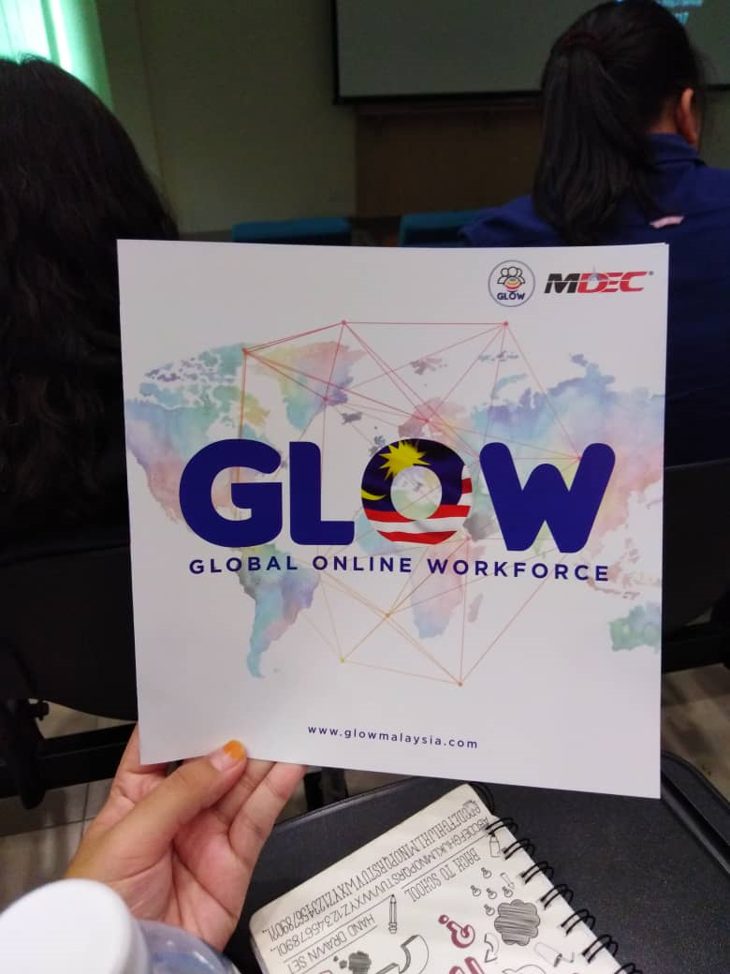
GLOBAL ONLINE WORKFORCE BY MDEC PROGRAMME

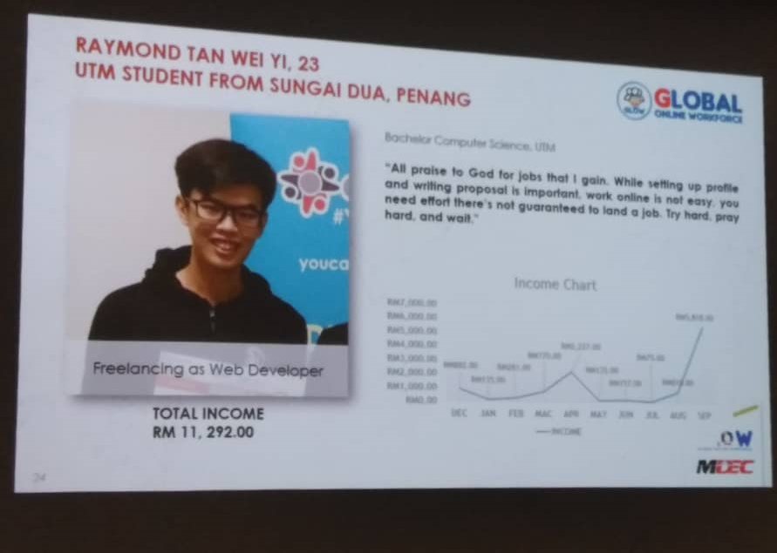
Transcriber content writer & translator
Degree In Engineering at University Flensburg Germany
Freelancing of web developer
graduated from UTM and from Sumgai Dua ,Penang when he at 23 years old

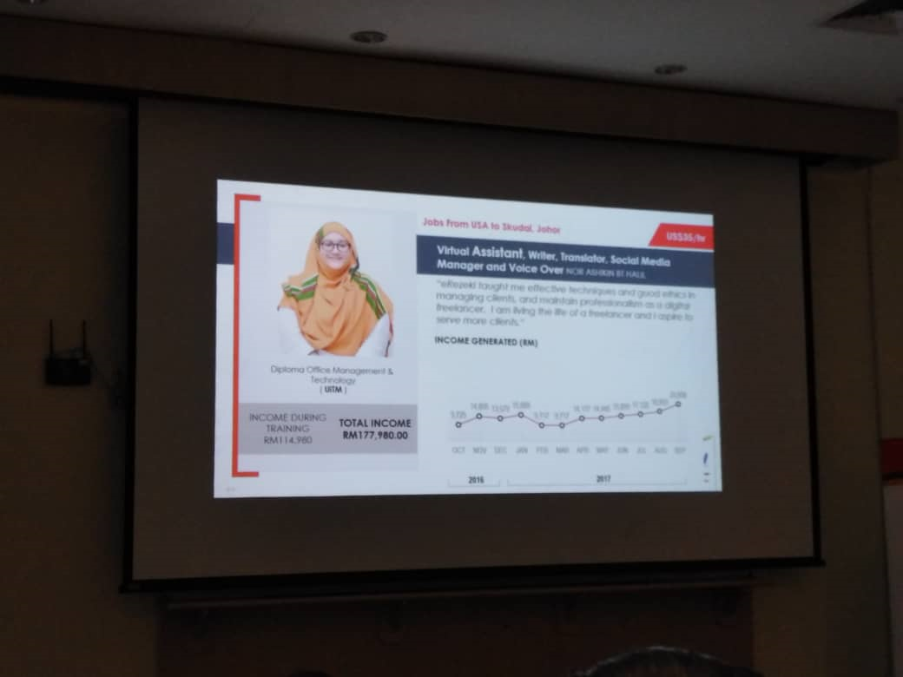
Translator ,subtitler and transcribe
Master in Office System Management
(Hons)
Virtual Assistant writer,Translator Social media manager and Voice Over
Diploma in Office Management & Technology

References:
1.https://erezeki.my/about
2.https://www.businessinsider.com/jeff-bezos-inspired-by-alibaba-jack-ma-speech-2015-5/?IR=T
3.https://www.nytimes.com/2015/12/02/technology/mark-zuckerberg-facebook-charity.html

