Technology Information System
(SCSP1513 Section 7)

PC ASSEMBLE

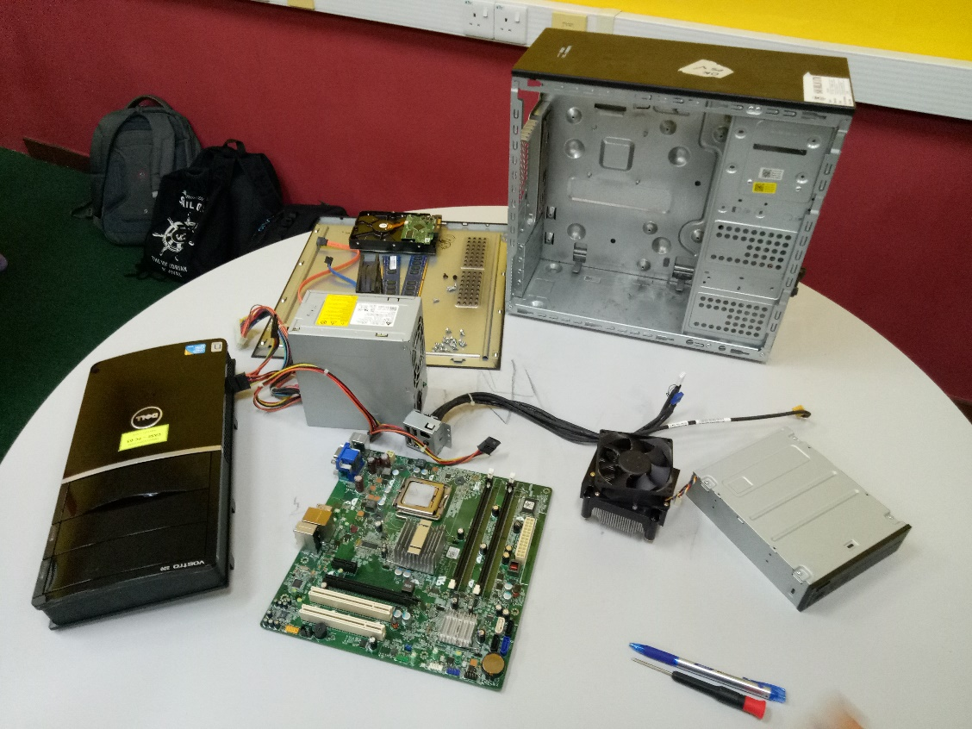

Name : Choy Wan Ling

Matrix Number : A18CS0049

IC Number : 980822 – 06 - 5468

Course : Computer Science - Network and Security

Lecturer : En. Hairudin bin Abdul Majid
Date : 21th OCTOBER 2018
Time : 11.00 a.m. – 12.30 p.m.
Venue : Software Innovation Lab (322-02, Level 3, N28)

Steps to assemble a computer hardware :
- Install power supply. Secure the power supply to the case using the proper screw.
- Install CD ROM drive. Secure the CD ROM drive to the case using the proper screw.
- Install hard-disk drive. Secure the hard-disk drive to the case using proper screw.
- Install Random-Access memory (RAM) onto motherboard. Align the notches on the RAM module to the keys in the slot and press down until the side tabs click into place.
- Install motherboard. Insert all of the motherboard screws and tighten them.
- Install fan assembly onto the motherboard. Secure the fan assembly to the case using proper screw.
- Install cooling fan. Secure the cooling fan to the case using proper screw.
- Connect all the internal cables.
- Plug the power supply connector into motherboard.
- Connect one end of the SATA cable into HDD and another end of the SATA cable into the motherboard socket.
- Connect one end of the CD ROM drive cable into the motherboard socket and another end of the CD ROM drive cable into CD ROM drive.
- Connect both power cables of the fan assembly and cooling fan to the header on the motherboard.
- Cover the CPU case.

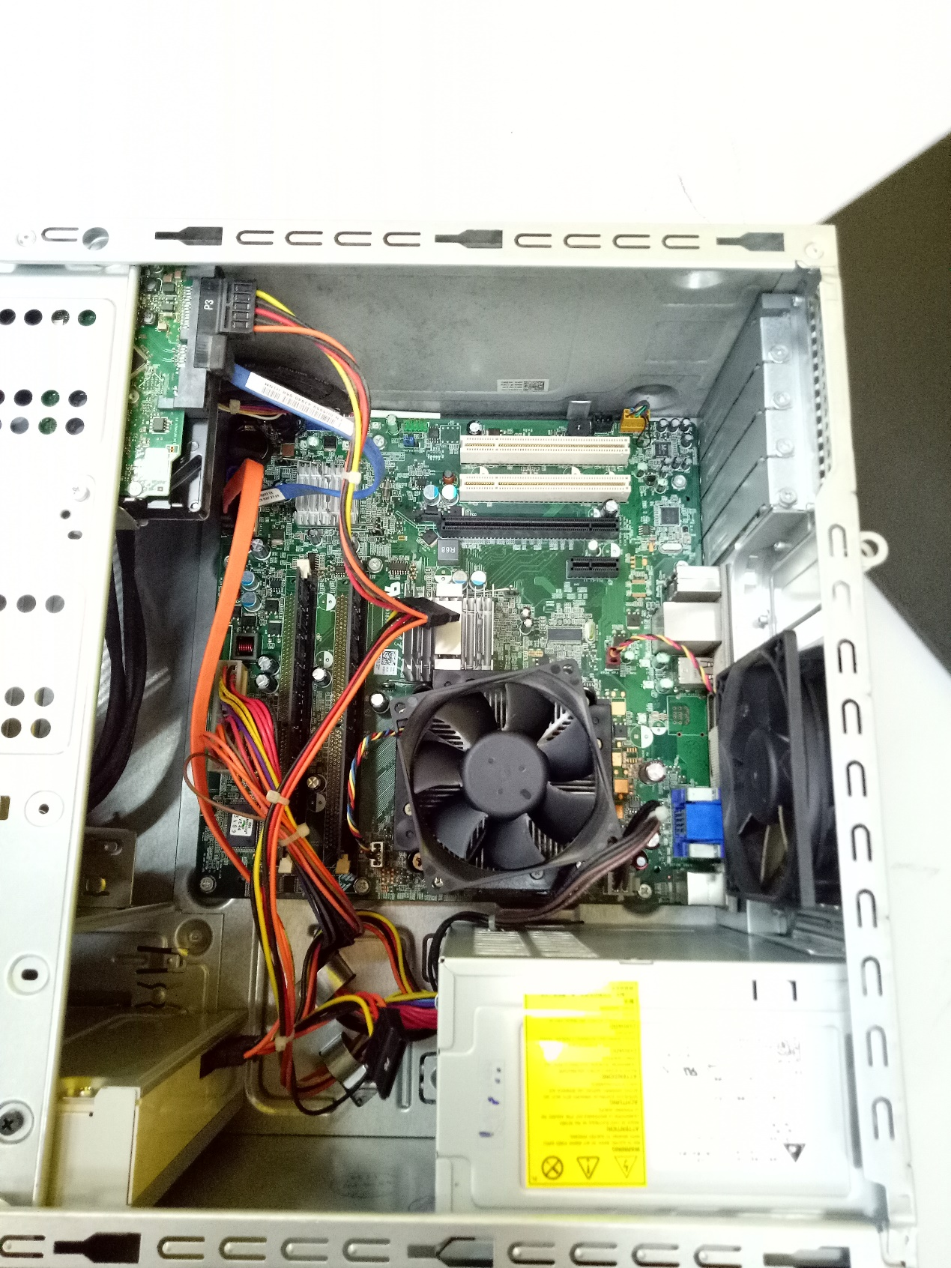
CPU after assembled

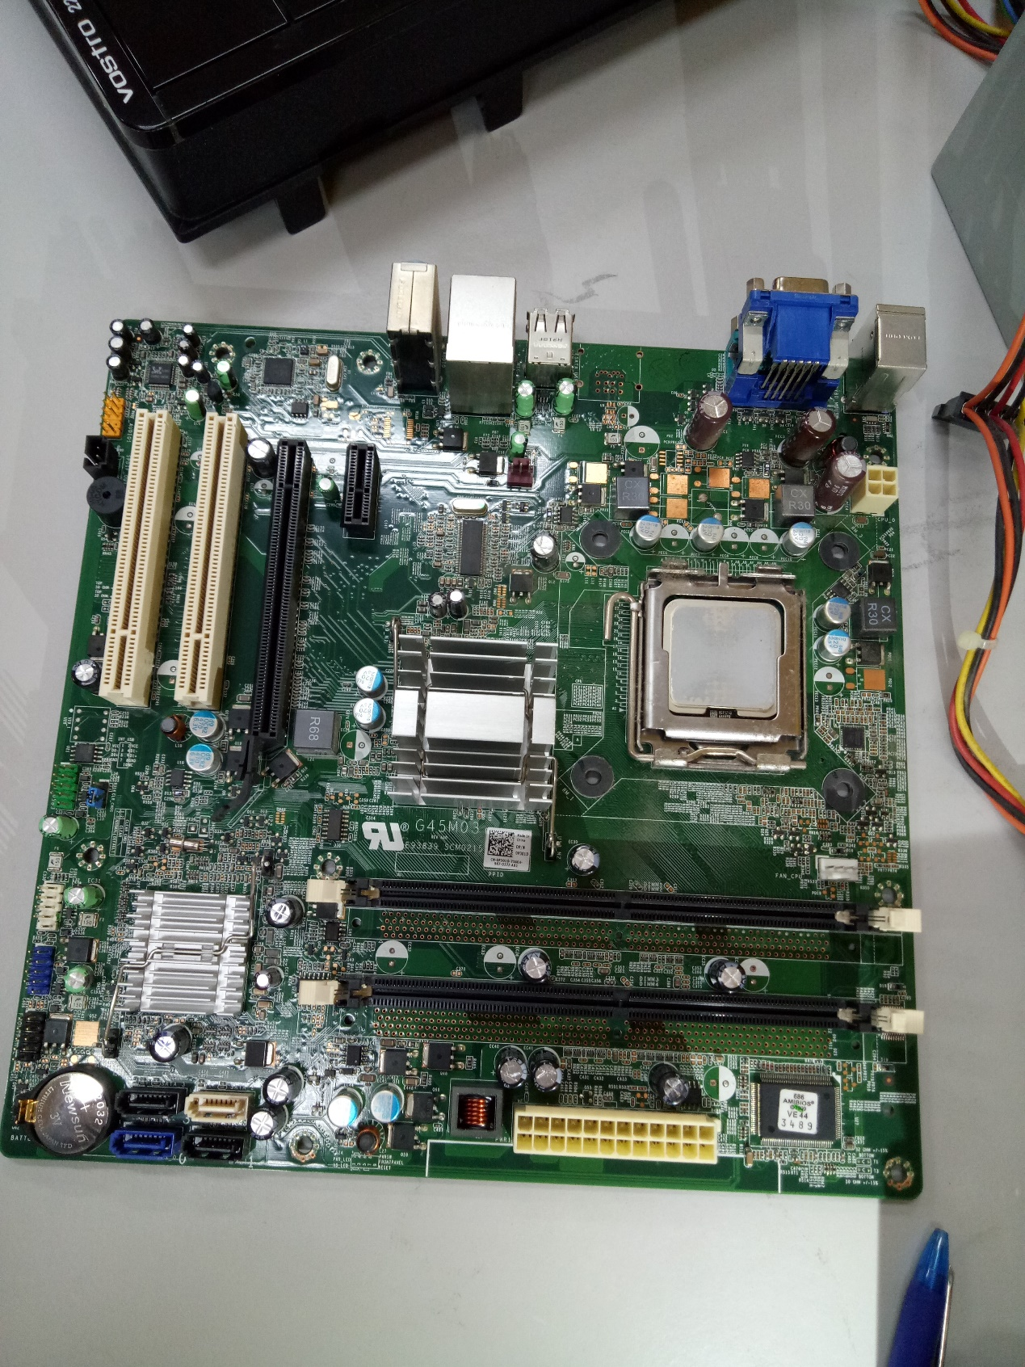
Motherboard

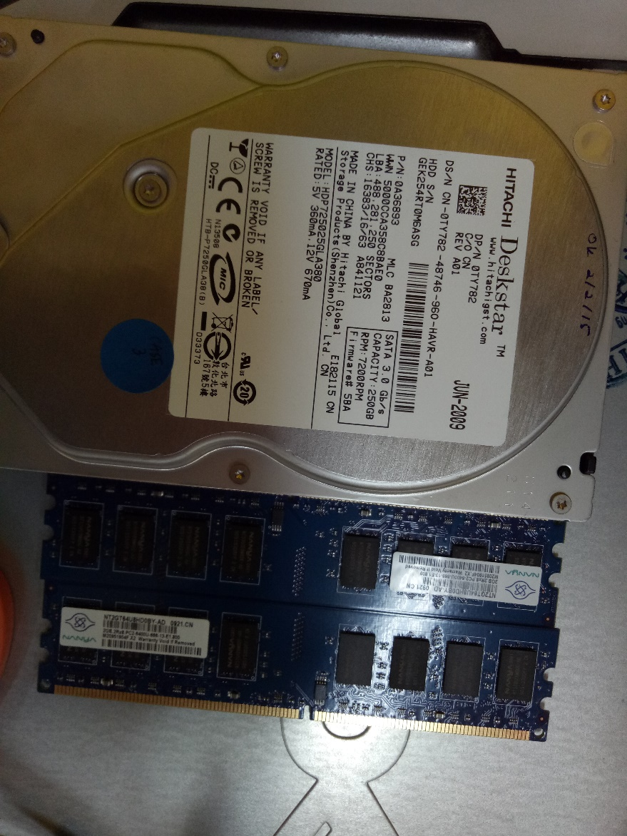
Hard-disk drive
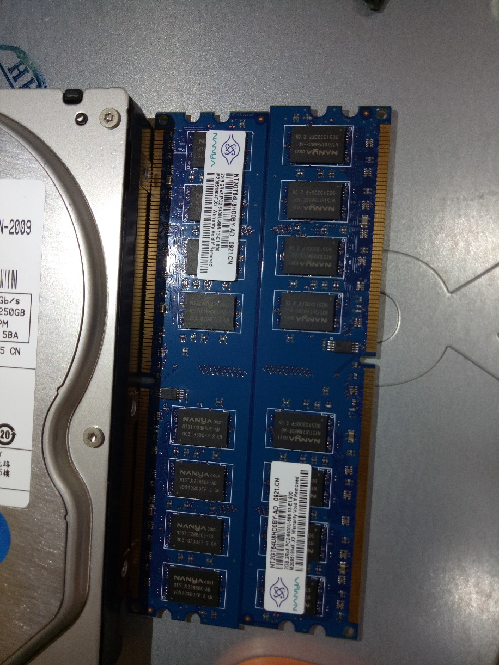
Random-Access memory (RAM)
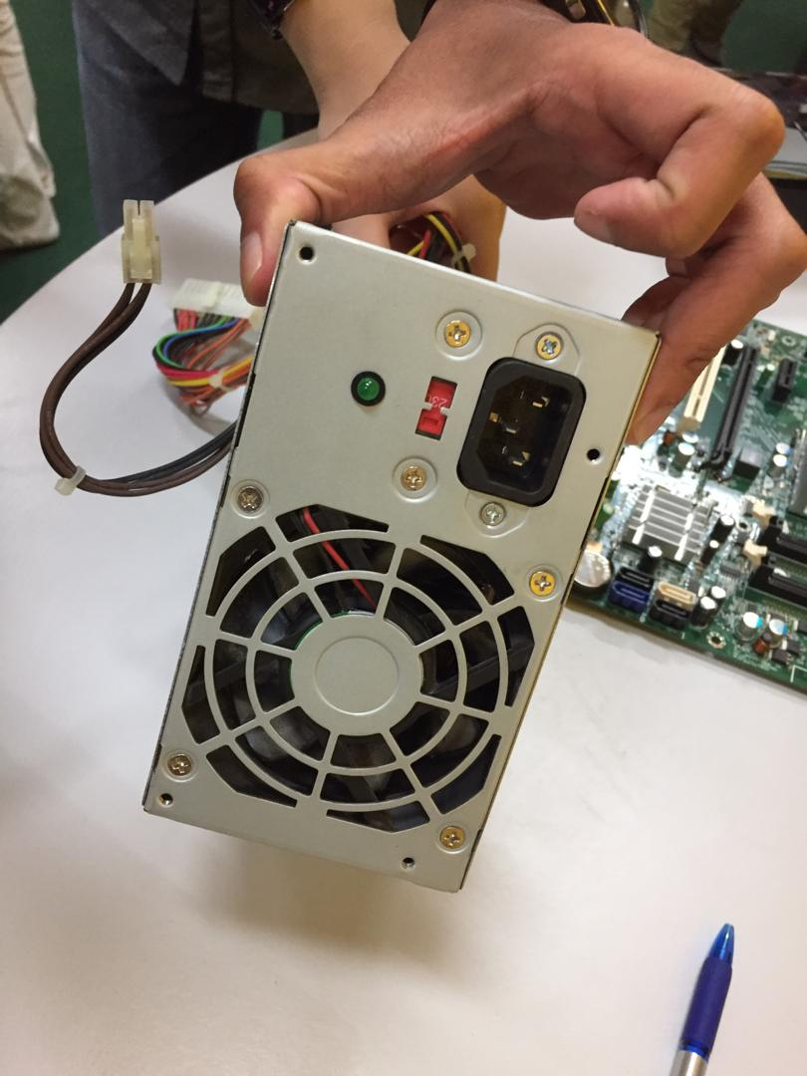
Power supply
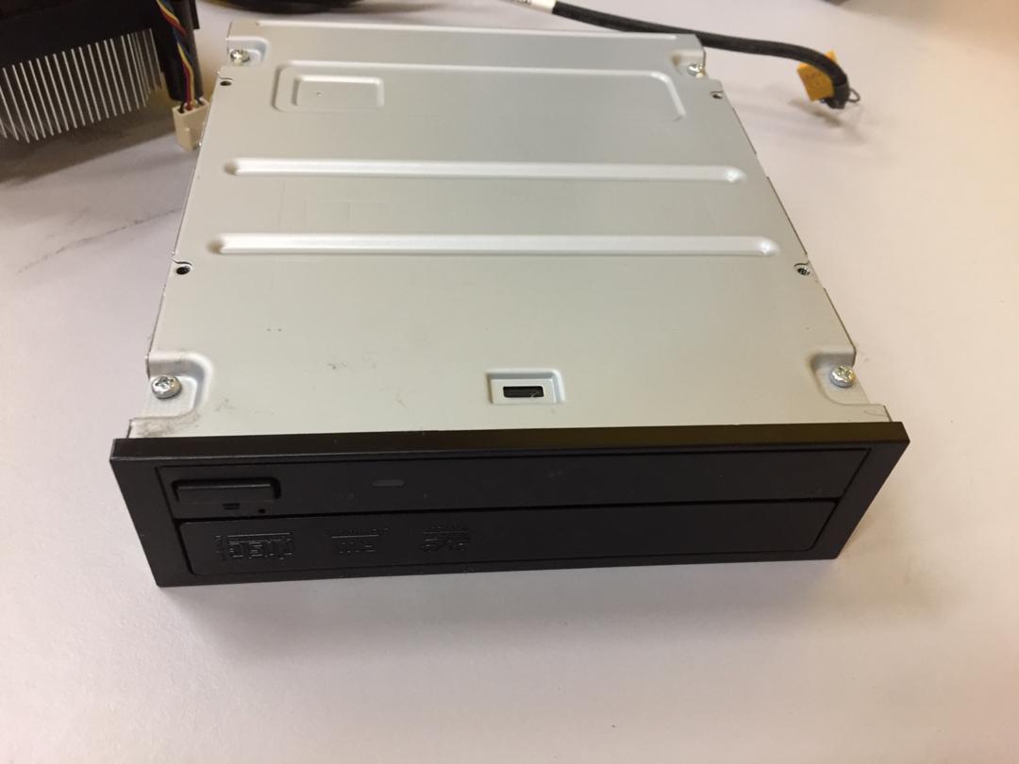
CD ROM drive
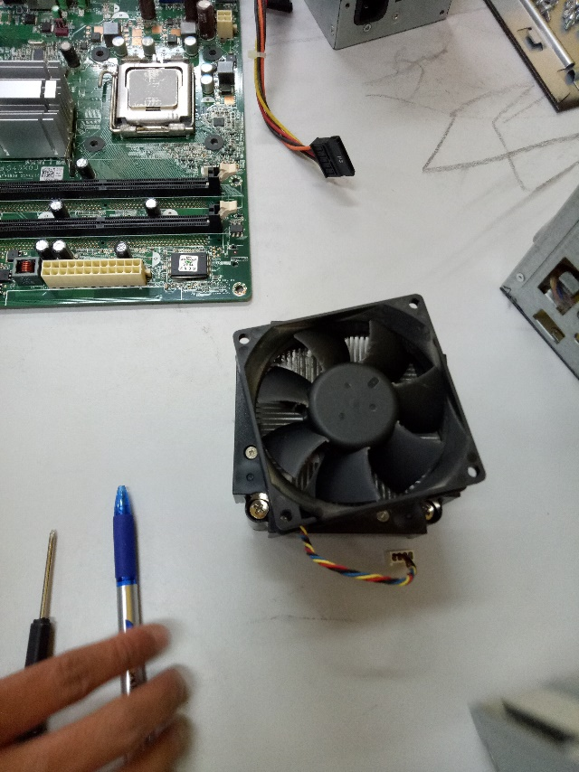
Fan assembly
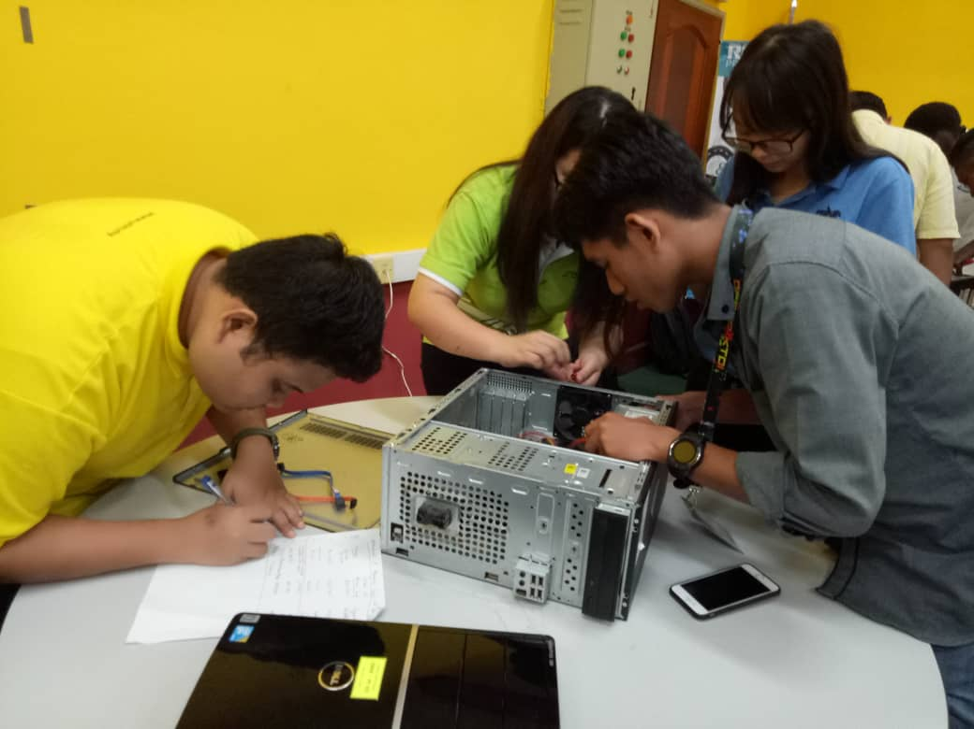
My group members and I are in the process of PC assemble.

