SEMESTER 2
SESSION 2019/2020
SECV2113 - HUMAN COMPUTER INTERACTION

ASSIGNMENT 4: HEURISTIC EVALUATION

PREPARED BY :

- LEE SZE YUAN (A19EC0068)
- HAM JING YI (A19EC0048)
- MOHAMAD AMIN HAZEEQ BIN HISHAM (A19EC0087)
- NUR IRDEENA BINTI CHE MOHAMAD ZULKEPLI (A19EC0130)
- SHASITHER A/L SANDRAN (A19EC0160)

LECTURER'S NAME: DR AIDA ALI
SECTION : 01
SUBMITTED ON : 20/6/2020

Introduction

The product developed by our group for this project is called Eyes on AI Smart Glasses. Previously based on the established requirements, we were able to come up with the physical design for our prototype. In this part of the project, we were to perform heuristic evaluation on the developed product prototypes using the Nielsen’s Heuristics Evaluation technique. Based on the evaluation on the designed user interfaces, we would be able to identify possible issues that might arise for the users. This will help us to effectively troubleshoot the issues found according to its severity. The Heuristic Evaluation enables us to refine our prototype interfaces to be even better and able to perform its tasks appropriately. In this report, we have described all the problems identified according to the heuristics that have been violated. Then, we have also improvised the issue and have described the recommended improvements on the prototype interfaces.

Methods

Firstly, we have to do the heuristic evaluation discussion through an online meeting so that each of the group members understand what the issues are and fix them together. Discussion is a must just to make sure all group members know the situation well and come up with a result. At the same time, each of us share the prototype of the user interface based on the tasks that we already divide each other with our team members.
In order to perform heuristic evaluation, we first had to come up with sketches and drawings of our prototype user interfaces. The sketches and drawings of our prototype user interfaces are our materials for evaluation. To do that, we used a software called Invision Studio where we can design our interfaces using various built-in features in the software. We designed the interface for our three main tasks which are 3D modelling and designing, watching tutorial videos and 3D pictures motion. The interfaces are all designed based on what we feel suitable for users from different groups. We considered their needs and limits so that the interfaces are user-friendly and the users will not feel burden to use our product. After we have completed the interface designing process, we then reviewed the interfaces. We tried to use the system as if it was functional. We followed the flow of achieving the three tasks and while doing that, we identified any issue or problem that we faced during the process of completing each task. In order to let our system works perfectly, we jotted down all the problems found while doing the task.

To be more detailed, we want to fix all violations of our prototypes according to Nielsen's Heuristics. So, we conduct the heuristics evaluation at every stage of the design process. We do this because all of us can get more feedback and comments at every design stage which can help us to create a more perfect user interface. Firstly, the 10 heuristics are in our minds while sketching the refined user interfaces. When we move on to the second stage of prototyping, which means the refined part, we create the correct user interfaces according to the 10 heuristic. When the prototype is done, heuristics evaluation is conducted again and we fix the violation according to the 10 Heuristics as well. All of the group members are the evaluators and all of us think at the side of usability experts while carrying the three tasks. The heuristics evaluation always included all of the group members because most of the problems will be found and all of the group members can understand the situation well. The most important thing before conducting the evaluation is that all of the evaluators are briefing with the same instructions so that we have a clear and common goal. When we find out the issues, all of the group members will discuss and provide an ideal solution to fix the issues.
In our view, the heuristics evaluation should be conducted in every stage of design because it can help us to increase the system maturity and provide a fully functional system. This is because this evaluation is the approach that will point out where the problems of the system are. When we are done reviewing the interface, we then move on to classify the problems based on the heuristic that each of them has violated. We then included its severity or seriousness and we also drafted out some recommendations to fix and improve every issue.

Results
Applications | Problems | Average Severity Rating | Heuristic Category
Home page | Users don't know how to navigate the main interface | 3.00 | #10: Help and documentation
 | Users don't know how to reduce ‘alert’ meter | 2.00 | #9: Help users recognize, diagnose, recover from errors
 | Lack of consistency in the design of buttons and icons | 2.00 | #3 Consistency and Standards
Youtube | User are not informed about the status | 2.00 | #1: Visibility of system status
 | Typo when searching | 1.00 | #5: Error prevention
 | No list of options when searching | 2.00 | #6: Recognition rather than recall
Home Planner | No feedbacks | 1.00 | #1: Visibility of system status
 | Undo and redo button | 3.00 | #3: User control and freedom
 | Exit button | 3.00
 | No tips or help menu | 2.00 | #10: Help and documentation
3D Modelling | Limited working field | 1.00 | #8: Aesthetic and minimalist
 | Similar icon but different function | 1.00 | #4: Consistency and standard
 | Error in identifying the different aspects of measurements of the model | 3.00 | #5 : Error Prevention
 | Click for further actions using traditional method (icons) | 2.00 | #7 : Flexibility and Efficiency of Use
 | Error of choosing the correct icon | 2.00 | #5: Error prevention

No. | 1 | 2
Prototype Image | 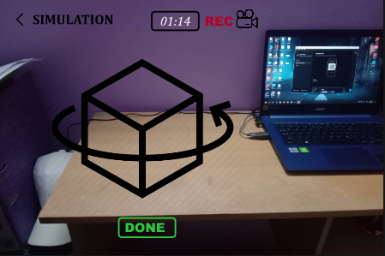  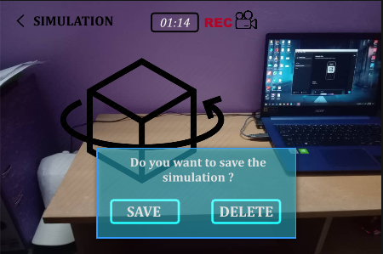 | 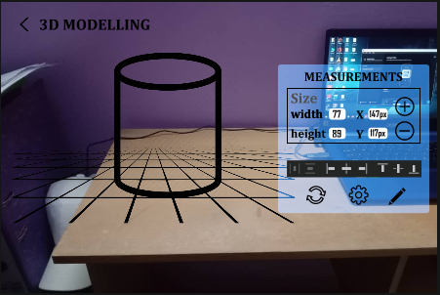
Identified Issue | The issue encountered after the evaluation was for the simulation function, the users are required to click on their further action which is to either Save or Delete the recorded simulation. This function seems like a traditional method of doing a task. It will be greater if the users are provided efficient ways to save or delete the simulations relative to minimalist design concepts. | In this 3D Modelling measurements function, it is quite easy for the users to get confused with the different aspects of their model which will eventually lead to errors in deciding the measurements. In that case, it will also be difficult for the users to measure when dealing with complex 3D Models which will require even more precise measurements. Users could easily make errors if they were not guided properly.
Heuristic And Severity | H7: Flexibility and Efficiency of Use  S2: Minor issue | H5: Error Prevention  S3: Major issue
Revised Image | 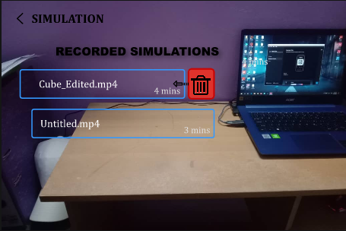 | 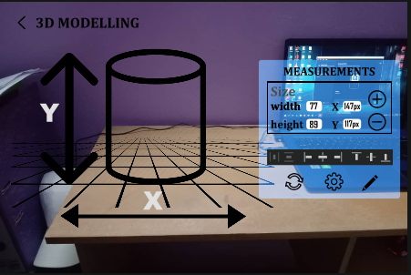
Revised Explanation | As it can be seen on the revised image, users will now straight away proceed to a list of available simulations. This means they are not necessarily required to click on their actions (Save or Delete). Here, they can review the list of simulation videos. If they decide to delete any of them, they can simply slide the video bar to the left to directly delete them. This interaction provides users the flexibility through gesture interactions with the prototype interface. | In order to give better guidelines for the users while setting measurements of their 3D Models, several labelling adjacent to the 3D Models, could make things easier as well as prevent potential errors. Although it seems to be a minor issue, it may influence the users’ perceptions and usability experience on their preference to use the 3D modelling feature in Eyes on AI Smart glasses to accomplish their tasks.

No. | 3 | 4
Prototype Image | 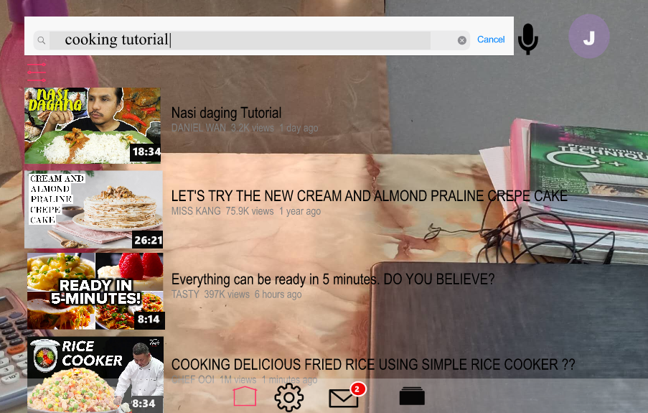 | 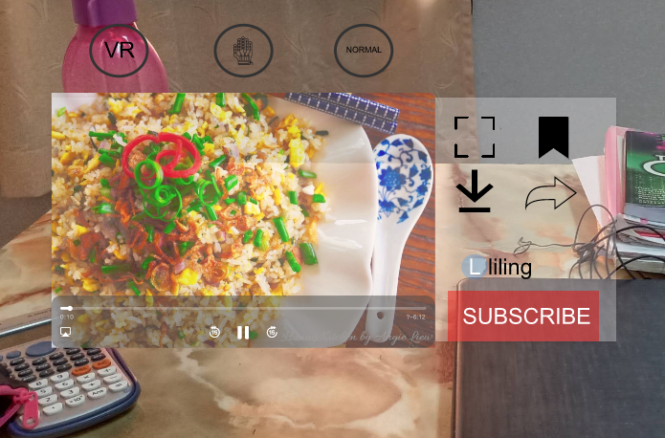
Identified Issue | After the user typing the words “cooking tutorial”, there is no list of options for them to choose. Users have to recall back what are the complete words in their mind and type the complete words. They have to recall the whole thing. | The filled saved icon will be shown at the upper right after the users press the unfilled saved icon to save the video. However, users will get confused whether they saved the video or not. Since the unsaved icon is not filled while the saved icon is filled with black.
Heuristic And Severity | H6: Recognition rather than recall.  S2: Minor issue | H1: Visibility of system status.  S2: Minor issue
Revised Image | 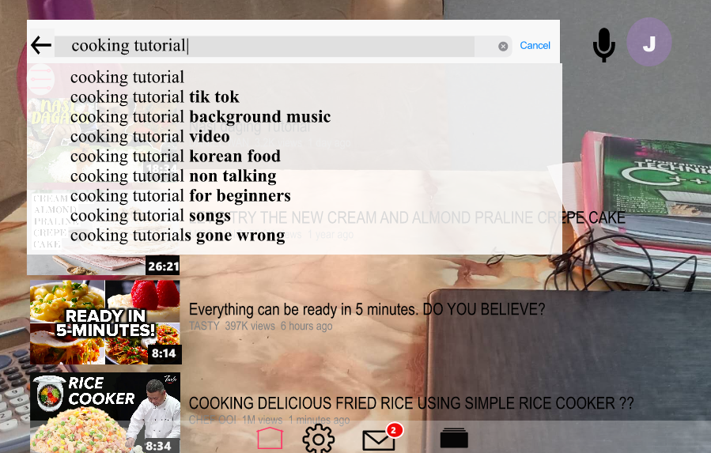 | 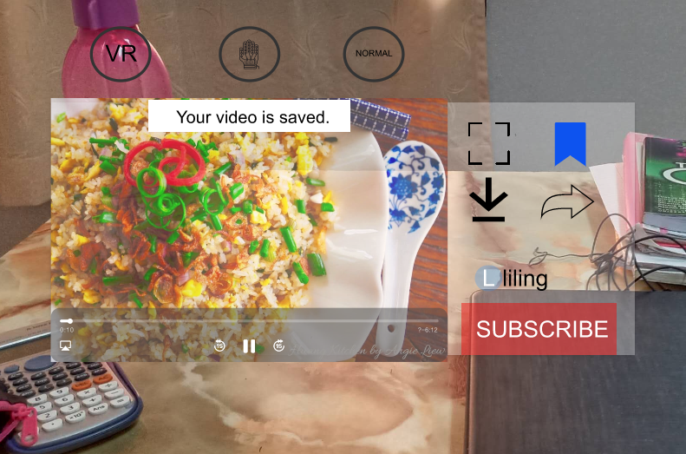
Revised Explanation | A list of correspond and possible options will appear after the users enter the words. | A filled black saved icon is replaced with a bright blue icon to catch users’ eyes and remind them the video is already saved to watch later. Besides, a message of “Your video is saved” will pop up to let users know the status of the video.

No. | 5 | 6
Prototype Image | 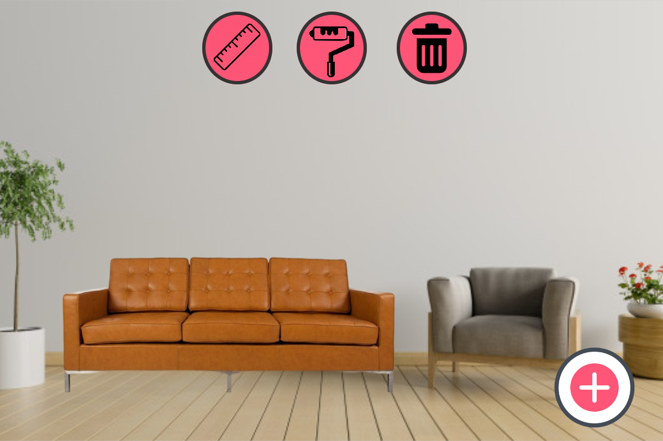 | 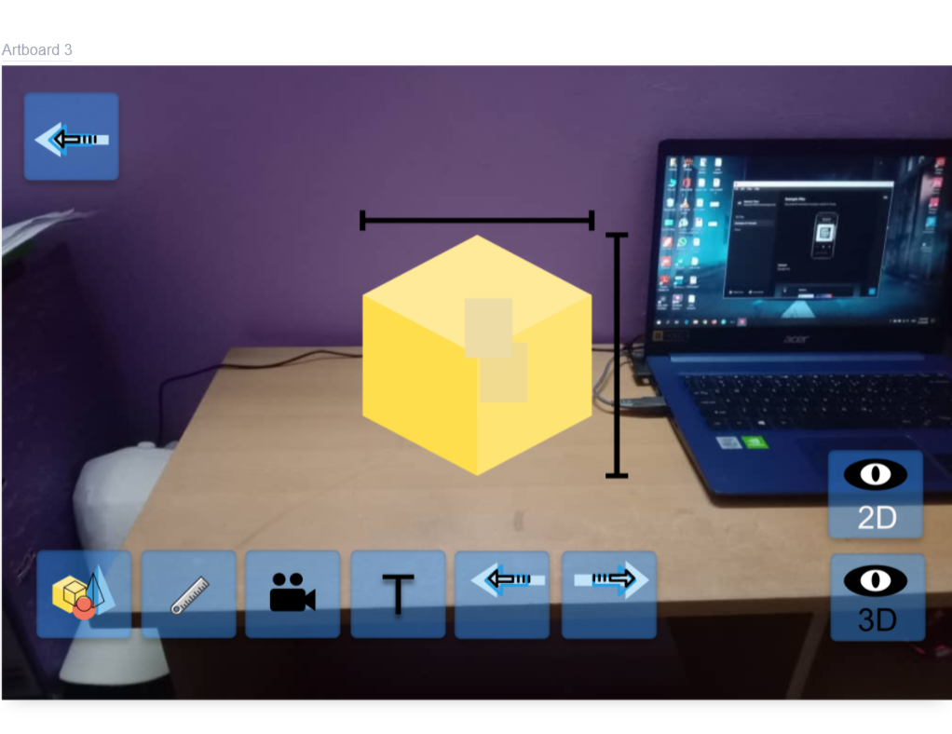
Identified Issue | After users have made a change, for example placing new furniture in an area, they cannot go back to the way it was before. The only choice that they have is to delete the changes that have been made which cannot be undone. | There are 9 buttons on that screen that always display while the program is working on the modelling 3D object which is a little bit limited to the user's vision.
Heuristic And Severity | H3: User control and freedom  S3: Major issue | H8: Aesthetic and minimalist design  S1: Cosmetic issue
Revised Image | 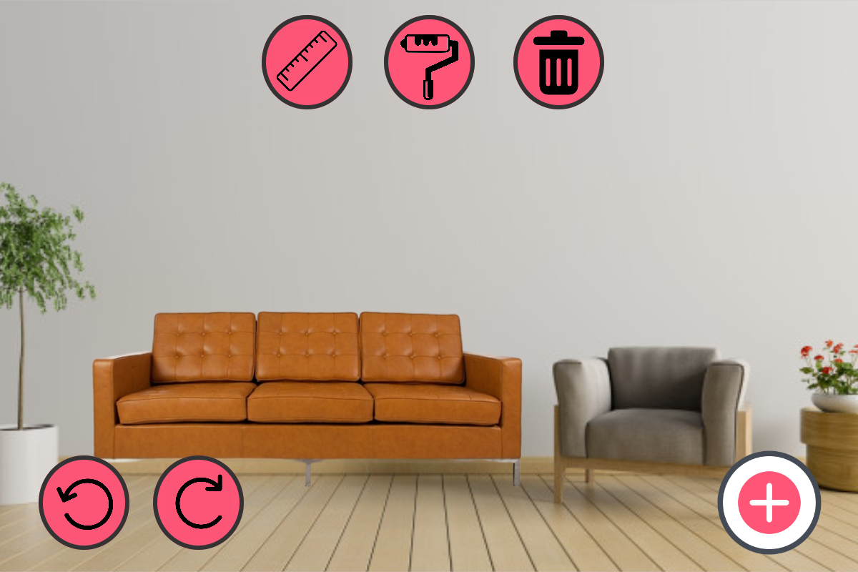 | 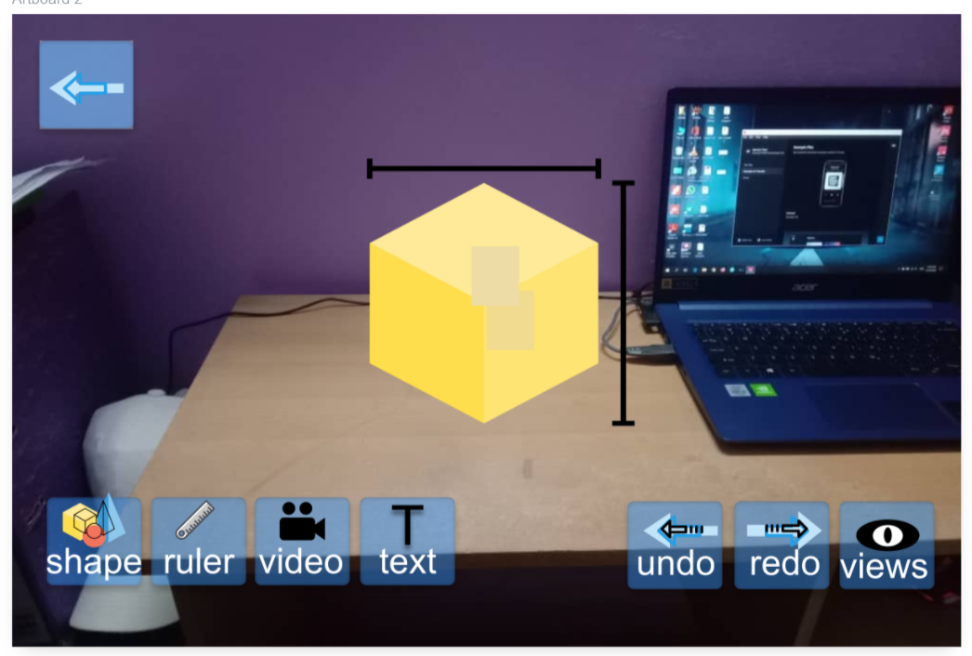
Revised Explanation | Undo and redo buttons are added so that users can easily undo the changes that they think are not suitable. They can also redo them back if they change their mind anytime. | We have maximized the negative space.By including the 2D and 3D button in one “views” button that will also display the 2D and 3D button at the other page with lesser unnecessary buttons placed on that page.

No. | 7 | 8
Prototype Image | 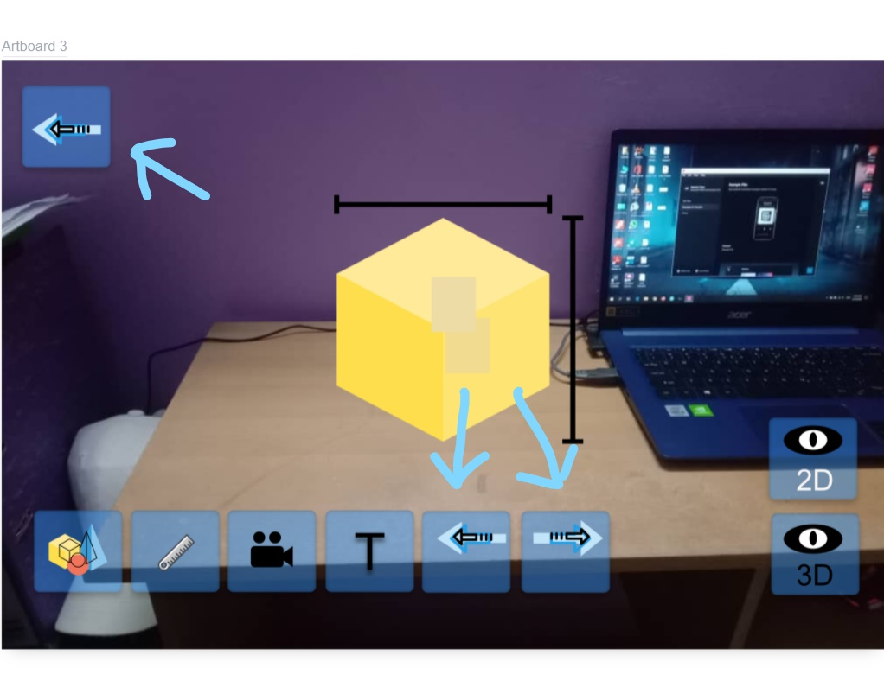
Identified Issue | Those 3 symbols are ambiguous, it is just placed there in a rather vague position. Is the upper one undo or back or home button? and both two buttons at the bottom are for what? Because the developer accidentally used almost the same icon if we as the normal user have no time to check the detailed icons. Clarification is needed. | All of the icons are displayed without any good notation or short information to the user. If the case just only has one button is okay, but how do the older people come to deal with it with many different types of icon? That error of choosing the correct icon will come after that frequently and this will make the work less efficient.
Heuristic And Severity | H4: Consistency and Standards  S1: Cosmetic issue | H5: Error Prevention  S2: Minor issue
Revised Image
Revised Explanation | The back button, undo and redo button can be easily understood and differentiated by the user after putting some changes on the icon shape based on its colour and direction. | All of the buttons can easily be understood by the user after putting its name on it with contrast colour fill-in. The choosing of icons is easy and makes the interaction more effective and efficient. Users do not like being called upon to detect and remedy problems.

No. | 9 (yuan) | 10(Yuan)
Prototype Image | 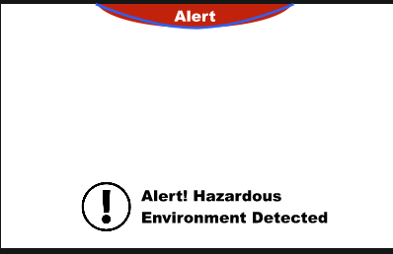 | 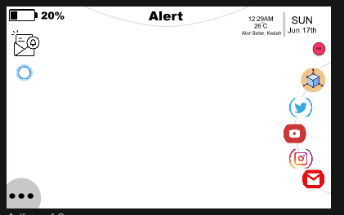
Identified Issue | This is how the interface will look like when the smart glasses detect there are some objects approaching users at a relatively high speed or when the system detects this environment as hazardous for users continue using smart glass. The problem with this interface is that it suddenly shuts down all the apps that are blocking sers vision then removes everything but the ‘Alert Meter’ and the Warning message which is depressing. It doesn't help users how to reduce the ‘Alert’ meter and get the system working back normally. | This is our main interface. As you can see, there are lots of components in this interface. And all these components actually can be interacted by users. So, the problem here is that there are too many components for users to learn how to interact with it. And there is no guidance or tips or user handbook.  So first time users might having trouble in how to navigate the system and might feel frustrated at the first few time using our smart glass
Heuristic And Severity | H9: Help users recognize, diagnose, recover from errors.  S2: Minor issue | H10: Help and documentation.  S2: Minor issue
Revised Image | 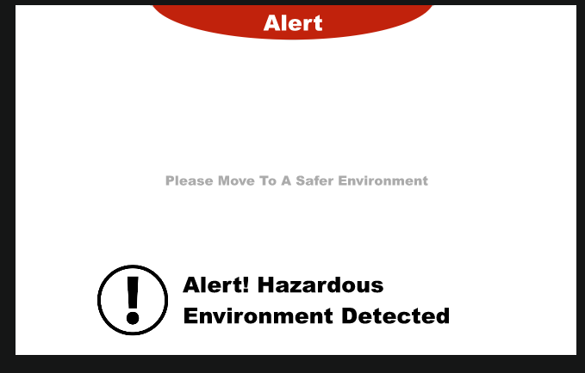 | 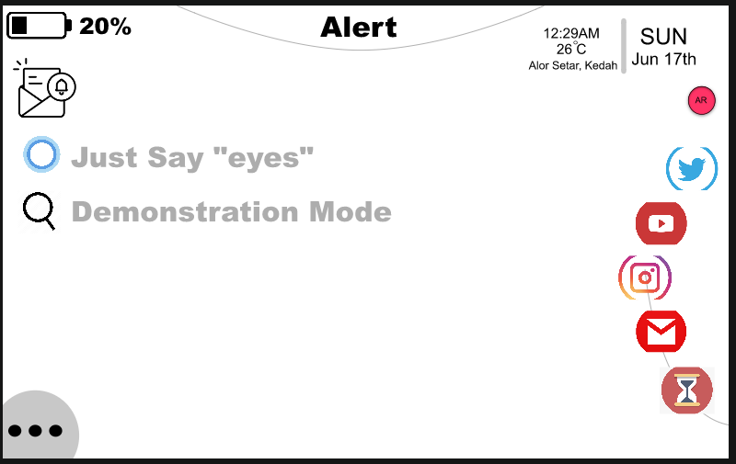
Revised Explanation | So, to help users how to recover from these errors, we decided to put a tip in the middle of the screen. This tip “Please move to a safer environment” will appear in half-transparent form and at the center of the screen. So, users will know what they need to do to resolve the errors. Besides, the reason to make it transparent is to ensure this tip is noticeable by the users, at the same time, it won't hinder users’ vision. | Then, we solve this problem by putting a few tips/ guidance for users when they turn on our system. Then as you can see, we have added another ‘Explore’ icon. Users can click this icon. Then, the system will start a demonstration mode of the main interface. It will show users how each component in the interface can be interacted.

Discussion

Heuristics evaluation is a good method and it should be considered in every single stage of prototype designing so that most problems can be fixed rapidly. This is because it can provide quick and quality feedback to designers. At the same time, the effectiveness and efficiency of the system will be increased too.

Main Interface
Through Heuristics Evaluation, we found that there are good parts on our main interface, there are also some bad parts. Example of good parts includes that our interface has used a minimalist design. We always keep our interface looking clean and spacious (less icon, information et cetera), so users don't feel annoyed as their visions are being entirely blocked all the time while wearing our smart glass. Besides, we keep most of the application windows, icons, nev-bar, notifications in a half-transparent (low opacity) form. So, this will make users feel elegant using our system at the same time, they still can see the things that are “behind” the applications windows., There are also good parts like we also make sure our system matches with the real world. For instance, we make sure every button or icons we have in the main interface can be easily recognized by the users.
Then, there are also bad parts, we have mentioned some above. For example, we didn't make sure that whenever users encounter an error, they know how to resolve the error. Besides, although our system uses icons and buttons that are familiar to the users, we have designed different ways to navigate the system for users. But we didn't make sure users know how and did not design a handbook or something for users. Then, there are also problems like there is non consistency in the design of buttons and icons. We believe this might cause confusion to users under some conditions.
The suggestion of improvement we have prepared is first, we need to make sure users are being well informed across every page of the system. They need to be able to know what the current status of the system is and also know how to resolve errors if any. Then, we also need to prepare a handbook or a demonstration mode for users whenever they have to open a new page or use a new feature for the first time. Last one is that we need to change the design of some buttons or some icons so that the design is consistent. Then, the users will feel less confusion while using our system.

Task 1: Accessing Video Tutorials using YouTube
When evaluating the interfaces by applying Nielsen’s heuristics, the violations of YouTube in our product are H1 visibility of system status and H6 recognition rather than recall. The users are not informed about the status of the product. For instance, after users press the save icon to save the video to watch later, they are not informed about the status whether the video is successfully saved. Our suggestion to make this part more perfect is, some information pop up could be changed into voice messages. Then, it is time for the user to choose either check the status of the pop up or just ignore it. This is also related to H3 User Control And Freedom means give users the freedom to perform some actions. Next, our system should have a list of options when searching to prevent users from recalling the whole thing. This will be easier for the user when searching something on YouTube without recalling.
Moreover, we found that there is minimalist design on the interfaces when carrying out accessing video tutorial tasks in YouTube. After entering the interfaces of YouTube, there are only important and relevant buttons shown. These buttons really help a lot in accessing the task. In YouTube, users can choose the modes such as VR, hand-gesture and normal mode when watching the video. If users choose a hand icon, it means that the video and all the buttons could be controlled using hand movement. Users can move the whole video to a side or move it in front or somewhere else using hand movement. This a new mode for the users and they will be not familiar with it. We purposely keep the icons of VR, hand-gesture else normal mode clean, clear and consistent throughout the interfaces in order to make sure that users can know and familiar with them after some time. So, our suggestion on this part is to give some guidance like comment on every icon when first time usage and press “ok” to skip the guidance. The second example is when users press to watch video, the icons beside the video will be some important and relevant icons only like share, download, saved, subscribe and full screen. On the other hand, we are not going to work on the error prevention in this section since when there is typo in searching, the result shown will be near to what user key in and there will be a list of options to be chosen. Besides, the list of options will show the correct words and sentences. Users can directly choose from the list.

Task 2: 3D Pictures using Home Planner
Home Planner is an application which focuses on users who feel like decorating their house to become cozier and have a better look without having to spend their money just to find out that the chosen furniture does not fit or is not suitable for their house’s theme. When conducting Heuristic evaluation, we found some problems on the application’s interface. One of the major issues falls under Heuristic category 10 which is help and documentation. We discovered that the application does not have the feature where it can help users achieve their goals. It also fails to assist users in making the best choice of furniture to decorate their house. This will be a problem for those who are not familiar with Augmented Reality technology, especially the old people as it is considered a new invention for them. To fix this issue, we came up with a new interface where it has a help button. When the user clicks on this button, the system will pop up message dialogues where they tell users what to do and what each button on the interface does. This will help users understand each feature better and the process of achieving the task which is choosing the best furniture for their house will be faster and smoother. The help button is also crucial to make the system and flow of achieving the goals easier to be memorized by the user.
Another big problem which violates the Heuristic category 3 which is user control and freedom. When evaluating, we found out that the system does not let users have all the control on what they are doing. When users place a new furniture and resize it to a certain size, they cannot go back to see what size the furniture was before they modified it. This is because there is no undo button in the application. In order to go back to its original size, users can do nothing but to delete the entire furniture and choose it back from the catalogue. This will make users stressed out if they are already close to making a choice. To fix this problem, we decided to add an undo and a redo button on our interface. This will make it easier for users to see the previous look of their house and also the after look in just two clicks, thus making the process of completing their task not complicated and takes little to no time to be done.

Task 3: 3D Modelling
Firstly, as we can see on the 3D modelling interface we found that there are some ambiguous buttons which look similar with one another. At the left top of the interface the back button icon looks very similar to the undo/redo icon in terms of the shapes but those have different functions to the users. This issue stated under H4: Consistency and Standard which is the idea that designs should minimize how many new concepts users have to learn to successfully use the interface and the severity caused comes under cosmetic issues or (what is the point of using almost the same icons that literally will confuse the user and this new concept is fail to the users). Using different types of icons for the “back” button can clear the confusion among the user and make it consistent and standard with the different icons for different functions.
Next, on the 3D modelling we found that the developer uses new types of icons (unfamiliar) which are not standard with the icon that already exists. All of the icons are displayed without any good notation or short information to the user. If the case just only has one button is okay, but how do the older people come to deal with it with many different types of icon? That error of choosing the correct icon will come after that frequently and this will make the work less efficient. This falls into H5: Error prevention while the severity enrolls in the minor issue which hinders the user’s ability to navigate and should be fixed when possible. Choosing icons is easy and makes the interaction more effective and efficient putting its name on it with contrast colour fill-in.
On the 3D modelling interface we found that there are many buttons on the interfaces that literally block or limit the movement for user to do their works (making 3D object) and this falls into H8: Aesthetics and minimalist design while the severity is cosmetic issue as user also still can do their 3D modelling but less comfortable with many buttons on the interface. So, using less buttons will maximize the negative space also called white space (name given to the empty areas of an interface). The display must be reduced to only the necessary components for the current tasks, whilst providing clearly visible and unambiguous means of navigating to other content. Negative space has been called the backbone of minimalist interfaces. Many minimalist designers use it as a tool to try to direct users’ attention and allow them to digest content more easily.
Apart from that, the 3D modelling function has measurement features whereby the users can set the size and other measures of the 3D Model manually. Here, there are high chances for the users to make errors of understanding the different aspects of the measurements. This issue can be considered as Heuristic #5, Error Prevention. In order for users to easily get to know the measurement aspects and reduce the probability of making errors while designing their 3D Model, labelling representing different aspects of the measurements will make the users to easily understand them without much confusion.
Besides, once the user has already recorded the simulation of the 3D Model, there will be a pop-out from the interface requesting the user to click on their further action (Save or Delete). This seems like a traditional way of completing a task. For a futuristic device like Eyes on AI Smart Glasses, it is important to have a much easier way of completing the task. In that case, this comes under #7 : Flexibility and Efficiency of Use. At the refined interface, once the user completes the simulation recording, it will directly lead to a list of available simulations that are already saved including the current simulation video. There, users could review their simulation video and then decide on whether to delete or keep them. Once the user decides to remove the simulation video, they can easily slide the specific video bar to the left to perform the delete function.

Conclusion

In the whole process, we did not realise that there were a few flaws and deficiency of the UI design in the beginning of the interface design. But then, we found that we have to fix our mistakes through the help of Nielsen’s heuristic that we already learn from the video given by our lecturer. Nielsen’s heuristic concept made the problem spotted much easier for us because some of the problems were not that easy to spot as we can look into it with more detailed information. So, we list out the problems we found in our system, then through discussions and modifications, we improve our system time by time. We did not solve the problems just by adding a few new things or delete things from our interface. We have to think and plan carefully how to solve the problems because we are afraid that some reckless change in our interface will cause the rise of even more problems. So, we also follow the Nilsen’s heuristics concept while we do the improvement of our system. And this is the current result of improvement of our system. We will continue to look for possible problems within our system and test it then keep on refining it until the last day of our project submission date.

References

Wong, E. (2017). Heuristic evaluation: how to conduct a heuristic evaluation. Dostopno na.

Moran, K. (2015). The Characteristics of Minimalism in Web Design.

Wong, E. (2017). User interface design guidelines: 10 rules of thumb. Interaction Design Foundation.

