TECHNOLOGY INFORMATION SYSTEM (TIS)
SESSION 2019/2020 SEMESTER 1

PROJECT REPORT
DESIGN THINKING PRIVACY AND SECURITY

GROUP 6 (UNDER GOOGLE)
AARON RYAN SHAMIKA (A19EC0001)
YU KAH WEI (A19EC0178)
CHONG HONG LEI (A19EC0035)
NUR SYAFRINA BINTI AHMAD (A19EC0139)

LECTURER
DR. SARINA BINTI SULAIMAN

INTRODUCTION
Design Thinking is an iterative process in which we seek to understand the user, challenge assumptions, and redefine problems in an attempt to identify alternative strategies and solutions that might not be instantly apparent with our initial level of understanding. Design Thinking is a design methodology that provides a solution-based approach to solving problems. An easy way to begin to understand the value of design thinking is by exploring what it is. It used to be de rigueur to call it ‘thinking outside the box’. it revolves around a deep interest in developing an understanding of the people for whom we’re designing products or services. There are few approach been taken to overcome this issue and one of it is to develop Design Thinking.

Design Thinking helps students to get the opportunity to view a problem from a different perspective. Students have to put themselves in the place of their learners to determine what problem they are facing and how can remedy that problem. By viewing it from an entirely different perspective, students can gain ability to look at the challenge facing their learner from a brand new angle, so that they can formulate a solution based upon their specific needs.

Furthermore, Design Thinking helps students to encourages innovative thinking and creative problem solving. Design Thinking offers students the chance to use their innovation and creativity to solve the problems that learners face on a daily basis. The process involves a great deal of brainstorming and formulating new ideas that can help to expand learner knowledge. By taking a Design Thinking approach, students can collaborate with other professionals to get their input and feedback, which helps you to create a complete experience.

Design Thinking give students the opportunity to embrace their experiment by building a prototype. Prototyping is not a simply to validate your idea but it is an integral part of your process. Design thinking process can be divided into 5 major steps, which are empathize, define, ideate, prototype and process.

DETAILED DESCRIPTION
EMPATHIZE
After doing interviews with random strangers, we obtain a few information regarding their daily activity involving surfing the net. We found out that only two operating systems used, which are currently using Windows while the other uses Mac operating system. The problems they are all facing are surprisingly different when surfing the net due to the fact that they are all using different browser which are Chrome, Mozilla Firefox, Internet Explorer and Safari respectively. All four browsers have different problems when surfing the net but have one in common, which is the speed of the browser when surfing the net, using same internet speed of 1Mbp/s. Although the speed of loading the web page is not noticeable and irrelevant because the difference between the browser’s loading speed is a measly 0.1 second but when it is accumulated throughout the years of using the internet, it does become a significant factor when it comes to time management. The main factor that affects the speed of loading are advertisements because the time to load the web page increases slightly by 0.1 second per advertisement in the page and it increases to a whole second when a pop-up ads appears randomly and that leads to the opening multiple tabs. Opening multiple tabs also increases the loading time because each tab need its own data transfer thus the internet speed is divided equally among the tabs in the browser, and other software that uses the internet when the computer is running. We can conclude that the main problem is the speed of loading the web page.

DEFINE
The main challenge that leads to this project is to protect the user’s privacy by providing a tight security algorithm that prevent the user’s information from being leaked to third parties especially hackers. The reason why time is one of the factor that leads to information being leaked is because the longer you are surfing the net, the more data that is being constantly transferred online encrypted, but hackers could take that encrypted data, decrypt it and suddenly all your accounts have been hacked into. Hackers are not the only one that uses the information, your own search engine uses it as well. Every search engine has an algorithm that “helps” user to search what they are looking for by suggesting some possible continuation of the words that they used for searching and that algorithm is always constantly changing and varies based on the user’s search history. This might not seem an important aspect for normal people but it is significant when doing work under a company whether it is private or under government to protect the company’s data.

IDEATE
We held a meeting in Cafe Mak Ngah (M01) in order to overcome the problems that they are facing at the current moment. Each and everyone of us write down ideas on a piece of paper based on the criteria:
- Rational choice
- The most likely to delight
- The long shot
- The darling (your favorite)
Although almost all the ideas are good, we took the ones that we thought would work well together and solve the problems as well:
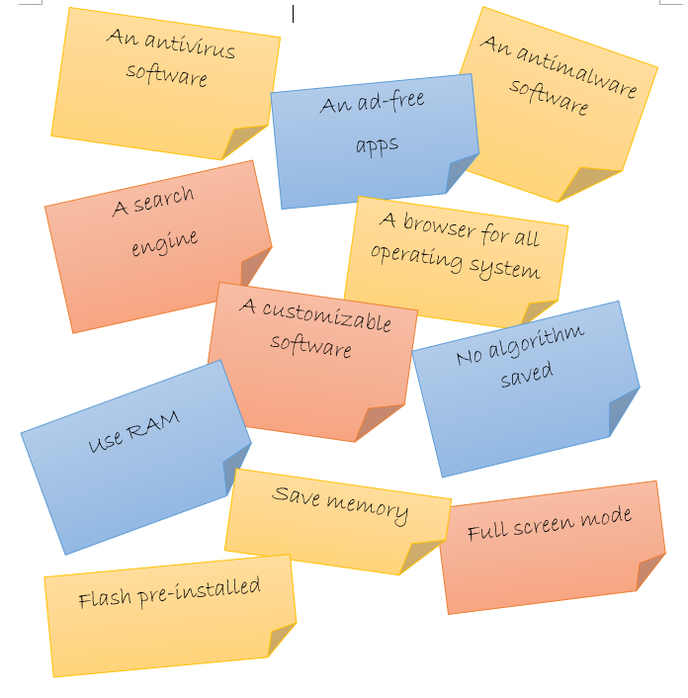

PROTOTYPE
After we chose the ideas, we decided to combine it all one by one. Yu Kah Wei, our programmer codes the software using C++ language, according to the ideas. Every time an idea can be combined into the software, we would make it run to see if it works After some trial and errors, not all the ideas can be combined in time so we decided to do the final touch up, make it look pretty and user friendly as well as customizable-free to make it look unique only to the users and we decided to call it Poogle.

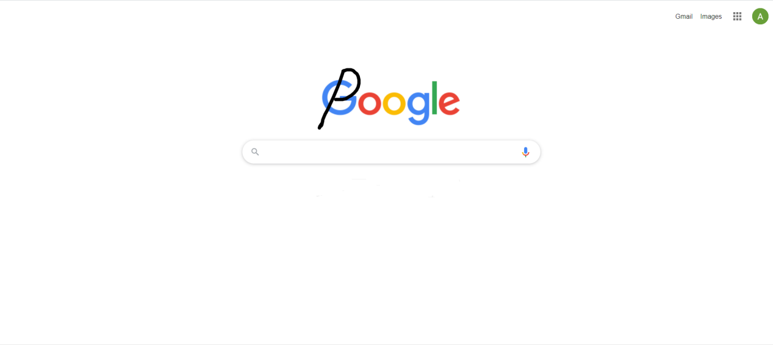

TEST
This is the final stage we had for the design thinking assignment. It goes hand-in-hand with prototyping. We tested it and tried it out to see how well it can solve our problems after every refining. Many comments and feedback from the users guide us to display the superiority of our product. Testing will yield unexpected insights and allowed us to continue empathize with the subject. Testing might not only reveal that the solution is incorrect, but it helps us to verify the mistakes and correct it. It is the last step to finalize our solution and decide whether it is a good invention or not.

REFLECTION
Design Thinking made us want to share the ideas we learned and how we could apply it to improve our problem solving processes. The Design Thinking method makes it very easy for a group of people to work together and brainstorm ideas to overcome the intended problem. This method is the good way to get the best possible outcome because it creates a platform for all of the members to give their opinions. We believe that we need to improve some criteria to improve our potential in the future. The main improvement that is needed is communication. Effective communication allow group members to exchange their ideas on improvements of the design or constructing methods easily. We believe that we need to improve more of our communication skill in working as a team

