Semester I 2019/2020

Subject : Digital Logic
Section : 03
Task : XEROX System (Lab 4)

Lecturer : Mr. Firoz

GROUP
NAME | MATRIC NUMBER
CHEONG CHIEN LI | A19EC0186
YONG JING XUAN | A19EC0177

Dedication and Acknowledgement
I dedicated this project to my group member as he has contributed a lots and without his input this project cannot be accomplished successfully and perfectly.
Special thanks to unit laboratory of UTM for provided and prepared lab materials and equipment for us to complete our project.
Lastly, I wish to acknowledge with sincere gratitude, our supervisor and mentor, Mr. Firoz who provide technical advice and tutorial during the project.
Table of Content
1. | Background
2. | The Problem
3. | Objectives
4. | Flowchart
5. | Component
6. | Materials and Software Used
7. | Circuit Implementation
8. | Physical System Implementation
9. | Conclusion
10. | Reference
11. | Appendix

1)Background
This mini project will implement 3 different components on a single GAL device, those components are 3bit Count Up Counter, 3bit Comparator and Clock Disabler.
2)The Problem
User will initially enter amount of copies, the counter will count the number of copies that has been photocopied. The machine will stop once the required number of copies produced.
3)Objective
To introduce students to the development of PLD device and a simple Hardware Description Language.
4)Flowchart
Write and compile the codes for 2bit Comparator and 2bit Counter in WINCUPL

Burn the codes into GAL using Wellon Programmer

Implement the circuit on breadboard

Test the circuit by using ETS 5000 Training Kit

Repeat the step with 3-bit solutions

5)Component
Switches, Counter, Comparator and Clock Disabler
6)Materials and Software used
DTS 5000 Training Kit – to test the circuit
Breadboard – to implement the circuit with components
GAL22V10 – a PLD
Wellon Universal Programmer & Tester – to burn the compiled JED file into PLD
WINCUPL 5.0 Software – to run and compile the codes and generate JED file
7)Circuit Implementation
2 BITS CIRCUIT IMPLEMENTATION:

VCC
PULSER
24
23
22
21
20
19
18
17
16
15
14
13
12
11
10
9
8
7
6
5
4
3
2
1
G22V10

RESET SWITCH
q1
PRESET SWITCH
q0
a0 SWITCH
a1 SWITCH

LED 7
b0
LED 6
b1

START SWITCH

GND

For the 2-bits circuit implementation, we wired the circuit according to the diagram above. Firstly, the PLD Chip was powered up by connecting pin 12 to “Ground” on the breadboard and pin 24 (VCC) to a 5 volts power supply. Then, 6 input switches are connected to the PLD Chip; pin 1 is connected to the pulser switch, pin 2 to switch 0 for “RESET” function, pin 3 to switch 1 for “PRESET” function, pin 4 to switch 2 for “a0”, pin 5 to switch 3 for “a1”, and finally pin 10 to switch 4 for “START” function. Next, pin 7 (b0) is connected to pin 21 (q0) and pin 8 (b1) is connected to pin 22 (q1) for comparison between the outputs of the counters a1a0 and b1b0. Additionally, the outputs of the comparator, pin 17 and pin 18 are connected to two LEDs, specifically LED 6 for pin 17 and LED 7 for pin 18. LED 6 should be green when a1a0 and b1b0 are not equal and turn red when they are equal, while LED 7 should be red when a1a0 and b1b0 are not equal and turn green when they are equal. Lastly, the two BCD displays are connected to the PLD Chip. There are 4 connections to each BCD display, namely D, C, B, and A. For BCD display 1 (input copy), D and C are connected to GROUND because they are not needed in a 2-bits circuit, while B and A are connected to pin 5 (a1) and pin 4 (a0) respectively to display the values of a1a0. On the other hand, for BCD display 2 (output copy), D and C are also connected to GROUND, while B and A are connected to pin 22 (q1) and pin 21 (q0) to display the values of b1b0.
3-BITS CIRCUIT IMPLEMENTATION:

VCC
PULSER
24
23
22
21
20
19
18
17
16
15
14
13
12
11
10
9
8
7
6
5
4
3
2
1
G22V10

q2
RESET SWITCH
PRESET SWITCH
q1
q0
a0 SWITCH
a1 SWITCH

a2 SWITCH
b0
LED 7
LED 6
b1
b2

START SWITCH

GND

For the 3-bits circuit implementation, we wired the circuit according to the diagram above. Firstly, the PLD Chip was powered up by connecting pin 12 to “Ground” on the breadboard and pin 24 (VCC) to a 5 volts power supply. Then, 7 input switches are connected to the PLD Chip; pin 1 is connected to the pulser switch, pin 2 to switch 0 for “RESET” function, pin 3 to switch 1 for “PRESET” function, pin 4 to switch 2 for “a0”, pin 5 to switch 3 for “a1”, pin 6 to switch 4 for “a2”, and finally pin 10 to switch 5 for “START” function. Next, pin 7 (b0) is connected to pin 21 (q0), pin 8 (b1) is connected to pin 22 (q1), and pin 9 (b2) is connected to pin 23 (q2) for comparison between the outputs of the counters a2a1a0 and b2b1b0. Additionally, the outputs of the comparator, pin 17 and pin 18 are connected to two LEDs, specifically LED 6 for pin 17 and LED 7 for pin 18. LED 6 should be green when a2a1a0 and b2b1b0 are not equal and turn red when they are equal, while LED 7 should be red when a2a1a0 and b2b1b0 are not equal and turn green when they are equal. Lastly, the two BCD displays are connected to the PLD Chip. There are 4 connections to each BCD display, namely D, C, B, and A. For BCD display 1 (input copy), D is connected to GROUND because it is not needed in a 2-bits circuit, while C, B and A are connected to pin 6 (a2), pin 5 (a1) and pin 4 (a0) respectively to display the values of a2a1a0. On the other hand, for BCD display 2 (output copy), D and is also connected to GROUND, while C, B and A are connected to pin 23 (q2), pin 22 (q1) and pin 21 (q0) to display the values of b2b1b0.
PHYSICAL IMPLEMENTATION OF CIRCUIT:
2-BITS:
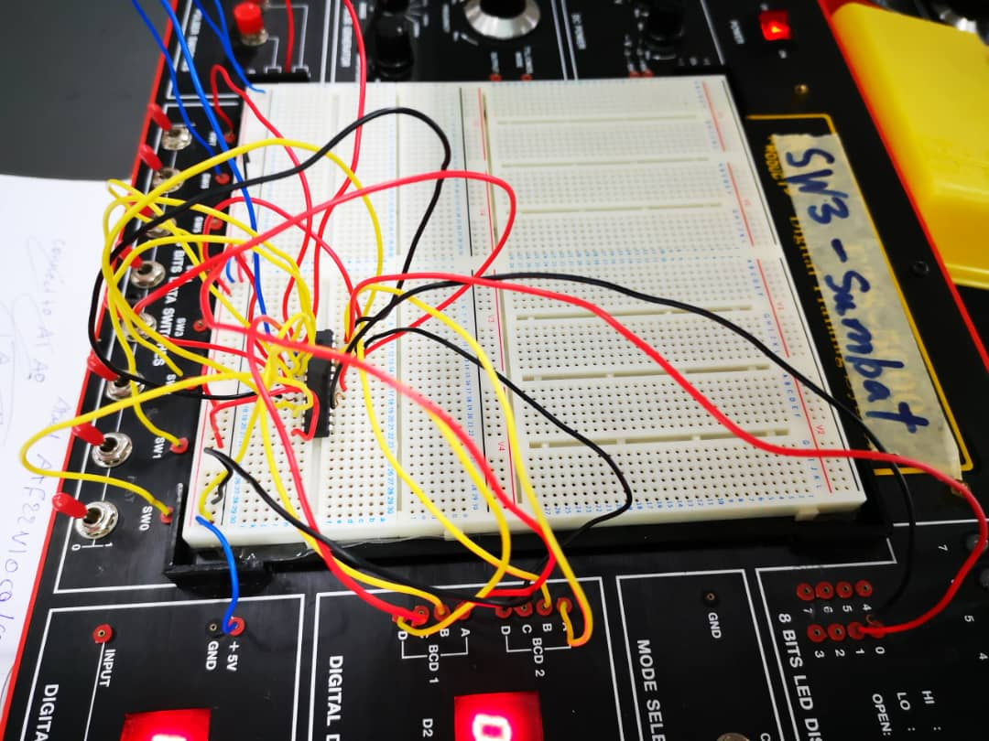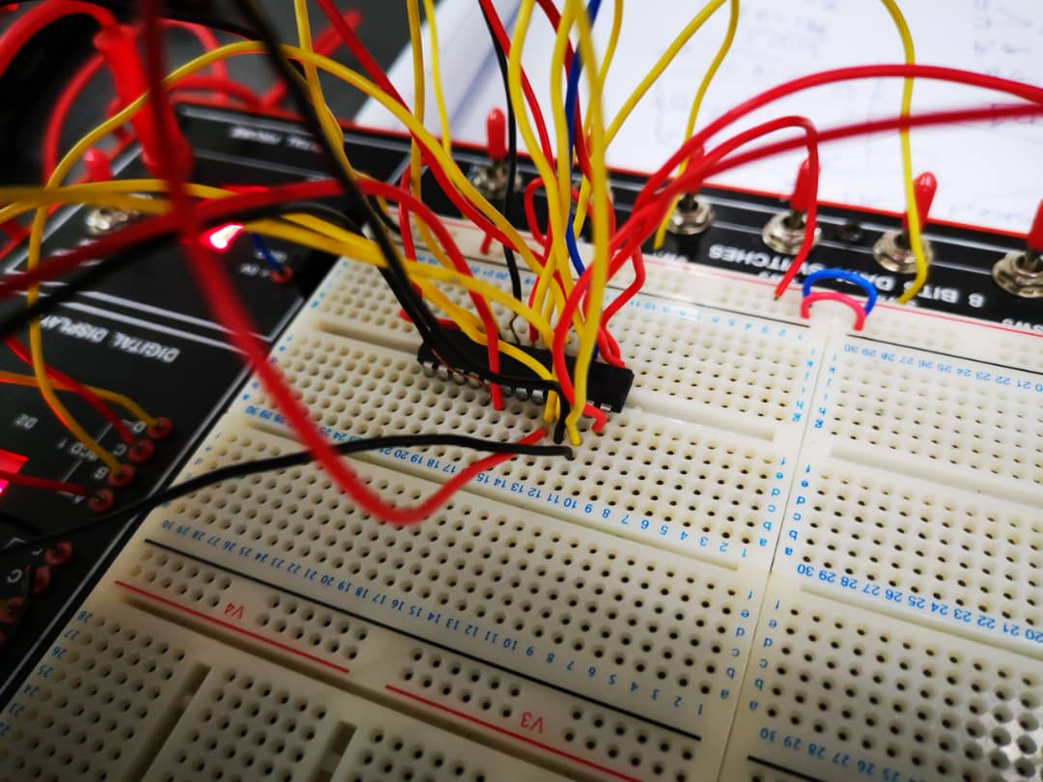

Firstly, the PLD Chip was programmed with the 2-bit Xerox machine code by using a Wellon Programmer and the WinCUPL 5.0 Software. Then, the PLD Chip was placed onto the breadboard firmly. After that, some jumper wires were used to allow the flow of GROUND and VCC (5 volts) in the bottom two rows of the breadboard. Moving on, the PLD Chip is powered up by connecting pin 12 and pin 24 to GROUND and VCC (5 Volts) respectively. After that, the remaining pins were wired according to the description above. Lastly, the circuit was tested. For 2-bits, the maximum copies that can be made is $2^{2}$ which is equal to 4 copies. Firstly, the RESET switch is flipped to HIGH and back to LOW to set a1a0 and b1b0 to 0. Then, a value of a1a0 less than or equal to 4 is set using switch 3 and switch 2. After that, the START switch is flipped to HIGH and the pulser switch is pressed to activate the counter b1b0. When b1b0 is equal to a1a0, LED 6 would turn from green to red while LED 7 would turn from red to green to indicate that the comparator detected the changes in equality between a1a0 and b1b0.

3-BITS:
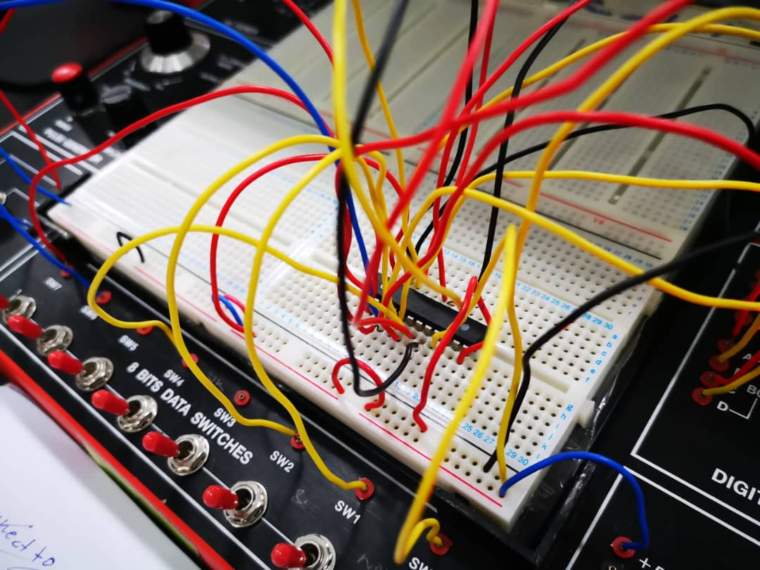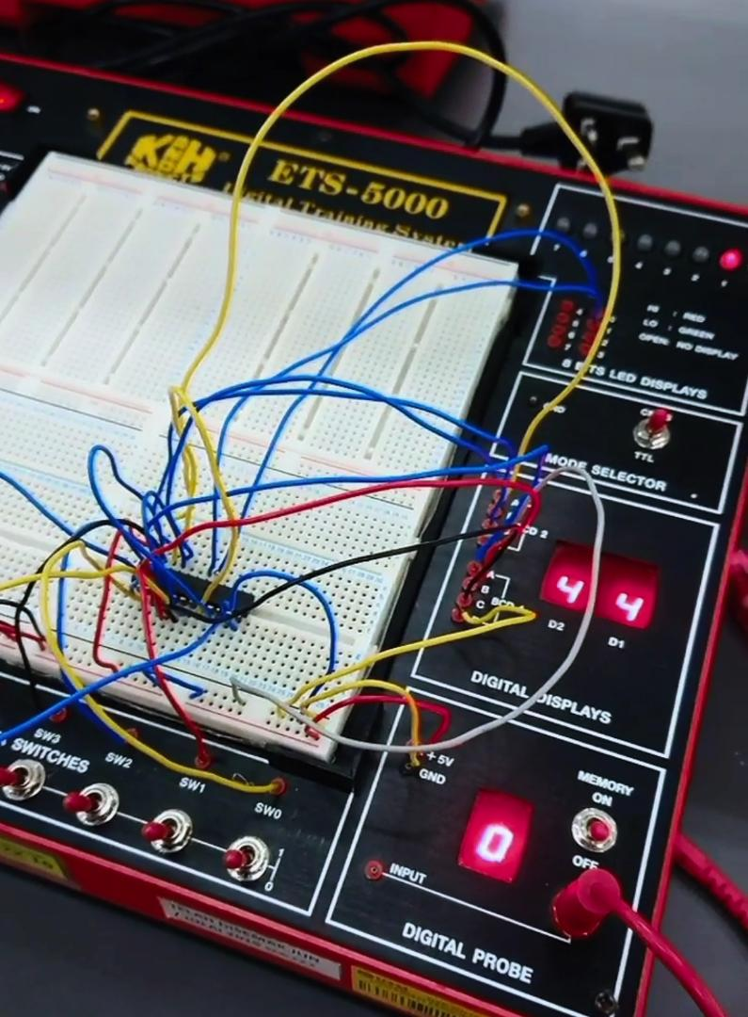
Firstly, the PLD Chip was programmed with the 3-bit Xerox machine code, which was modified from the 2-bit code by using a Wellon Programmer and the WinCUPL 5.0 Software. Then, the PLD Chip was placed onto the breadboard firmly. After that, some jumper wires were used to allow the flow of GROUND and VCC (5 volts) in the bottom two rows of the breadboard. Moving on, the PLD Chip is powered up by connecting pin 12 and pin 24 to GROUND and VCC (5 Volts) respectively. After that, the remaining pins were wired according to the description above. Lastly, the circuit was tested. For 3-bits, the maximum copies that can be made is $2^{3}$ which is equal to 8 copies. Firstly, the RESET switch is flipped to HIGH and back to LOW to set a2a1a0 and b2b1b0 to 0. Then, a value of a2a1a0 less than or equal to 8 is set using switch 4, switch 3 and switch 2. After that, the START switch is flipped to HIGH and the pulser switch is pressed to activate the counter b2b1b0. When b2b1b0 is equal to a2a1a0, LED 6 would turn from green to red while LED 7 would turn from red to green to indicate that the comparator detected the changes in equality between a2a1a0 and b2b1b0.

8)DISCUSSION
The objectives of this lab session are to introduce us to the development of a Programmable Logic Device (PLD) and also to expose us to a simple Hardware Description Language. It was without a doubt that the objectives were all properly conveyed by the end of this lab session. Each group of students were able to learn about the development of a PLD by having hands-on experience when partaking in the whole process. Students were also able to learn something about the Hardware Description Language when they had to modify the 2-bit code into a 3-bit code by studying and understanding the 2-bit code provided by the lecturer. Both of us had achieved something amazing together and also individually, which includes learning about how to properly wipe and reprogram a PLD chip, how to wire a circuit containing a PLD properly according to its schematics, and most importantly how to work together as a team by communicating and trusting each other in order to get the circuits ready and working. It had really been an amazing learning experience for both of us.
However, there were some problems that we faced along the session. The first major problems that we faced is that we did not program our PLD properly for the 2-bit circuit implementation. There might have been some steps that we missed while burning the code into the PLD, which caused it to still be unprogrammed when we started to do our wiring according to the schematics. As a result, much time had been wasted because we rewired the whole circuit 3 times and it still would not function properly. It was only when our lecturer Mr. Firoz checked the PLD that we realize that our PLD had not been programmed the whole time. Then, we quickly programmed the PLD again and split our tasks so that one of use went ahead to start with wiring the 3-bit circuit. There were no problems for the 2-bits circuit after we reprogrammed the PLD Chip and wired the circuit again. On the other hand, the 3-bits circuit was nearly perfect apart from one minor problem, where LED 7 did not light up even after we plugged it into pin 18, which was supposed to turn from red to green when a2a1a0 is equal to b2b1b0. This problem might be caused either by some errors in the 3-bits code or by wiring the circuit wrongly somewhere. Unfortunately, time ran out and we were unable to fix this last issue with LED 7.
Some improvements can still be made to the system that we have done to further improve its performance in a future project. Firstly, we can add a small speaker to the circuit by connecting it to pin 18 so that a sound can be heard whenever a2a1a0 is equal to b2b1b0. This can slightly improve the system’s performance because it notifies the user clearly when the amount of copies is reached. Next, instead of connecting pin 1 to a pulser switch, we can connect it to a clock pulse that is activated whenever we flip the START switch to HIGH and deactivated when the required number of copies is reached. This will allow the system to automatically start the count up process as soon as we flip the START switch to high and we would not need to press the pulser switch ourselves in order to increase the value of the counter. Lastly, with the improvement of the automatic clock, we can further improve the system by adding a “CANCEL” function, which would instantly deactivate the clock and stop the count up process when the CANCEL switch is flipped to HIGH. In short, these suggestions will definitely help improve the system greatly in future projects.

9)CONCLUSION
In conclusion, this mini project had greatly improved our knowledge and soft skills according to the objectives stated. Throughout this project, we were able to expose ourselves to the development process of a PLD which starts from writing a code using a Hardware Description Language, burning the program into the PLD using a Wellon Programmer, and then implementing our system by completing the wiring of the circuit on a breadboard. These were all great hands-on experiences for us and had undoubtedly enabled us to greatly improve our knowledge. Apart from technical knowledge, we were also able to learn and improve on our soft skills. This is because we had to have a great communication between each other and also have a strong sense of trust towards one another in order to successfully get this project completed. The soft skills that we have learned includes being patient and communicating clearly with each other to solve problems, helping out each other whenever they need help, and also mutual teaching and learning between each other where we exchange our understandings about a particular part of the circuit to come up with a best solution.
After thorough discussion, both of us have realized that the Digital Logic Course is very important for our studies in the future as Computer Science students. This is because the Computer Science Course relies heavily on logical expressions and implementations, all of which are the basis of Digital Logic. Besides, it is important for us because knowing how to write a program is only half of the process. In order to completely implement a system by ourselves, we also need to have at least some fundamental knowledge on the electronic components and how to wire them properly according to their schematics. By learning Digital Logic, we have gained this basic knowledge of physical implementation of a circuit and we are now one step closer to being able to develop our own systems from start to finish all by ourselves. Those are the importance of learning Digital Logic in our opinion.

10)REFERRENCE
- Yusoff, A.B., Salleh, M., Rohani, M.F., Isnin, I.F. (2018) Digital Logic. Desktop Publisher.

11)APPENDIX:
2-Bits Xerox Code.pld:
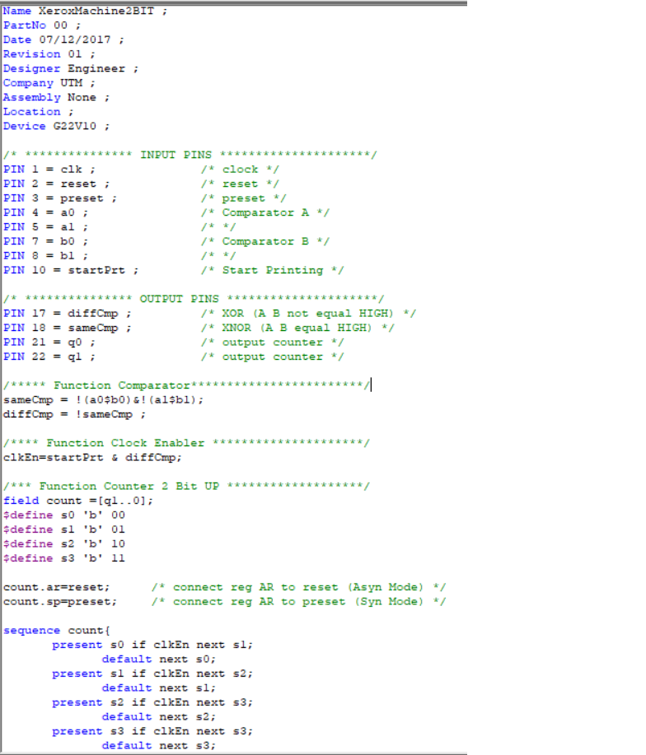
3-Bits Xerox Code.pld:
