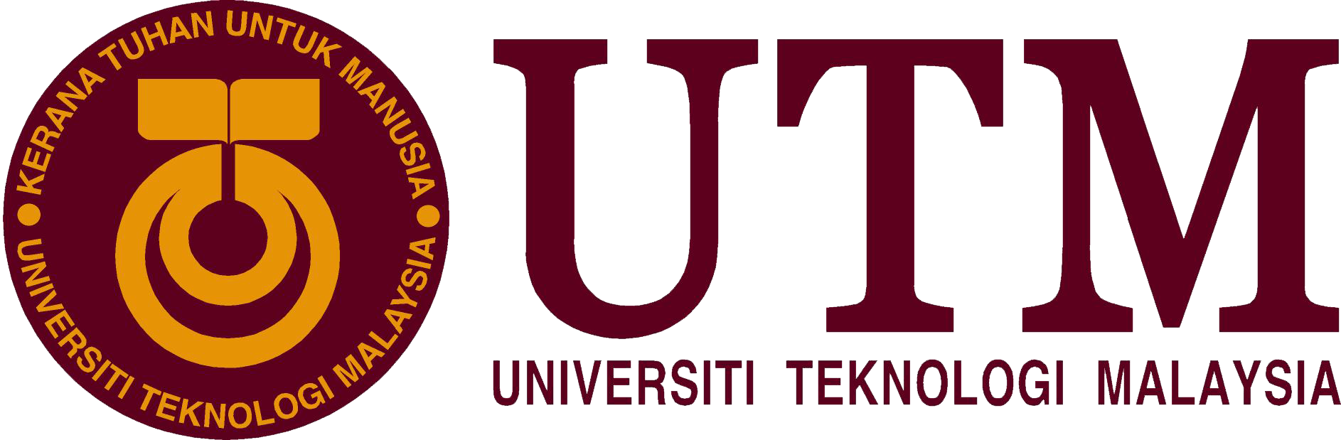

SCHOOL OF COMPUTING
FACULTY OF ENGINEERING

TECHNOLOGY AND INFORMATION SYSTEM
(SECP1513-02)

INDUSTRIAL VISIT TO CICT, GALLERIUM PSZ

PREPARED BY:
- IMRAN HAKIM BIN NORASMADI (A19EC0189)
- TEE HUI YOU (A19EC0170)
- LEE TONG MING (A19EC0069)
- NUR SHUHADA BINTI ABDUL HAKIM (A19EC0202)

LECTURER: DR. ARYATI BINTI BAKRI
SUBMISSION DATE: 11/11/2019

Table of Contents
1. INTRODUCTION 3
2. DETAILED DESCRIPTIONS 4
2.1 CAMERA 4
  - 2.2 MAINFRAME DATA STORAGE AND BACKUP 5
2.3 IBM COMPUTER HARDWARE 6
2.4 APPLE MACINTOSH CLASSIC COMPUTER 7
2.5 IMPACT PRINTER 7
2.6 COMPUTING RELATED COMPONENTS 8
3. REFELCTIONS & CONCLUSION 12
4. TASKS FOR EACH MEMBER 13
5. REFERENCES 14

  - INTRODUCTION
Last 21st October 2019, during Technology Information System class, we went to Centre for Information and Communication Technology (CICT) building for an educational visit. The visit took place from 2pm until 5pm. The CICT building was located quite near from our school so it was easy for us to go there in time for the program. In presence being our guardian was Dr Aryati Bakri, our lecturer for the subject.
During the visit we were asked to stay in our groups to make it easier for the CICT staff to handle us. All the staff in presence were very friendly and clear in giving explanation.
Centre for Information and Communication Technology (CICT) is a big unit of staffs that offer and deliver services in terms of ICT for the university. We were explained that their main focuses are on ICT infrastructure, system development and academic administrative activities. According to their main website https://cict.utm.my/, their services includes internet and wi-fi maintenances for whole university, infrastructure and security; firewall, URL filtering, application control, they also in charge of multimedia in terms of montage, video making, graphics design, as well as managing complaints and university events, id account and access, software, web management, application development an lastly ICT facilities such as computer and multimedia lab. This shows how important CICT roles are in this university.
The visiting program were conducted with a few exhibition items which were:
- Camera /
- Mainframe Data Storage & Backup /
        - IBM (9345B22) /
        - IBM 9309 /
        - IBM (3420) Magnetic Tape Unit /
- IBM Computer Hardware /
        - IBM Personal Computer 300GL /
        - IBM P70 Model 6554-673 /
        - IBM Personal System/2 Model 70 386 /
        - IBM Power Server 550 /
- Apple Macintosh Classic Computer /
- Impact Printer /
- Computing Related Components /
        - Floppy Disk & Floppy Drive /
        - CPU Components /
        - Network Card /
        - Hard Disk & IDE Cable /
        - External CD-ROM /
        - RAM /
        - Motherboard /
        - Mouse /
All the exhibited items will be further explained in this report.

  - DETAILED DESCRIPTIONS

2.1 CAMERA

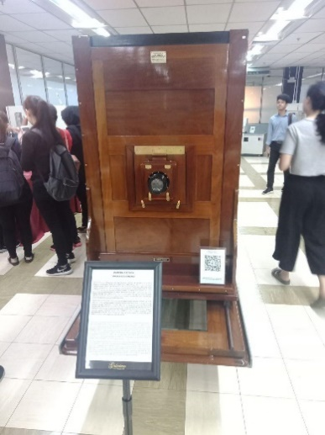
Process Camera
A proses camera was used in UTM. The process camera was manufactured by Hunter Penrose Ltd., a company from United Kingdom and was gifted by Department of Survey and Mapping Malaysia (JUPEM). It was used during the early 1980s until late 1990s in Cartography Department, Faculty of Surveying to educate the students about the principles and procedures of photography production. For example, students of land surveying courses drew map sketches using technical pens to produce maps conventionally. Black-and-white or coloured topographic maps were printed from the film was used only for education purposes of the faculty. In the early 2004, the camera was ceased as digital technologies were invented.
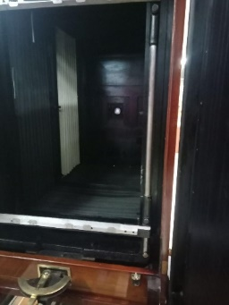
This picture shows the inner part of the process camera.

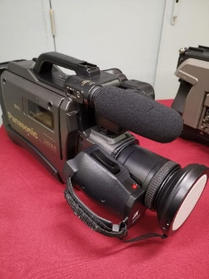
Movie Camera
There was another camera, which is a Panasonic M 9000 Movie Camera was used in UTM’s library during 1990s until early 2000s. The movie camera was used in programs and activities’ recording purpose for library media service.

2.2 MAINFRAME DATA STORAGE AND BACKUP

Moving onto another type of technology that was showcased in the galleria, were the various types of technology that was used for data storage in UTM. These are some of the data storage technology that were used:
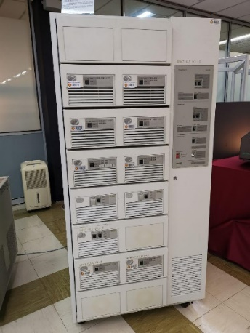
This is an example of a mainframe data storage; the exact model being IBM (9345B22). Being first used in 1970s at UTM’s Computer Centre, UTM campus in Kuala Lumpur. The primary use of the mainframe was to control the data of students and staff of UTM. Some other functions of the mainframe were processing, storing, securing, and printing the University’s information and data. Mainframe technology has now been used for almost 20 years in UTM.

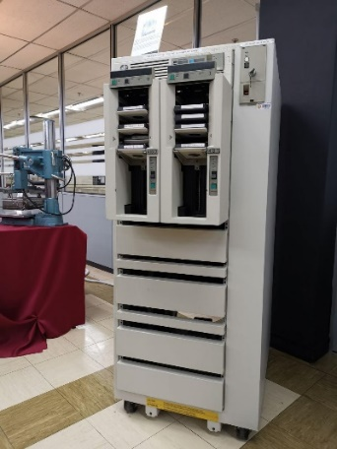
This is the mainframe tape subsystem, specifically the IBM 9309. Being the complement of the mainframe that was used to store and process data. The tape subsystem primarily functioned as the ‘back up’ for the mainframe system and the information database for UTM students and staff as well as other universities’ information systems through the years 1987 to 1995. This particular model used squared shaped tapes as the circular shaped tapes were no longer used at the time.

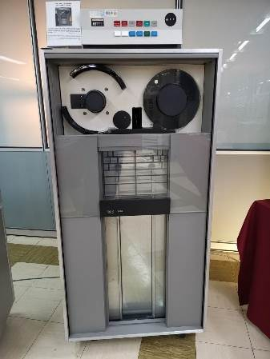

This is the IBM (3420) Magnetic Tape Unit. Similar in function to the mainframe tape subsystem; it was used as a ‘back up’ to the mainframe data storage. Storing and controlling the information database of students and staff of UTM alike, as well as other information system of the university, from the year 1976 until 2010. This particular model unlike the tape subsystem used circular shaped tapes, which would later be swapped out for squared shaped tapes.

2.3 IBM COMPUTER HARDWARE
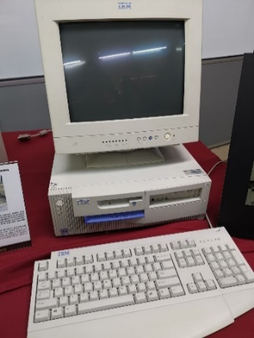
IBM PERSONAL COMPUTER 300GL
The IBM Personal Computer 300GL has helped increase the productivity and reduced the cost of ownership of UTM Library by being an all-inclusive and affordable computer. The transformation of system is taking place constantly in the Library. Apparently, technological revolution of computer usage coincides with system change and this was evident with the application of Dynix system for 10 years.

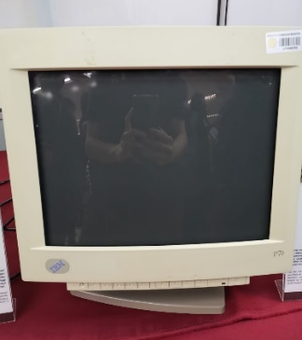
IBM P70 MODEL 6554-673
The IBM P70 Model 6554-673 was used in UTM Library in early 1998 to contribute to work performance. As such, Library was liable of all modules, databases, software operations and data accessibility. With its ability to support up to 16MB on disk storage, the computer system provided a performance improvement on desktop operation.

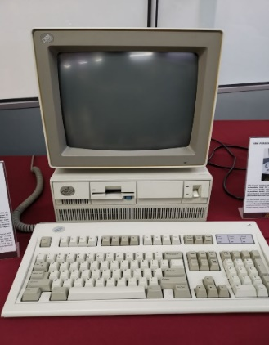
IBM PERSONAL SYSTEM/2 MODEL 70 386
The IBM Personal System/2 Model 70 386 featured a high-density memory technology and a range of integrated features. The computer, with its systems, supported the Library significantly in performance improvement for desktop operation. It was also compatible with most software products available for a personal computer system in UTM Library.

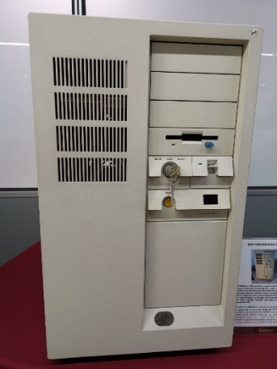
IBM POWERSERVER 550
The IBM 550 PowerServer boasted an outstanding performance with its fastest chip in the world during the 1990’s technology. It was considered as an apt system for a medium-sized database at the time. In relation to the Library’s technology, the application of the library management system on a ‘freeze’ terminal which operated on a Mainframe was seen as a starting point of the information technology evolution and played a great impact on UTM Library’s history.

2.4 APPLE MACINTOSH CLASSIC COMPUTER

Among the popular computers used by the university was the Macintosh Classic. The Macintosh Classic had high praises back when it was introduced due to its ease of use and price, its performance will get one working on worksheets and most people found it handy and convenient for work at the 90s.
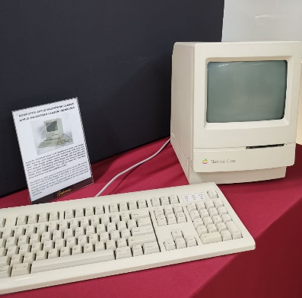
The Macintosh Classic was first introduced in early January 1984 and has since been used in UTM Library in early 1990. It was equipped with a software memory of 1MB of RAM and 2MB to 40MB of hard disk. With its large capacity of the time, the computer was used in the library along with the Lotus 123 and Word Star applications for work and simple calculation.

2.5 IMPACT PRINTER
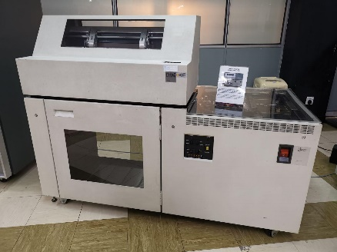
The IBM (4245) Impact Printer was one of the models of printers that were used in UTM. Also known as the Dot Matrix Printer it was used in UTM in the 1990s until 2011. The main usage of this machine was to print out the data information of students and staff that met University’s targeted requirements. This printer was capable of printing out high volumes of data and do it non-stop for 48 hours.

2.6 COMPUTING RELATED COMPONENTS

Here are some images of computing related components and their detailed descriptions:
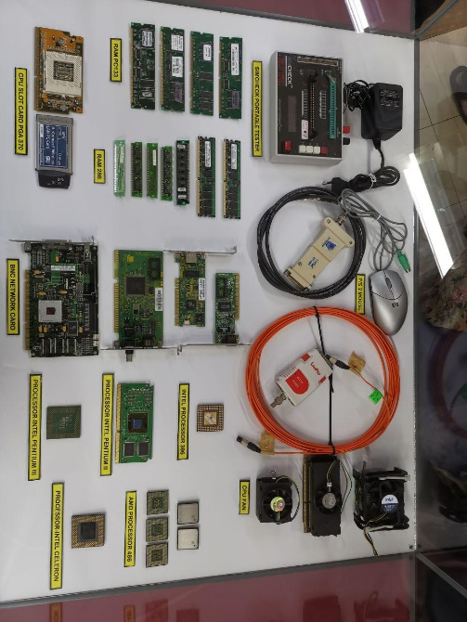
This image shows components such as INTEL processors, AMD processor, CPU fan, BNC network card, CPU card slot, RAM and mouse.
This image shows components like hard disk, motherboard, floppy disk, floppy drive and IDE cable.
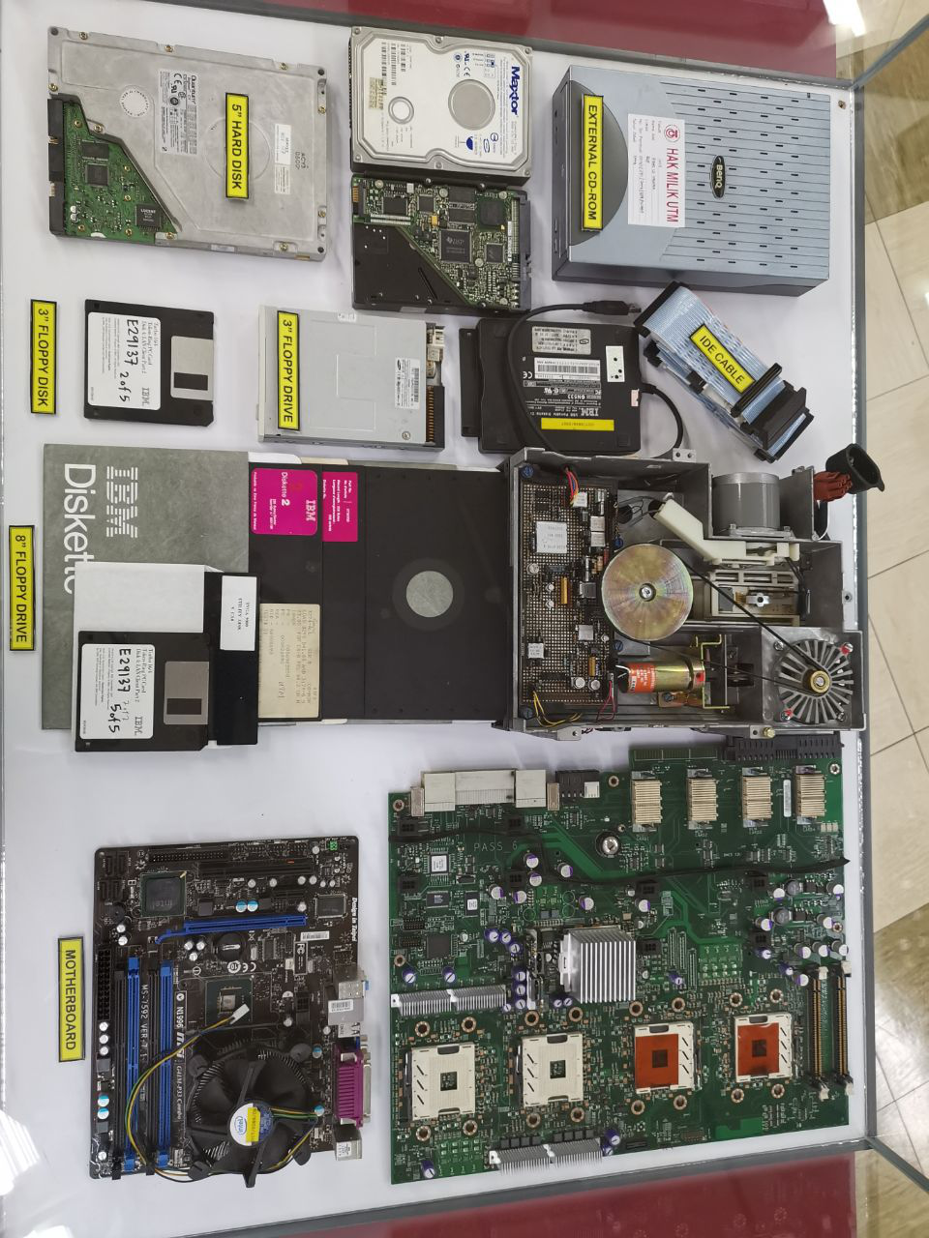

COMPONENTS | DETAILED DESCRIPTION
Floppy Disk & Floppy Drive | Floppy disk is a data storage device which is widely used in 19th century. It requires a floppy disk drive installed in computer to read and write the floppy disk causing a floppy disk to be in limited use nowadays. A floppy disk is required to be formatted before storing data on it. Floppy disk consists different sizes and its storage is smaller compared to the removable data storage devices nowadays.  During 1980s, floppy disk was invented and floppy disk drives were included in majority of the personal computers. It is then modified so that data can be written on both sides of the floppy disk. A 5 ¼ inch floppy disk can store about 360kB to 1.2MB of data. For 3 ½ inch floppy disk, a double density disk is capable to store 730kB of data while a high-density disk is capable to store 1.44MB of data. An 8-inch floppy disk is capable to store data of 250MB to 1.2 MB. In 1990s, Zip disk were invented which is capable to store 100MB, 250MB and even 750MB of data. However, its popularity declined as it is expensive.  As CD drives, pen-drive, hard disk drive and other removable data storage devices were invented, floppy disks were no longer in use.
CPU & Its Components  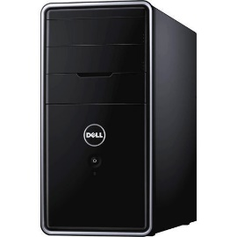  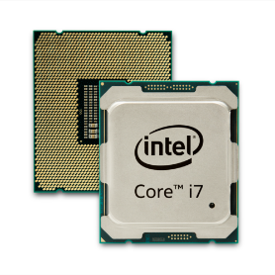  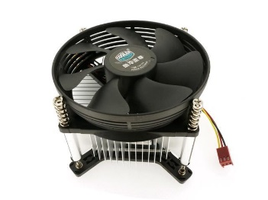 | Next up is the various CPUs that were put on display, ranging from AMD and Intel. Both respected household names in the CPU manufacturing business. A central processesing unitc or more commonly known as CPU, is the main brain of any PC. As suggested in the name it takes instruction from a program or application and preforms a calculation. The CPU fetches the instruction from a system’s RAM, then it decodes what the instruction actually is, before it is executed by the relevant parts of the CPU. On the intel side, there was the Intel Proccesor 386, a 32-bit processor which was introduced in 198, manufacturing began in 1986. The Intel Pentium 2 was introduced in 1997, refering to Intel’s sixth-generation microarchitecture P6 and x86-compatible microporcessors. It featured an improved version of the first P6 generation core of the Pentium Pro, with max CPU clock speeds of 233 MHz to 450MHz. Its replacement later down the line; the Pentium 3 was a near identical to the Pentium 2, which it only added the then new Streaming SIMD Extension instruction set. On low cost end of the Intel spectrum was the Intel Celeron which was microprocessors models that targeted at low-cost personel computers. On the AMD side the was the AMD 486 produced in the 1990s. Eventhough, Intel beat AMD to the market by 4 years they offered better performance for the same price. They are some CPU cooler fans that were shown were used to cool the CPU.
Network Card  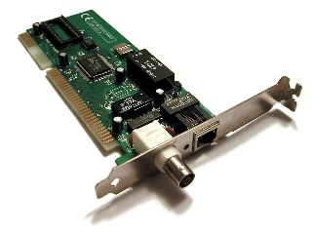 | A network card, NIC or network interface card/controller is an electronic device that functions as a connector for a computer to a computer network usually a LAN. Network card is considered as a hardware. The card contains electronic circuitry which required to communicate using a wired connection known as ethernet or a wireless connection knows as wi-fi.
Hard Disk & IDE Cable  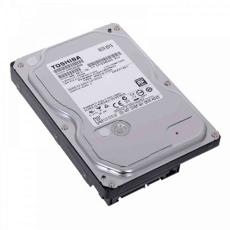  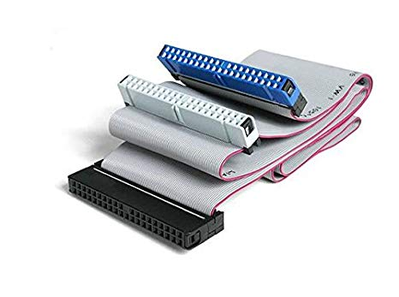 | There were also some used Hard Disk Drives or HDD for short that were exhibited in a glass case. They were shown alongside some floppy disk, floppy drives, external CD-ROM, IDE cables, IDE cables and some motherboards. There were 3inch and 5inch hard disk were the variety of sizes that were shown. Hard Disk Drives are devices which are used to store data and information, usually one can see them in PCs and smaller ones being used in laptops. A HDD’s one of the main components are the platters, spindles, read/write arm and the actuator. Even now, HDD are still being used to this day, can be found in any PC, as an important device for storage alongside the (faster) Solid State Drive, which HDD are increasing in size tremendously. And to connect these HDD (storage devices) was the Integrated Drive Electronics (IDE) or also known as Parallel ATA (PATA). They were commonly used to connect HDD to the PC’s motherboard back in day, but now a faster variant is now commonly and widely used today, which is the Serial ATA cables.
External CD-ROM  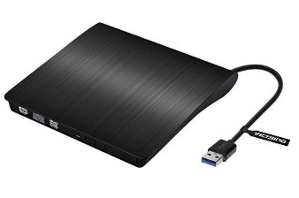 | External CD-ROM is actually the short form for Compact Disc Read-Only Memory. It is an optical disc containing software data or audio whose memory is read-only, and it is read by a CR-ROM drive or optical drive. Denon first developed the CD-ROM format in 1982, expanding the CDDA (compact disc digital audio) format, allowing the CD-ROM to not only storing audio but also data. The first CD-ROM disc introduced was at a Japanese computer show, in which it having storage capacity of 553MB. Until today, a standard CD-ROM disc is capable of storing up to 700MB of data, or up to 80 minutes of audio. Usually, CD-ROM drives have speeds in between 1x to 72x. Optical drives are capable of playing audio and reading data CDs, including CD-R and CD-RW discs, however they cannot read DVDs as the format of a DVD is different. Different interfaces are used to allow CD-ROM and other disc drives to connect to a computer, for example, IDE, SATA, SCSI and USB.
RAM  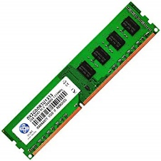 | RAM is an acronym that stands as Random-Access Memory. It is a type of computer memory which can be accessed randomly without any hardships. We were told that any byte of its memory can be accessed easily without needing any touch on the preceding bytes. This component is mainly found in servers, tablets, PCs, printers and other devices such as printers.
Motherboard  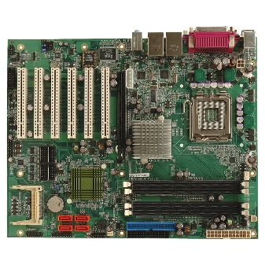 | Motherboard is a printed circuit board and the biggest board in a computer system unit, which serves as a foundation of a computer. It is also known as the mainboard, main circuit board, or system board. The function of a motherboard is to allocate power and allow communication to and between the RAM, CPU, video card and other hardware components. There are various types of motherboards, with each type designed to work with specific types of processors and memory. Although motherboards cannot work with every type of processors, majorly they work with hard drives which are universal. Motherboard consists of a lot of components such as memory slot, screw hole, inductor, capacitor, floppy connection, serial ATA connections, USB headers and a fan connector, while some older motherboards will contain fuse, cache memory and chipset. The first motherboard was believed to be used in the IBM Personal Computer released in 1981, at a time where it was known as planar instead of motherboard. It would work together with the IBM Personal Computer to set the standard for IBM-compatible computer hardware going forward. Nowadays, there are even motherboards in laptops, smartphones or tablets, more often referred to logic boards. The difference is that the logic board in these devices have no slots that support a replacement or upgrade of components like a traditional computer motherboard.
Mouse  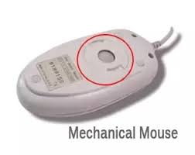  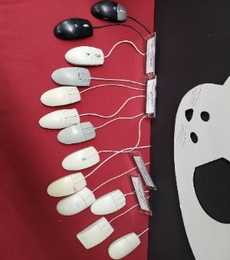 | Computer mouse is a hand-held input device used in pointing and selecting purposes. It controls the movement of pointer displayed in the monitor by sensing 2-Dimensions movement of mouse relatively on a surface.  Through the revolutions in past few decades, there is a huge morphological change of computer mouse. Originally, the mice invented were connected to the computer using a cord and is in squarish shape with uncomfortable edges presence. The size is relatively big too. After revolution in the past few decades, computer mice nowadays can be wireless which transfers data to the computer using a Bluetooth or an infrared radiation connection with an independent USB connected to the computer. The size and shape of the computer mouse has also modified to become more user-friendly. The mouse nowadays has thinner curved-line design and its’ size is reduced to fit the human palm size so that users can grab the mouse more comfortably.  The first public demonstration of computer controlling of mouse is on 1968. Early mice consist of a rolling ball or a track ball to detect the motion. However, common type of mice used by people nowadays is optical mouse which uses more precise optical sensors to detect the motion of mouse. Furthermore, the “wheels” are added to the computer mouse for rolling-over function. Example of other types of modern mouse are gaming mice, stylus mouse, cordless 3D mouse etc.

  - REFELCTIONS & CONCLUSION

From the visit to CICT, we have learnt that in order to achieve a great efficiency in terms of managing our duty or assignments or anything we must have thorough strategic planning on our time management and how to solve our job or problems. From what we observed, the CICT unit is very thorough in arranging their tools and what not, all these can be seen have increased their efficiency in maintaining everything under their scope of work.

It was truly admiring to see how hardworking everyone in the CICT unit is. We hope that one day we can be as good as them, in terms of strategic planning and problem-solving skills.

We hope that we will be able to have a great career in ICT field because it’s very fascinating and admiring on what have everyone in this sector capable of doing. We hope that someday we will also be able to make such big innovations and improvement of some old systems which can benefit everyone as a whole.

We hope that through this visit all of us will be as inspired to achieve our goals having a career in ICT department. The creativity of all the CICT workers in designing the system, software, apps and so on are very fascinating. The strategic plan of their duty’s arrangement was also very inspiring.

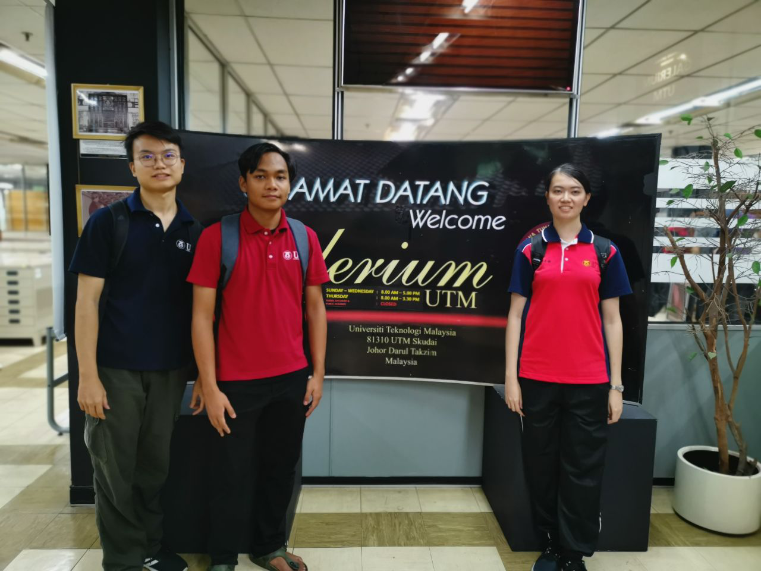
The visit to CICT was an enriching experience for us.
  - TASKS FOR EACH MEMBER

NAME OF MEMBER | TASKS
IMRAN HAKIM BIN NORASMADI | - CPU Components  - Hard Disk  - Main Frame Storage & Backup  - Impact Printer
TEE HUI YOU | - Floppy Disk  - Camera  - Mouse
LEE TONG MING | - IBM Computer Hardware  - APPLE Macintosh Classic Computer  - External CD-ROM  - Motherboard
NUR SHUHADA BINTI ABDUL HAKIM | - Introduction & Conclusion  - Distribution of tasks  - RAM  - Network Card

- REFERENCES

- Cameron, E. (2017, Feb 10). Types of Floppy Disk Drives. Retrieved November 9, 2019, from https://itstillworks.com/types-of-floppy-disk-drives-10248.html
- Computer Hope (2019, Dec 9). Motherboard. Retrieved November 8, 2019, from https://www.computerhope.com/jargon/m/mothboar.htm
- Jon Martindale (2019, Aug 28). What is RAM? Retrieved November 8, 2019, from https://www.digitaltrends.com/computing/what-is-ram/
- Nick Ross, Fergus Halliday (2019, May 9). Which CPU is best: Intel or AMD Ryzen? Retrieved November 9, 2019, from https://www.pcworld.idg.com.au/article/615216/which-processor-best-intel-amd/

