SEMESTER 1
SESSION 2019/2020
SECR1013-02

MINI PROJECT REPORT

PREPARED BY :

- AINA ALIAH BINTI RUSLAN (A19EC0012)
- NUR IRDEENA BINTI CHE MOHAMAD ZULKEPLI (A19EC0130)

LECTURER’S NAME: MISS RASHIDAH BINTI KADIR

DEDICATION AND ACKNOWLEDGEMENT

First and foremost, we would like to express our gratitude to Almighty Allah s.w.t for granting us the opportunity and strength to complete this report titled “Mini Project Report”.

Secondly, it is also a genuine pleasure to convey our deep sense of appreciation to Miss Rashidah Binti Kadir, the lecturer who taught us Digital Logic. She has always been very dedicated and passionate in helping her students in our studies, making us more determined to finish this report. This task would have not accomplished without her countless advice and assist. We also value the infinite time that she spent just to educate us so that we could achieve a deeper understanding on the subject, which then helps us a lot in settling this report. Despite her hectic schedule, Miss Rashidah would still give us endless motivation and guidance throughout the process of completing this project, which drives us to not give up and keep moving forward.

Lastly, we are very thankful for our fellow course mates who are extremely helpful and constantly willing to lend their hands whenever we need. They are also the ones who make the learning activities more fun and enjoyable, leading to a university life that is stress-free.

Table of Content

DEDICATION AND ACKNOWLEDGEMENT i
Table of Content ii
1.0 The Background 1
2.0 The Problem 1
3.0 Objectives 1
4.0 The Flowchart 1
5.0 Component 2
6.0 Materials and Software’s Used 2
7.0 Circuit Implementation 3
8.0 Physical System Implementation 5
9.0 Discussion 6
10.0 Conclusion 7
11.0 References 7
12.0 Appendix 8

The Background
This mini project will implement 3 different components on a single GAL device, those components are 3-bit Count Up Counter, 3-bit Comparator and Clock Disabler.

The Problem
User will initially enter an amount of copies, then the counter will count the number of copy that has been photocopied. The machine will stop one the required number of copies is already produced.

Objectives
The objectives of this mini project are to introduce us to the development of a PLD device and simple Hardware Description Language.

The Flowchart
Figure shows a flowchart that describes the steps in designing a photocopying or xerox machine. Firstly, the design of a logic circuit for the machine is roughly sketched. Next, the design is entered into the computer by creating an input file in WinCUPL. When there is no syntax error in the codes, the compiler will then process the input file and creates a JEDEC file which is a fuse map. The JEDEC file will be downloaded to the programmer in Wellon and the programmer will burn the fuse map into the simple programmable logic device, which then can be used on a breadboard and a xerox machine can be executed.

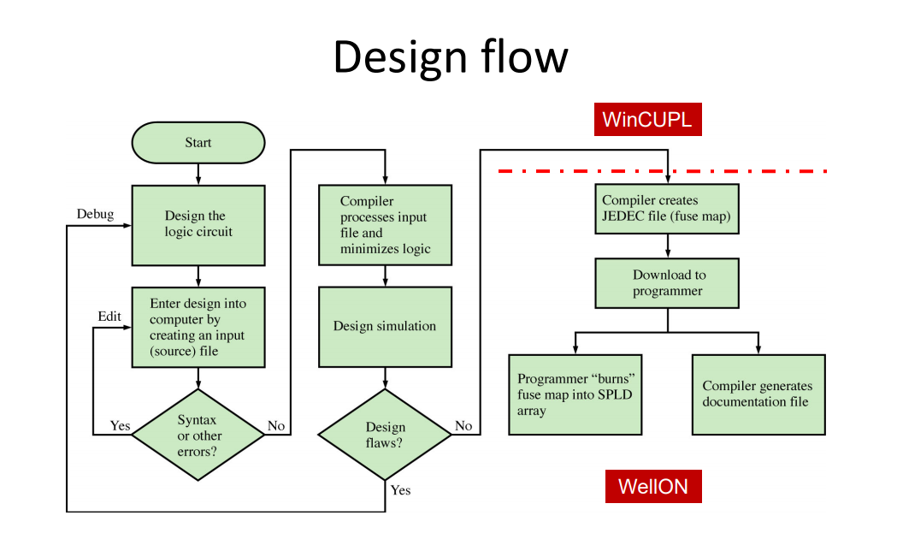

Component
The components used in this project are listed below.
- Switches – Switches are used to set the required number of copies in binary, allow
the machine to start printing and to reset and preset the machine.
- Counter – Counter are used to count the number of copies that has been made.
- Comparator – Comparator are used to compare the number of copies required with
the number of copies produced.
- Clock Disabler – Clock Disabler are used to stop the operation of counter.

Materials and Software’s Used
- Breadboard
- GAL 22V10
- ETS – 5000 Digital Training kit
- Wellon Universal Programmer & Tester
- WinCUPL 5.0 Software
- Handouts :
- “WinCUPL user manual”
- “GAL 22V10 Data Sheet”
- “How to use Wellon Programmer”
- “How to use Win CUPL 5”

Circuit Implementation
- Circuit implementation for 2-bit xerox machine

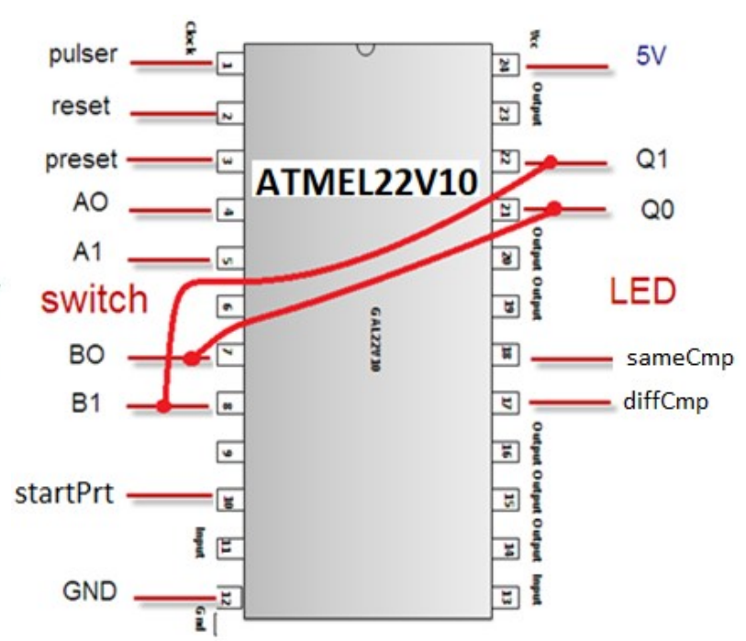

As seen in the diagram, pin 10 is connected to a switch and if it is turned on, the machine will start printing. Pin 24 is connected to the Vcc, meanwhile pin 12 is connected to GND. Pin 2 is used as a reset button that functions the same as a start button which will set the number of copies to 0 if it is flicked. Pin 3 is a preset switch. Pin 4 and pin 5 are connected to one switch each, representing A0 and A1 respectively and are used to set the number of copies desired by the user. Pin 7 and pin 8 are B0 and B1 respectively and function as comparators which will compare the number of copies that have been made and the number of copies required by the user. Both B0 and B1 are connected to pin 21 and 22 which are Q0 and Q1 respectively and will display the number of copies required and the number of copies that have been photocopied. Pin 1 is a pulser, connected to the pulser switch and if pressed, it will increase the number of copies that have been photocopied. Pin 18 and pin 17 are both connected to LED. The LED for pin 18 will change from red to green if the number of copies photocopied is the same with the number of copies required, while LED for pin 17 display green light as long as the number of copies photocopied is different from the number of copies required.

- Circuit implementation for 3-bit xerox machine
As for 3-bit xerox machine, Pin 1, 2, 3, 4, 5, 7, 8, 10, 12, 17, 18, 21, 22 and 24 are connected to the same port as they are in 2-bit xerox machine. In 3-bit xerox machine, pin 6 is connected to another switch so that the number of copies is allowed to be set from 0 to 7. That being said, another switch must be connected to pin 9 as B2, which also have to be connected to Q2 at pin 23 so that the number of copies made can be displayed accurately.
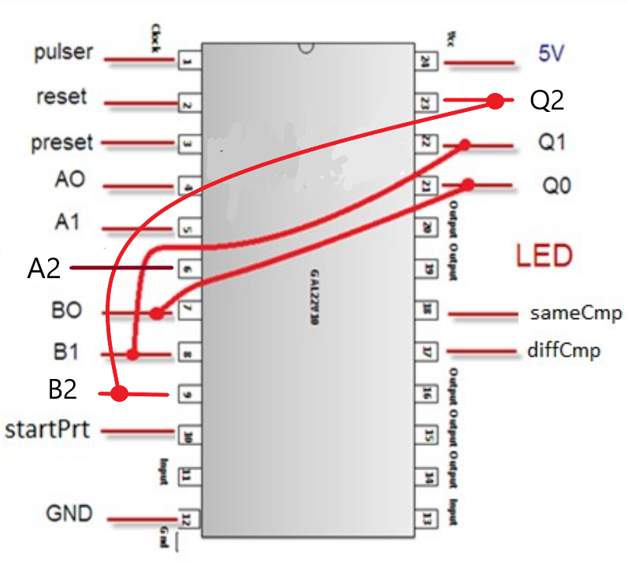

Physical System Implementation
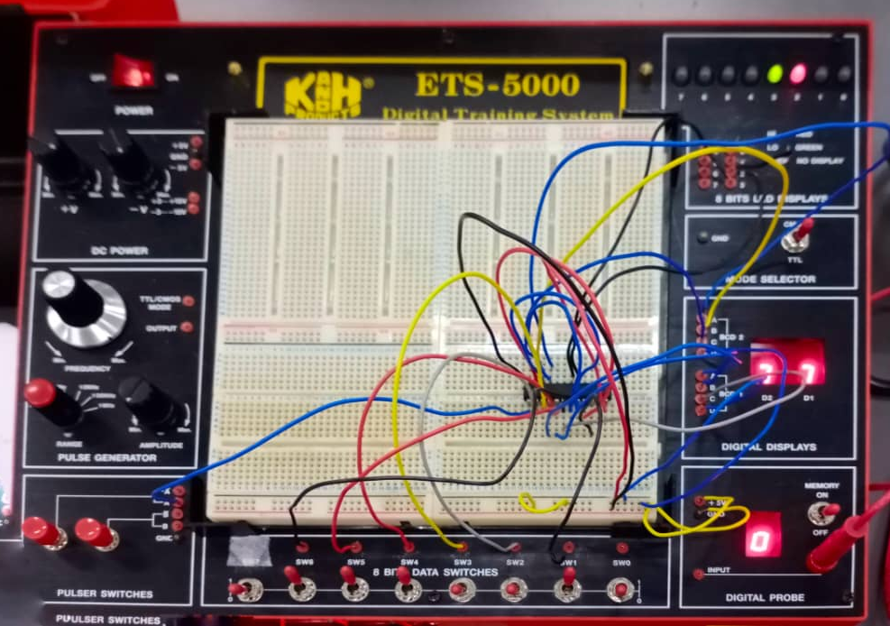
- Switches
Use the switch provided by the ETS 5000 Digital Training Kit. As for our Mini Project required us to implement 3-bits counter-up counter, so there are 3 switches needed for user to enter the input. The input represent the number of copies that we need to copy. Each switches represent a single bit and since 3-bit only can store 000 to 111, so the user can only input value between 0 to 7.
- Counter
Counter is used to count the number of copies that has been made. To count the number of copies, we used 3-bit JK positive edge and was controlled by the clock. The JK counter counts based on the clock enabler and it will stop counting when it reach the number of counts that was entered by the user on the input switch.
- Comparator
A comparator is a combinational circuit that can be designed using XNOR and XOR gate. The comparator is used to compare the number of copies required with the number of copies produced. Both pin 17 and 18 and connected to LED 2 and 3 respectively. For LED 2, it will display green light as long as the number of copies required is not the same as the number of copies produced. For LED 3, it will display red color light as long as the number of copies required is different from number of copies produced. LED 3 will turn into green light if the number of copies and produced are same.
- Clock disabler
Clock disabler is a circuit to disable the clock so that the counter will stop counting. This clock disabler used 2-input AND gate. That two input of AND gate is the clock source and the output from the comparator. The clock disabler will be activated if only both of input are active. When the number of copies produced are same as number of copies required, it will stop counting.

Discussion
The main purpose of the mini project is to introduce us students to the steps in developing a programmable logic device (PLD) and expose us to a simple hardware description language (HDL) which is most commonly used to describe the structure and behaviour of digital logic circuits. We followed the steps that were given by our lecturer precisely to program the PLD using the two special softwares, WinCUPL and Wellon Programmer. We then executed the circuit on a breadboard and connect each pin to its switch or port correctly. When the circuit has been connected perfectly, we tested the circuit and turned out, the circuit worked fine.
Throughout the process of completing the mini project, we discovered some of our strengths. Firstly, the ability to think critically for alternatives way to execute the circuit whenever something in it went wrong. Secondly, the capability to always be patient when completing the project. Thirdly, the potentiality to refrain ourselves from giving up and always push ourselves to finish what we started. With these strengths and potentials, we eventually achieved our goals which is to get the photocopying machine works, even though we took quite some time to accomplish it.
We also faced some implications during the process of finishing the project. On our first attempt, the reset button did not work. To overcome the problem, we tried to change our PLD and breadboard to the new ones. We, too, tried to re-program the PLD and after multiple failed attempts, we finally succeed in executing the correct circuit. There were times when our LEDs did not light up. When we checked the wire connections one by one, it turned out that some of the wires were connected to the wrong ports, so when we correct them, the LEDs finally lit up.
We would like to suggest that a buzzer could be added to the circuit so that when the number of copies made is the same as the number of copies required, the buzzer will buzz as an alert message so that the user will know that the machine has done its job. Other than that, an encoder could also be an extra so that the xerox machine will be more secured and only authorised users can use the machine.

Conclusion

By doing this Mini Project, we can learn how to type the code using WinCUPL and also how to burn the code onto an ic using Wellon Programmer and then start to implement the circuit. We realised that by doing this practically, we can understand more how the machine works rather than by only learning theoretically. Also, during the process of implementing the circuit, we had face some problem and after correcting that problem, the machine start to works correctly. From these mistakes, we can see that we must follow every single step that has been taught. Because the machine is really a sensitive machine, so we must take care of it properly. Every silly mistakes can lead to errors which will makes our machine does not works correctly.
Teamwork is another soft skills that our group has obtain from doing this Mini Project. Having a good teamwork with each other can help to make the works easier. During the process of implementing the circuit, we divided the task with our member fairly so that both of us can do that process together and gather as many as can the experiences using the tools. Also, because both of us doing our own task, the circuit can be done quickly.
Last but not least, as a Computer Science student, we can see that it is important to know how to use a software and hardware of a computer or machine as for the future, we will more involve with the usage of the machine. So digital logic is one of the important subject that will help us to better understanding the process. This subject allow us to put the theories that we learn into practices. This indirectly helps us to prepare ourselves for the future.

References

- Abd. Bahrim Yusoff, Mazleena Salleh, Mohd Fo’ad Rohani and Ismail Fauzi Isnin. (2018). Digital Logic (Fifth Edition). Johor, Malaysia. Desktop Publisher.

Appendix
- The program source code of 2-bit XEROX System.

- The program source code of 3-bit XEROX System.

