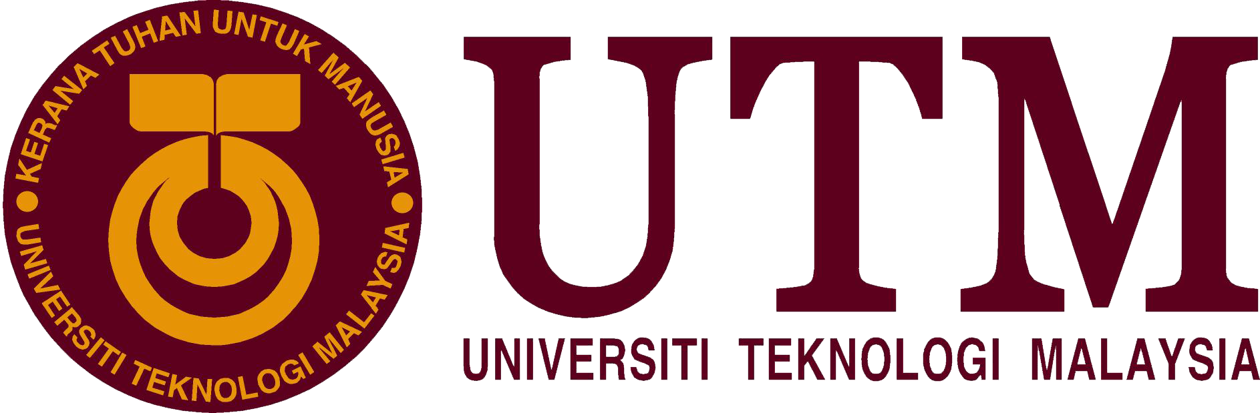

SCHOOL OF COMPUTING

TECHNOLOGY AND INFORMATION SYSTEM
(SECP1513-02)

INDUSTRY VISIT TO PETRONAS

NAME :
1) MUHAMMAD NURSYAKIRIN BIN AMIR HAIDI
2) AHMAD ZULHAKIM BIN ZAINAL
3) JAYANEYSANRAJ A/L JAYARAJ

LECTURER : DR. ARYATI BAKRI

SUBMISSION DATE : 29 SEPTEMBER 2019

Table of Contents
1. INTRODUCTION 3
2. DETAILED DESCRIPTION 5
2.1 Organization Structure 5
2.2 Services 6
2.3 Achievements and Awards 6
3. GROUP TECHNICAL DATA 7
3.1 Group Technical Data Custodian 7
3.2 Group Technical Data Dimensions 7
4. Tour to GTD Department 9
5. REFLECTIONS 10
6. CONCLUSION 12
7. REFERENCE 12

1. INTRODUCTION
As we know today, data is very important. Data is the key to understanding customer in companies. The data helps you know which of your products are selling like hotcakes on the market. Knowing a product is in demand allows you to increase the inventory of that item to meet the demand. Not knowing such important info will cause you to miss out on significant profits. To avoid this problem, companies need to hire data engineers who can handle the data, manage it properly, store it safely and avoid any losses.
The Technology and Information System (SCSP1513) assignment of session 2019/2020 that was given by University Technology Malaysia is a report regarding the trip to Petronas on 11th September 2019. This trip was organized by Dr. Aryati Bakri, lecturer of Technology and Information System and Dr. Muhammad Iqbal Tariq. The tentative of the trip is stated in Table 1 :

Table 1: Tentative of the trip
Time | Venue | Agenda
9.00 – 9.10 a.m. | VIZ 2, Level 22 PDCC | Welcoming remarks and overview of GTD
9.10 – 9.40 a.m. | VIZ 2, Level 22 PDCC | Experience Sharing by GTD Data Operation
9.40 – 10.00 a.m. | VIZ 2, Level 22 PDCC | Q&A session with representative of GTD
10.00 – 10.15 a.m. | Pantry Area, PDCC | Light refreshment
10.15 – 10.30 a.m. | Visit to Level 44, Tower 3 | Office tour and meeting with current 10 UTM seniors students

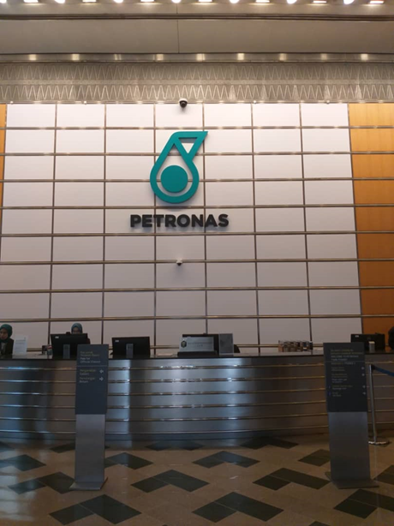
Figure 1: The entrance at the ground floor of Petronas tower
As data engineering students, our main purpose for this visit is to study the scope of our work as data engineers in this big company. We also want to know how this big company deals with a lot of data and how they manage to store it safely.
We arrived at the Petronas Twin Tower at 9.00 a.m. The entrance of the tower is shown above in Figure 1. Then we met with Group Technical Data (GTD) of Petronas. They guided us to the conference room which was on the 22nd floor. Then, the session with GTD begun. We also had a Q&A session with seniors who studied Data Engineering from UTM Johor Bahru at level 44 of Tower 3.

2. DETAILED DESCRIPTION
As we know, Petronas is a multi-billionaire company in Malaysia and one of the biggest oil and gas company in Asia. Petronas ranked 8th as the most profitable company in the world and Asia according to Fortune, a multinational business magazine . Since being found 45 years ago, Petronas has grown into an integrated international oil and gas company with business interests in over 35 countries. All of these could not be achieved without the help of the board of directors and their executives.

2.1 Organization Structure
Based on the official website of Petronas, the organization structure is stated at Figure 2

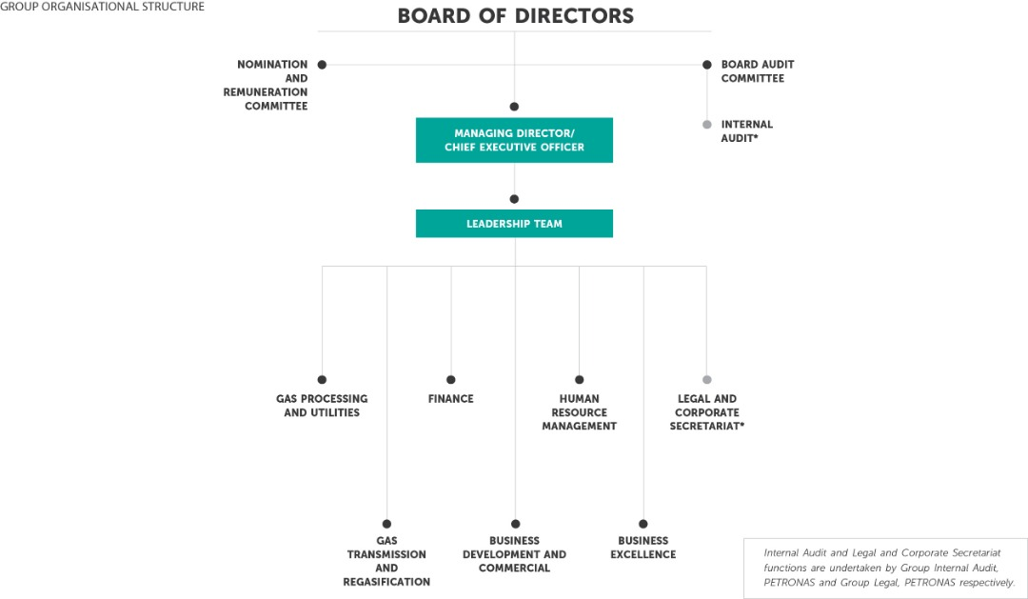
Figure 2: Organisation chart of Petronas
Based on Figure 2 ,the main group that governs Petronas is the Board of Directors that leads 3 main group which consist of Nomination and Remuneration Committee , Managing Director Board Audit Committee. Under the Managing Director/Chief Executive Officer is the Leadership Team which consist of 7 teams such as Finance and Human Resource Management.

2.2 Services

Petronas has two main services which is upstream and downstream. Through upstream, they managed to deliver world class projects and some of the world’s first integrated oil and gas value chain from their vast knowledge and experience. Meanwhile in the downstream service, they are involved in manufacturing and marketing process. For manufacturing process, they focus on producing petrochemical products, gas processing and transportation, regasification, utilities marketing, and power generation. But in marketing process, they focus on distributing the products.

2.3 Achievements and Awards

Based on the talk given by the representatives of GTD in the conference room, Petronas have managed to save RM5.3 billion via analytics. GTD’s efforts in providing Petronas with insights to come up with solutions in many sectors managed to cut cost in Petronas expenditure and improve their business. The amount of savings just benefits from 5% of data in GTD custody.

According to Petronas official website from their performance in 2018, Petronas was granted several awards:
- Asia Pacific Award
- APAC NOC of the Year Award

We were informed that GTD governed under Petronas Project Delivery and Technology. What did group project delivery do is make accountability for developing platforms in Petronas. They received project and found new ways to overcome the challenges in extracting oil. Then, they told us the role of GTD in Petronas. GTD is involved in upstream, downstream and technical data. Then, what can be done with the data? This is where Group Technical Data comes in.

3. GROUP TECHNICAL DATA

The representative said that Group Technical Data of Petronas was known as data management and founded in 1974. In 2006, they have been centralised as Group Technical Data (GTD). They are involved in all sorts of data including from upstream and downstream. Through analytical processes, they gained insights from the data and produced more accurate technical decisions. Based on GTD design principles, the responsibility of protecting the vast amount of Petronas technical data is handled by GTD. They analyse the data, diagnose and provide insights to experts to form solutions that benefits their businesses. All in all, GTD has become a part of Petronas success today. GTD custodian and dimension can be referred below :

3.1 Group Technical Data Custodian
- They have access to all technical data
- Govern and steer data safely and efficiently
- Guard, save and keep data so that it not lost

3.2 Group Technical Data Dimensions
According to the talk given by the representative GTD has 3 dimension in it which can be refer to Figure 3.

Figure 3: Group Technical Data Dimensions

Based on Figure 3, the dimension of GTD consists of 58% of Computer Engineering, 29% of Accounting and 13% of Information System. It means that GTD governs Computer engineering as majority.

Then, GTD explained the importance of data engineers. It is because not only data engineers can bring values to the work scope but data also plays a major role for other companies to make the right decisions. Data operation manages the data flow and structured data, ability to appreciate data and business knowledge. Then there are data operations surface which consists of :
- Data capture
- Data inventory
- Data delivery
- Data and technology forecasting

4. Tour to GTD Department
The next slot was a Q&A session with our Data Engineering seniors who were doing their internship in Petronas . Figure 4 shows our session with 10 UTM interns in Petronas.
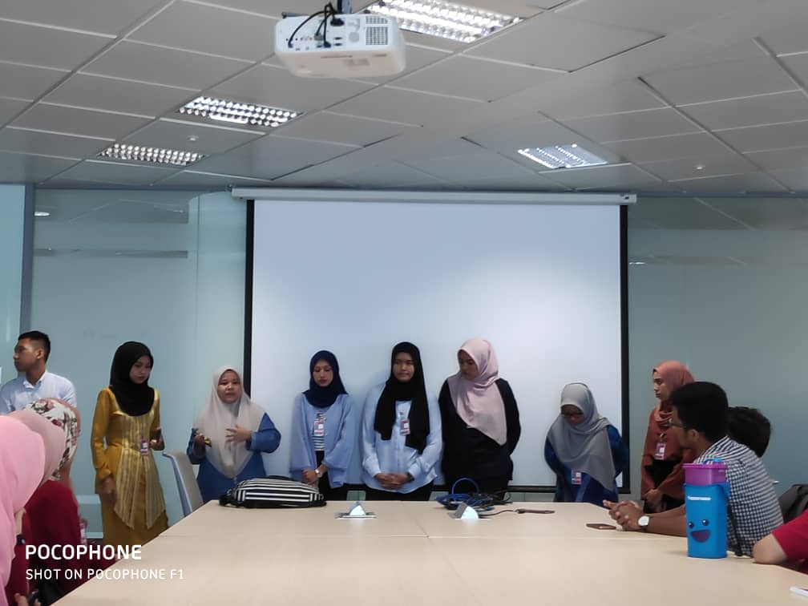
Figure 4: Q&A session with 10 UTM interns in Petronas
Based on our Q&A session in Figure 4, we managed to ask them a few questions which are stated below :
- Do companies prefer experienced workers or fresh graduates?
It is neutral. The company just wants to hire someone that has experience in handling data only. So, if you more experienced in handling data then you will be hired even though you are just a fresh graduate student.
- What programming language do they use in Petronas?
It is python because it is a universal programming language.
Then before the session ended the seniors gave us some advice such as:
- Work hard and study more compared to other courses.
- Explore more about programming language by yourself than in class.
- Ignore negativity and focus on your studies.

5. REFLECTIONS

Jayaneysanraj:
As a data engineering student, I felt immensely proud to step foot into such a prolific
company such as Petronas. Petronas is one of the biggest companies out there. This visit did
more than just impact my dream of becoming a successful data engineer. The company
speaks for itself. The facilities provided were top notch. The company was well equipped
with tools or machinery needed by data engineers. There is a specific task force just for data
engineers. The demand for this job position is still booming. During the visit, the staff
members explained to us the importance of a data engineer in their company. They played a
big part in earning the company’s revenue. That one fact motivated me . A course which is
still so new plays such a big role in such a top company. I felt proud of the path I chose.
Everyone’s dream is to work for Petronas for a lifetime. I want to learn from this company
and bring my experience to companies that are in need of data engineers. Especially
companies that are no match to Petronas. I want to work towards an internship in Petronas.
Even if I am not offered a permanent contract by Petronas, I will leave with tons of
knowledge and experience. Group Technical Data was very well organized and professional.
They knew their responsibilities and roles for the company. A data engineer could learn a
thing or two from this group of professionals. My dream now is to get an internship in
Petronas and learn as much as I can. The visit most definitely motivated me to work smarter
and not harder because Petronas not only recruits the best but they also require an
individual who has numerous soft skills.
During the visit, I realised I still have a lot to work on to improve my potential in the
industry. Being a pure science student, I have to improve on my programming skills since it
is widely used in the industry. I also have to improve on my critical thinking skills. I have to
solve problems efficiently and think out of the box. I have to read up more on artificial
intelligence as well because Big Data and artificial intelligence go hand in hand.
Furthermore, I should have a sense of curiosity. I should always ask questions. Before any of
that, I must understand the industry properly. I should understand the way the industry
works and how data are collected, analysed and utilized.

Syakirin:
The industry visit to Petronas recently was a turning point in my life because before
this I thought data was a simple thing that sometimes does not affect much in a company.
Now, I realize that even a small loss of data can cause in a drop of profit. A data engineer is
needed to handle this data and that made me interested in this course. It is my dream to
become an expert data engineer.
In order to improve my potential in this industry as data engineering student, I need
to improve in digital logic and programming technique subject. If you want to be a
successful data engineer, you need to have logical thinking skills.

Ahmad Zulhakim:
My recent industry visit to Petronas has given me the big picture of how Data
Engineers play a significant role in the industry. Companies, big or small nowadays are in a
race of achieving data to improve their revenues. Data has become a valuable asset because
companies can gain information and knowledge by making analytical processes to have a
better insight towards certain issues and finding solutions beneficial to them. These
complex processes have to be handled by professionals. That’s where Data Engineers play
their roles. Data engineers take the duty of exploiting the data for the company use, to
improve themselves in many aspects.
Hence, I do believe that I need to prepare myself to be able to persist with the career
demands. I must be well-equipped with all sorts of knowledge needed as a Data Engineer;
designing database, data mining and analytical skills. Besides, I must also develop my
interpersonal skills because in an organisation, the team must be able to interact with each
other to thrive together. A healthy work environment would surely bring benefits to the
organisation. Employers also nowadays need particular things to distinguish potential
employees since there is a lot of competition among them due to the abundance of
graduates. Last but not least, I should frequently take part in exhibition industry so that I
would be more exposed to the industry, know what companies want in their candidates,
discover jobs opportunity, the trends and growth of industry and many more.

Before we left the Petronas building, we managed to take a group photo with the representative of GTD. The photo can be seen in Figure 5.

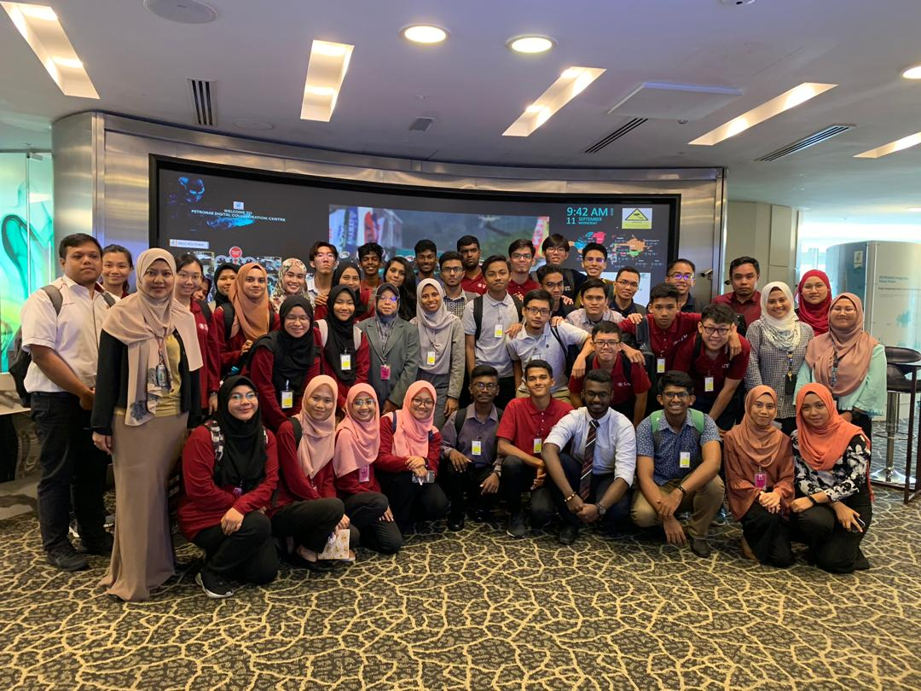
Figure 5: Last group photo with the representatives of GTD in the Group Technical Data office

6. CONCLUSION

In a nutshell, it was a life changing experience for all the three of us. We did not
know that data played such a big role in a company. We are proud to be data engineers that
handle all of this data. We realised that data engineers play a pivotal role in big companies.
It is a career worth studying for in our humble opinion. When it comes to self-improvement. We all have our own flaws that we need to rectify. We could all agree that logical and analytical thinking skills are very important in our field. We also have to improve our
programming skills since it is a must in this industry. Lastly, we should work on our
communication skills to develop a healthy working environment.

7. REFERENCE

- Petronas Nasional Berhad. (2018). Retrieved September 26, 2019, from Petronas.com.my: https://www.petronas.com/about-us/awards

- Petronas Nasional Berhad. (2018). About Us. Retrieved from Petronas Nasional Berhad: https://www.petronasgas.com/aboutus/Pages/cs.aspx

