SEMESTER 2
SESSION 2019/2020
SECV2113

TRENDS IN INTERFACES: DESIGNING SMARTWATCH INTERACTION

PREPARED BY :

- LEE SZE YUAN (A19EC0068)
- HAM JING YI (A19EC0048)
- MOHAMAD AMIN HAZEEQ BIN HISHAM (A19EC0087)
- NUR IRDEENA BINTI CHE MOHAMAD ZULKEPLI (A19EC0130)
- SHASITHER A/L SANDRAN (A19EC0160)

LECTURER'S NAME: DR AIDA ALI
SECTION : 01
SUBMITTED ON : 28/4/2020

INTRODUCTION
Nowadays, taking notes has become crucial as people usually have various tasks to be done in a short period of time and they sometimes forget which duties should be done when. When this happens, there will be further consequences, for example an employee getting fired as he or she forgot to start working on a project paper that has been requested from their manager months ago. This is where jotting down a note and setting a reminder to remind people about the note become important. However, as people keep getting busier day by day, they might not even have some time to take out their smartphone and list down their daily chores that need to be done. In addition, using a physical notebook is just really infuriating. Thus, our group decided to design a notes-taking application which can be installed inside a smartwatch. Our designed application is really easy to use and requires little to no energy from users as most of the functions and features inside the application can work only by receiving voice instructions from the user. We named our notes-taking application as “Ideapad”. This is because we understand that people always have great and innovative ideas crossing their mind almost all the time, thus one of our goals is to provide a suitable medium for them to express those bold and ingenious theories without making them feel irritated but instead, the application will assist them in creating more imaginative thoughts. Our application has five main functions and each of them work together to achieve our purpose. One of them is to allow users to reveal their creative side or simply to write down important notes such as meeting minutes or lecture notes and organise them using folders. Ideapad also lets them jot down their daily tasks that need to be done and it will further help users to get them finished by allowing users to set a reminder for each duty listed. Other than that, our application, too, has a function that permits users to keep their personal details including QR codes of their social media accounts and their bank cards. Ideapad also enables users to keep their tickets or passes inside the application, so that they will be easily accessible anytime and anywhere besides reducing the use of physical papers. It will also become helpful whenever the physical tickets, passes or bank cards are missing as everything will be kept inside the smartwatch application.

FUNCTION 1
- Creating new event reminder in calendar and new alarm reminder
- Designed by Mohamad Amin Hazeeq Bin Hisham
- Screen and interaction design:

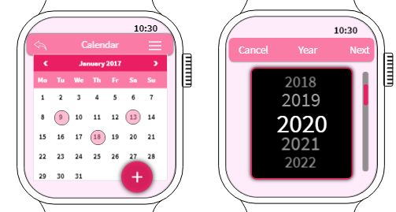
{Screen 1} {Screen 2} {Screen 3}
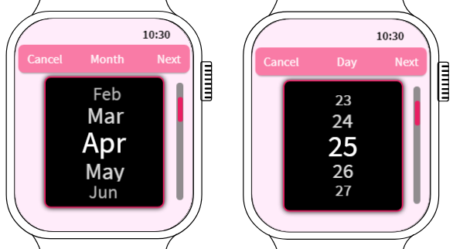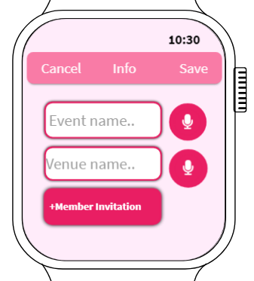
{Screen 4} {Screen 5} {Screen 6}
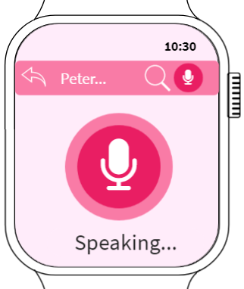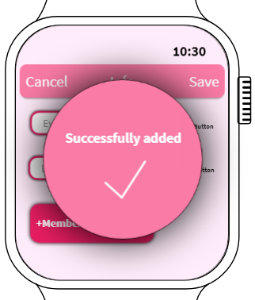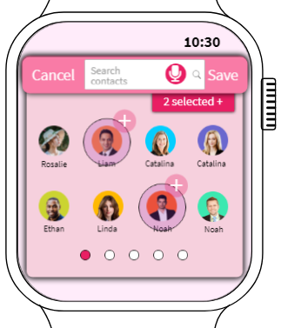

{Screen 7} {Screen 8} {Screen 9}
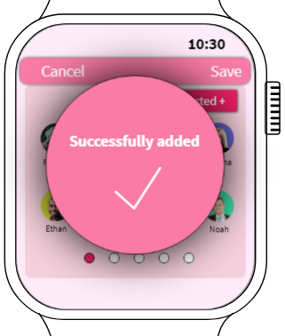
{Screen 10}
There are 5 icons which have a background of dark pink will be shown on the main page of Ideapad at (Irdeena’s screen 1). Tap on the icon of small “table clock” and then it will display the main page of that icon which give an access to “Calendar” and “Time” shown in screen 1, there is back icon button on the top that allow user to go back on the main page of Ideapad at (Irdeena’s screen 1).There is also a home button at the bottom which is for instant back to homepage of the smart watch. When the user presses the “Calendar” it will bring the user to the main page of the calendar which is in screen 2. From screen 2, the user can see some of the events roughly that have been added by the user and the added events are in the pink circles on the calendar. If users want to see the events in the future or at the other months, they can swipe to the left to see the future months and swipe to the right to see the previous months as the icon shows "<" and ">". Users can go back to screen 1 by pressing the “back” icon on the top bar. There is a dark pink circle consisting of a “plus” icon that can enable users to add new events. Touching that icon will bring the user to screen 3 that will show the user the year selection using scrolling option so that users only need to scroll instead of typing on this small size touch-screen display. If users want to cancel they can simply touch “Cancel” so it will go back to screen 2 but if when users touch “Next” it will go through to screen 4 with the selected year.
Screen 4 displays the month selection that uses the scrolling feature to select the month. If users want to do some exchange on the previous page they can simply touch “Cancel” so it will go back to screen 3 but if when users touch “Next” it will go through to screen 5 with the selected month. Screen 5 displays day selection that also uses the scrolling feature to select day .If users want to do some exchange on the previous page they can simply touch “Cancel” so it will go back to screen 4 but if when users touch “Next” it will go through to screen 6 with the selected month. On screen 6, it displays the info required for event attachment such as event name, venue name and member invitation. As we can see there are two blank spaces for users to fill in. These apps use voice input to fill in those blank spaces but it still provides the keyboard with key-in information just in case if one day the mic is not functioning so there is a temporary or backup action task if you are in emergency, chaos or big trouble. To activate the voice input, just simply touch the dark pink circle with mic icon in it and it will bring the user to screen 7. Screen 7 shows the voice input is in ready to use and all the user needs is just speak on that mic icon and wait for a while for the system to generate the voice input word-by-word and translate it into desired input. This voice input translator is very intelligent and powerful and will generate the voice input word-by-word and translate it into desired input accurately.

After speak at the mic icon in screen 7 it will go back to screen 6 to save the info by touching “save” button on the right-top and then the pop-up “successfully added” appeared on the middle of screen for not more than 1 second based on screen 8 to show your event really added.After that it will go back to screen 2. Before we move too far, on screen 6 there is a dark pink button “+Member Invitation” at the bottom of page users can optionally add the invitation of their members as a new event also can be saved without pressing the “+Member invitation” button. But when the user touches the invitation button, it will display page on screen 9 the selection of contact. There are three options for users to select the members for invitation. First, they can just simply swipe to the left as it will display others' contact list and then select who you are interested in. Second, this app provides voice input to instantly search your members and it will also display on screen 7 after the user touches the mic icon on top of page 9. Third, is the classic typing input only activated when the user presses the white blank space. Member invitation is a new feature for wearable apps as we can coordinate and contact with events participants without leaving “Ideapad”. After speak at the mic icon in screen 7 it will go back to screen 9 to save the info by hitting “save” button on the right-top of the screen and then the pop-up “successfully added” appeared on the middle of screen for not more than 1 second based on screen 10 to show your event with member invitation really added. After that it will go back to screen 2

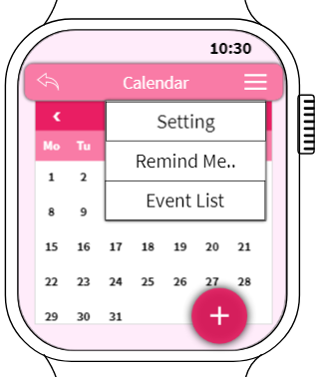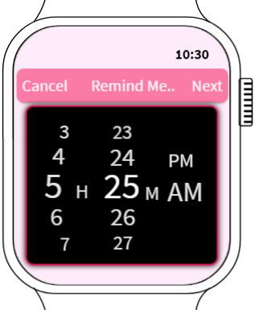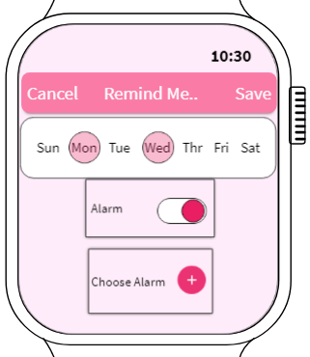{Screen 11} {Screen 12} {Screen 13}
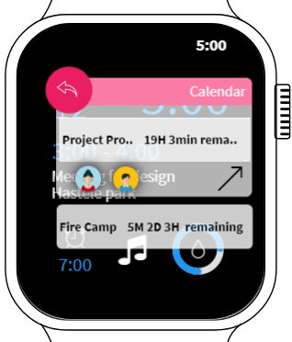
{Screen 14}
After successfully adding an event,it will go back to screen 2,as you can see are the menu bar with 3 white bars icon on the right-top of the page. If the user wants to go to the menu just simply touch on that 3 white bar icons (menu) and it will bring the user to screen 11, that shows “Setting”, “Remind me” and “Event list”. When users want to activate the reminder of an event, they can touch the “Remind Me…” button from the menu on screen 11 and then move to screen 12 which displays the time selection in hour, minutes and am/pm using the scrolling feature. If users want to cancel they can simply touch “Cancel” so it will go back to screen 11 but if when users touch “Next” it will go through to screen 13 with the selected time. On screen 13, there is another infos required so the reminder can do their task efficiently and effectively. First users need to select on what day that they need to be reminded. Next there is a toggle for alarm if the user wants the alarm activated, just simply put the toggle on by swiping to the right until the toggle turns dark pink, otherwise the alarm mode will keep in small vibrations instead of using alarm notification. Next, below the alarm toggle there is a button to choose an alarm that you may like when the alarm is on or activated. When the reminder reaches its time that has been set by the user, then it will display on screen 14 and be a small pop-up to get attention from the user. User don't need to close that pop-up reminder as our system has set it to display notification around 5 seconds so there is nothing to be worried when many notification come in as they will self-erase after 5 seconds but user still have an option to remove instantly just press the back button on the left-top of the pop-up reminder.

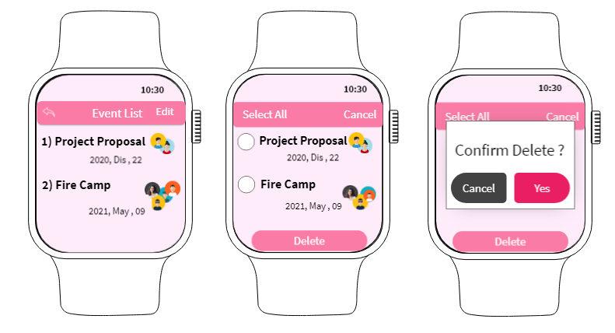
{Screen 15} {Screen 16} {Screen 17}

Based on screen 11, the menu also has an event list button. If the user presses that button then it will bring the user to screen 15, so in this screen 15 it will show the whole event list that you have been added and saved in the list form. There are some pros and cons between event lists in list form on screen 15 or in calendar form on screen 2. Basically calendar form is to display roughly events that exist on a calendar but may look messy and hard to manage but not in list form as it is easier to manage the event just in case. If users want to remove the cancel events they can touch “Edit” on right-top of screen 15 and then it will go to screen 16. Screen 16 shows an option for the user to delete some event by selecting on by one at the blank circle or select all events by pressing the “Select all” on the left-top of screen. Next step press the “Delete” button at the bottom page on screen 16 and then the confirmation pop-up immediately appears on the middle of screen based on screen 17.Users will be double confirmed before deleting the pass in screen 17. If the user presses “Yes” the selected events will be lost and then it will show back screen 15. If the user presses “Cancel” it also shows back screen 15 but no events will be lost. It is a kind of safety feature so the user can protect the events from loss after accidentally hitting it wrong.

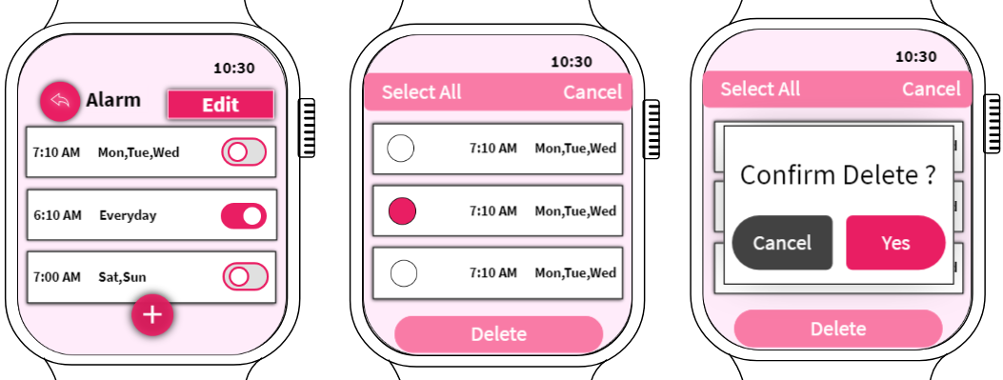
{Screen 18} {Screen 19} {Screen 20}

From screen 1, when users want to go to time reminder, they hit the “Time” button on screen 1, then it will move to screen 18 to display the main page of “Time”. From screen 18, it shows the list of alarms that have been set by the user. The left-top of the screen has a back button in dark pink to enable users to go back to the main page of Ideapad at (Irdeena’s screen 1). There is an “Edit” button on the right-top of the screen to enable the user to edit the list of time reminders (alarm) whether it is needed or not. At the list of alarms there are toggles attached on each of the alarms which function to enable the alarm activated or not. To know that, when toggles are in dark pink colors means it is enabled otherwise it is unable by the user for a certain period only it is not the same concept as delete the alarm. To delete the alarm, the user needs to hit the “Edit” button and then it will bring the user to screen 19 . Screen 19 shows an option for the user to delete some alarms by selecting on by one at the blank circle or select all events by pressing the “Select all” on the left-top of screen. Next step hit the “Delete” button at the bottom page on screen 19 and then the confirmation pop-up immediately appears on the middle of screen based on screen 20. Users will be double confirmed before deleting the pass in screen 20. If the user presses “Yes” the selected alarm will be lost and then it will show back screen 18. If the user presses “Cancel” it also shows back screen 18 but no alarm will be lost.

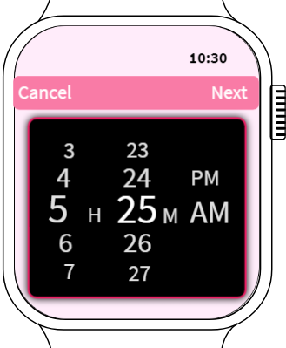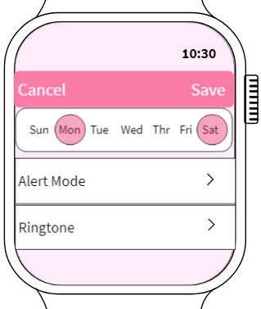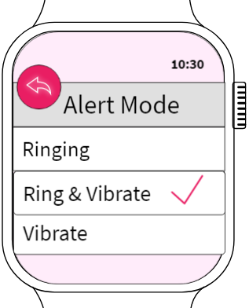
{Screen 21} {Screen 22} {Screen 23}
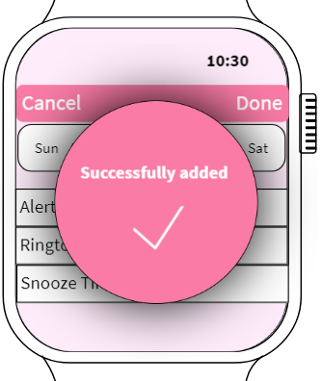
{Screen 24}
From screen 18, if the user wants to add a new alarm just simply hit the “+” icon in dark pink circle then it will move to screen 21 to select the time with time selection in hour, minutes and am/pm using the scrolling feature. On screen 22, there is another info required so the reminder can do their task efficiently and effectively. First users need to select on what day that they need to be reminded. Second user can choose alert mode ,when user hit the alert mode it will move to screen 23 and user can do selection by hit each of the 3 option “Ringing, Ring & Vibrate, Vibrate” .Next user need to hit back icon button on left-top of screen so then it will move back to screen 22. Users can have an option to change the ringtone by hitting the “Ringtone” button if not it will remain to use default smartwatch ringtone. To save the alarm is by hitting the “Save” button on the right-top of screen and then the pop-up “successfully added '' appears on the middle of screen for not more than 1 second based on screen 24 to show the user alarm is really added. After that it will go back to screen 18

- Design for lightweight interaction

First, using a voice input translator is the better choice rather than typing input text nowadays because people prefer to do things easier and with a minimum number of steps especially in these wearable apps. For example, to search the contact list all we need is just hit the mic icon button and it allows you to search the contact that we desired accurately. The other example is when you have to type an event, venue name using voice input translator can be done quickly although the name is too long , actually the name is not too long but the wearable screen apps is small in size so it is very needed more time when you have to type using keyboard.
Second, is use simple words and icons, it is better to use simple words rather than use full sentences in instruction mostly. Using icons also can help the lightweight interaction. So, the use of words and icons must be balanced as it will contribute to the variety and art of design. Not just that, some words are hard to interpret in icons-form such as “X” is for “Cancel” or “Delete” and some icon like floppy disk for “Save” is it still suitable for this generation that have never seen and even don't know what is “Floppy Disk”. Sometimes it will bring the user to hit the wrong buttons/icons thus will contribute to a big problem for the old-folks user as some of them will easily lose their memory and make the interaction longer. But, using icons has its pros because people easily understand from doing mistakes and make it to memorize the previous mistakes not to be repeated again. So it is still considered to use short and simple words so that old folks users still can understand the word to do the interaction.
Next, colour minimalism is one of the things that contributes to lightweight interaction. Every single colour should be very carefully used. Make sure that there is no redundant colour and the colour used in wearable apps must not be colourful in the same button but at different locations which will contribute to the user to feel confused and uncomfortable with that interface and not efficient in doing any lightweight interaction on the wearable apps. It is okay to have a colourful icon, button or something else but it must have consistency in the usage. If all of the buttons, icons, fonts are in the same code colour this also will contribute to increase the number of steps to achieve the task and make people bored and confused.

- How it follow the guidelines for wearable apps
Context of information is used to provide specific information at a glance. The reminder of upcoming events do not come in ringing and vibration but with specific information like the time remaining of some events so the user will get notice accurate and correct information rather than just being noticed with sound or vibrate with no meaning that might get the user feel confused. I designed a small reminder or notification with the accurate time remaining display on the homepage but not longer than 5 seconds as it will self-erase. Designing for wearables is designing for context as it will enhance the use of devices which make the device worth buying and useful in your daily routine. Smart devices are full of sensors and it’s possible to utilize built-in device sensors to determine and for example to calculate time remaining information will increase your level of awareness with the upcoming events and make the user well-prepared.This will help enhance the user’s experience by making the context-relevant information glanceable.

Wearable apps should be as short as possible. Minimize the number of steps and keep interfaces simple to make it small in the number of steps and quick interaction. Wearable apps need only showing what’s essential for a user to complete a task. For example, when users need to search contact lists or insert the event and venue name using a smartwatch,I provide a voice input option in wearable apps if a user is in a hurry or basically to make it quick interaction. The powerful voice input translator will generate the voice input word-by-word and translate it into desired input accurately.

Every interface that in the wearable apps are very clear and contrast in colour interface. This is to make sure users are able to read whatever interface that has been put on the screen. Contrast and clear colour usage design is ideal for smartwatches and wearables. because it will easily interact although users are not in static condition. For example, the selecting info using scrolling feature is made in black and white colour and the white colour can differentiate with the unselected info that also on white colour but not bright enough and smaller size than the selected info size.The reason why year,month,day i designed separately because the space is longer and lengthy as the size of fonts need to be small if want to make it on one page. Plus it is to avoid scrolling info wrongly. Designing for wearables is all about making something that looks great and useful on a tiny screen.

FUNCTION 2
- Creating folders to organise the notes
- Designed by Nur Irdeena Binti Che Mohamad Zulkepli
- Screen and interaction design:

{screen 5} {screen 6} {screen 7} {screen 8}

On the main page of Ideapad which is in screen 1, users need to click on the folders icon to go to the folders section, which is on screen 2. On screen 2, there are two documents that the user has already created before. “Lecture Notes” and “Passwords” are the names of each folder respectively. To go back to the main screen of Ideapad, users just need to tap on the previous icon next to “Folders” and screen 1 will be on display. Next, to create a new folder, users have to click the plus icon which is located at the bottom right of the screen. This will direct users to screen 3, where users will be asked to choose from existing notes to be added into the new folder. To edit the folder name, users only need to click on the first defaulted folder name which is “<Folder Name>”. Next, the screen will ask the user to set the folder name by just simply using their own voice. When users have confirmed the desired folder name, they will have to click on the tick icon. Screen 4 shows that the user wants to set the new folder name as “Urgent”.

{screen 5} {screen 6} {screen 7} {screen 8}

After the folder name has been set, the screen will be directed back to screen 5 which shows the lists of existing notes, asking for users to choose the notes that they want to be in the newly created folder. To choose a note, users will need to tap and hold on any wanted note until the note’s border becomes thick. Screen 6 displays the interface of the note changes when it has been chosen, in this case, the note with the name “Don’t Forget” has been chosen. To cancel the selection of the note, users can just tap again on the selected note and the note’s border will go back to usual. To cancel the adding notes function, users need to tap on the cross icon, and screen 8 will appear. Screen 7 shows that the user has chosen two notes to be added into the new folder. Number 2 beside the cross icon indicates that there are currently two notes inside the folder. When the user has done adding notes into the folder, they need to tap on the tick icon located next to the folder name and they will be directed to screen 8, which reveals the contents of inside the new folder. If there are no notes chosen, then screen 8 will only display the folder name, indicating that the folder has no contents inside it. If suddenly the user feels like they want to add more notes into the folder, they can simply click on the plus icon and screen 5 will appear again.

{screen 9} {screen 10} {screen 11}

From screen 8, when users tap on the previous icon next to the folder name, the screen will be directed to screen 9. Screen 9 shows the list of existing folders, including the one that has just been created. To delete a folder as whole, users only need to tap and hold on any folder until the folder’s border becomes thick or bold. In screen 10, a folder with the name “Passwords” has been chosen to be deleted. Number 1 at the bottom center of the screen indicates that one folder has been chosen. To revoke the deleting folders function, users will have to tap on the cross icon which is located at the bottom right. When users have made a decision on which folder to delete, they just have to tap on the trash bin icon, the one at the bottom left. When the folder has successfully been deleted by the system, screen 11 will appear. Notice that on screen 9 there are three existing folders and when the user has deleted a folder, there are only two existing folders left as in screen 11.

{screen 12} {screen 13} {screen 14}

{screen 15} {screen 16} {screen 17}

Screen 12 is the main page for the folders section inside the Ideapad app. On the screen, it is shown that there are currently two existing folders that have been created before. The number on each folder is to give insight to the users on how many notes are there inside each folder. To open any folder, users can simply tap on any folder they want to open to see its contents. Screen 13 shows that the user has tapped on the “Lecture Notes” folder. On this screen, we can see the contents inside the folder. The scrolling bar at the edge of the screen indicates that the contents inside the folder are more than three. Screen 14 shows that the user has swiped the screen up and that the screen has scrolled down to the bottom. We can see that there are four notes inside the folder, just like what the number on screen 12 says. To delete any notes inside the folder, users will need to tap and hold on any notes they want to delete. Screen 15 shows that the note with the title “Chapter 1” has been chosen to be deleted as the note’s border has become bold or thickened. Number 1 at the bottom means that one note has been chosen. To delete the chosen note, users will tap on the trash bin located at the bottom left. Screen 16 displays that the chosen note has been deleted as there is no more “Chapter 1” note just like there was on screen 13. When the user taps on the previous icon, the main page of the folders section will appear. Screen 17 is the main page of the folders section and we can see that the number on the “Lecture Notes” part has decreased from 4 to 3.

- Design for lightweight interaction
The creating folders function in Ideapad has multiple features including deleting a folder and adding notes into the folder. However, the function has been designed so that each task can be achieved only by receiving minimum interaction from users. For example, deleting a folder can be done only by selecting any folder and tapping on the trash bin icon, instead of having to drag the folder all the way to the trash bin icon which would be quite difficult to do on the small smartwatch screen.
In addition, most of the options and features buttons use icons instead of words or texts. The icons chosen to represent every feature are understandable by different generations, from a small child or a teenager who has been living in a technology-driven world to an old folk who might only know how to use a smart device a few years ago.
Other than that, in the steps to create a new folder, there will be no unsuitable and tough actions needed as the function was designed perfectly to reduce any possible inconvenience for users. For example, to set the folder name, the screen will only ask the user to say the name they want out loud, instead of having to type in the name using the keyboard on the smartwatch screen. Using voice input will be much easier besides avoiding the users to feel irritated and it is considered as a lightweight interaction in the function.

- How it follow the guidelines for wearable apps
The creating folders function implements hierarchical navigation. This way users can easily see the insight of every content inside the folder that they are viewing. Furthermore, the folders are arranged according to the date it was created. This makes it easier for users to find any folder as users would usually remember if the folder that they are looking for is a new folder or a months-old folder that has been created a long time ago. At the top center of each screen, there is a label where users can see what page or folder that they are currently on so that users will not need to go back to the previous screen to remind them which page or folder that they have clicked on. This will help users remember their place during navigation.
Other than that, the creating folders function only includes pages not more than three. This is because each page is filled in with only the most necessary information for users as a smartwatch is obviously being used to substitute larger devices like smartphones. Smaller number of pages will support users in achieving any task using the function in a short period of time. Plus, creating folders inside Ideapad will be more convenient for users as they do not have to go through too many levels of pages inside a folder.
Every interface that appears during execution of the creating folders function is also glanceable. This means that the buttons, icons and texts used on every page are in a big enough size that users can clearly see each and every information or options displayed on the screen without having to bring the smartwatch nearer to their eyes. This helps in reducing trouble to read and understand the information on the screen especially for those with limited vision.
Last but not least, the creating folders function inside Ideapad application was designed specifically for offline usage. This is to avoid disruption if the user is having an Internet connection problem when they really need to keep their notes organised.

FUNCTION 3
- Display Quick Response Codes (QR Codes)
- Designed by HAM JING YI
- Screen and interaction design :

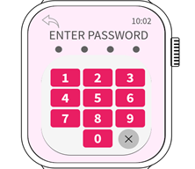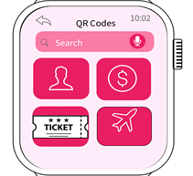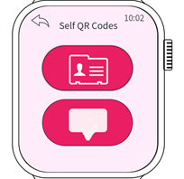
{screen 1} {screen 2} {screen 3}
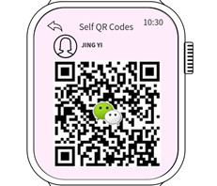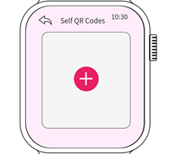
{screen 4} {screen 5}

5 icons which have a background of dark pink will be shown on the main page of Ideapad (Irdeena’s screen 1). Tap on the icon of QR codes, users have to enter password first (screen 1). After the password is successfully verified, a new screen (screen 2) will be entered and there are 4 icons to be chosen. Tapping the icon of a profile picture will guide us to a screen containing 2 columns(screen 3). Tapping the icon of chat will guide us to the interface of chat QR codes that users have downloaded. This QR code of the card may consist of your Wechat QR codes and more, just press on the + sign if users want to add chat application QR codes. To exit from this section, just press the Back icon at the top of the left side. On the other side, The column of Card has the same function as the Chat column. This Card column may consist of your business card QR code and working card QR codes. Press “Back” to return to the main menu of QR Codes.

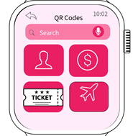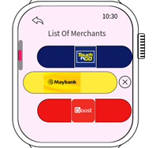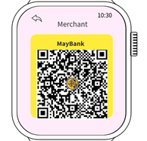
{screen 6} {screen 7} {screen 8}
Next, when users tap on the money icon (screen 6), users will enter screen 7 consisting of various merchants’ QR codes such as Boost, MayBank and Touch ‘n Go. These QR codes in screen 8 are not going to change every 60 seconds and it can last long without changing their pattern. Users can get detailed information through the linked application in smartphones. If users want to add more merchant’s QR codes, this can be done in the smartphone. Press X on screen 7 to delete merchants’ QR Codes. Press Back icon to return to the main menu of QR codes.

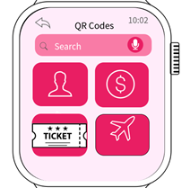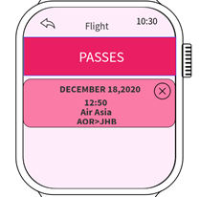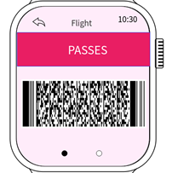
{screen 9} {screen 10} {screen 11}
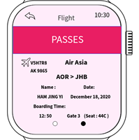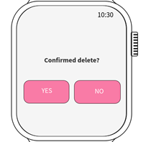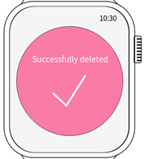
{screen 12} {screen 13} {screen 14}
Press the flight icon on screen 9 to enter the page of boarding passes(screen 10). This page can save e-boarding passes and users can delete it by tapping the X sign. After the user taps the pass column, a bar code of the boarding pass is shown in screen 11 and swipe to the left (screen 12) is the information of the passenger. Users can get detailed information through the linked application in smartphones. To delete this pass, back to screen 10 and press X. Users will be double confirmed before deleting the pass in screen 13. If press “Yes”, screen 14 will be shown. Press Back icon to return to the main menu of QR Codes.

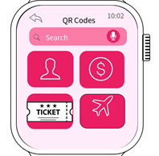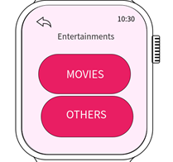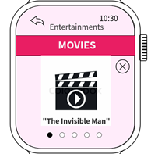
{screen 15} {screen 16} {screen 17}
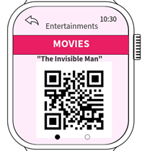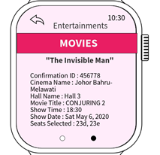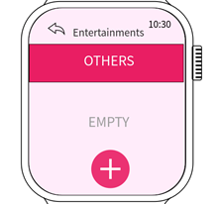
{screen 18} {screen 19} {screen 20}
Press the Ticket icon on screen 15 to enter the page of entertainment(screen 16). Tapping the movie column will get the QR codes of the movie tickets on screen 18. Users can know the movie information by swiping to the right. Users can get detailed information through the linked application in smartphones. Users can delete the whole file of the movie by pressing the X sign. Pressing the others will show the tickets for others except movies. Press + sign to add ticket. Press Back icon to return to the main menu of QR Codes.

- Design for “lightweight” interaction
For example, I use the icon to keep the interface simple instead of using text. This is because users will spend time reading the long text inserted in each column. For the list of QR codes, each function is represented by a simple and easy-understand icon to reduce the interactions of the users. This is to ensure that users interact with our application within 10 seconds At the same time, users can quickly get what QR codes they want to use by using the voice input in the QR codes interface. For a long text, I will replace them using the related icons in order to minimise the interactions and users can also save their time by looking at the easy-understand icons.
- How it follows the guidelines for wearable apps
It is designed for glanceability. When users want to delete something, just press the X button and a new interface will pop up. This interface will ask the users in a simple and clear sentence, that is “Confirmed delete?”. I make this sentence short because users can see things more clearly on a tiny screen and I am sure that users will spend less than 5 seconds on this page. After the users press the “Yes” button, they will enter the next page which contains only a big sign of a tick with words “Successfully deleted”. I make it simple enough as users just want to know whether things are successfully deleted or not. According to this glanceability, a most basic visual feedback is more than enough.
This application ensures the users’ privacy. As we know the QR codes are part of personal information. In our application, users must enter the password before entering the QR codes interface. Users can erase the wrong password by using the cross sign at the right bottom of the number pad. To keep things simple, a password required 5 digits instead of the characters.
This application is designed to have a clear minimalistic interface. The main colours we choose for this application are 3 types of pink, grey, white and black. When users enter the QR codes interface, they will see there is sharp colour contrast. I am sure that users will look at the 4 main functions first, the search is second. The background colour must not catch the attention of users. So, we choose a dark pink for the essential tasks and a very light pink for the background. Dark pink will make elements easy to see and complete a task quickly. The font we use is only simple fonts so that users will not feel confused and they can read easily. On the other hand, I ensure that there is enough space between elements and all the elements are arranged neatly. All of the essential elements are included and at the same time, there is enough space between elements. Keeping things simple is a very important guidelines for wearable applications.
This wearable application can also be used for offline usage. This is because all of the QR codes are saved inside our Ideapad. Sometimes users will experience connectivity problems. However, users can also access the saved QR codes. There are some parts that users can only add the QR codes from other applications or other devices when there is good connectivity.
This wearable application has interaction with the smartphone. Some of the QR codes like the wallet QR codes, the flight QR codes and the movie QR codes cannot be added directly in the wearable applications. All of these QR codes must be added using the applications in smartphones. So, users must link the application in smartphone with the application in wearable to make the ecosystem better. At the same time, since some of the QR codes must be added through application in smartphones, the total number of pages in wearable application is reduced. When we say linkage with the smartphone, it means that the detailed information can be found in the smartphone and only essential information will appear on the wearable application. This will reduce pages in wearable applications and consequently form quick and convenient interactions.
Moreover, I select the proper navigation model for the wearable application. This is because my function that I designed has more than one screen. Mostly, I choose the page-based navigation. This is because the users will know where the position is and there are how many pages for that part. In page-based navigation, users can swipe left or right to navigate from page to page. I use the hierarchical method once in the merchants’ wallet part. This is because users can choose one of the merchant’s wallets to be used and pressing one of it will get the merchant’s QR codes of one of the wallets.

FUNCTION 4
- Creating To-Do lists and Set Reminder for recorded tasks
- Designed by Lee Sze Yuan
- Screen and interaction design:

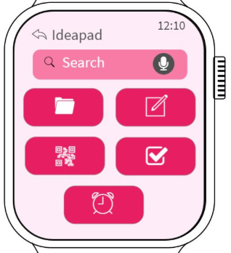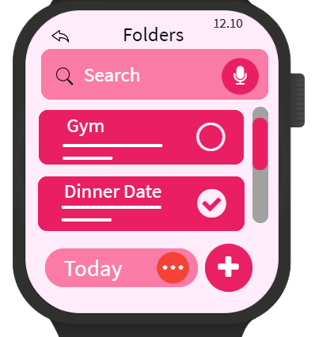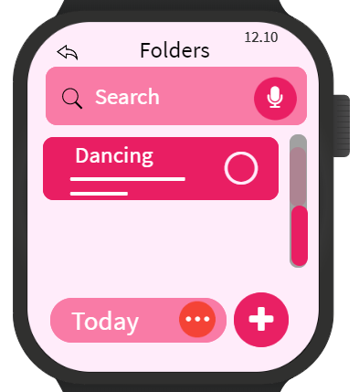

{Screen 1} {Screen 2} {Screen 3}
On the main page of Ideapad which is screen 1, users just need to press on the To-Do list Icon, the system will lead the users to the To-Do list section, which is on screen 2. On screen 2, we can see there are 2 tasks being displayed. Just like what is being shown in screen 3, users can view all the tasks they recorded by scrolling up and down. Then, users can search for their recorded tasks by using search function. This search function supports voice input mode. Besides, users can monitor their tasks here too. For example, if they finished the task, they can click the small tick box at the left of the task directly on this screen. If they want to check the detail of the task, they just need to click on the task they want to view, the system will lead to a new page (screen 9 & 10) and show the detail.

Next, if users want to add a new task, users can tap on the big “+” button which is located at the bottom right of the screen. This will lead users to screen 8. When users want to check the To-DO list of other days, users just need to tap on the button which is labelled “Today”, then the system will display a list of dates and let users choose the date.

When the users want to go back to the main page of Ideapad which is screen 1, users just need to tap on the “back” button which is located at top left of screen.

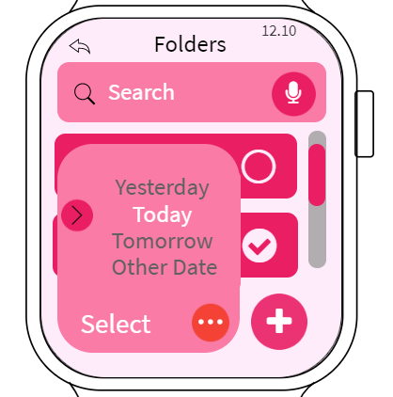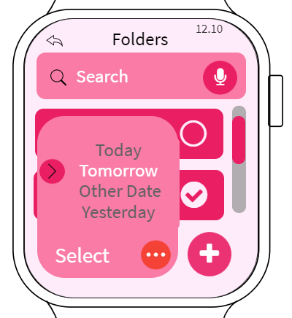
{Screen 4} {Screen 5}
Like what we mentioned above, users can click on the button with “Today” labeled. Then, like what is being shown in screen 4, the system will display a list of days for users to choose. This list normally will only show 4 options “Yesterday”, “Today”, “Tomorrow” and “Other Date” only. Users can choose the day they want by scrolling up or down. There is a pointing arrow that tells users what days are being selected currently. If users are not satisfied with the options of “Yesterday”, “Today” and “Tomorrow”, users can choose the “Other date” option, the system will display a calendar and let users choose the exact date that they want.

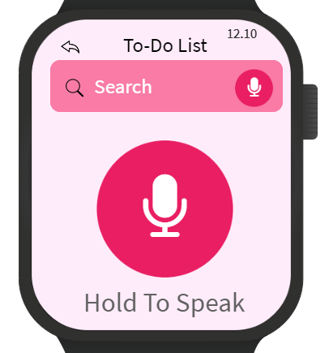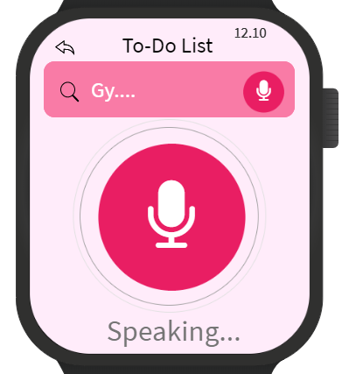
{Screen 6} {Screen 7}
When users want to search for a specific task they have recorded before, they just need to tap the search bar. The system will lead the users to page like screen 6. When users want to input or key in the name or keyword of that specific task. Users need to press and hold on the big, centered “Microphone” button before they start speaking to the microphone of the smart watch. Like what is being shown on screen 6, the system will display a tip “Hold to Speak” to tell users to press the :microphone button before they speak.

In screen 7, after users press and hold the button, the system will display “Speaking” to inform users that the microphone is turned on and listen to what users said. As users speak, the microphone will receive the user's sound and the system will interpret the sound wave and convert it into text, then display the text inside the search bar on the screen.

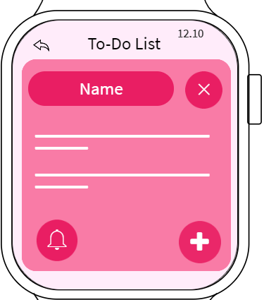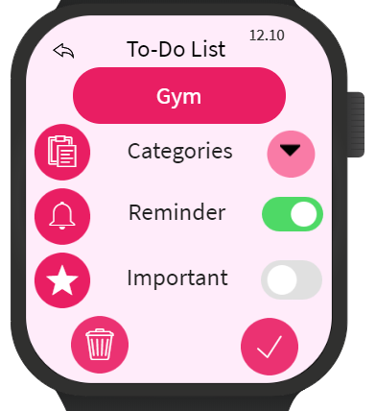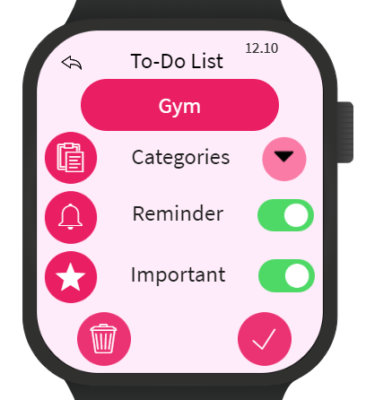
{Screen 8} {Screen 9} {Screen 10}
After users tap the “+” button on screen 1, the system will lead the users to a page like screen 8. This page allows users to key in the information of their new tasks. First, users can type the name of the tasks. Then, users can key in some short information about the tasks below the name of the tasks. Then, users can set a reminder if they feel like by just pressing on the big bell button which is located on the bottom left of screen 8. If users just accidentally press on the “+” button or just want to stop “adding a new task”, users just need to press on the “X” button that is on the right of the name of the task.

If users want to check the details of their tasks, users just need to tap the task on the To-Do list, the system will lead the users to pages like screen 9 and screen 10. As shown in screen 9 and 10, users can check and change setting for the task. For example, users can check and edit the categories of the task, the reminder and mark the task as “important” if they want. After finishing editing the details, users need to press the “+” button, so the system will save and record the changes in the details of the tasks.
Besides, users can delete the task by tapping the dustbin icon button. AFter tapping it, the system will delete the task.

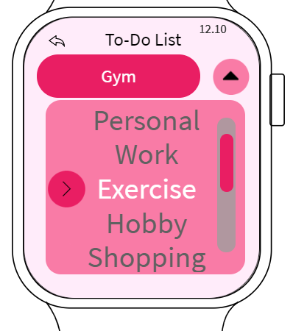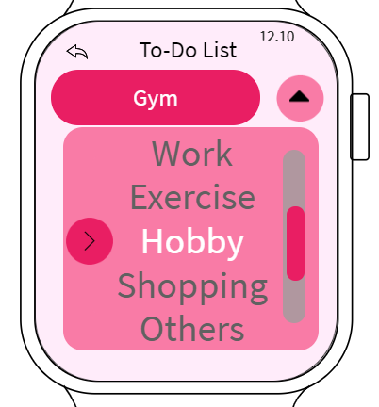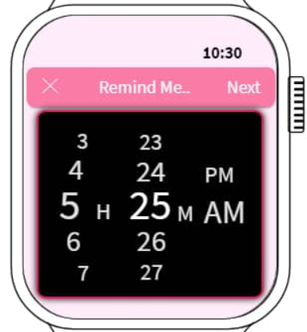
{Screen 11} {Screen 12} {Screen 13}
On screen 9 and 10, users can set the categories of the task. After pressing on the “categories” part on screen 9 and 10, the system will display a list of categories and let users choose. This is just what is shown is screen 11 and 12. Like before, users can choose the category they want by scrolling up and down. Then, there is a pointing arrow icon telling users what category is being chosen currently. If users are not satisfied with the options provided on screen 9 and 10, users can have more choice by choosing the “Others” option. Then, the system will show more categories and let users choose.
Then, on screen 9 and 10, users can set reminders by turning on the “Reminder” button, after turning on, the system will display a time selecter. Like what is shown in screen 13, users can choose the time they want. Then, the reminder is finished setting up. The watch will remind the users when it is time. If users want to cancel the reminder, they just need to turn off the reminder which is shown in screen 9 and 10.

For every page mentioned above, we have set a “back” button. This button will let users quit and go back to the last page they visited. The system also shows the destination of the “back” button on the right of the “back” button.

- Design for lightweight interaction
This To-Do function of Ideapad also implemented a lot of icons instead of texts or words. For example, the voice input button is represented by a microphone icon, “add a new task” button is represented by “+”, and the time reminder is represented by a bell icon. The icons that are being used are understandable to various people. These icons help users to understand the functions of each button easily and require less user's energy to read or think before operating on the Ideapad application.
Then, this To-Do function only requires minimum interaction with the users. For example, if users want to create a new To-Do, users just need to click the “+” button on screen 2. Then when users want to type the name and detail of tasks. The system will lead them to screen 6. Users just need to speak out what they want. Then the system will analyse the voice input and convert it into text. The number of steps is not a lot and doesn't require the user's effort a lot.
The To-Do function of Ideapad also follows the KISS principle. We avoided putting lots of buttons, icons, texts in one page. We only put the few most important icons and information on each page. For example, on screen 9 and 10. We only display the name of the task, toggle switch for time reminder and “Important”. Then users just need to press the “tick” icons to finish their change. We can also see this on screen 6 and 7. The screen only shows the big “microphone” button and the text input that are analysed and displayed based on the user's voice input.
Lastly, the To-Do function only focuses on core functionality. We only include actions and features that are necessary. For example, ‘add new task”, “view task”, “set reminder” etc. We didn’t include unnecessary actions and functions that only lengthen the interaction time between users and the Ideapad.

- How it follow the guidelines for wearable apps
The To-Do function of Ideapad has the design for glanceability and minimalistic interface. On every screen, there are not many texts or words being shown. Only icons that represent actions and important information of tasks are being shown. And the important information is being shown in different fonts and sizes. Then, there is sufficient space between texts and texts, icons and icons, texts and icons. We also have used different colours to create clear contrast for users. So, users can use this function of Ideapad easily.
Secondly, the To-Do function of Ideapad has predictable navigation too. For example, the total number of pages is not a lot. The number of pages required by each action of the To-Do function only requires 2 to 3 pages. Like we mentioned just now, there is only essential information being shown. We also only keep the most needed actions in creating or viewing To-Do lists. Then, the To-Do function also has a proper navigation model which is hierarchical. For example, like in screen 9 and 10, when users tap one of the tasks in a To-Do list, a new screen appears that displays details about that task. When users further tap the detail of the selected task, another screen appears that shows extra detail of the tasks.
Thirdly, the To-Do function is also designed for offline usage. So, even if there is a connectivity problem between the Ideapad app and the internet, users still can access every action or feature in the To-Do function.. For example, users still can add or delete new tasks in thh To-Do list when there is no internet connection. This is because all the information and setting of the To-Do function are saved in the memory and storage of smart watches. However, the cloud backup function that can’t be accessed when there is no internet connection.
Lastly, the To-Do function of Ideapad also has implemented a correct and suitable Visual design. The interface has used suitable topography in displaying essential information. Then, the selected colour scheme also creates a visual continuity between different screens. For example, we have used light colors for text because it’s easier to achieve proper contrast and legibility with such colors.

FUNCTION 5
- Notes-taking feature
- Designed by : Shasither Sandran
- Screen and interaction design :

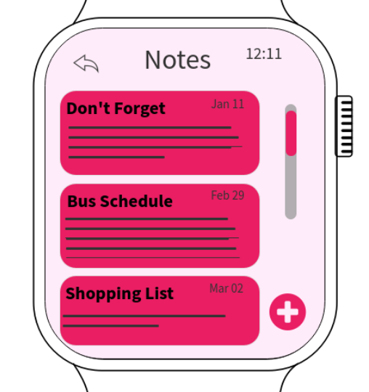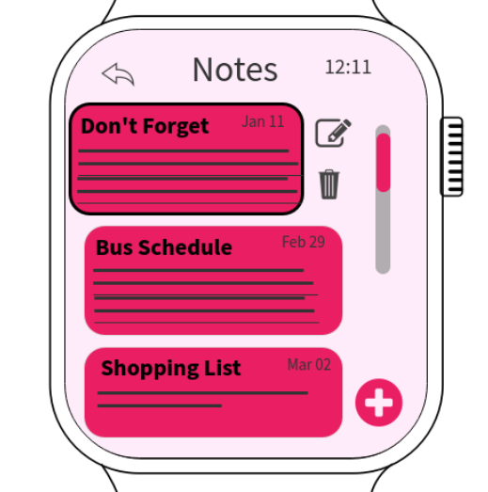
{Screen 1} {Screen 2} {Screen 3}

On the main page of Ideapad application (Screen 1), there will be a functional icon for notes taking function of the app. By clicking on the icon, users will be directed to (Screen 2) which consists of a list of previously saved notes. The notes are arranged based on date of note creation while the notes are all can be accessed through the scroll bar to navigate through the list of notes. In order to either delete or edit the existing notes, users have to tap on the note. The note will slide to the left providing the users with two options that can be done on the specific note (Screen 3).
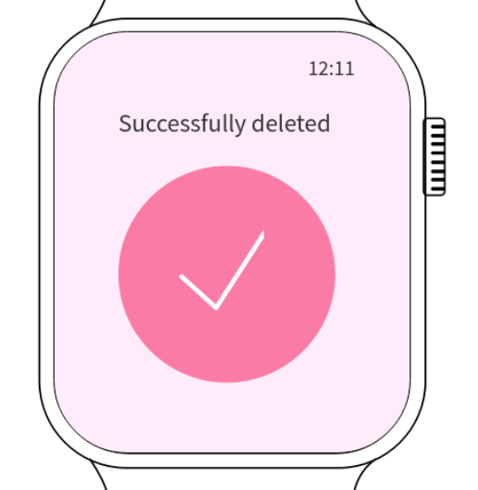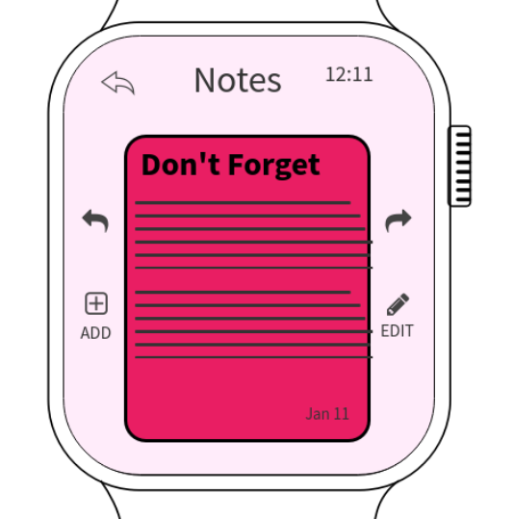
{Screen 4} {Screen 5} {Screen 6}
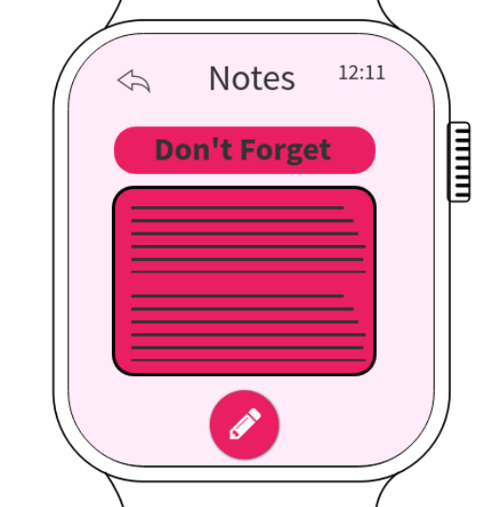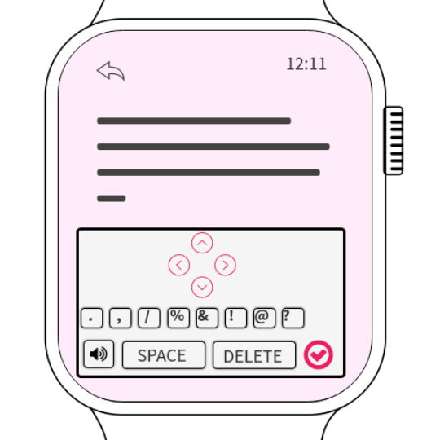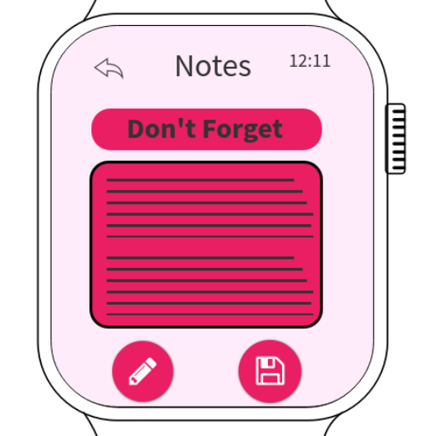
{Screen 7} {Screen 8} {Screen 9}

In one case, if the user decided to remove a note since it is no longer necessary, a message (Screen 4) will be shown to notify the user that the selected message has been successfully deleted. In the other case, if the user decides to edit the existing note (Screen 5), users will be shown two types of editing that can be done on the note (Screen 6). Users have the option to either click on the types of editing to be done or swipe the note on the specific direction. Firstly, if the user swipes to the right, which is the option for technical editing, users have to choose whether the title or the content of the note to be edited (Screen 7). Once selected, a pad consisting of several important keys/symbols will be shown (Screen 8) for the users to be included inside their note. There is also a navigation bar for the users to easily navigate through the note. Once done, a final review interface (Screen 9) will be shown for the users to go through and make a final check on the note before being saved.

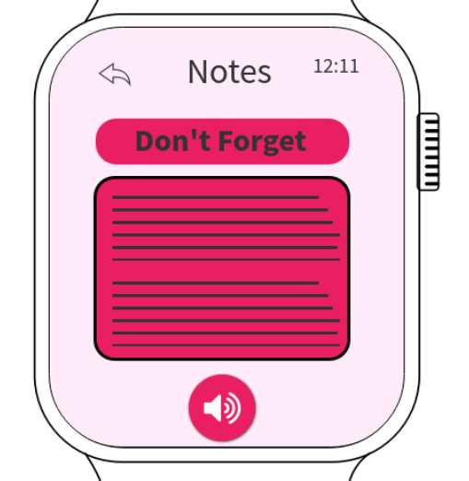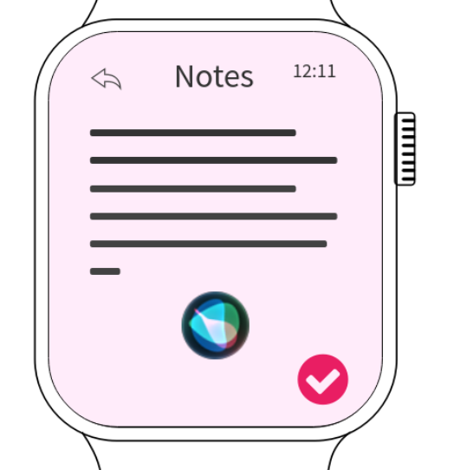
{Screen 10} {Screen 11} {Screen 12}
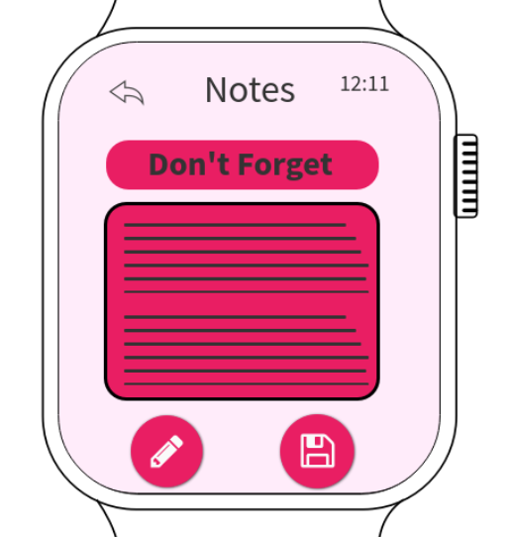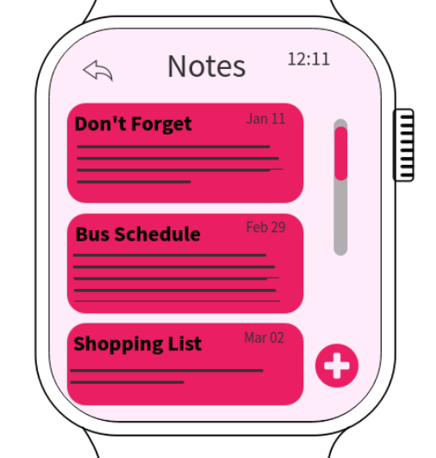
{Screen 13} {Screen 14}
Alternatively, if the user decides to swipe the left (Screen 10), which is the option to add more inside the existing notes, users have to choose whether the title or the content of the note to be added (Screen 11). After that users can begin to voice note by clicking on the speaker symbol which will lead to (Screen 12) where the voice note will be written on the screen for user reference. Once done, tap on the tick icon in the bottom right, which will then lead to the preview interface (Screen 13). This is where users can view the newly added part inside the existing note. If a user wishes to do technical editing, clicking the icon on the bottom left will lead to (Screen 8) where in-depth editing can be done. But, if the user clicks on the save icon, the edited note will then be sent to the list of existing notes (Screen 14).
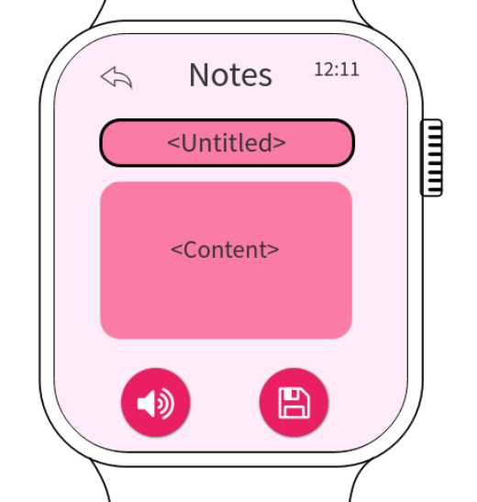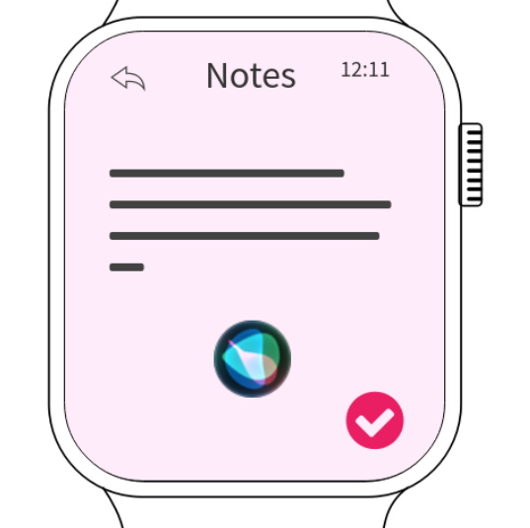
{Screen 15} {Screen 16} {Screen 17}

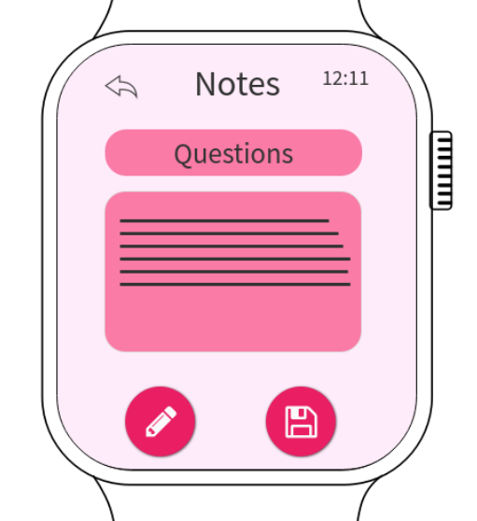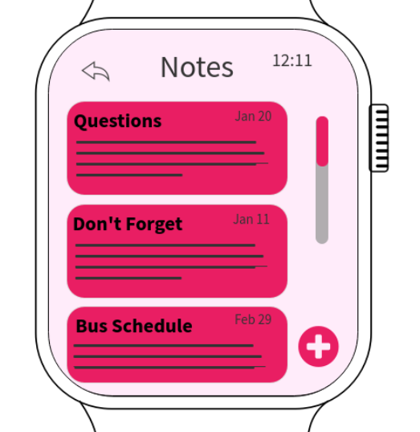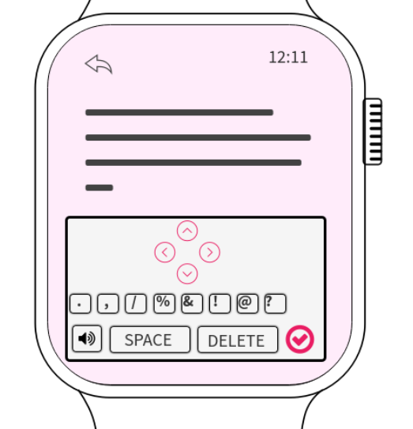
{Screen 18} {Screen 19} {Screen 20}
{Screen 21} {Screen 22}

On the other hand, if the user wishes to create a new note, they just have to click on the plus icon on the bottom right of the main interface for Notes function (Screen 15). The interface that will then come out is the new empty note (Screen 16). Now, users can select either the title or the content box to add in the note. After tapping on either of the boxes, users are required to click on the speaker icon bottom left. After that, users can start to voice note which will be written on the screen for user reference (Screen 17). Once done, click on the tick icon then it will lead to the preview interface (Screen 18). Here, the user can save the new note which will then be included in the list of notes (Screen 19). Otherwise, if the user wishes to make technical editing they can click on the edit icon on the bottom left of the screen to be led to the editing interface (Screen 20). Once editing is done and the tick button is clicked, the preview interface will appear again for the users to make a final check before being saved (Screen 21). After that, the newly added note can be seen on the list of notes (Screen 22).

- Design for lightweight interaction
The notes-taking function in the Ideapad application achieves the design goal for lightweight interaction in several ways. One that should be highlighted the most is the simplified operation through micro-interaction with the UI. The interface is designed for simplicity to make the notes-taking process much easier without hustle. The number of steps to create a new note is only within a few steps and can be accomplished in a shorter time period. Adding to that, the use of functional icons to represent a specific operation instead of word-labelled icons makes the interface much more simpler and user friendly. Besides, it also efficiently safes space on the screen and makes sure the interface is not filled completely. Apart from that, the notes-taking function has several capabilities such as creating new notes, editing existing note as well as deleting the existing note. Operation simplification features are considered while creating the interface in order to enable users to accomplish their desired task with the minimal steps of operation.
Besides, more focus is given to its core functionality which is notes-taking in order to achieve the design for lightweight interaction. Therefore, unnecessary features or icons are totally avoided thus the priority is given to the most essential functions required in there for comfortable user experience. For example, basic navigation panel, status bar at the top on the interface with battery status, connectivity and etc are all removed as it is non-essential in the perspective of a notes-taking function. Significant reduction in the total number of screens consisting of all the functions within notes-taking is also emphasized. This is because, users only opt for essential information for quick and convenient interaction. Therefore, focus should be given there to reduce the time consumption during in-app navigation.
Furthermore, colour minimalism is another key for designing the lightweight interaction in apps. According to the current trend, users prefer a cosy and elegant design instead of rainbow-coloured themes used back then. It is essential to greatly optimise the source of attraction through the colour theme of the app. In this case, the main theme colour for this app was pink, using 3 different density of pink colours for the entire functions in the Ideapad app. It is essential because this is not just limited to the attraction factor but also determines the mood of the user while using/experiencing the application’s function. Among the reasons to select pink as the theme colour is that its harmonious colour feature which soothes the operational mood.
- How does it follow the guidelines for wearable apps ?
The notes-taking function in the Ideapad application follows several guidelines for designing good wearable apps. Firstly, the design for Glanceability which is focusing on giving the user exactly what they face to see at the moment. This is where the notes-taking feature in Ideapad app emphasizes on displaying only the most critical information. For instance, the voice note recorder enables the user to only view the note that is being written (Screen 12). So, users take shorter time to understand and gain clarifications on the content of the note. Besides, the selection of notes is done by tapping on the note instead of ticking in the circles. This simplifies the task and quickly proceeds to request users to click on the operation to be done, either delete or edit (Screen 3).
Next, lightweight interactions with clear minimalistic interfaces is also a crucial part of the guidelines for good wearable apps. Shorter interaction period with the UI means being able to accomplish desired task easily without undergoing too many steps or more specifically too many interfaces. Here in Ideapad, this can be seen through the swiping feature instead of selecting the operation to be done by clicking on buttons (Screen 6). In terms of minimalistic interface, users must be able to read whatever on the screen and easily interact with it even while moving. This is a crucial part for notes-taking as it is important for users to easily view their note without difficulties. Apart from that, the notes-taking feature in Ideapad focuses on simple typography such as bolded text to differentiate the title and the content of every note, the spacing between each note ensures the interface looks uncluttered and improves visibility.

Another component that should be given attention while following the guidelines for wearable apps is the visual design as well as non-visual user interface. The visual design which is also discussed above includes typography. Besides, users should also be provided with essential symbols which could be added into their note manually (Screen 8). This helps to avoid user-system complications as well as improves the readability of the notes. Another visual design component that can be seen in the notes-taking function of Ideapad is the navigation buttons to enable easier user navigation while doing manual editing (Screen 8). On the other hand, non-visual user interface is used mainly through the use of voice input to compose a new note or add in an existing note. This capability provides an alternative for users to effectively interact with the interface instead of using their fingers on the smartwatch display screen (Screen 12).

