Design Thinking Report
Subject: Technology and Information Systems (SECP1513)
Section : 07
Lecturer: Dr. Sarina binti Sulaiman
Group 9
Members:
1. Chai Ming Choy (Leader)
2. Wan Nur Atiqah binti Junaidi
3. Goh Jo Ey
4. Zaimi Mohamed

1. Introduction
Design thinking is a process that utilizes empathetic, creative, innovative and analytical skills to provide solutions to an established and understood the problem. This process keeps the end-user in mind. It is a cycle which can be repeated for multiple times. Design thinking involves 5 steps: which is empathize, define, ideate, prototype, and test. Empathize phase is to observe the user and their behaviour in the context of their lives, engage with users through scheduled and short “intercept” encounters and also to immerse into the problem to experience what the user experiences. Define phase is to analyze, interpret and plan. This is where we will unpack and synthesize the empathy findings into compelling needs and insights, and scope specific and meaningful challenges. Ideate phase is where to imagine, research and ponder for the solution suggested. In this phase, the focus is to generate new ideas and explore a large quantity and diversity of ideas. Prototype phase is to apply the creativity of the creator to create a prototype. Getting the ideas and explorations out of our head and bring it into the physical world. The last phase which is test, a process to review and revise the improvements that can be made on the prototype produced in order to produce a better quality solution or product.
The topic for our design thinking is “Systems Analysis and Design”, which is Chapter 12 for our subject. Systems analysis is the process of collecting and interpreting facts, identifying the problems, and decomposition of a system into its components. Systems design is the process of planning a new business system or replacing an existing system by defining its components or modules to satisfy the specific requirements.
Systems Analysis and Design is a six-phase problem-solving procedure for examining and improving an information system. The six-phase are preliminary investigation, systems analysis, systems design, systems development, systems implementation, and systems maintenance.

2. Detail step and description in design thinking and evidence for each phase.
DATE | ACTIVITIES
13th OCTOBER 2019 | - Briefing by Dr. Sarina  o We have a rough idea on design thinking  o Our topic for design thinking is  Chapter 12: Systems Analysis and Design
14th  OCTOBER  2019 | - Met up with team members (Chai Ming Choy, Wan Nur Atiqah, Goh Jo Ey, Zaimi Mohamed)  - Had a brainstorming session regarding our topic  - Divided the task for each member  - Had a discussion about the details and flow of the interview  - Prepared questions for the interview
16th  OCTOBER  2019 | - We had an interview with the programmers about the topic of systems analysis and design
17th  OCTOBER  2019 | - Met up with team members (Chai Ming Choy, Wan Nur Atiqah, Goh Jo Ey, Zaimi Mohamed)  - Came out with two ideas  - A forum for the discussion  - A template to save data which helps the user to conserve their time  - Had a discussion for the new ideas
23th  OCTOBER  2019 | - We had a discussion with Dr. Sarina and checked with our outcomes  - We started to rectify our problems for the ideas  - We decided to make the interviews with a project manager and a client as well
24th  OCTOBER  2019 | - We had two interviews with the project manager and the client.  - We have identified the problems  - We came out with a solution that can benefit three phases in the process of systems analysis and design which are project manager, programmers, and client  - We have designed the prototype for the solution
25th  OCTOBER  2019 | - We have completed the interface of the prototype  - Had a discussion on the prototype we did  - Done some improvements for the prototype
2nd  NOVEMBER  2019 | - We started to edit the video  - We started to write the report
6th  NOVEMBER  2019 | - We have completed the video  - We have completed the report  - We have completed the slides for the presentation

Our design thinking project is totally based on this topic and aims to create a new solution in this specific area. Our focus will be on the three phases of systems analysis and designs, which are the project manager, programmer and the client. The details and descriptions for the five major steps of this design thinking project are:
- Empathy – We have to empathize with the problem and see it from a different perspective in order to solve the problem.
- Define –Identify the core problem from the data gathering, analysis and synthesis in order to generate a solution for it.
- Ideate – Create and generate new ideas and solutions in order to solve the problem stated. Critical and creative thinking is an essential key in this section.
- Prototype – Implement the solutions to a scaled-down prototype to investigate and improve the end product
- Test – Test the final prototype. Improve and refine the prototype in order to make the final product better.

3. Detailed descriptions include problem, solution and team working
3.1 Problems
A. Communications between the project manager, project programmers and client
As for the project manager, it requires him/her to contact or communicate with the client and programmer separately using different interfaces or applications which might cause confusing and complex interpretation of the message when it comes to handling different types of projects at the same time. On the other hand, if the conversation between the project manager and the programmer or with the client are made through WhatsApp, their conversations may be mixed up with other people’s conversations. In addition, the project manager would find it hard to trace back their conversations. In the matter of the programmer, he/she might find it difficult to connect or contact the project manager or even contact other programmers who are in the same project to ask for information or help.

B. Hard to trace the progress of the project
A project manager might require more than one programmer to speed up the process of finishing up a big project. It will be hard for the project manager to trace the progress of the programmers who are working under him and it might cause delay on the project. The client also needs to trace the progress of the project as well, but the applications now hardly have the interface or the function to do so.

C. Running a lot of applications at the same time for a project
As different types of applications have its own functions, the project manager needs to run a lot of applications at the same time in order to keep track of the project progress of the programmers, communicate with the programmers and client and also to trace the projects that he/she needed to handle.
3.2 Solution
We have come up with three solutions in total for the problems that the interviewees have faced. First, we have thought of making a website which includes a forum for programmers to connect and communicate with each other in solving a program. Anyone who learns to program whether they are a professional or non-professional can willingly solve the problems and give ideas on how to solve to another programmer who asked about their problems faced in programming.
Secondly, we have also come up with another solution in which we make templates for each problem and solution in programming. The idea originated is to ease the programmers in making a program in which they do not have to repeatedly programmed for the same function or interface. If they were given the same type of problem, so there will be a general solution for it.
The last solution that came up from our mind was to design an application which combines the functions for multiple applications into a single application. By developing an application which can benefit the three main sides and phases of systems analysis and design, which are the client, project manager, and the programmers. This application can help to ease all these sides by making the progress of the project faster and easier. The application which enables its users which are project manager, programmers or the client to trace progress or project, look at the descriptions and details of the project, setting due dates and reminders and chatting or messaging with any side of the projects. We think that this will be an effective and efficient solution for the problem that is stated by all three sides or phases of the systems analysis and design.

3.3 Team Working
The following are the things that we did as a team in this design thinking project:
- Discuss and understand the topic
- Generate ideas for design thinking project
- Identify the problem statement and creating solutions
- Gather tools and materials to make the paper prototype
- Film videos for some of the phases in design thinking
- Making a report and presentation together

4. Design thinking assessment points, where assessment happens
a. During the end of the project demonstration
At the end of the project demonstration, we have collected some useful opinions and feedback in order to make our prototype better. We realized that we have missed some of the useful and more user-friendly functions which can make the experience of using our applications created better. The main point that we missed out is the privacy problems. The user suggested us to increase the level of privacy of the application. For instance, the user can set permission to decide who can view their timetables themselves. The other suggestion from the user is to have an alarm system in our application. The alarm system can be set by the user to alert them on some specific task. Other than that, an online conference call is one of the suggestions by the user. With this function, the user can have face-to-face communication via video call with other sides or people who are involved in the project. They felt more comfortable with this type of communication. Therefore, we still have room for improvement even for the prototype that we think is the best. We will reflect and learn from all these suggestions and make improvements to make our final product better.

b. During the transition between design thinking phases
After the empathize phase, we need to ensure that the sides or people that we choose to identify the problem from the person from the correct position, which is from a project manager, a programmer and a client or user before proceeding to the next phase which is the define phase. After the define phase, we have listed out the core problems. Then, we managed to find some similarity between the problems stated. Therefore, we produced a solution which can solve all these problems in one shot in our ideate phase. After the ideate phase, we did another brainstorming session where we need to think on how to implement our ideas in the ideate phase into a real-life prototype as it is hard to make something abstract into something concrete and touchable. After the prototype phase, we thought of letting the user to test and view our prototype as the user of the product can give a more reasonable and constructive comment in order to help us improve our prototype and final product.

5. Design thinking evidence
a. Sample work by students working to solve the design challenge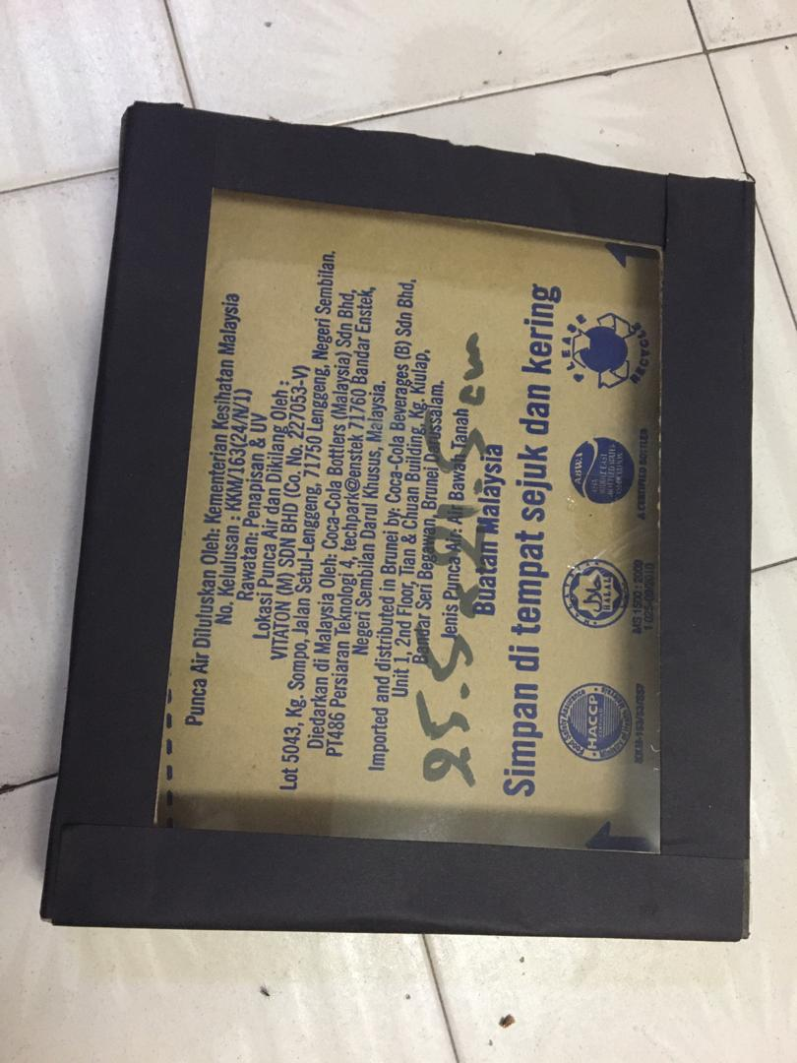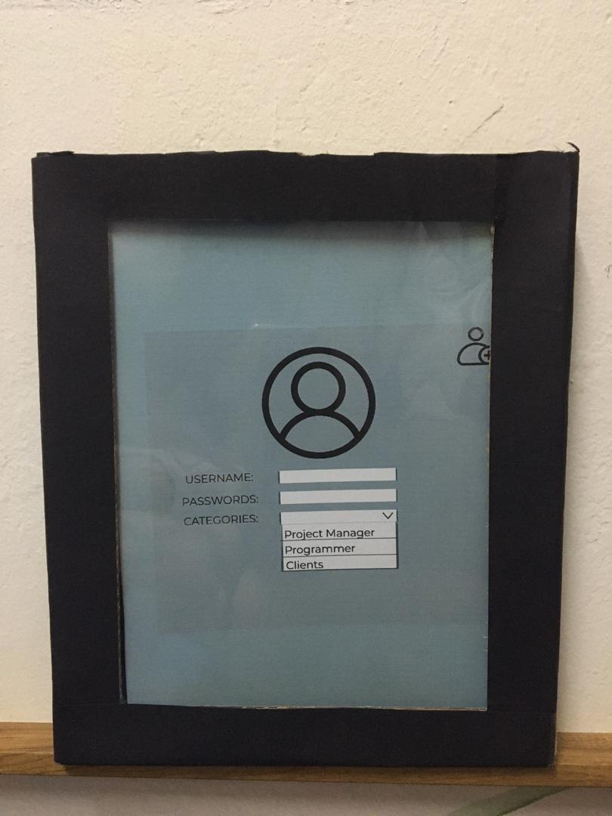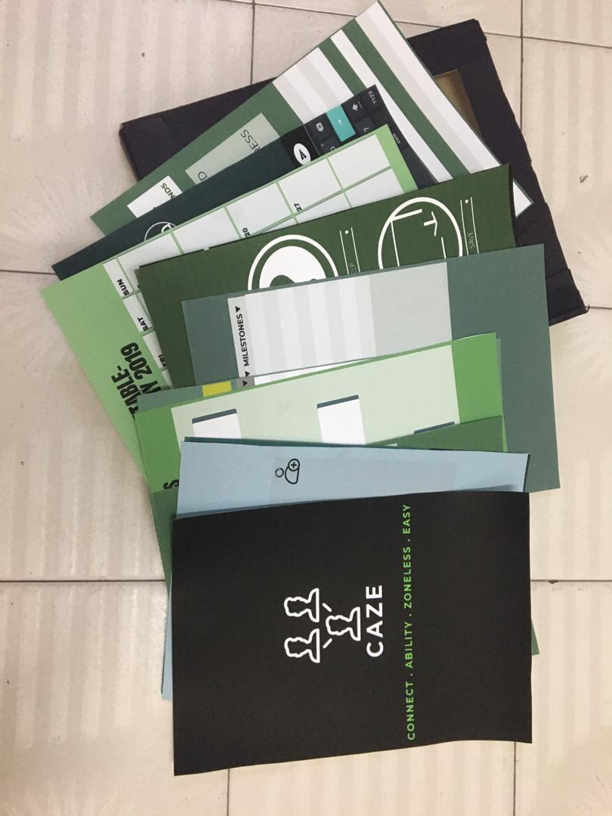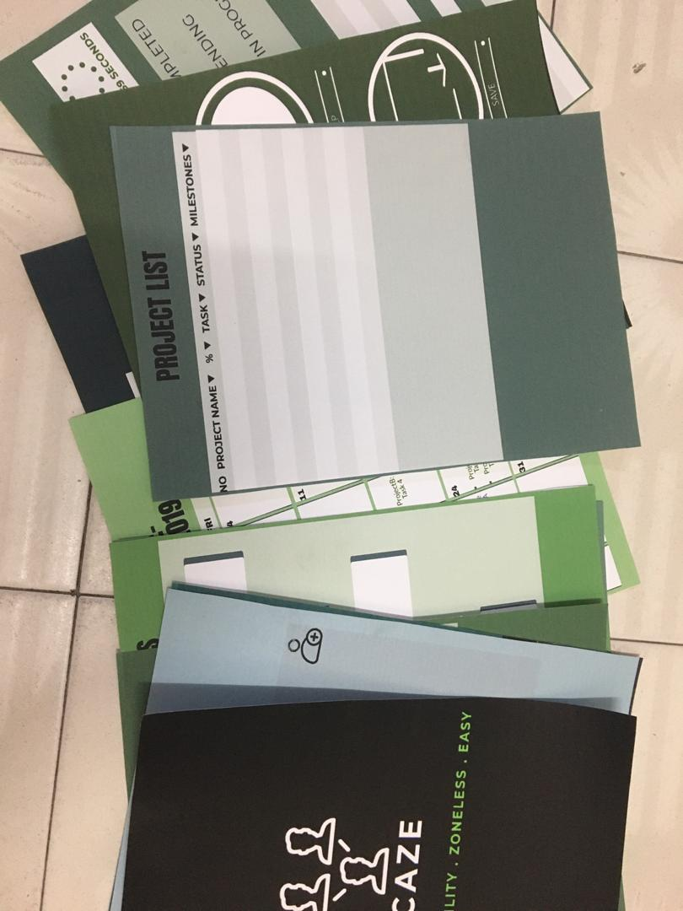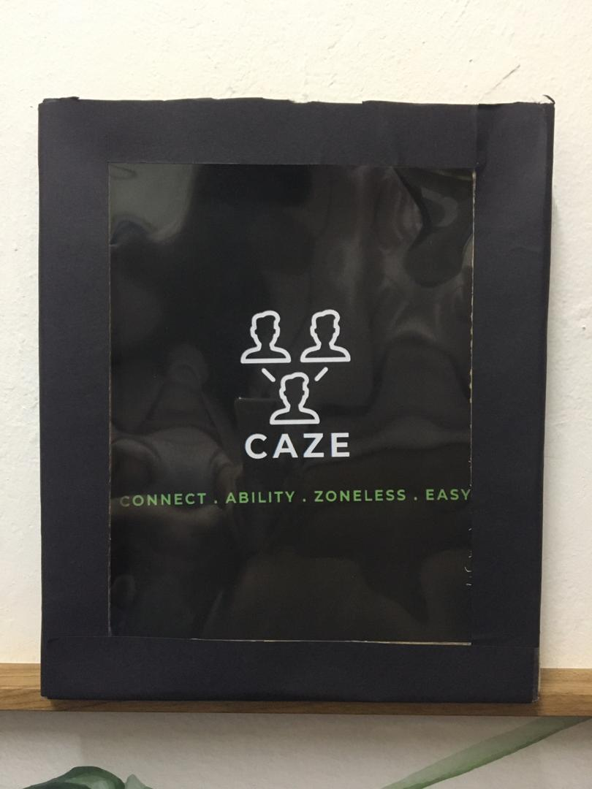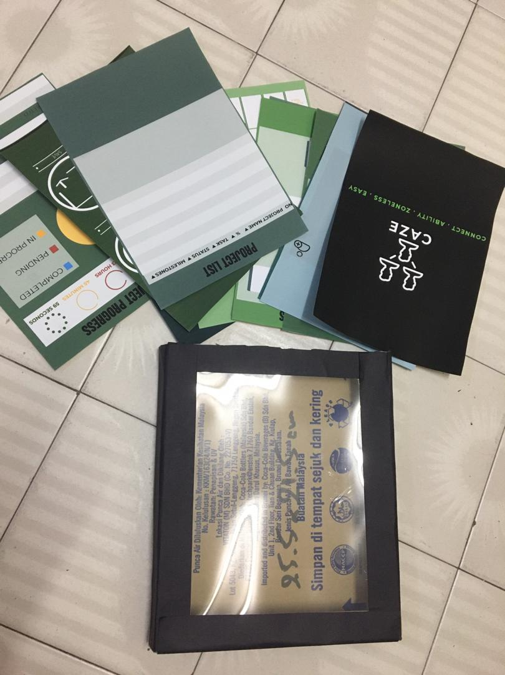

b. Record for each phase
i. Empathy: list of possible questions and answers for the user, and the composite character ( User: age, background, and others)
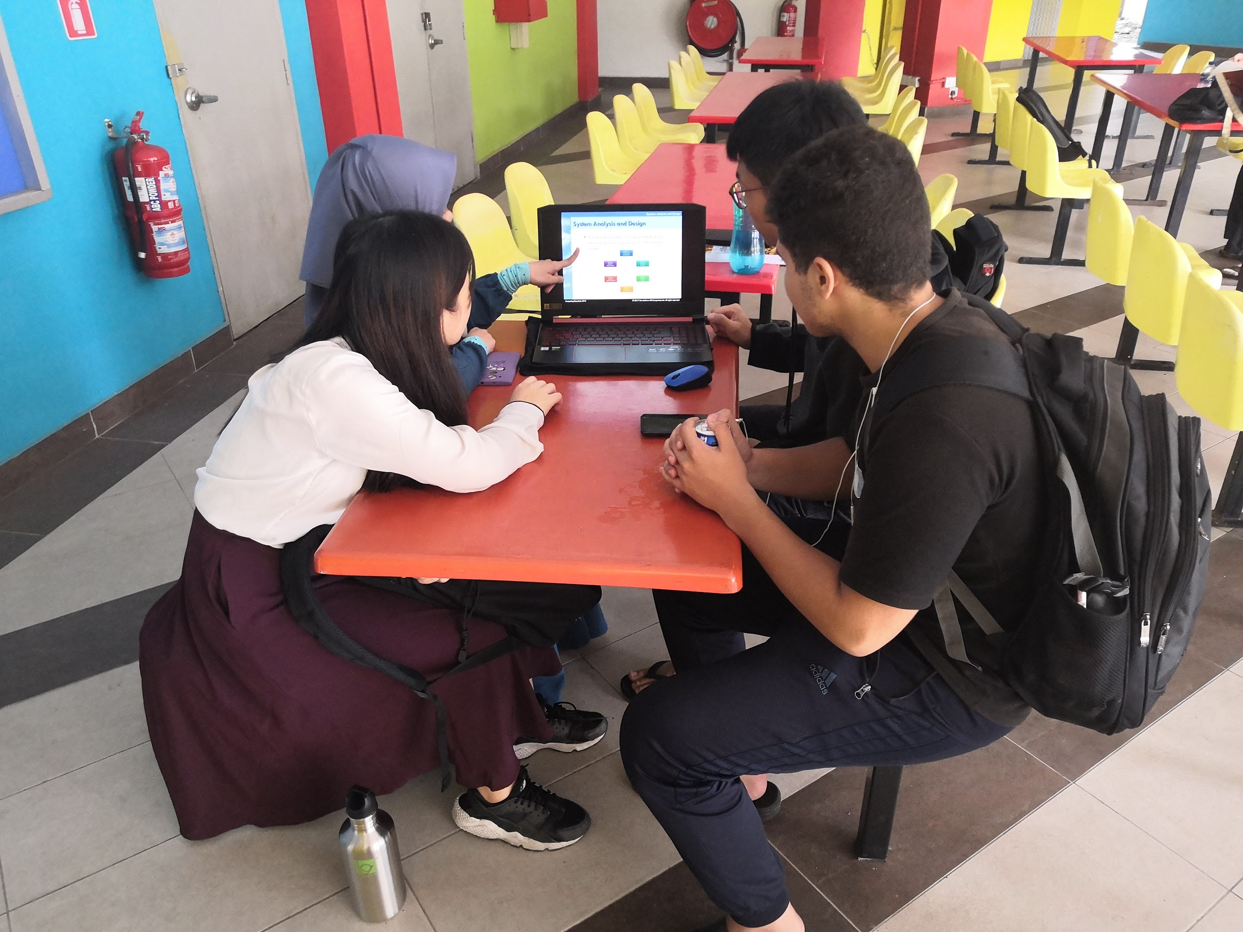
Figure 5b(i): Discussion about the possible questions that we were going to ask
Goh Jo Ey was assigned to interview a project manager, Wan Nur Atiqah was assigned to interview a programmer while Zaimi Mohamed was assigned to interview a user.
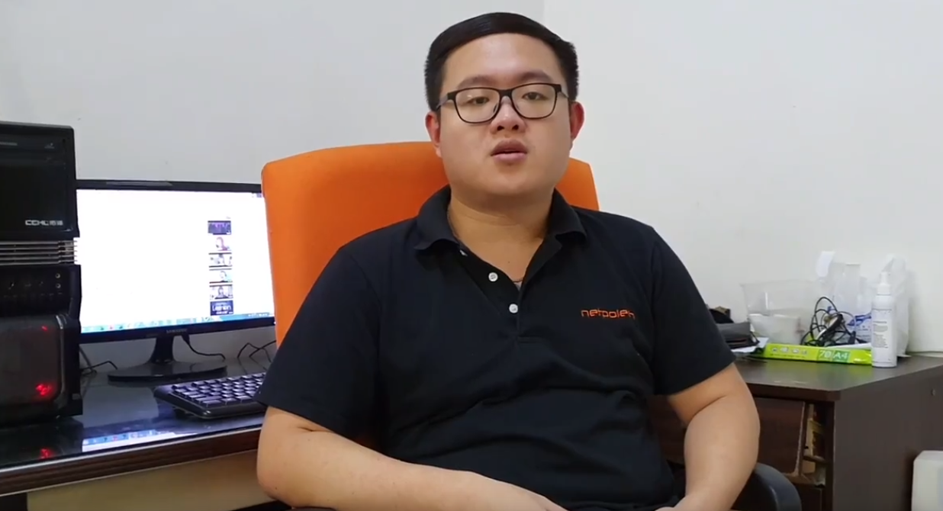
Figure 5b(i): The interview of project manager
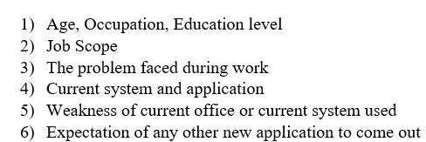
Figure 5b(i): A list of the possible questions that we were going to ask the project manager
The project manager that we interviewed was Goh Wei Ming. He studied computer science major in network and information security and graduated from UTHM. He is 25 years old and currently working as a project manager in a network and security company. His job scope is to manage projects (coordinate with clients, report the progress to the clients, check the programmers progress) and make sure the project runs smoothly. He is using Office 365 and email tools to manage his work. He found out that he needs to run a lot of software at the same time to complete his project and also needed to contact the clients and programmers one by one. All these processes wasted a lot of his time. He hopes that there is an application launching which can help him to connect all tasks together in a project.
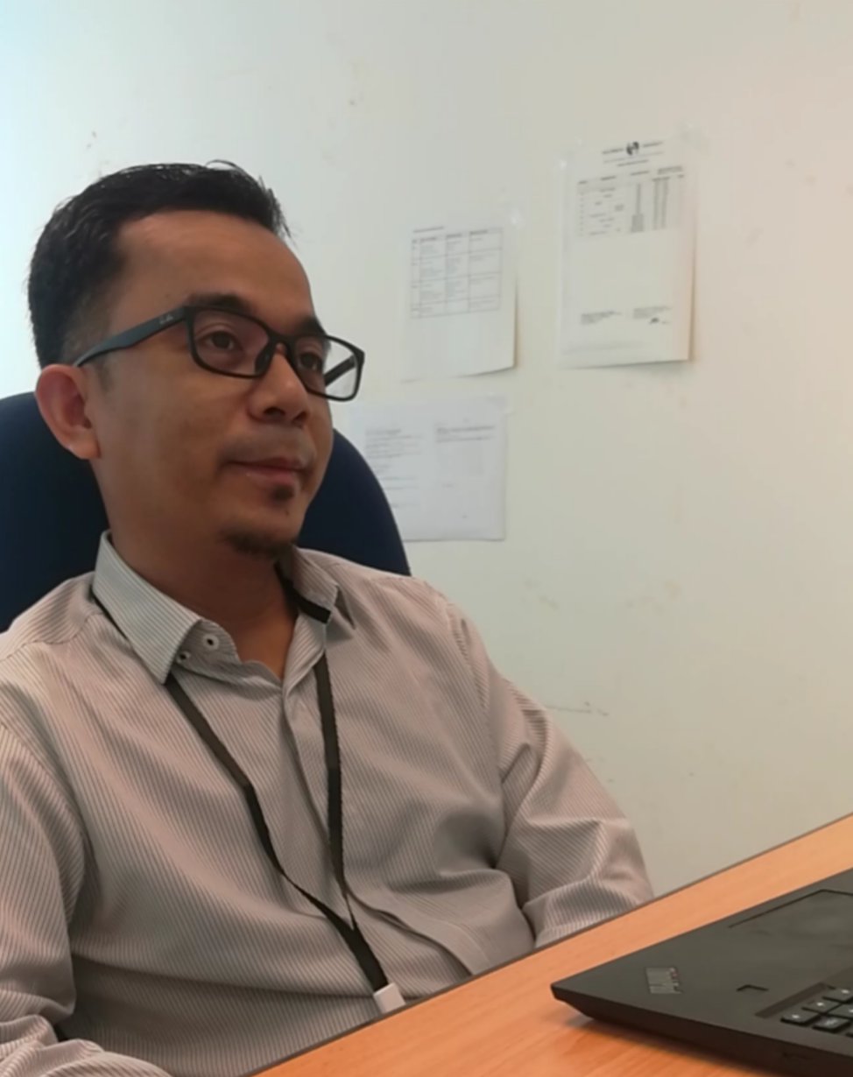
Figure 5b(i): The programmer that we interviewed

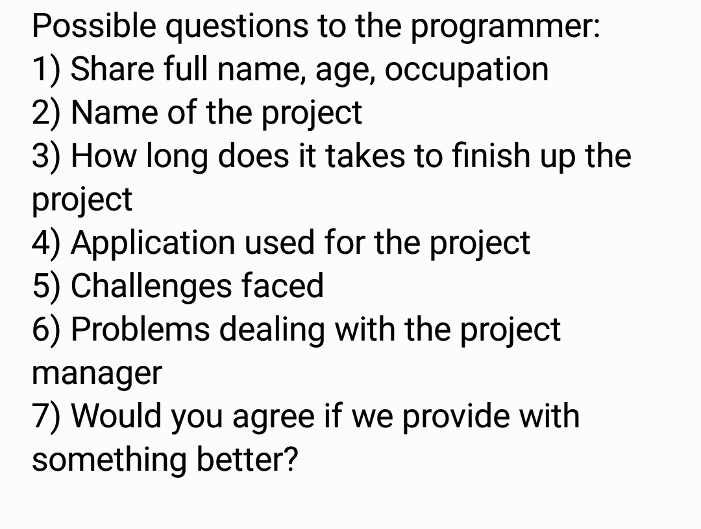
Figure 5b(i): A list of the possible questions that we were going to ask the programmer
The programmer that we interviewed was Junaidi bin Abdullah. He is 42 years old and currently working as a senior lecturer in Multimedia University, Cyberjaya. He did a project before named “Developing Speech Module” and it was dedicated to the Linguaphone company. He used JavaScript application for the project and managed to finish it up for about 6 months. JavaScript is a web-based application which it is easier for him to make the program since the speech module would be on the website. The key challenges that he faced were debugging problems and finding the right tools for the speech module plus to be integrated into web-based. Thus, help from other programmers in finding the solutions is required. In terms of dealing with the manager, it was not a problem for him because he could easily communicate with the manager through WhatsApp and did a few meetings. Tracing his conversation with the manger through WhatsApp was hard so he said that anything that he had problems to discuss in WhatsApp, they will conduct a meeting. He had no problem in agreeing if there was a more innovative way to connect between only him and the project manager.
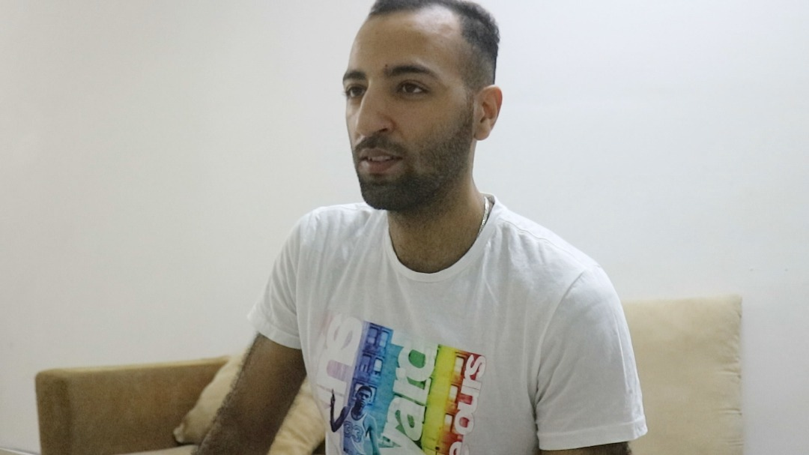
Figure 5b (i): The interview of a client or a user of the system
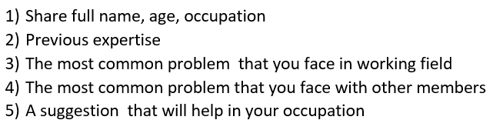
Figure 5b (i): A list of the possible questions that we were going to ask the user
The user or client we interviewed is an MBA student and a business owner, Bennaidja Sofiane, 25 years old second master student in UTM. In his previous years of working in the business field, he faced a lot of problems that can be summarized into the communication between him and most of the programmers he worked with before. One of the main points that he highlighted, in the industrial field, it is almost impossible to keep up with every single side involved in making the product itself. On top of that, sometimes it is hard to manage a meeting so that they can find out about the progress of the project. Therefore, he stated that it would be great to have an application which could help him with the communication of each side and also to manage meeting for any of the projects.

ii. Define: the list of define
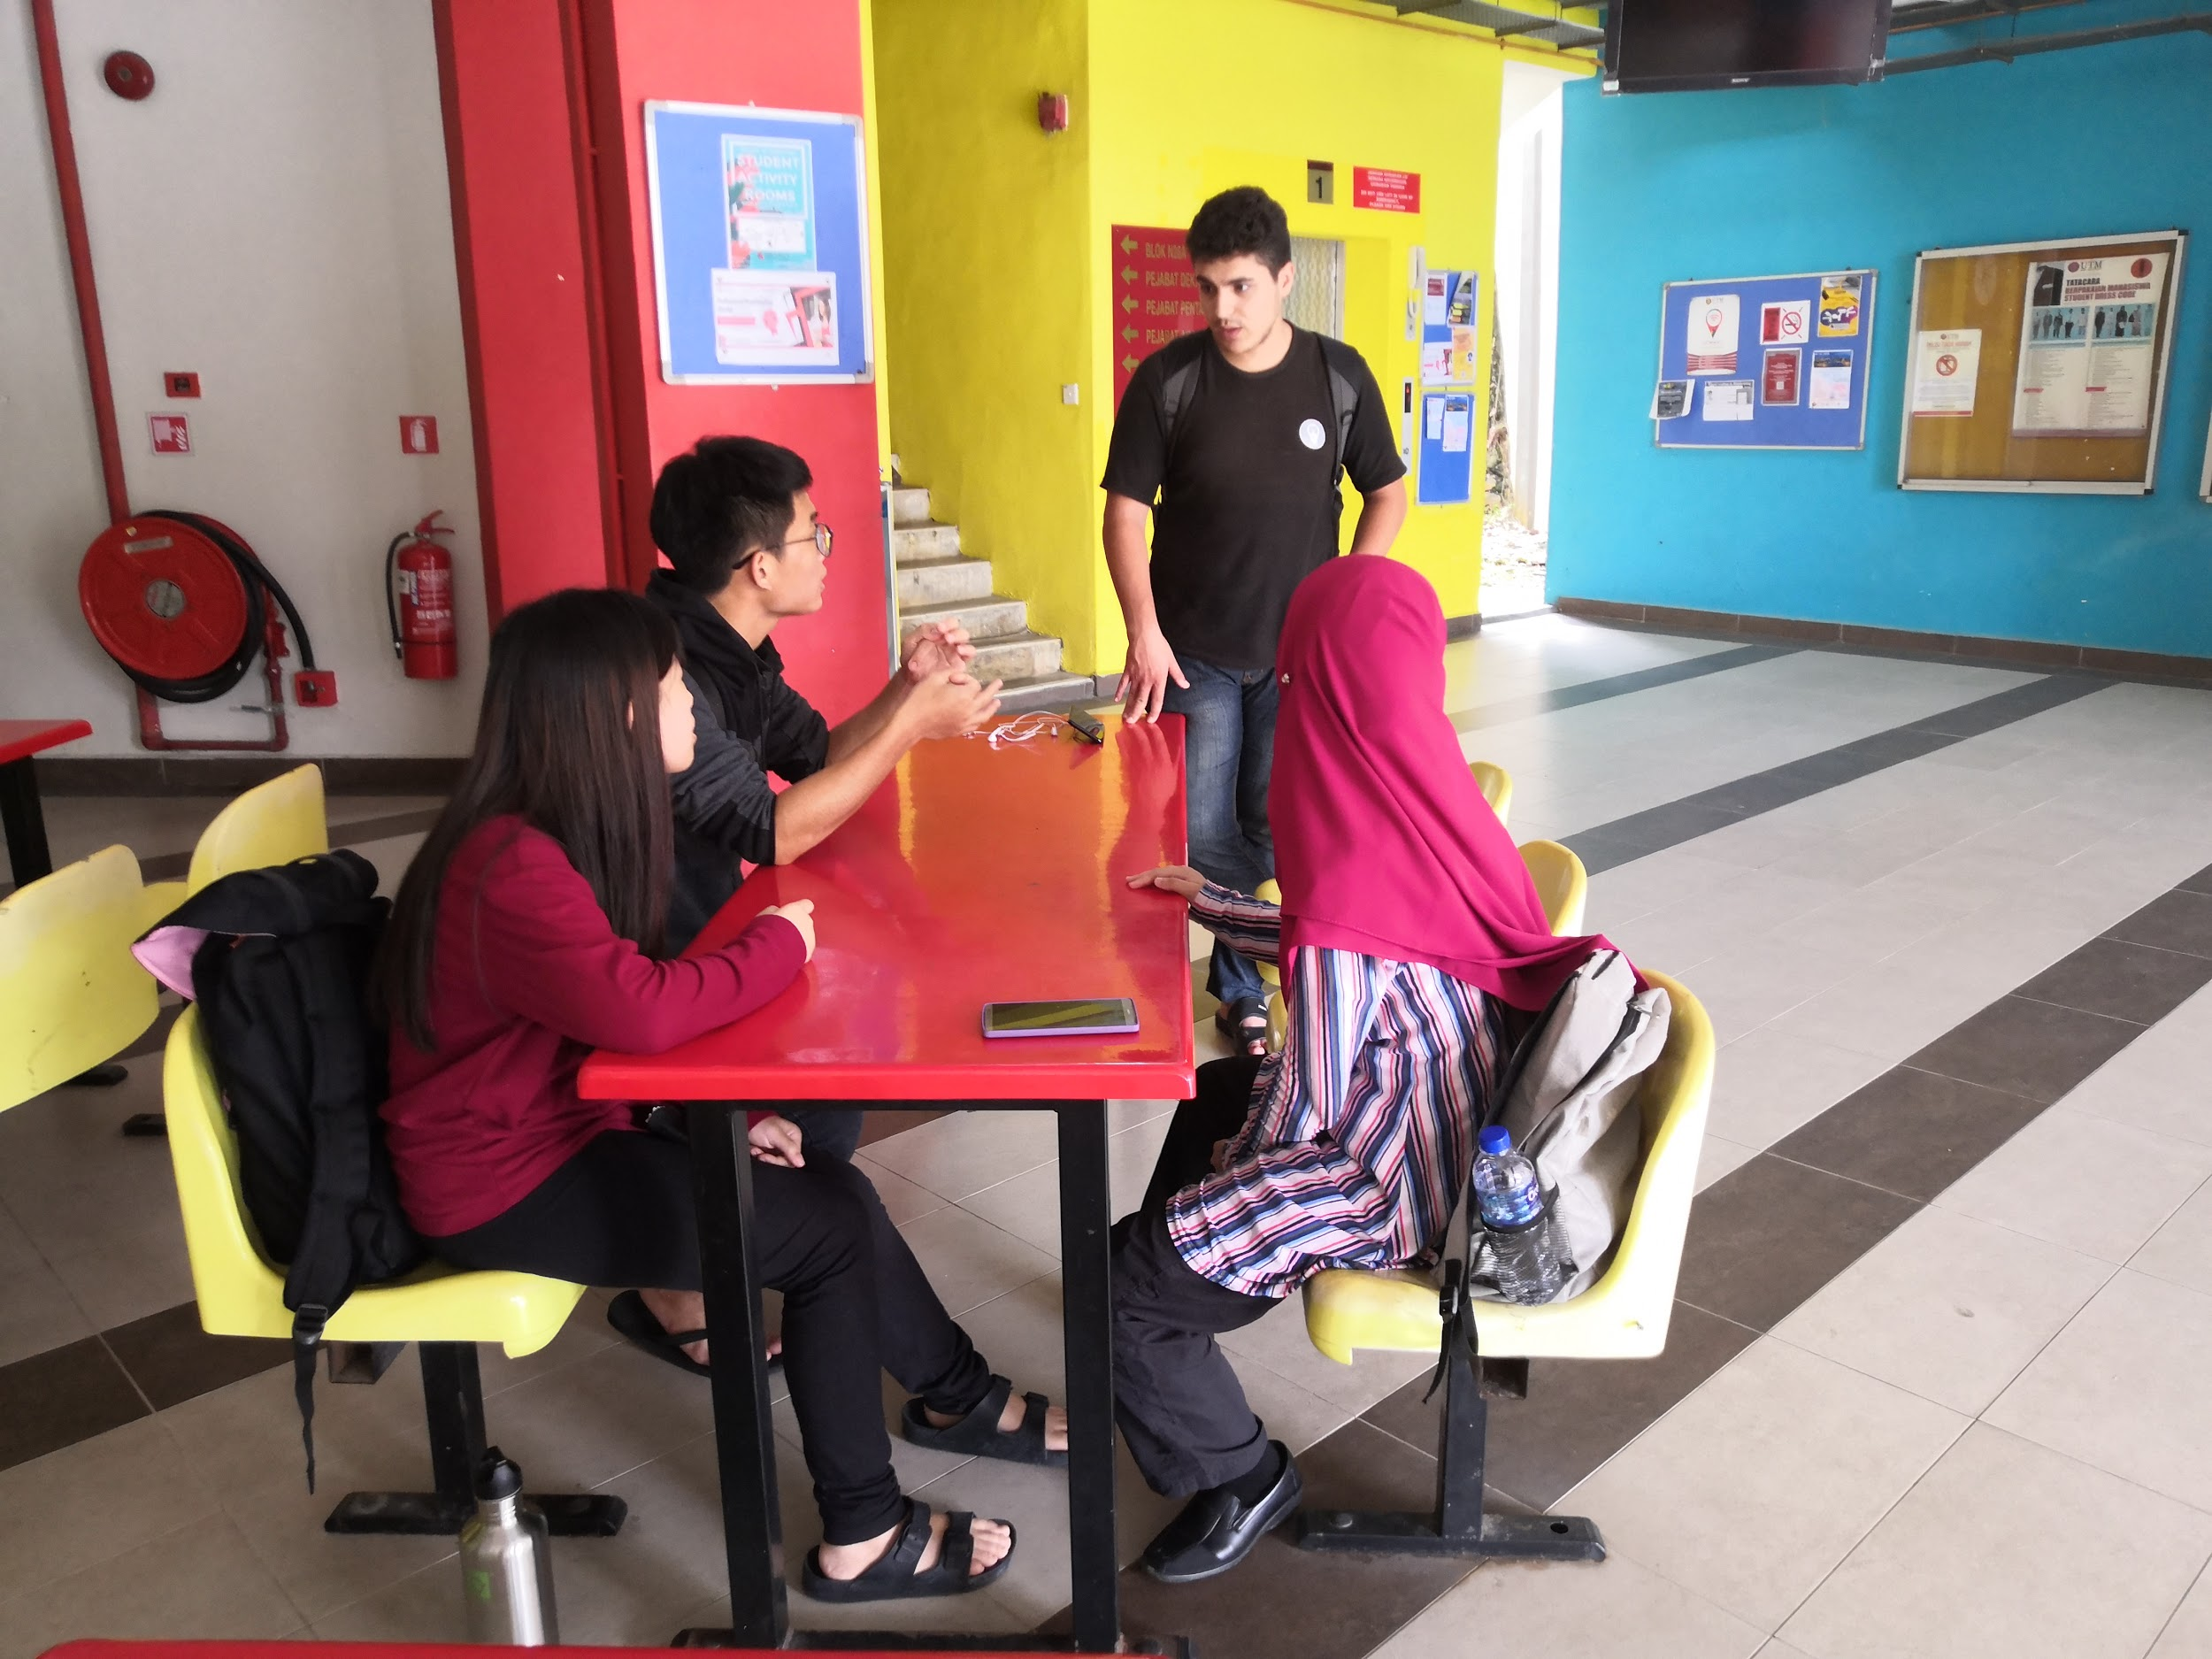
Figure 5b(ii): Discussion about the problems that the interviewees have faced
From the empathy process, we have successfully identified the core and common problems for all three sides (programmer, project manager and client).
The first common problem will be communication between these three sides. For the project manager, it requires him/her to contact or communicate with the client and programmer separately using different interfaces or applications which might cause confusing and complex interpretation of the message when it comes to handling different types of projects at the same time. The programmer might find it difficult to connect or contact the project manager or even contact other programmers who are in the same project.
Secondly, it is hard for all sides to trace the progress of the project. A project might have more than one programmer. It will be hard for the project manager and programmer to trace the progress for each programmer and it might cause delay on the project. The client also needs to trace the progress of the project as well, but the applications now hardly have the interface or the function to do so.
Lastly, all of them need to run different and many types of applications for a project. As different types of applications have its own functions, the project manager needs to run a lot of applications at the same time in order to keep track of the project, communicate with the programmers and client and also to trace his/her other projects. It is the same for programmers, to run different types of applications in order to complete, synchronize and check their tasks in the project.

iii. Ideate: Brainstorm process
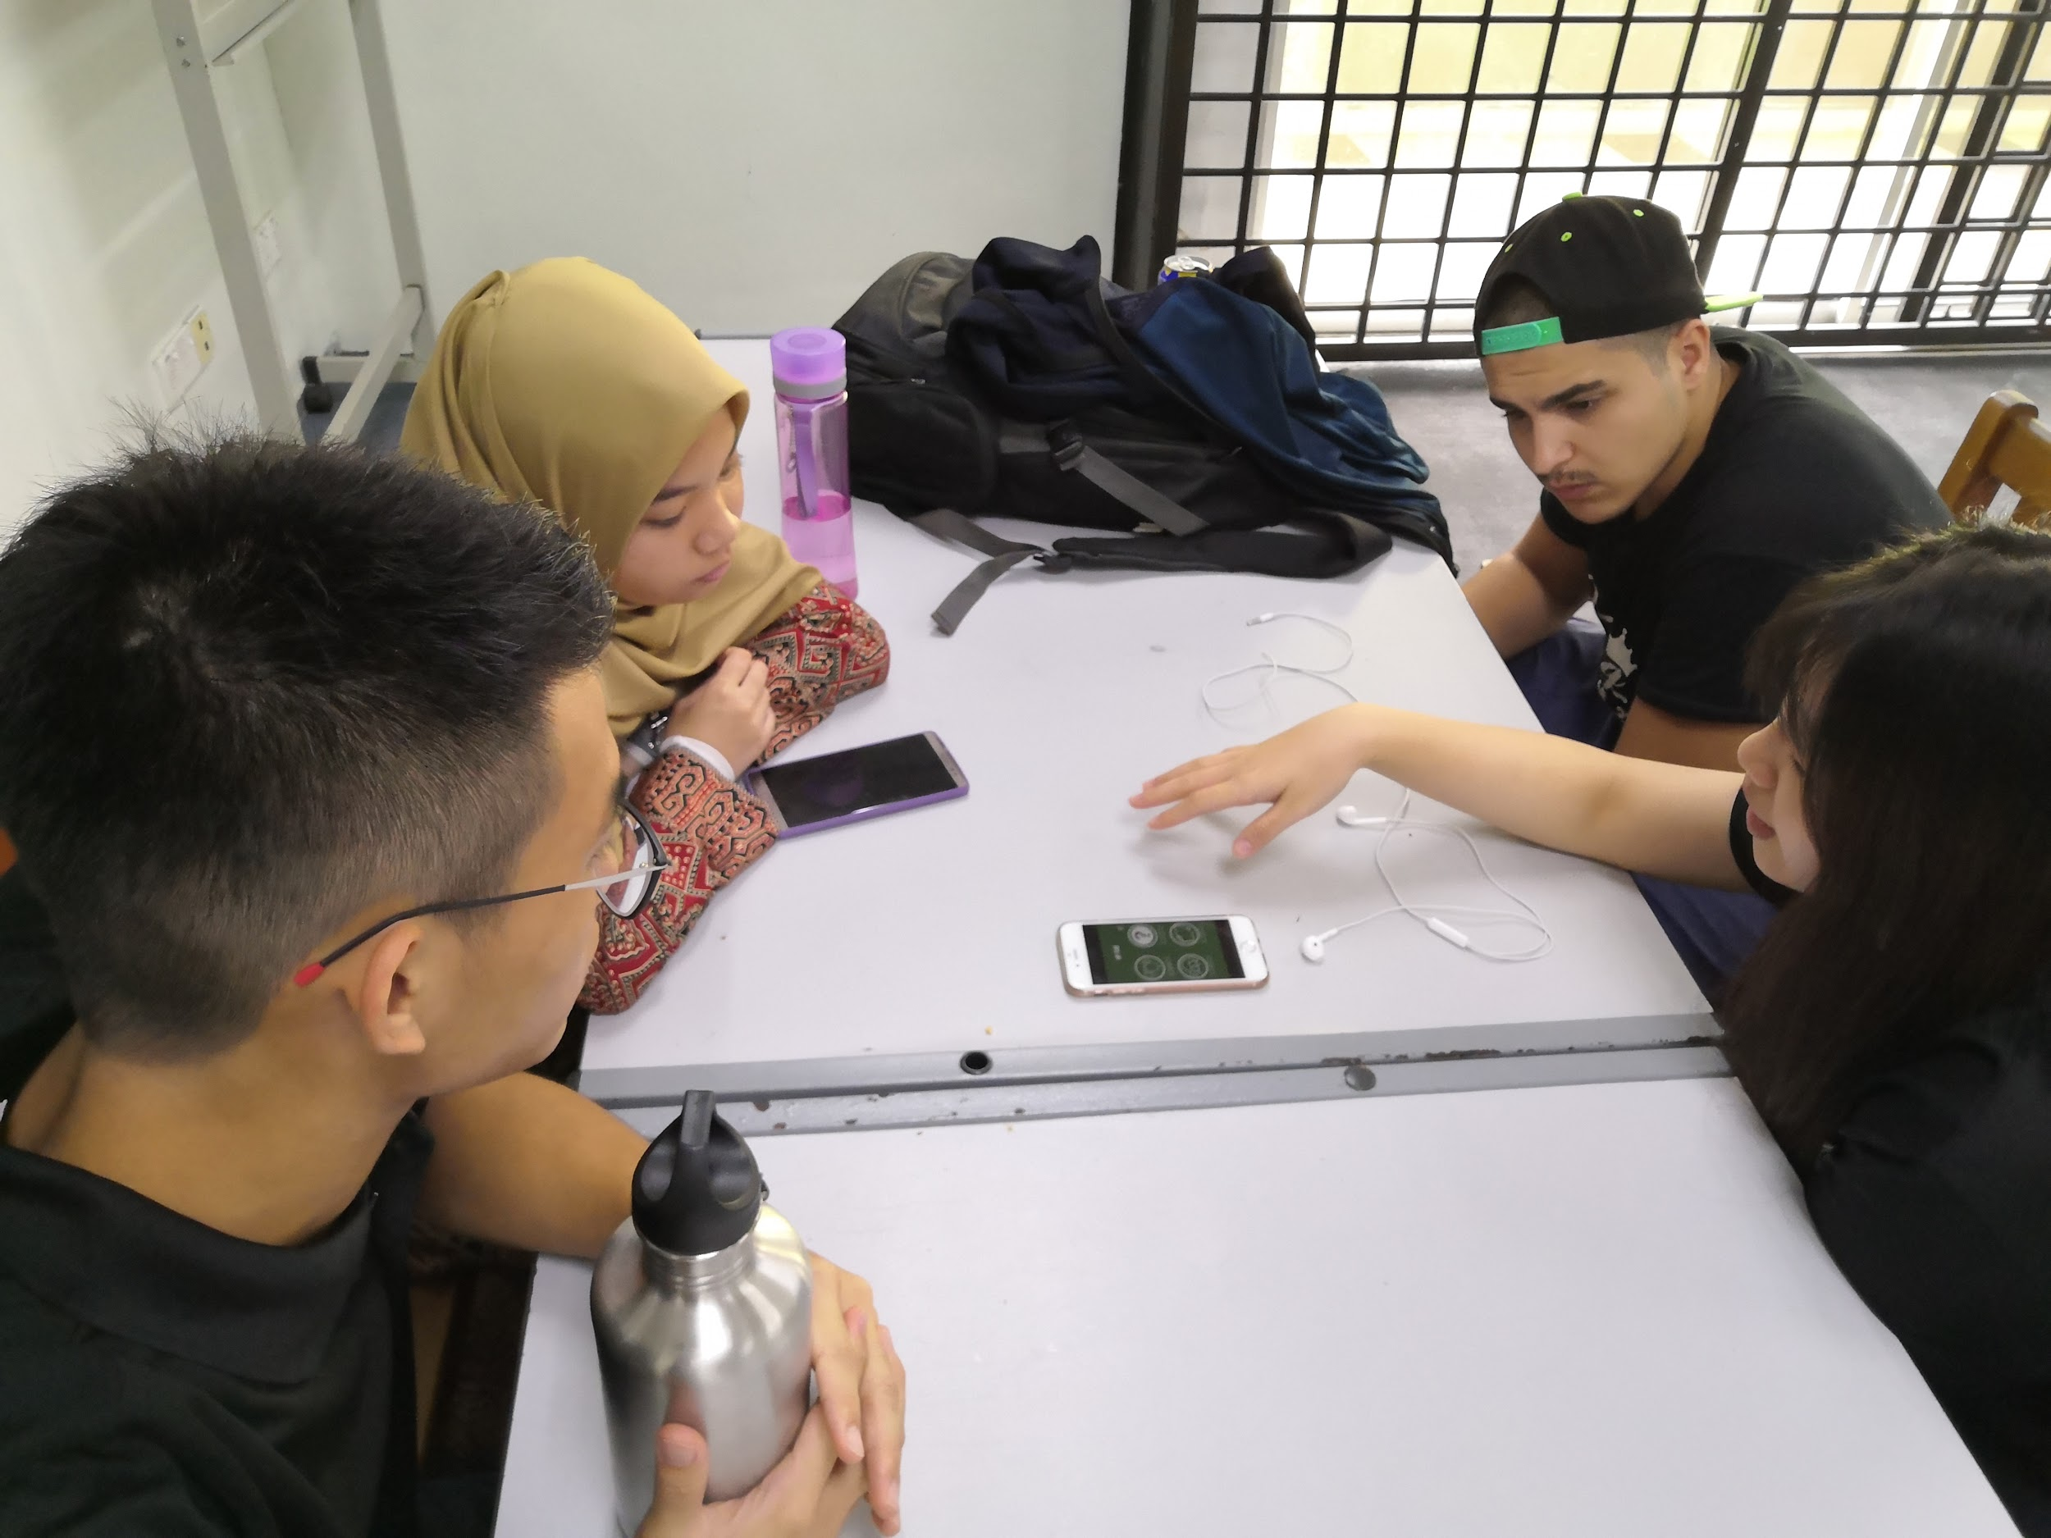
Figure 5b(iii): Discussion about the possible solutions for all the problems faced by the interviewees
We can identify the common problems for the project manager, programmer and the client are difficulties in communicating, tracing and tracking the progress and also need to run a lot of different applications or programs in order to ensure the project is running smoothly for different aspects. Therefore, after analysing the interviews, we have come out with multiple solutions. The first solution will be a forum for programmers to connect and communicate with each other in solving a program. The second solution will be a template for the common problems and solutions in programming so that they do not have to repeatedly write the same part of the program for the same function. The last solution will be to design or create a new application which has multiple functions in order to ease the overall progress of the project. After asking opinion from our lecturer, we have decided to take the last solution to develop as our prototype since the idea itself is more well-rounded and can benefit all phases for system analysis and design process.

iv. Prototype: How the prototype is developed?
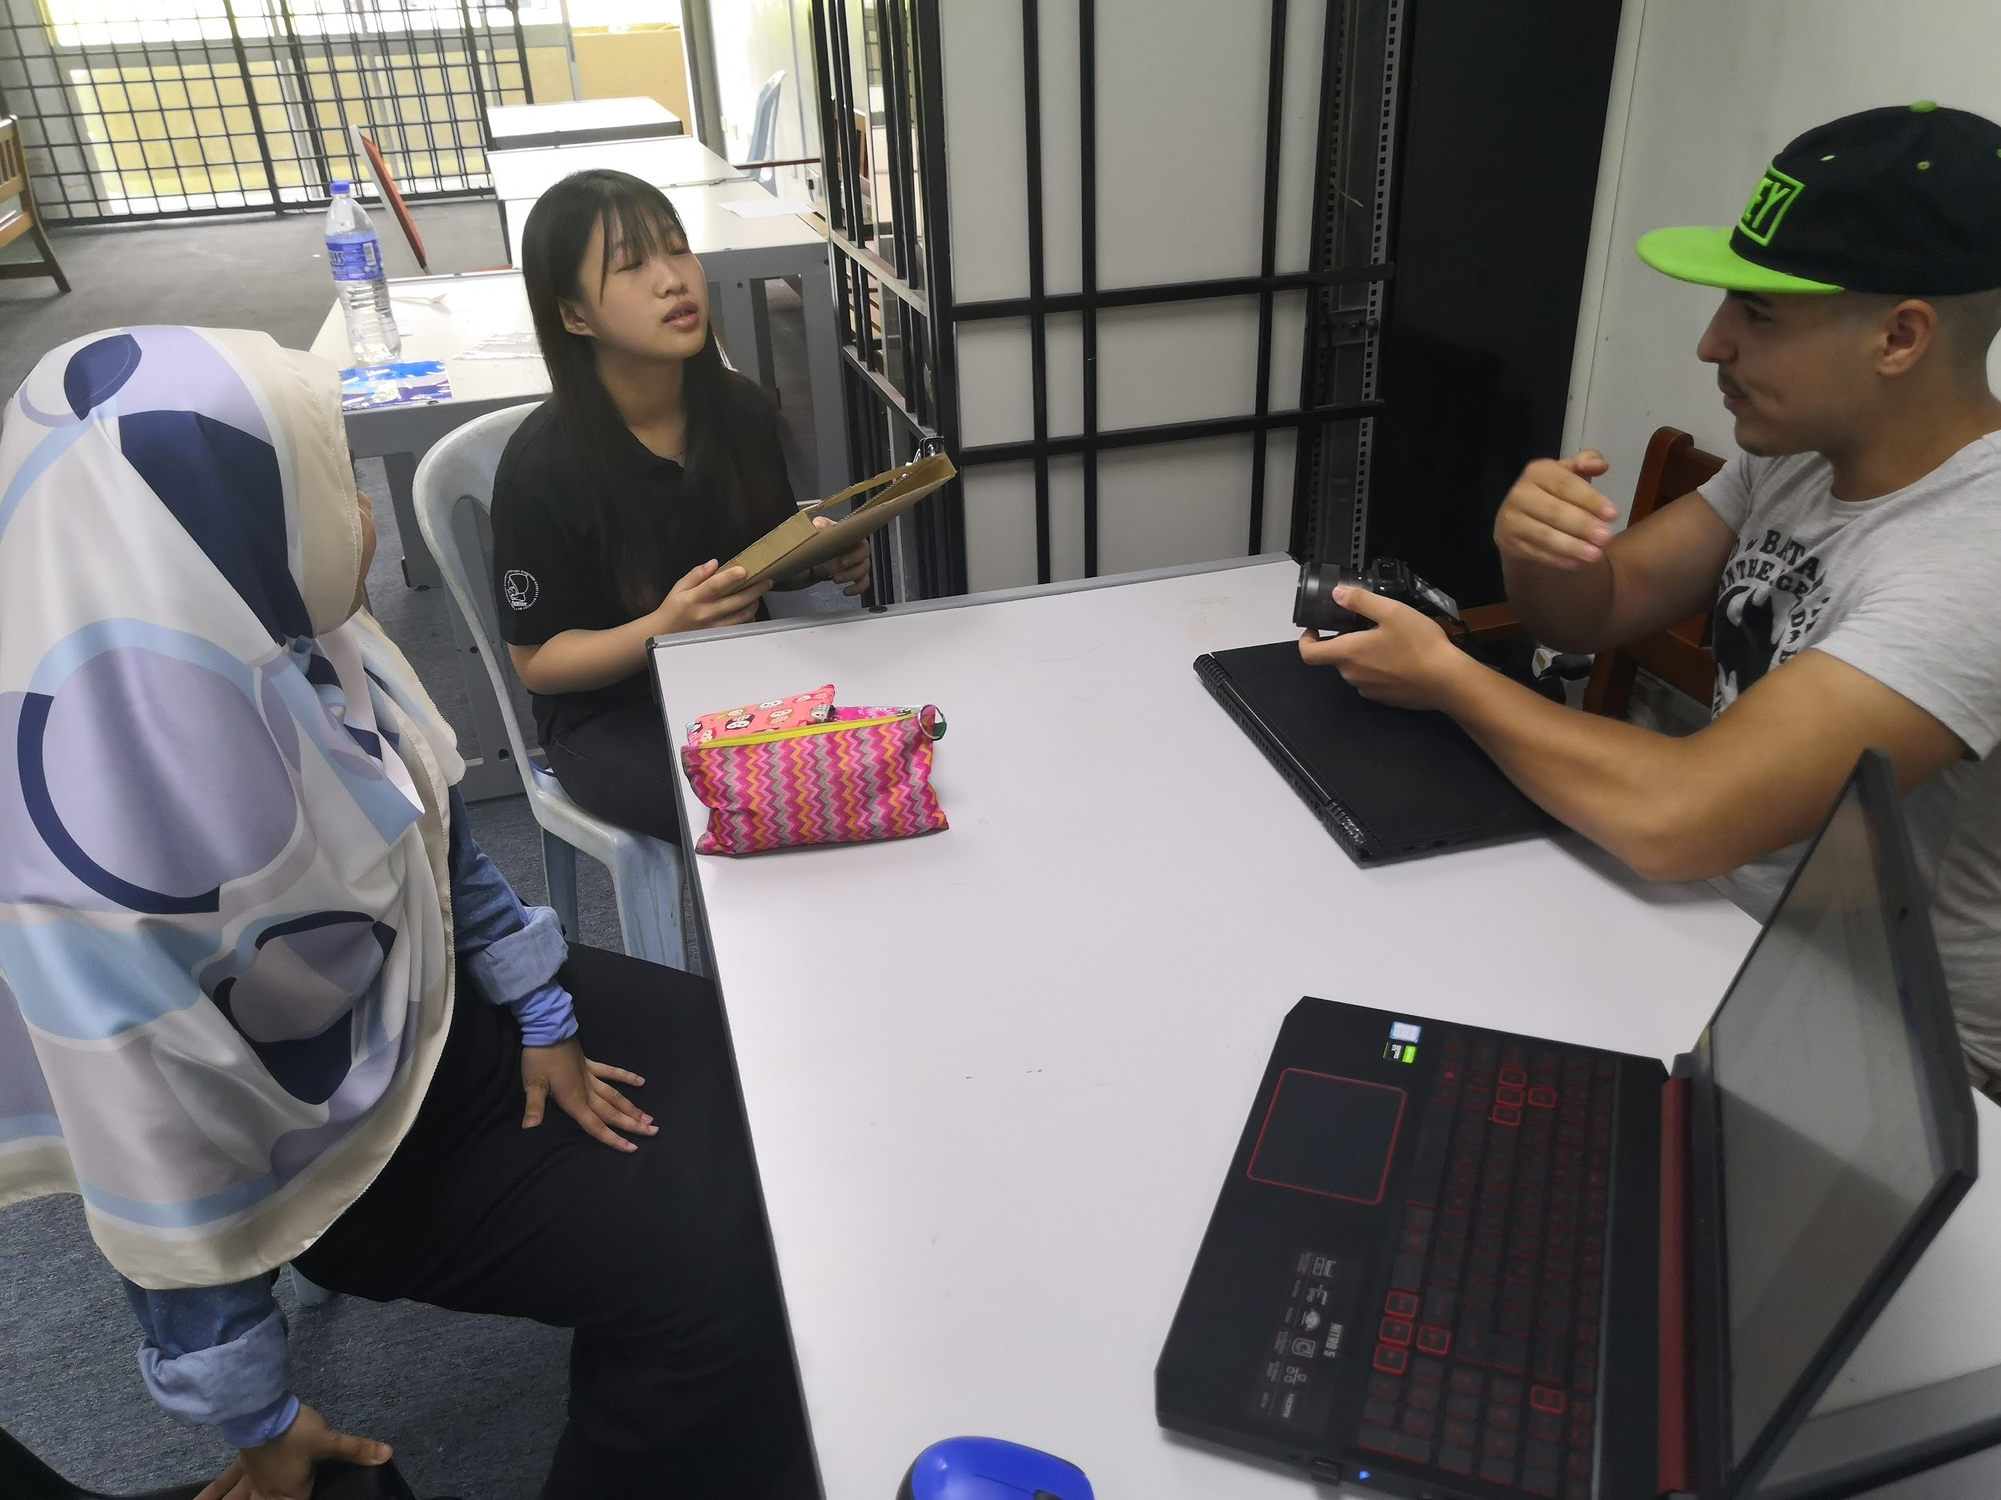
Figure 5b(iv): Discussion on how to make the prototype
The idea for the paper prototype is to make a tablet or laptop screen in order to display the interface or functions of the application. Cardboards were used to make the frame of a tablet and leaving a space in between to display the interfaces of the application. Hard cardboards were used to print out different interfaces of the applications and will be inserted into the space in between the frame to display as an interface of the application.
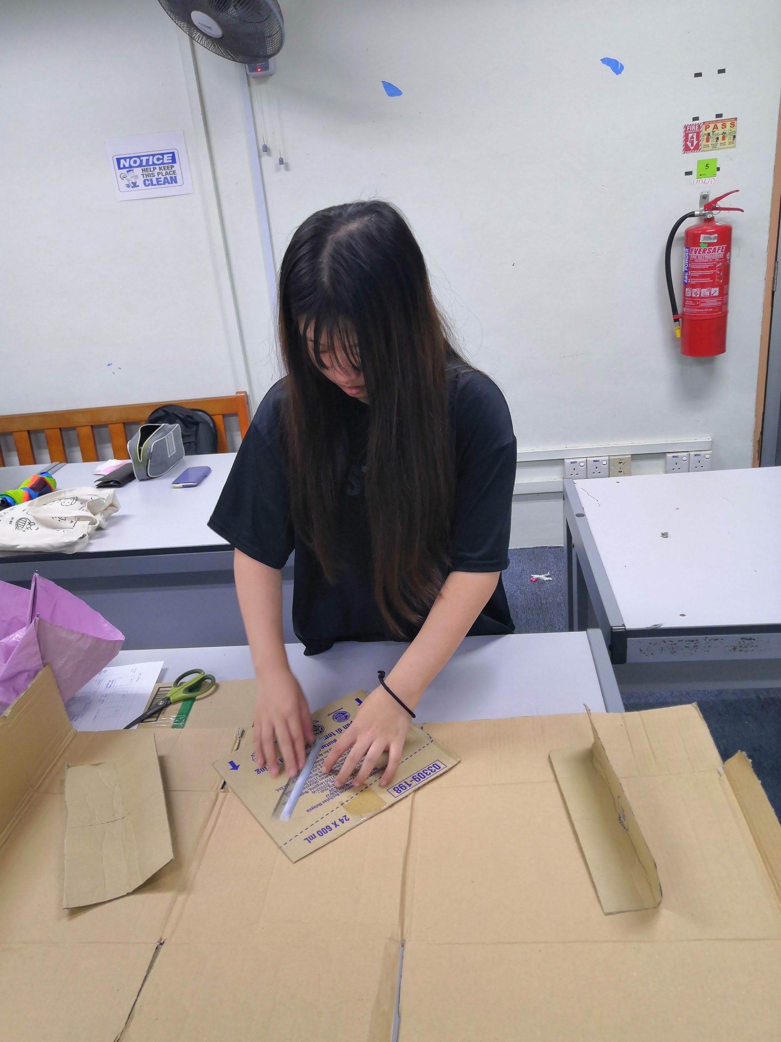
Figure 5b (iv): The making of paper prototype
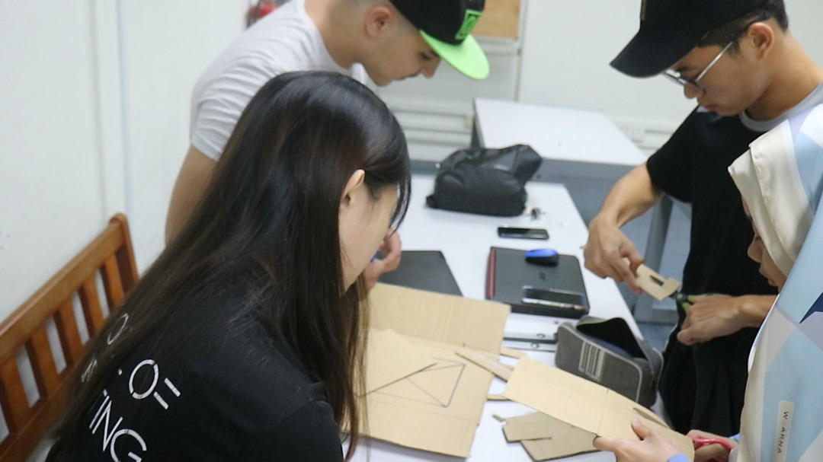
Figure 5b (iv): The making of paper prototype
Figure 5b (iv): Paper prototype of the tablet and interfaces of application

v. Test: Test the prototype to the user
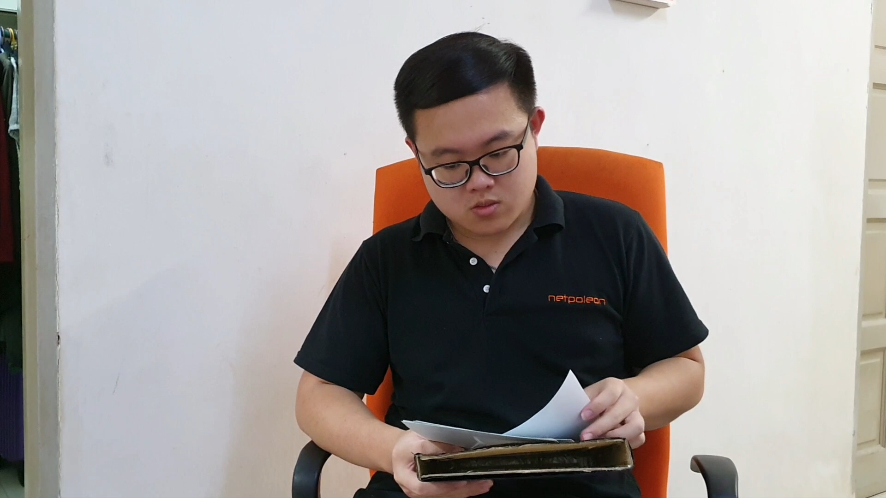
Figure 5b (v): The project manager viewing and giving an opinion on the prototype
Figure 5b (v): The client viewing the paper prototype
The user is quite satisfied with the prototype as the user stated that it does save time and make the flow of the project better and easier for all three sides of the project. However, the user gave some suggestions to improve the prototype such as: first, make our application to have more privacy for users. The user can set permission to decide and allow who can view their timetables. Secondly, to have an alarm system in our application. The alarm system can be set by the user to alert them on some specific task. Last suggestion will be to add in the function of video call meeting as face-to-face communication is more comfortable and direct.
6. Reflections:
a. What is your goal/dream with regard to your course/ program?
Computer graphic designer, game developer or a multimedia programmer will be the answer to the goal and dream of all of our group members. All these careers that we dreamt to be of are our main motivation and reason for us to select this course or program as our choice in the course selection for university.

b. How does this design thinking impact on your goal/ dream with regard to your program?
This design thinking project had helped us to develop our critical and creative thinking skills. As a future graphic and multimedia designer or programmer, we need to establish not only our programming skills but also our way of thinking in order to solve problems creatively and critically. It is crucial for us to develop this skill as it will be very helpful for our future career as a programmer needs such skills in order to design a solution to solve a problem by using coding. Other than that, we can also learn to see the perspective from the different side when designing a solution or solving a problem. This helps us in making a better consideration and decision for a suitable solution that we plan to execute. We also understand about the flow or methodology in solving or designing an invention or solution. All the phases in design thinking can help to create a better product or solution. All these enable us to develop and learn about the attributes which we need to acquire and take note on the process of designing and creating a new invention or solution which we can imply in our future dream career in order to make our career better and successful.

c. What is the action/ improvement /plan necessary for you to improve your potential in the industry?
We as an undergraduate, need to acquire as many soft skills or thinking skills as possible other than just knowledge, as there are a lot of aspects that need to be considered when making a decision, or when planning for a solution in our future career. Thus, by joining more activities, workshops and doing more projects, we can learn and establish more and more skills which surely will help us to make our future career more successful and better. This helps to increase our potential as we can develop ourselves not just within a certain range or area in the industry, but also in other types of related industries with good skills in order to achieve more and gain more experience and knowledge in the future.

7. The task for each member

Members | Task
Chai Ming Choy | - Ensure overall project runs smoothly for video, report and prototype  - Report making  - Presentation slide making
Wan Nur Atiqah binti Junaidi | - Interview for the programmer  - Report making  - Presentation slide making
Goh Jo Ey | - Interview for project manager  - Making prototype  - Report making  - Presentation slide making
Zaimi Mohamed | - Interview for user  - Editing video  - Report making
All | - Check overall report, video and prototype  - Brainstorm for ideas  - Presentation

8.Reference

- The Interaction Design Foundation. (2019). What is Design Thinking and Why Is It So Popular?. [online] Available at: https://www.interaction-design.org/literature/article/what-is-design-thinking-and-why-is-it-so-popular [Accessed 30 Oct. 2019].
- tutorialspoint.com. (2019). System Analysis and Design - Overview - Tutorialspoint. [online] Available at: https://www.tutorialspoint.com/system_analysis_and_design/system_analysis_and_design_overview.htm
[Accessed 5 Nov. 2019].
- O'Leary, T., O'Leary, L. and O'Leary, D. (n.d.). Computing essentials 2015. New York: MC GRAW HILL Education, pp.305.

