ExCEL Mini Report
Activity: Fundraising Carnival X Hackathon

Name: LIM ZENG KAI
Matric No: A20EC0068
Programme: Bachelor of Computer Science (Computer Networks and
Security)
Academic Advisor: Dr. Muhalim Bin Mohamed Amin

1. Activities Information
Date: 20 May 2022 to 27 May 2022
Venue: Webex
Organizer: PERSAKA UTM collaborated with UTM CyberX

2. Graduate Attributes
  - Leadership and teamworking skills
  - Communication skills
  - Thinking skills
  - Adaptability

3. Position/Role
My role in this program is a committee

4. Mini Report
The reason why I entered this program is that I get the invitation from my PERSAKA member and I also like to join this kind of event because it can help me to develop my skills.
The graduate attributes that are focused on communication skills, thinking skills, leadership and teamworking skills and adaptability. In this event I work in the multimedia department, I have to work with another group member since we need to separate the work among us to let the events work smoothly. For example, when I created a poster and I need to ask for all the detail from another department member. Therefore, I also need to communicate with them to discuss which detail is more suitable used in the poster. Besides, I also need to think about how to solve the problem. For example, my event director asks for my help to conduct the Webex meeting since the people in charge of Webex are not free during that time and my director knows I have some experience on handle all the technical things.
This program is held for 7 days and the first 5 days are run for the hackathon events and the last two days are run for the fundraising carnival. For the hackathon, we give the CyberX UTM to handle for the speech and the competition which is Capture The Flag (CTF) and we have two speech during the fundraising carnival.

5. Self-reflection
The impact of the activities on the development of the students’ Graduate Attributes is strengthened my leadership and teamwork skills because I have to work with other units to ensure all the posters and certificates can be completed in time. My communication skills have increased as a result of having to interact effectively with other committee members to understand the issues we have and how to address them. My thinking skill is developed as I need to always think about how the design the poster and certificate. My adaptability skills are developed as I need to adapt to any unexpected incident that will occur during the events since I had been asking to help with the technical issue.
Self-strength/ advantage toward the activities is that I learn how to communicate and design all the poster which is related to the event. Besides, I also learn how to handle the problem since many unexpected incidents occur. For example, the people who are in charge of technical things suddenly tell us he is not free and we only have one day for the event so I use what I learn in the previous event to handle it and make the event run successfully.
My challenge in the program in I didn’t have experience in designing the certificate so I have to find all certificates I get from the other event. Besides, I also find some certificate designs on the internet to make my certificate design for the program. After that, I also need to know all the event procedures short time since I had been told to help with a technical issue and I don’t the procedure. Therefore, I have to use my experience for handling the event.

6. Photo of Proof
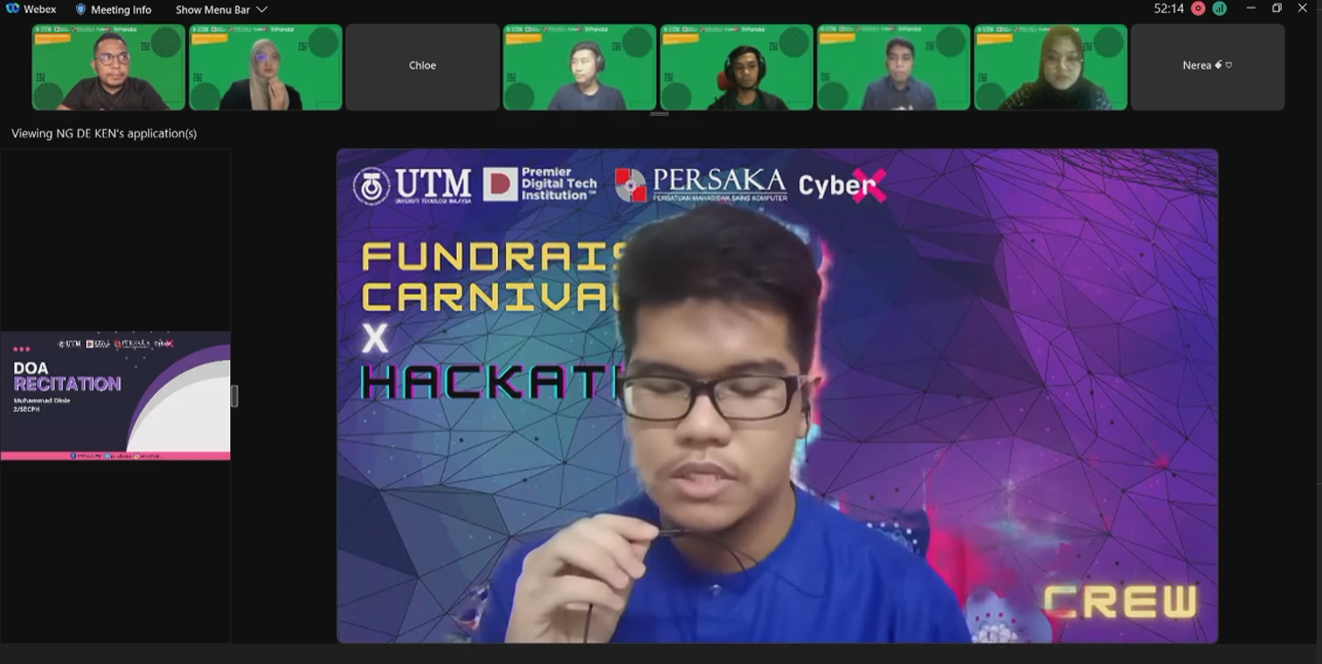
Figure 1: fundraising carnival

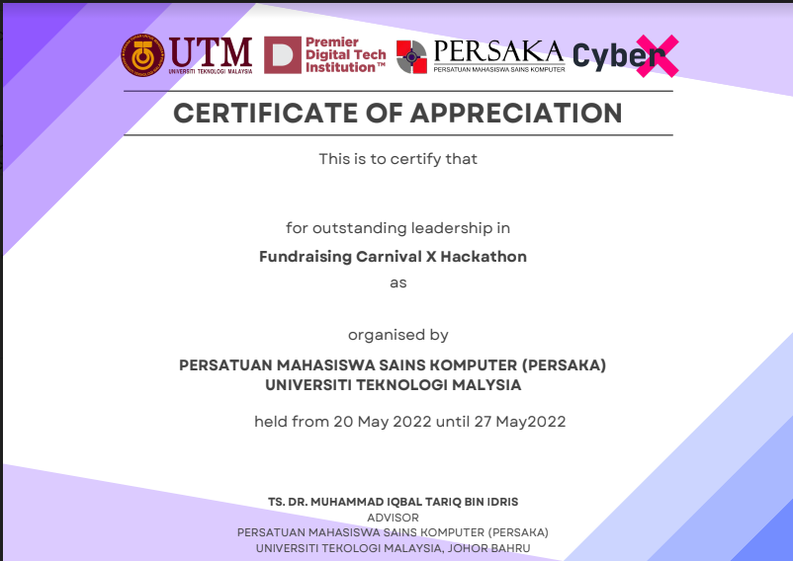
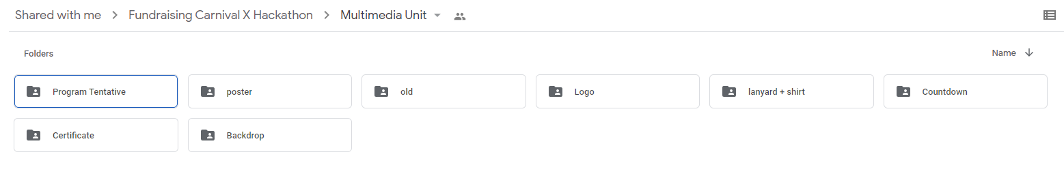
Figure 2: Multimedia folder

Figure 3: My certificate design (Empty certificate)

