UNIVERSITI TEKNOLOGI MALAYSIA
SCHOOL OF COMPUTING
SESSION 2019/2020 SEMESTER 2

COURSE CODE
SCSV 2113 – Human Computer Interaction
LECTURE’S NAME
Dr Aida Ali
T1-INDIVIDUAL ASSIGNMENT

TITLE
Persuasive Technologies: Foodpanda

No | Name | Metric Number
1 | LEE SZE YUAN | A19EC0068
2 | HAM JING YI | A19EC0048
3 | MOHAMAD AMIN HAZEEQ BIN HISHAM | A19EC0087
4 | NUR IRDEENA BINTI CHE MOHAMAD ZULKEPLI | A19EC0130
5 | SHASITHER A/L SANDRAN | A19EC0160

Contents
(A) Brief Description on The Purpose 3
(B) Specific Task/Feature of Foodpanda (1) 5
(B) Specific Task/Feature of Foodpanda (2) 8
(C)Video 10
(D) Fail Feature 11
Reference 14

(A) Brief Description on The Purpose
FIGURE 1: Foodpanda Logo
The persuasive technology we have chosen that contributes to one of the 17 Sustainable Development Goals is Foodpanda application. This Foodpanda fulfils the 8th sustainable development goal which is decent work and economic growth. Foodpanda is an online food delivery application that is available in 12 countries. However, in some countries like the Middle East in Africa and Latin American, it is called “Hello Food”. This application can be installed on smartphones and desktops so that it can be accessed easily. This service plays a crucial role in our life as it will send us the food that we order with just some clicks on the application and it will be delivered to our house as soon as possible. It is easy and comfortable to use. Once we open the application, the first thing we will see is a promotion code, then comes with the various categories of restaurants and their menus. The Foodpanda company offers pre-orders, discount codes and vouchers for all users. There are a lot of strategies to attract more users and grab their attention which we will discuss later. We can say that the company holds a really strong bond between the customers and the restaurants as it is a media for the customers to get food without driving around, wasting their time and energy walking around.
Based on the 8th sustainable development goal that is decent work and economic growth, the Foodpanda company provides many jobs opportunities for people. As we know, most of the jobs under this company are jobs on the road. It means that they need more riders to deliver the food. There are more youths working as gig workers nowadays in this growing gig economy. Gig economy workers from all over the world that work under Foodpanda will have a flexible working time, independent contract and they can access the worldwide market. This will grab many teenagers’ attention and they will sure go for it. All the riders can earn additional money based on the orders they delivered. For example, they are paid RM 4 per hour and additional RM 150 will be given if they have done 40 hours per week. On the other side, to start up a Foodpanda company, there must be various types of positions behind, this company also hires a lot of business intelligence analysts, vendor operations managers, city managers, social media managers and more. In Skudai, the riders, account managers, and business development executives are in high demand for Foodpanda.
Moreover, the Foodpanda will speed up the rise of the digital economy. Foodpanda really has done a good job on advertisements. This is because we can get a lot of discount code from the advertisements on Facebook, Youtube, Twitter, Instagram and other social media platforms. The company provides a lot of paths to let people remember this application, install it and use it. Normally, people nowadays are easily attracted by the discount given by Foodpanda and they will use it. Today, Foodpanda provides three types of payment methods which are cash on delivery, credit or debit card and online banking. The most important part is, Foodpanda could launch an e-wallet service for food delivery business in the upcoming years. Amongst the three methods, most of the people will choose the last two methods because they are safe, quick and easy. The users do not need to prepare cash and they can directly receive the food while carrying nothing if they choose online banking or card payment. When the users get used to this cashless method, they will prefer online ordering and buying as it is convenient. Users will use this digital method on various applications like Grab, Uber, Amazon, Shopee, Taobao and more. The nature characteristics of people is once they learn something new, and find it is good and useful, they will always use it. For example, users of Foodpanda will always use it for the food delivery after they first order the food. In addition, markets in this field will increase, income of merchants will grow, life qualities of people will be improved, and the digital economy will rise.

(B) Specific Task/Feature of Foodpanda (1)
Feature: Email notifications about ongoing offers
Target behaviour: To order meals using Foodpanda application
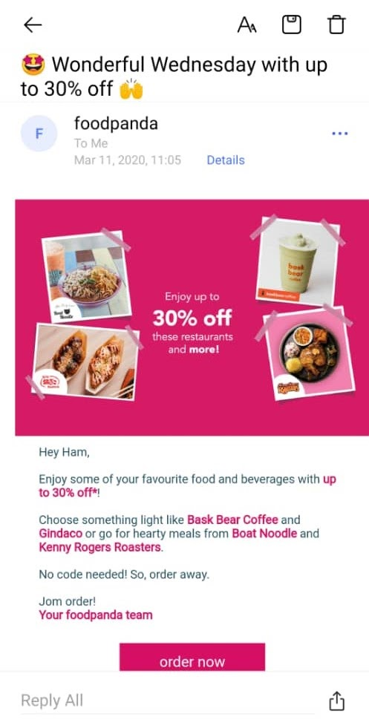
FIGURE 2: Image represent the Email Notification about Ongoing Offer
The target behaviour that is being focussed is to attract customers to order their meals using the Foodpanda app. One of the features to persuade users that can be found in the Foodpanda app is the email notifications about ongoing offers being sent to the users. This feature has a great ability to persuade users to order their meals through the Foodpanda application. The email notifications about ongoing offers makes it easier for the users to order their preferred food at their comfort and the food gets delivered at their doorsteps. Besides, these features also help the users to save time as they do not have to travel outside to get their food. In this way, they are also required to put out less physical effort. Apart from that, this feature is also great for those who do not have transport to go find food and for those short in time due to busy lifestyles. The app also informs the users the expected delivery time, which will eventually help the users to plan ahead and manage their time well. Adding to that, the food delivery comes with a very affordable delivery fee which is not more than RM5. The added advantage provided by the food delivery app, Foodpanda, in terms of convenience in time, money, and less physical effort will surely provide the ability for the users to order their meals using Foodpanda.

In terms of motivation, the email notifications feature simply can act as a pleasure motivator for the users in order to achieve the target behaviour. For instance, Foodpanda app sends timely notifications to its users mainly during the meals time of the day. Most of the notifications regarding latest promotions and offers of the day arrives during the lunch hour which is between 11am to 2pm and during dinner time from 6pm to 10pm. The motivation factor functions adaptively according to the customers' desire or needs. The well-timed notifications at the time of our greatest desire for meals certainly can motivate the users to order the meals using the Foodpanda app. On the other hand, there are also motivations in other forms such as hope whereby the notifications are able to convince the users that they will surely enjoy tasty meals by ordering through the Foodpanda application. Next, motivation can also be in the form of fear with the offers and promotions are valid only for a short period of time in order to reduce the time taken by the customers to think and act quickly before the offer ends. In total, there are various motivating factors that are found in the Foodpanda app in order for them to attract the customers to achieve the target behaviour.

In the aspect of trigger, the email notifications by Foodpanda app make use of several type of triggers mainly the Spark. This type of trigger usually is brought into play to the users at a moment when they can act. For example, in creating spark for persuasive experiences, the texts contained in the notification emails are highlighted accordingly on the keywords. Furthermore, the choice of attractive message lines that interacts with the users helps to attract the customer's attention while triggering them to perform the target behaviour. In addition to that, Foodpanda app also makes use of the Facilitator trigger type whereby the notification emails are included with hyperlinks such as "Order Now" icons which directly leads the users to the ordering page in the website. The simplicity in the process of ordering meals can be a major influence in convincing the users to execute the target behaviour which is to order meals using the Foodpanda app in this case. The persuasive design of the email notifications that focuses on increasing motivation, increasing the ability for the users through simplicity and well-defined triggering behaviour will greatly elevate the behaviour activation threshold which will then increase the chances for the user to perform the target behaviour.

(B) Specific Task/Feature of Foodpanda (2)
Feature: Advertisements popping up on the main page (when users open the Foodpanda application on their smart device).
Target behaviour: The advertisement usually has options to be chosen by the users which are “Miss Out” and “Order Now”.
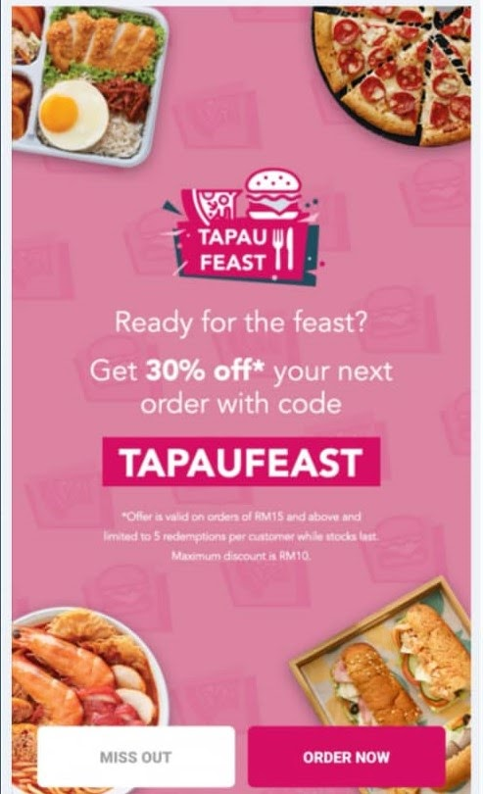
FIGURE 3: Image represent the Advertisement
Based on Fogg Behaviour Model, users would be motivated to click on “Order Now” option mainly because of the pain of feeling hungry and having an empty stomach during their free time, as they obviously will only open the Foodpanda application when they are not doing their work or outside office or lecture hours. Other than that, motivation might also come to users when they hope or expect to fulfil their cravings and satisfy their urge to eat some meals after long hours of working or studying. The thought of having to start the car and drive to any nearest restaurant that is probably located a few kilometres away from home and having to line up and wait for at least 20 minutes just to have a meal, will also drive users’ motivation to just order food online which is through Foodpanda. This is because by using Foodpanda, users’ do not have to waste their energy to get some food. An order on Foodpanda can be made only with a few clicks, and the application will notify the user if the food is ready or when the food has arrived at the user’s location, thus users can continue doing their work while waiting for their food, which would save a lot of time and energy. Other than that, users would also feel the fear of missing the discounts or promotions that are offered by Foodpanda, making them want to make orders on Foodpanda as soon as possible.

When users have adequate motivation to engage with the Foodpanda advertisements, this is when Foodpanda’s responsibility, which is to enable users to please their needs, comes into play. In terms of time element, it takes less than 2 seconds to click on one of the options on the advertisement which will bring users to the page where they can browse the food menus and make orders. Users also no longer have to take a lot of time to drive around and wait for the food at any restaurant. They can use the saved time finishing their work or tasks. In terms of money, clicking on the option costs no money at all and little to no physical effort as it is a norm or routine to tap or click on options in any smart applications nowadays. Compared to eating at a physical restaurant, more money must be spent to pay for their vehicle gas and sometimes, toll charges. This further explains how users would be able to fulfil the target behaviour as the tasks when using the Foodpanda application are free, easy and simple.

Last but not least, regarding the factor of trigger, videos and pictures showing variety types of mouth-watering food and beverages that Foodpanda offers that are shown on the advertisement would create a spark trigger to users. In addition, the use of bolded words with captivating colours would also work as a trigger factor for users, which then drive them stronger to click on the option and make orders. Next, the ease and simplicity of the target behaviour can actually function as a facilitator trigger for users. People love to perform a task as long as it is easy and not complicated. With just one action which is tapping on the “Order Now” option, users would already be directed to the page where they can then make orders of their needed or preferred meals.

(C)Video
We have posted the 2 videos that demonstrate features above on our youtube channel. The URL link for the short video are written below.
First feature: Email notifications about ongoing offers
https://youtu.be/GWVhLbwWCyQ

Second Feature: Advertisements popping up on the main page (when users open the Foodpanda application on their smart device).
https://youtu.be/r_4aCy57l_4

(D) Fail Feature
In persuasive technology, we often look at behavior as something that people cause to occur and behavior activation is usually the goal. But, there is another side to behavior change, such as preventing target behavior from happening. In our opinion, a feature that fails to persuade a target behavior on the Foodpanda application is some stores or restaurants in the app do not provide enough details of information including the images for each type of food they sell. This inconsistency will make the users feel frustrated and it will decrease the likeliness of users to perform the target behavior which is to order their food, as it would be hard to just imagine food that users might have not seen before or food that they have not heard about, for example in Figure 1 and 2 below.
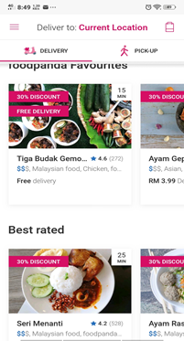
FIGURE 4: Image represent the restaurant only

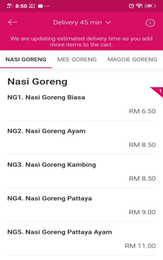
FIGURE 5: Some stores do not provide the images for each food and their description.

Why is this important to users? It is because when users look at the pictures of food, it will cause the users to be triggered and they would be incited to buy that food. Besides, users will also know the size of food that they choose to order and decide whether the portion is too small or too big or just nice for the price that they will be paying. The third factor in the FBM (Factor Behavior Model) is trigger. Without an appropriate trigger, users’ behavior will not occur even if both motivation and ability are high. Next, some of the stores do not use images specifically to each of the food types, as shown in Figure 3 below. Some of the images are just the same but with different names, and users would not be able to differentiate the types of food. This will make users feel doubtful and suspicious when they make an order from that company. This will also lower the trigger for users to execute the target behavior which is to make an order.

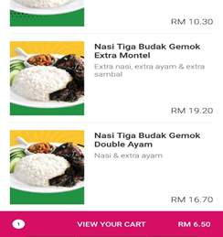
FIGURE 6: Using non-specific and confusing images.

According to motivation in FBM, this app lacks pleasure as there are only several stores that provide eye-catching and clear images with excellent descriptions about the food. Attractive food images are pleasurable, and it is one of the powerful motivators. People usually would respond to attractive moments and triggers to do the target behavior. When the motivation is low, triggers to perform target behavior will also not increase.
The only solution to the app is to advertise the stores that only fulfill the characteristics by using proper images based on type of food with the food descriptions clearly stated. The displayed stores must first pass the required advertisement characteristics before they can put their advertisements in public or in the Foodpanda application. Users can report the stores through the app by directly showing the images of food if what they receive is not the same as what is advertised on the Foodpanda app. Foodpanda should ban that kind of store in a certain period until the store makes changes on the food and advertisement characteristics, so that they will earn the users’ and customers’ trust to buy their food.

Reference
Fogg, Brian J. "A behavior model for persuasive design." Proceedings of the 4th international Conference on Persuasive Technology. ACM, 2009
Topic 2 Slide - Cognition and Emotions

