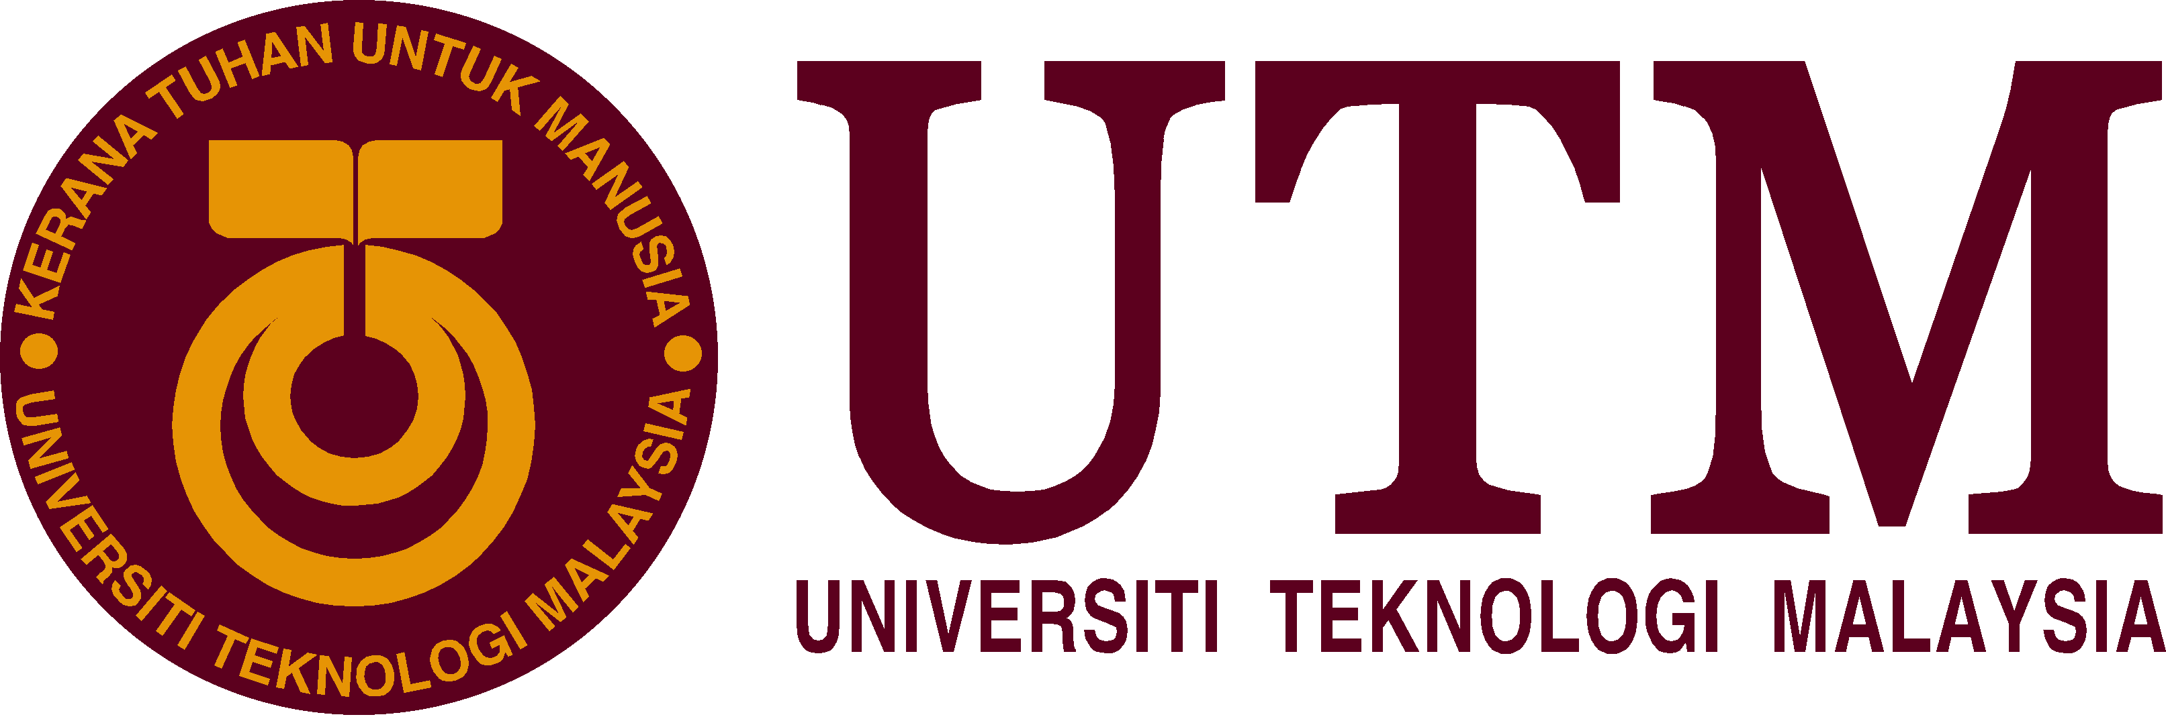

SCSP 1513
SECTION 6
TECHNOLOGY AND INFORMATION SYSTEM

PEPARED FOR:
DR. NORBAHIAH BINTI HAJI AHMAD

INDUSTRIAL VISIT 2

PREPARED BY:
SUNG SHEAU HUI A18CS0248
NUR FATIN BINTI ROZADIN A18CS0191
SIFRA MANALU A18CS0327
UMI HAIZA BINTI MAHAMUD A18CS0270
SALMAN MOHAMED IBRAHIM AHMED IBRAHIM A18CS0356
CONTENTS

1.0 INTRODUCTION 3
2.0 ORGANIZATION STRUCTURE 4
3.0 SERVICES 4
4.0 ACHIEVEMENT 7
5.0 WORKSHOP 1 8
I. FIRST BOOTH 8
II. SECOND BOOTH 9
III. THIRD BOOTH 9
IV. FOURTH BOOTH 9
V. FIFTH BOOTH 10
6.0 WORKSHOP 2 11
7.0 REFLECTION 12
8.0 REFERENCE 13

INTRODUCTION

We went to workshops in OneMaker on Saturday, 24 of November 2018. OneMaker Group Pte Ltd (OMG) is a leading Maker-centric service provider in the region and their core business revolves around Maker education, digital prototyping services and corporate professional development.
The first workshop shows us the high- technology stuff. Before we go to every single booth, we attend a talk about how the technology and machine developed nowadays and how the technology and machine will be the better again in the future. Within the work shop there are five stages. The first booth that we visit is artificial intelligence. They show us a wooden head figures, simple computer and connected to a program, so it can run a google assistance. The second booth that we visit code and colors. They give us colorized marker and a little robot that will walk on the blank paper. Fly a drone was showed at the third booth. We only need to control the drone by the application that we can download on our device (PC or mobile phone). The fourth booth is they teach us how to use SketchUp application. This application used for design something in 3D. The fifth boot is they provide us a 3D printer. First, you can design what you want to be printed. With this opportunity, they print some of our group member's name.
The second work shop, there are 2 activitie which are the Virtual Reality Talk & QuirkyBot Making. Virtual Reality Talk told the students about the virtual reality technology in our everyday life. For QuirkyBot Making, it required students to design a small robot by using things given by the organizer. For example, ice cream stick, plastic bottle, cardboard and battery. These workshops help us learned more about the technology and machine and how we can do the simple robot.

ORGANIZATION STRUCTURE

SERVICES

- Makerspace Development
OneMaker customizes the makerspace according to their clients’ wish. They also provide services such as supplying tools, materials, machines and equipment to the clients.
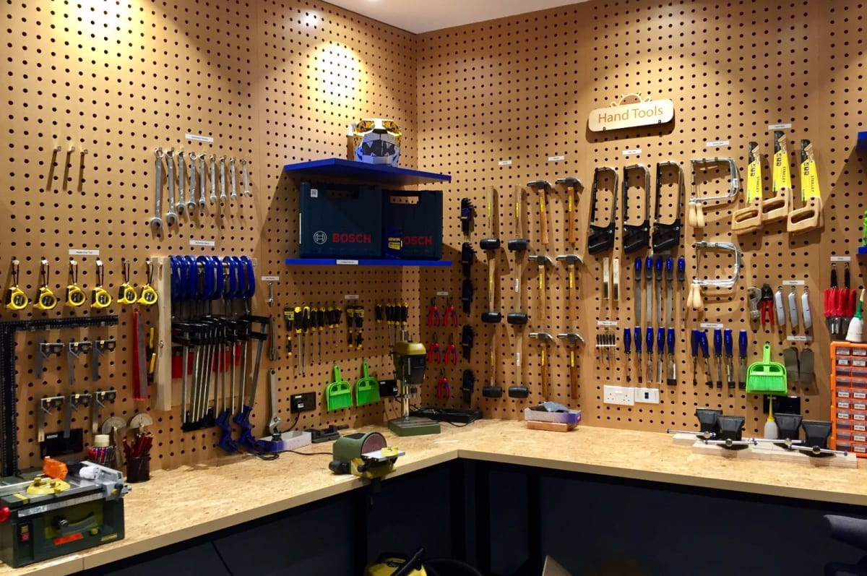
Figure 1 Tools, machine and equipment

- Prototyping and Consulting Services
OneMaker offers 3 ways of producing prototype which are 3D printing, laser cutting and Computer Numerical Control(CNC) Routing for their clients’ design and model.

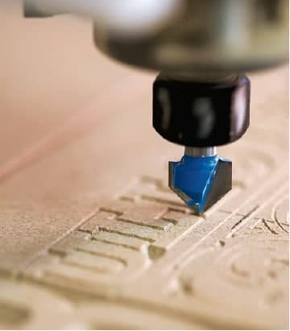
Figure 2 CNC Routing

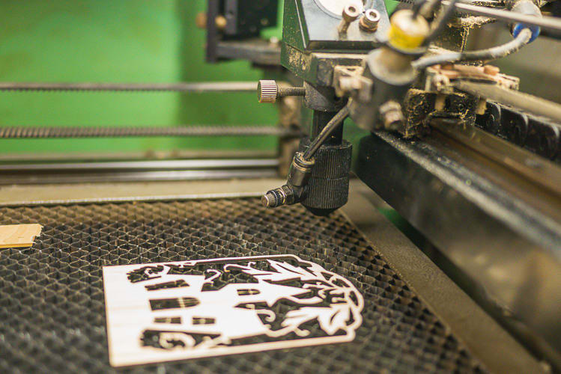
Figure 3 Laser Cutting

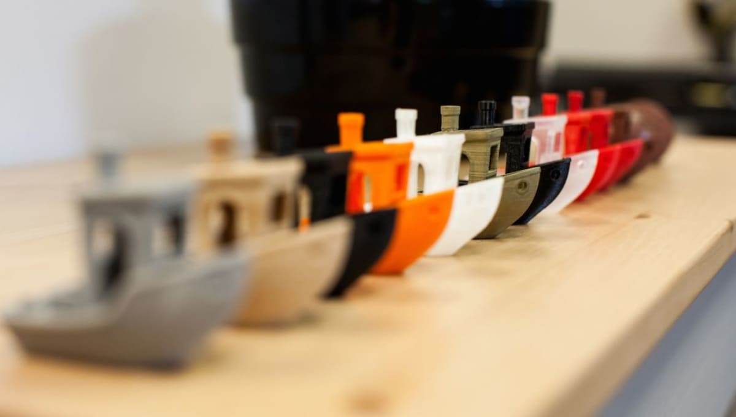
Figure 4 3D printing

- Makerspace Pass
OneMaker provides flexible access pass to the space. They offer induction course to the new user before they start working in their space.

- Event Consultancy and Management
OneMaker can customize events according to the clients’ needs.

- Official Certification
OneMaker provides a certificate to whom has participated in the Arduino CTC (Creative Technology in the Classroom) 101 project. CTC is Arduino’s one kind of STEAM(Science, Technology, Enginnering, Arts, and Mathematics) program for upper secondary students. It also can be customize for upper primary or lower secondary school. Students can learn foundation of programming, electronics and mechanics through this program.

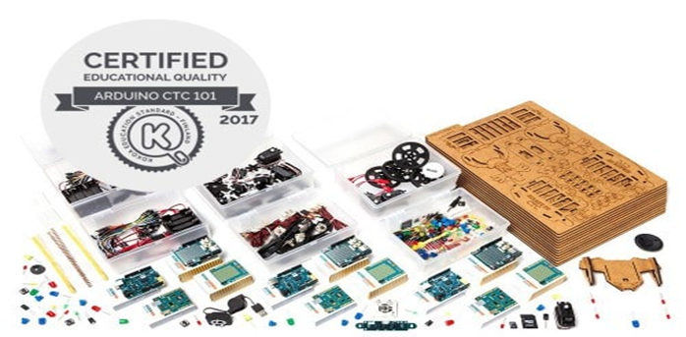
Figure 5 Certificate of Arduino CTC (Creative Technology in the Classroom) 101 project

- Professional Certification
OneMaker has partnered with Fast Lane Asia. They help company to earn and develop technology skills. After this, those who can master using the technology tool will capitalise on its benefits.
Figure 6 Fast Lane Asia

ACHIEVEMENT

OneMaker Group Pte Ltd (OMG) organized many events for clients such as Designathon We Remember 2018, JuMP Make-Vember Camp, Makervilla 2.0: Creative Learning Retreat for Maker Educators and more.
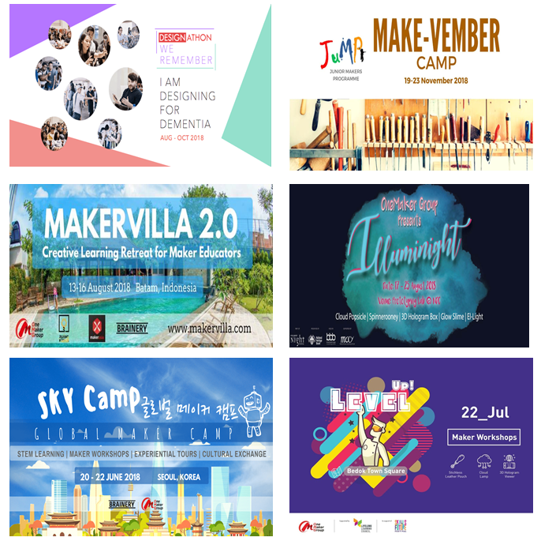
Figure 7 Event Organized by OneMaker

WORKSHOP 1

There are five booth that OneMaker presented to us. All the booth shows us the high-technology stuff. But, before we go to every single booth we attend a talk, that talked about how developed the technology and machine nowadays and how will the technology and machine will be more developed again in the future. Below is the development of the machine from generation to generation:
- First: Steam
- Second: Electricity
- Third: Computer
- Present: Artificial Intelligence, IoT, Big Data

FIRST BOOTH

The first booth that we visit is the Artificial Intelligence booth. They show us something like a wooden head figure, that have a simple computer on it and it connected to a program, so it can run Google Assistance. It uses a voice sensor. So, you only need to talk to the figure what you want to find for. You can ask the Google assistance to do so many things. It even can sing a song.
Figure 8 Google Assistance

SECOND BOOTH

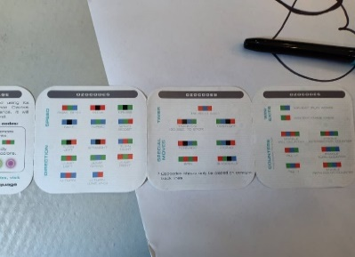
Code with colors is the second booth that we visit. They give us a blank paper and so many colorized marker and a little robot that will walk on the blank paper. And then they tell us to draw pattern with color and the robot will walk on the color that we draw. The color pattern will determine what will the robot do. And they give us a manual book that contains the color pattern
Figure 10 Color Code Bot
Figure 9 Manual Book

THIRD BOOTH

We fly a drone at the third booth. But, we didn’t use any remote control to move the drone. We only need to control the drone by the application that we can download on our device (PC or mobile phone). And then, connect the drone with our device with Wi-Fi. And you can custom the drone movement with only design what movement that you want in the application.
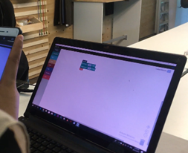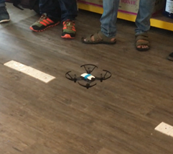
Figure 11 The apps that control the drone Figure 12 The drone

FOURTH BOOTH

Before we go to the fourth boot, they tell us to install Sketch Up Application first. They tell us how to use this application. This application used for design something in 3D. After we design our product with this app, you can print your design with 3D printer. That will be provided at the fifth booth.
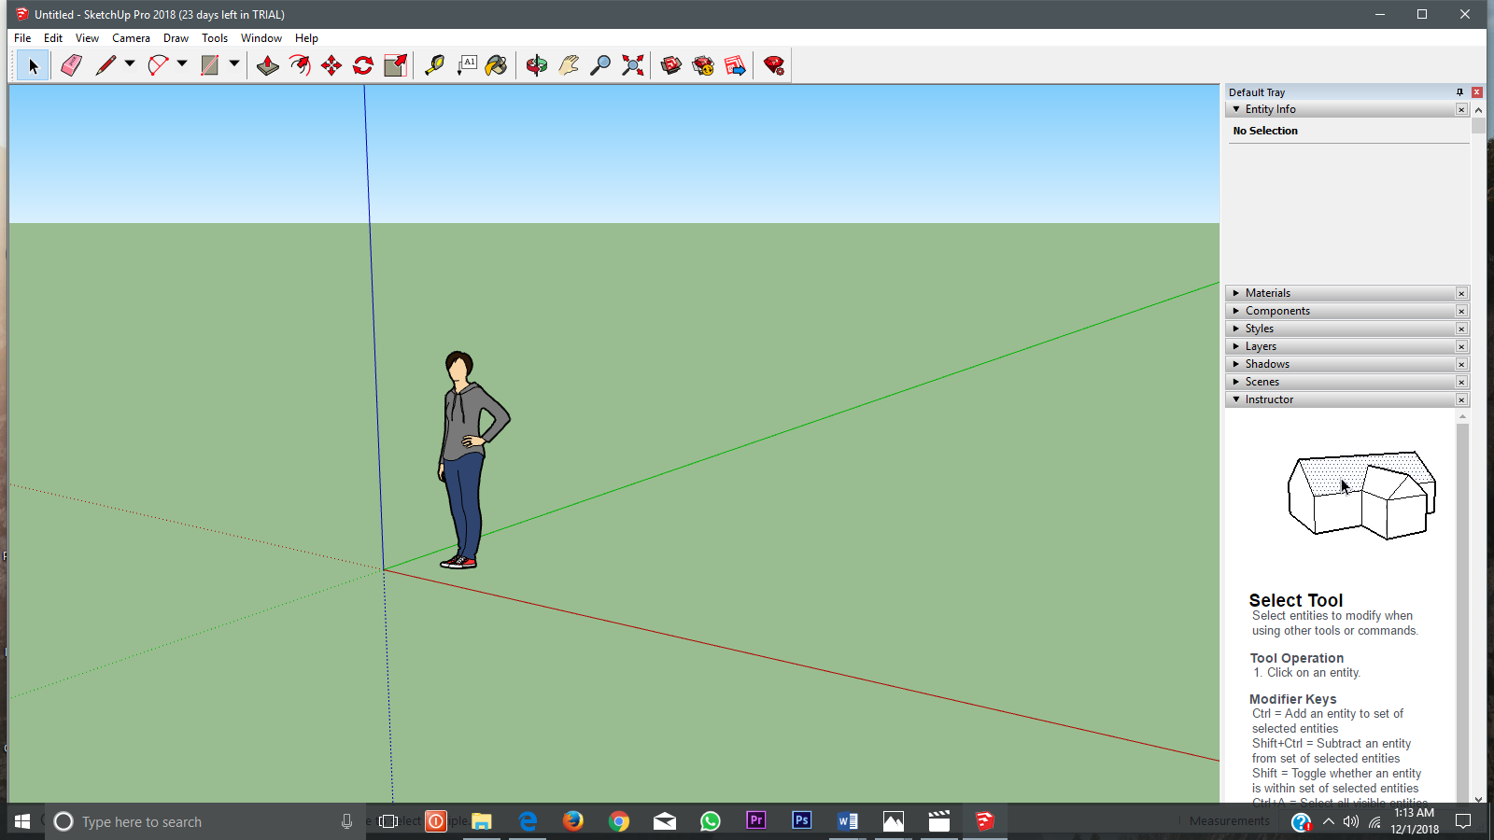
Figure 13 Sketch Up Application

FIFTH BOOTH

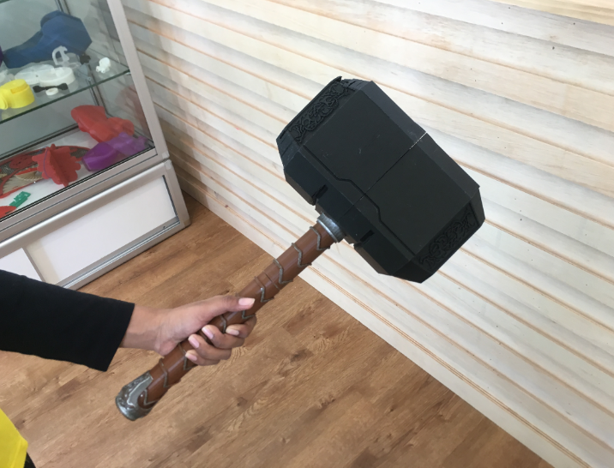
This booth they provide us a 3D printer. First, you can design what will you print. But at this opportunity, they print some of our name. There are a lot of figure that they produce with 3D printer. The 3D printer use material like a filament to print the stuff.
Figure 15 3D Printer
Figure 14 Product from 3D Printer
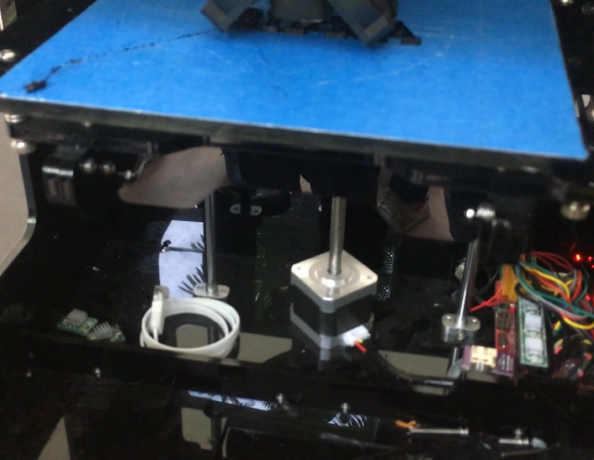

WORKSHOP 2

In workshop 2, there were two activities, the Virtual Reality Talk & QuirkyBot Making. The Virtual Reality Talk told the students about the virtual reality technology in our everyday life. Virtual reality is basically a term used to describe a three-dimensional computer generated environment which can be tried and communicated with a person. There are different kinds of virtual reality such as mixed reality, telepresence, immersive system and world on world.
World on world | Use a current computer to demonstrate a virtual world.
Immersive system | Normally equipped with Head-mounted Display (HDM) to fully engage the user perspective inside the virtual world.
Telepresence | Links remote sensors in the real world with the senses of human operator.
Mixed reality | Integrate the computer-generated virtual object into the physical world which become in a sense an equal part of our natural environment.

The talk also talked about the biodegradable plastic which is good for our nature. It is a water soluble plastic bag above 80ºC. This creation is towards no single use of plastic in world.
For QuirkyBot Making, it required students to design a small robot by using things given by the organizer. For example, ice cream stick, plastic bottle, cardboard and battery. The students were given time to design their own robot. The robot created by the students will be used in the Sumo Robot Competition after that.

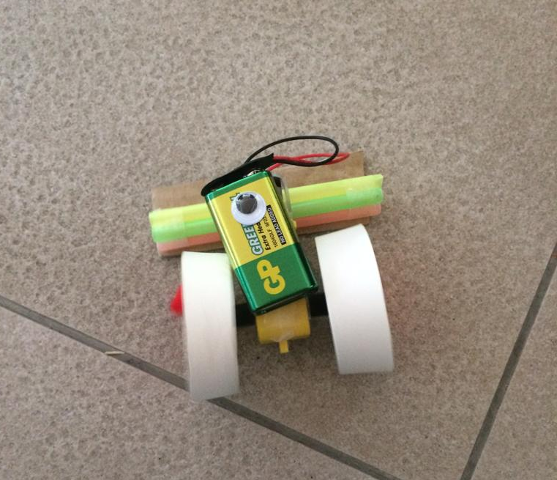
Figure 16 Robot created by one of the group Figure 17 Robot Competition

REFLECTION

- From this visit, I should think what kind of problem I want to solve after I graduate. I might want to create something that can help people in the world. I need to improve my critical thinking skills to improve my potential in the industry. Besides that, I should explore more about the new technology in the world. I should keep learning because just learning the knowledge from book is not enough. -SUNG
- I learned a lot about the technology created by nowadays people in this world. There are a lot of new inventions that have been created to ease everyone. People do not need to use much energy when doing certain things because the new technology will help them. - FATIN
- As a university student, especially in Software engineering major. We need to know how developed the technology and information system is. So, this workshop is very useful for us. So that, we can learn some of technologies that we never known before. From this workshop, we get gain more knowledge. We get a design thinking knowledge, that can we use when we are in the employment. - SIFRA
- As a student, I started to realized that in the revolution of 4.0 industry, the machine and robots are overtaking the job of human. As a computer student, I might think that we may not have job due to lack of work available. But, little did I know, the machines and robots still need a fix if broken and an update within time. As a youngster, I believe that if I change my mind-set, I will not only grow with them but also being the one who created and bring changes to the world – UMI
- We learned a lot of things in the trip, we need to know about technology and machine help us in the course. we learned the beginning of the robots. The work shop I was very helpful for us. We must develop ourselves to be the best. - SALMAN

REFERENCE

- https://www.onemakergroup.com/

