Lab Exercise
Page 84 & 85, Question 1 (a, b, c)
HAM JING YI (A19EC0048)

a)
Name of the aggregation approach | Description of the approach | The line number that implements the aggregation approach
By using pointer variable | Since an aggregation relationship is implemented by objects contain pointers to other objects. Besides, this means that Summon is the enclosing object while Officer is the enclosed object. | Line 40
By using reference variable | Dynamically allocate an object is like storing a reference to the object in the officer variable | Line 49

b) 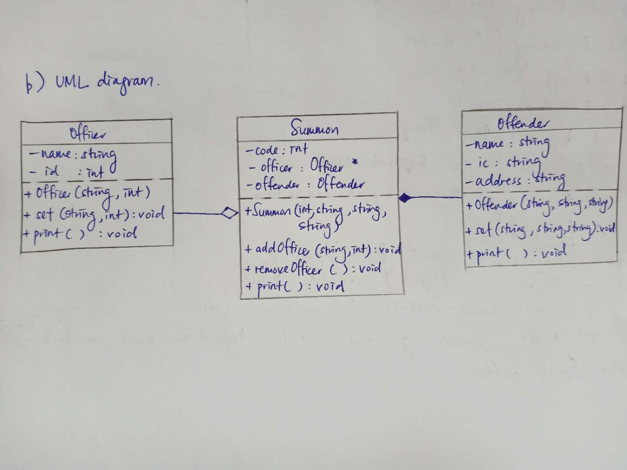

c) Output of Program 7.6 :

Officer : Ali 75381
Offender :Kassim 841203015311 NO 1 JALAN PS 13 TAMAN PERMATA SINAR

Summon Code : 12
Offender :SELAMAT 992112035621 NO 3 JALAN PC 31 TAMAN PERMATA CAHAYA
Officer : Ahmad 87611

