UTM BACHELOR OF COMPUTING SCIENCE (DATA ENGINEERING) COMPUTING PROGRAMME

GRADUATE SUCCESS ATTRIBUTES
(UHMT1012-27)

CASE STUDY
(DRUNK DRIVERS IN MALAYSIA)
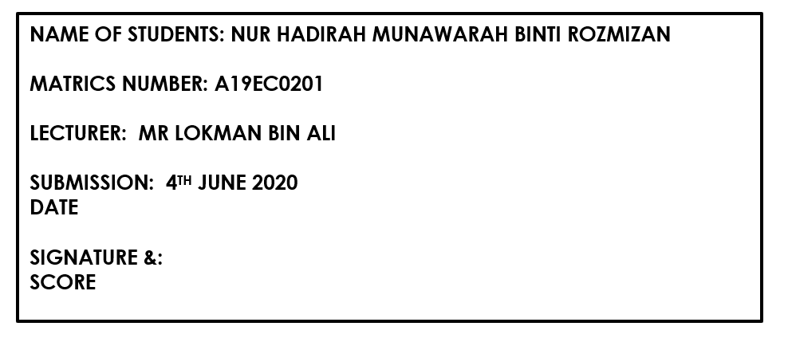

DRUNK DRIVERS IN MALAYSIA

Driving a vehicle while having the influence of alcohol is one of the hottest topics in Malaysia. Besides being one of the most dangerous things people can do, people still tend to do it frequently. Nowadays, people don’t take much care on rules and regulation of driving without any alcohol.One night drink and little drive mistakes combine the best when driving. Thus, it affects in so many ways such as the victims, the family and everything. Even though they knew the consequences, they still stubborn to do so.The victims’ family also will be traumatic as well as the driver. Road trauma is real when someone that we know, died just like that because of drunk driver’s wrongdoing.In Malaysia, the legal blood alcohol concentration (BAC) limit for drivers is below 0.08. However, people who drunk while driving still refuse to undergo a breathalyzer test for either alcohol or drugs if police asked them. According to section 43 of The Road Transport Act 1987, it states that a person who drives “without due care and attention or without reasonable consideration for another person using the road” is considered guilty of an offence. Nevertheless, they can still guilty if their blood alcohol concentration (BAC) is high. The more they drink, the higher the blood concentration, it will affect your chance of getting a road accident.

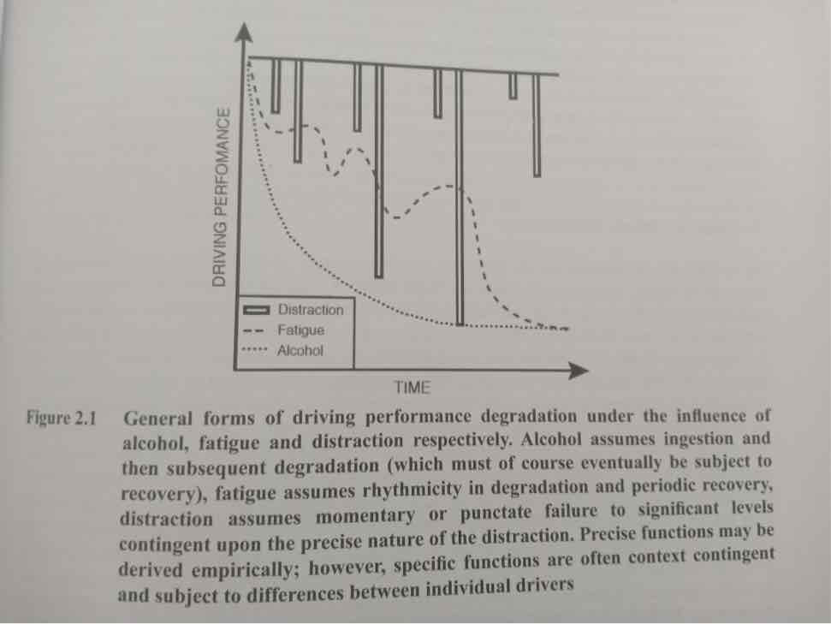

On February 2020, A mother and her 12-month-old baby girl had seriously injured in a crash. This is due to a man driving under the influence of alcohol near Persiaran Sultan Abdul Hamid, Alor Star. She and her daughter has serious injuries meanwhile her husband and son, suffered minor injuries. From the incident, it seems that the alcohol man, 58 years old drove a really fancy car which was BMW car. The cause of the incident was the man was in lost control due to high alcohol take. At he scene of the incident, the vehicle skidded and hit the family members. They were treated at the Hospital Sultanah Bahiyah for further treatment meanwhile the drunk man was treated in private hospital. Another incident happened in Seremban, a drunk driver crashed his vehicle into another car and three motorcycles, one person is killed and others is injured at Lekas Highway on 16th February 2020. The driver was 30 years old man who drives Ford Fiesta, he drove against traffic flow on 3.20 am morning. The driver has major injuries on the head and body. The case reported that the man had the influenced by alcohol by using urine’s test to determine his blood alcohol and drug level. Therefore, the man is unconscious and make a big move which drove against highway in midnight. Just last week, a couple (39 years old man and his wife) was seriously injured after their motorcycle was hit by a car driven by a man that was drunk. The couple has 5 children. Based on what it observed, there is always a news that related with drunk drivers and road traffic incident in Malaysia as well as ASEAN countries, Thailand and Vietnam. This recent Chinese New Year holidays, there were about 138 deaths from road accidents within 9 days. This diagram shows drunk driving accidents in Malaysia.
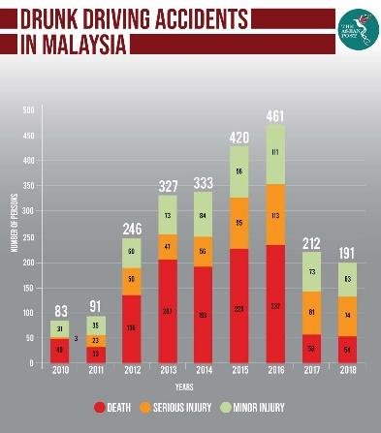

Drunk driving is a serious problem for use that continues to take hundred of deaths each year. Drunk driver does not affect only them but the people who surround them when they drive. It affects their family and friends too. However, what is the main causes of the problem? It all stated with the trends in Malaysia. Usually, people are easy influenced by surround them. Therefore, youngsters and adults are the main target to easily get drunk when going back home. Another reason is that they take the warning of rules lightly. With high fines and long duration of prison, they still ignore the rules and regulations and assume this is very minor case. Most of them are also selfish which is they don’t want to take taxi or grab to go back home when drunk. If they concern about other in the road, they must have common sense to not drive alone. They can ask other friends that not drunk or just take the cab or grab to go home. Celebrating holidays such as Chinese New Year is also one of reasons there are many drunk drivers on the road. This is because their tradition must have wine and other fine foods to celebrate the day. The drinks will represent friendship, happiness and other wishes. In addition, everyone in the family or friends must take a sip on that night to protect from bad luck. Other reasons is that some people will drink the alcohol to forget the past experiences. They drink to get positive feelings with alcohol and less pressure. The reason why is they might be stressed. The alcohol drink helps to remove their negative feelings and stress of anxiety.

Based on the book title “Driver Distraction and Inarrention Advances in Research and Countermeasures, Volume 1” by Michael A.Regan, John D.Lee and Trent W.Victor, page 293-295, they stated that the effects of high doses alcohol give low attention and it is observed to have delays in a reaction time to their surroundings. Another research is that driver’s standard deviation of lane position when they were under the influence of alcohol was significantly higher than when they were talking on the phone or when driving with no phone or alcohol. Another effect is that the time frame for exposure to risks is relatively greater for alcohol impairment. In other words, they have slow reaction time, drinking slows their response time. Therefore, if there’s a car in front of them, it will take longer for their brain to process the situation and prevent the accident. Based on the book title “Driver Distraction Theory, Effects, and Mitigation” by Michael A.Regan, John D.Lee And Kristie L.Young, page 99-102, another cause is that drunker has lack of coordination. Coordination such as motor skills like eyes, hand and foot coordination. They might be unable to avoid an harmful situation. Too much alcohol can give difficult on your body as well as driving. It also reduces concentration, take for an example, when there is a traffic light on the road. Your vision are blurred and you can’t expect the object in front of you in meantime.

Therefore, there are several resolutions on this matter. One of the resolutions is Malaysia already stated the drunk drivers need to pay RM100,000 fine, jail 20 years in prison for drunk driving. The jail sentence for the offender will be increased to 20 years from 10 years. Furthermore, there are also different laws to discourage drunk driving. Having an awareness campaign for youngsters will give a big impact to the good drivers in the future. For non-Muslim under 21, high authorities must encourage them to not drink alcohol while driving. They are not allowed to drink. Another solution is that when we see one of our friends is drunk, ask someone to send their home instead of he/she drives their own car. Besides that, designation a member of the group the remain conscious or not drinking any alcohol is the safest way so that the person can drive everybody to go home without any risks. In addition, if they insist to get everyone drunk, they should use a ride-hailing service such as Grab, Mycar or Maxim. One of another resolutions is that police should take an action by doing some roadblocks for the road users. If they caught a person who drinks, they can arrest them straight away without having any accident. Mass media campaigns also give awareness for the drivers by sharing awareness on Whatsapp, Facebook or Twitter. These campaigns are most effective as nowadays many people like to see new updates on their own phones. In aspect of high authorities, the government should improve the roads such as improved clear lane markers that easy to see. Thus, it can save many lives.

In today’s society, driving while under the influence of alcohol has become a very dangerous death. The death would be preventable if Malaysian government had more severe laws against this issue. Family lives are shattered by the sudden death of loved one, family never return to their normal ways of life. While the drunker, just a certain time in prison, and then they go back to normal life. That is very unfair for them as the didn’t need to get punished by killed. Even though everyone is aware of laws which is everyone must not get drunk, but there is still certain people who are very selfish towards themselves without worrying the others. Usually in major accident due to drunk drivers, it is impossible for the victims to survive, if they are lucky then they must suffer injuries including partial or total disability. Governments should find ways to reduce the amounts of drunk drivers that might help decreases the vehicle crashes due to drunk drivers. Take for an example, strict laws should be enforced in every Malaysia against drinking and driving. The citizens also need to be educated on the effects and consequences of drinking and driving. On this way, they would know that drinking is must not be an option as it can harmful people. Lastly, no matter where you are in Malaysia, drunk driving is treated as a serious offence and any person who is found to be operating a vehicle over the legal limit, may face penalties.

References:
Journal articles and reading materials;
1)http://www.astroawani.com/berita-malaysia/ibu-bayi-12-bulan-parah-dirempuh-pemandu-mabuk-231139
2)https://www.nst.com.my/news/nation/2020/02/565868/rm100000-fine-jail-20-years-drunk-driving
3)https://www.nst.com.my/news/nation/2020/02/566067/drunk-man-kills-1-injures-4-while-driving-against-traffic-seremban
4)https://www.bharian.com.my/berita/kes/2020/02/656971/angkara-pemandu-terbabas-bayi-dan-ibu-cedera-parah

Academic text references;
- Michael A.Regan, John D.Lee And Kristie L.Young, Driver Distraction Theory, Effects, and Mitigation, Boca Racon, Taylor & Francis Group, 2009 (99-101)
- Michael A.Regan, John D.Lee And Trent W.Victor, Driver Distraction and Inarrention Advances in Research and Countermeasures Volume 1, MPG Book Group, 2013 (253-255)

