New Academia Learning Innovation (NALI)

Introduction:
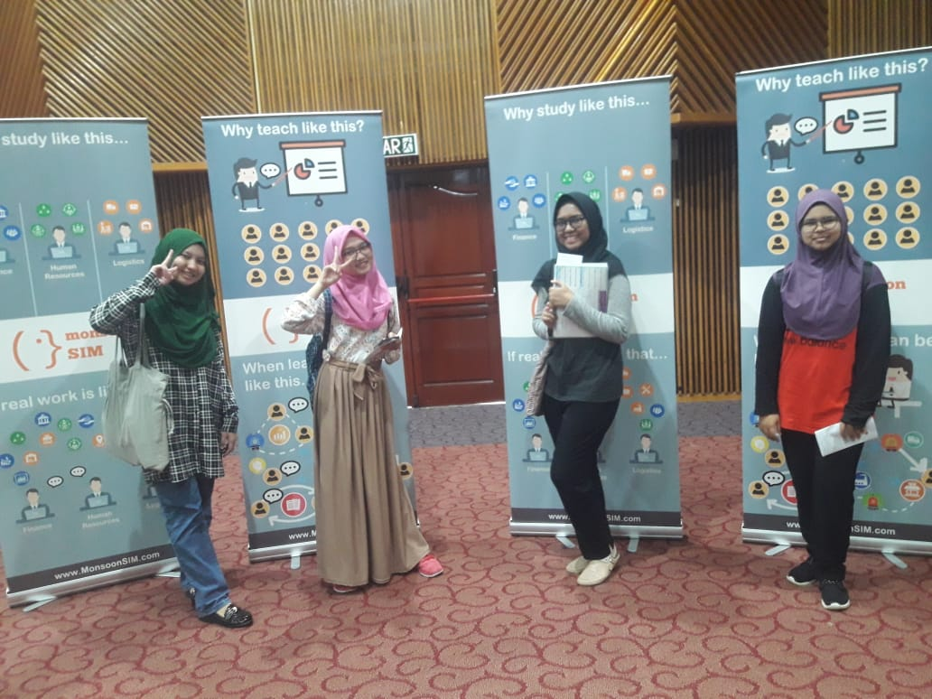
NALI (new academia learning innovation), which was organized by UTMlead at Dewan Sultan Iskandar hall. This event was mainly for showing projects on different advance teaching method and promoting university or courses.

There were many participants and the number of stalls almost 100. Every stall have their own unique and good idea. Among them, we were very interested in three stalls. The choice was made by our personal interest and with the help of our group leader. It was fun and also educational. We have learned how will be the future teaching or learning method.

Our group 9teen-1 visited NALI 2018 on 25th September. We arrived there at 10.45 am. And the stalls we visited was
• Stall 36
• Stall 24
• Stall

- Exhibition contents: MonsoonSim Business Simulation
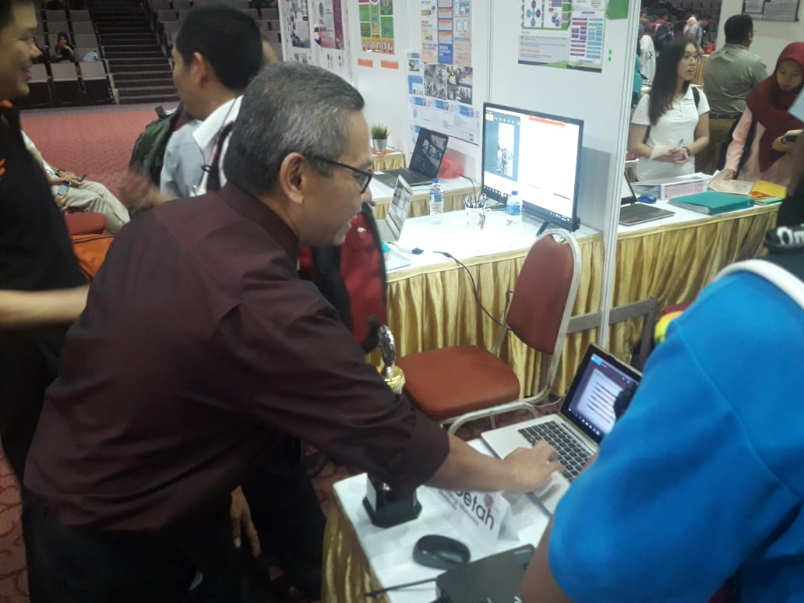

It's a simulation game developed by Sidharta H Gunawan. Basically, this game is for those who want to learn how to do business. It's a learning process of technical business concepts. You can't learn marketing or promoting your product here. But a real-time business strategy can be learned from here. Where the profit goes, what's the idea of buying a product, negotiable price, a strategic way to earn more all this concept are available in here. One can play the game like he or she owns the business and can do whatever they want.
MonsoonSim is providing five key basics of business like
1. supply chain
2. business process integration
3. how ERP system work
4. running a large business
5. importance of teamwork
It's also available in the cloud. A trained person who already mastered the game can teach other by hosting. He or she also can measure his student knowledge or strategic level through this game. That's the beauty of this game. It can be very useful in the company to monitor the business planning level of a person.
MonsoonSIM enterprise resource planning competition Malaysia final 2017, our UTM wins. But please don't be fooled with the picture, they are my teammates. They are holding the proof of the winner.

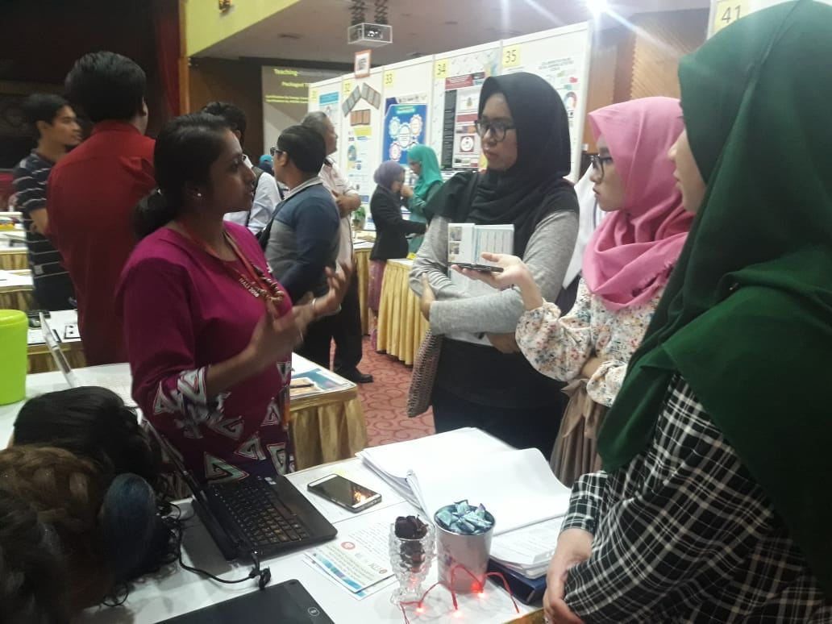
- Exhibition contents: Pedagogical Benefits of Youtube in Improving Hair Styling Performance and Interest among Learning Disability Students

Hemarani A/P Munisamy, MPP162030, Faculty of Social Science and Humanities, School of Education, UTM was the representative that explaining the contents of this exhibition to us. They use YouTube as the blended learning method that has the potential to increase the performance and interest among learning disabled students in vocational school. The purpose of this study is to enhance the students' performance and creativeness in hair styling and to investigate the difference of interest in hair styling after using YouTube among learning disability students. Ten (10) learning disability students that taking hair styling courses were been investigate by their teachers of the pre and post-test in the performance of hair styling after using YouTube. The teachers are using Case-Based Learning (CBL) approaches in giving instruction to the students. CBL process is the students are given the case that needs to be done and solved by themselves. So, they will analyze the case in the group and think to find the solution. From here, they will share their ideas and combined the ideas to make it more creative and simultaneously able to improve their soft skills such as communication, teamwork skills, self-confidence and responsibility to solve the problem as a student. To find the ideas, they will assess the ideas from many sources, especially from YouTube. YouTube has proven that it makes the students become more productive, creative, and innovative when it was adopted in teaching and learning activities. The students will be able to understand the problem better when they use YouTube as the main source to get the answers. As the conclusion, YouTube has made the implications for teaching and learning (T&L) process in improving students' performance and increased their interest in learning something new. YouTube also has proven that it can enhance the basic knowledge in hair styling
- Exhibition contents: E-service learning
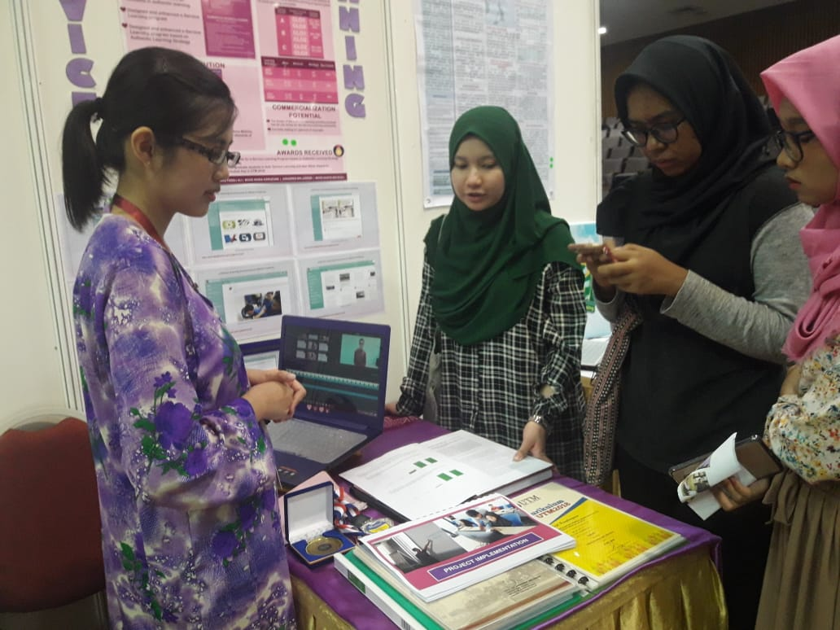

- Online service learning by using devices or electronic to deliver messages or instruction. Online courses hold massive potential to transform both services learning online.
- Nowadays students are increasingly pursuing their academic by education online likes e-learning, yet few are exposed to service-learning in their online coursework.
- Service learning is students allowed to learn by doing, connecting theory with practice. It is a method of learning through active participation in organized experiences that meet community needs.
- Improving students' learning outcomes through e-service learning based on the authentic learning strategy
- Students can apply knowledge and skills in the classroom or project by doing course assignments.
- Through course assignments whether in group or individual, students get benefits also with members, faculty that work together to achieve the best result based on community needs, create a new creation that involves many solutions for challenges.
- provide effective service to the local community so that they also can help make changes in new innovation. The community provides an educational experience for the student.
- E-service learning is online tool engagement on how they can teach, learning through virtual version. Example; a group of student can make discussion by using website e-learning and easy to chatting anywhere and anytime. They also can submit their assignment by using a portal in time.

The trend of digital learning for 2018

Firstly, the hottest modes of implementing training currently are Virtual and Augmented Reality. Augmented Reality (AR) overlays virtual objects on the real-world environment. This technology completely let users immersed in the virtual environment. Now, users even can experience the most advanced VR which included movements and hearing sounds. Traditionally, VR and AR are used more for gaming and movie experiences with wearable glasses headsets.
In digital learning, VR is used for complex procedures and handling high-risk tasks. More AR is used for just-in-time learning like the uses or functions of a tool, place that's too far; geography and etc.
Secondly, gamification and game-based learning. Other than fun, this type of learning-induced learners to think outside of their boxes. Game-based learning now established as the most impactful in imparting critical role-based information. Learners will take studying seriously as they fully immersed themselves in the process of gaming.
Gamification will increase training implementation as learners will know how things they have learned works in the real world. This method will coax the learners to invest their time in something they don't use to or in certain topics that they literally don't enjoy.
Thirdly, adaptive or personalized learning customized to specific learning needs. This is all about customizing existing modules available to a specific group. The pre-test is used to determine the understanding of learners. Then, modules are made based on the learners' performances. Modules are specific, have a series of questions and materials to improve areas where a learner has scored low. The best thing about this is, organizations don't have to provide all modules for learners but provide focus training and increase their return on investment.
Fourthly, interactive video-based learning. Video-based tutorials are getting more famous day by day especially on Youtube like hijab tutorials, braid tutorials, coding tutorials and also many more. Visual learners are going to benefit more in this type of learning. Organizations will use the video to maximum advantage to impart learning by having their own contents, adding questions and then posting it on sites.
Last but not least, microlearning. It has already become a strong trend. Microlearning is basically referred to as bite-sized training assets. Microlearning is focused, offering a just right amount of information that necessary to help learners achieve their objective or learning outcome.

Reflection
-Provide the bridge between the community service activities and academic content of the course
-Easy to access everytime and anywhere what they want to know and not to miss the current issue
-attract the attention of people to be more efficient, creative provides a mean through community service that can interpret and more understanding the meaning.
-many people can do money besides the program, they will know the experience and skill what will they standby by next.
-People can get more money easily by arranging the strategy on something like business.
-the opportunity of jobs in a variety of career expanded will help the economy of the country.

Reference
Talk of NALI
http://ctl.utm.my/nali/projek-projek-dibawah-nali/servicecommunity-based-learning/
https://citl.indiana.edu/teaching-resources/teaching-strategies/reflection-service-learning/

