HAM JING YI A19EC0048
1)
a) True
b) True
c) True
d) True
e) False (string university= “UTM”)

2)
a) string vehicle;
b)string student2= “vehicle”;
string student1(student2);
c) string city(“Pasir Gudang”);
d)string fullname= “vehicle”;
string firstname=fullname.substr(0,5);

3)
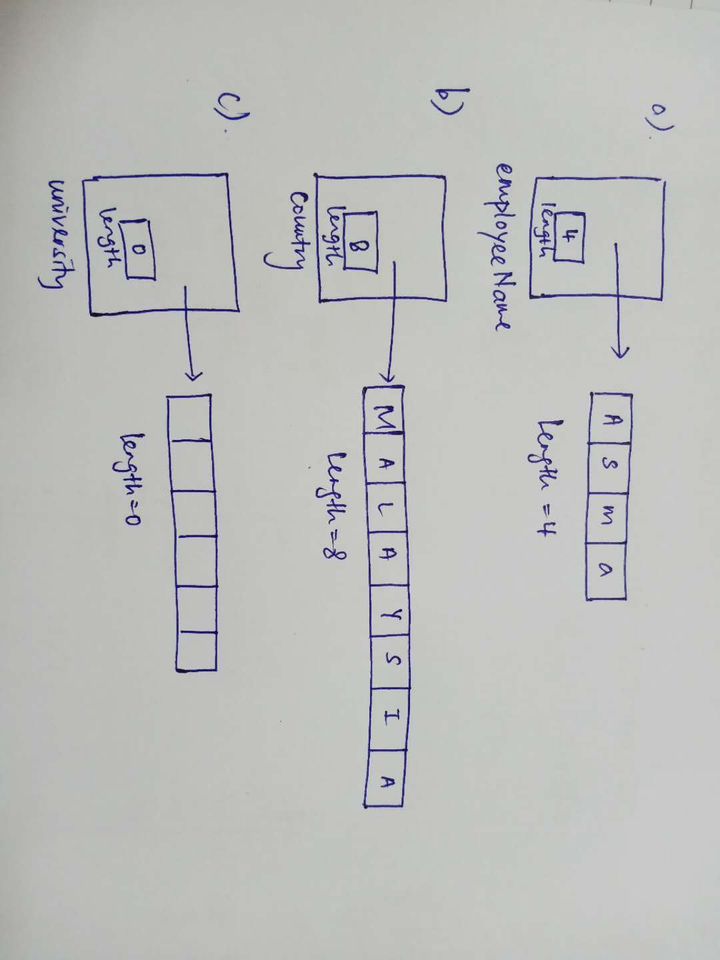
6)
a) WIRA
Assign s1 to s3.
b) SONA
Assign s2 to s3 begin from position 3 of s2 and takes only 4 characters.
c) WIRA
Append s1 to s4.
d) SON
append number of character from s2 starting at position 3 and takes only 3 characters.

7)
a) swap
//a : swap the contents of s with s1.
#include<iostream>
#include<string>
using namespace std;

int main()
{
string s="John";
string s1="JING YI";
s1.swap(s);
cout<<s<<" "<<s1<<endl;
return 0;
}

b)copy
//b : copy the character array (“JohnLilyJames”) to s1, beginning at position 4, for 8 characters.
#include<iostream>
#include<string>
#include<algorithm>
using namespace std;

int main()
{
string s="JohnLilyJames";
char s1[13];
s.copy(s1,4,8);
cout<<s1;

return 0;
}
c)empty
//c : returns true if the s1 is empty
#include<iostream>
#include<string>
using namespace std;
int main()
{
string s=" John";
cout<<s.empty()<<endl;
string s1;
cout<<s1.empty();
return 0;
}

d) find
//d: Return the first position at or beyond position 0 where ‘A’ is found in the string s2.
#include<iostream>
#include<string>
using namespace std;
int main()
{
string s2="zAnafg ";
cout<<s2.find('A',0)<<endl;
return 0;
}

e)insert
//e: Inserts a copy of s into s1, beginning at position 4.
#include<iostream>
#include<string>
using namespace std;

int main()
{
string s="Uni ";
string s1("UTM Johor");
s1.insert(4,s);
cout<<s1<<endl;

return 0;
}

f) substr
//f: Return a copy of a substring of s1 to s. The substring is a 7 characters long and begins at the position 0 of the s1.
#include<iostream>
#include<string>
using namespace std;

int main()
{
string s;
string s1="HAM JING YI";
s=s1.substr(0,7);
cout<<s;

return 0;
}

