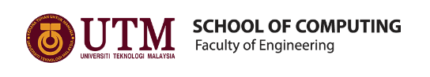

Semester I 2019/2020

GROUP MEMBERS : HAM JING YI A19EC0048
INTAN MARINA BINTI SULAIMAN A19EC0053
JOSIAH JEEVANRAJ JOSEPH A19EC0060

SUBJECT : TECHNOLOGY AND INFORMATION SYSTEM
SUBJECT CODE : SECP
SECTION : 02
TASK : BIG DATA WEEK
TOPICS : VISIT TO PETRONAS

NAME OF LECTURER: DR. ARYATI BINTI BAKRI

TABLE OF CONTENT
No. | Content | Pages
1. | Introduction and details of visit | 3-4
2. | Detailed descriptions | 5-7
3. | Group Technical Data in Petronas | 8
4. | Reflections | 9-10
5. | Reference | 11

INTRODUCTION AND DETAILS OF VISIT
On 11/9/2019, the undergraduate students from computer science (data engineering), school of computing, faculty of engineering, Universiti Teknologi Malaysia (UTM) were invited to have an industrial visit to Petronas. This industrial visit had been proposed by Dr. Aryati Binti Bakri who is the director of the Technology and Information System (SECP 1513) subject. This program involved 36 students who took SECP subject.
The purpose of this visit to Petronas is to show us the importance and uses of data and how data plays an important role in bringing a lot of profit to Group Technical Data (GTD).These data really helps a lot in the field of strategics, technicals, decisions and operations performances. All of us were given a talk in a Petronas Collaboration Centre in KLCC about the GTD, upstream exploration and production of oil and gas to downstream oil refining, how the extracted data helps in the field of gas and developing new energy else how the artificial intelligence gets access to all technical data of Petronas and how the DATA OPS functions. Moreover, we were exposed to data analytics in improving the business and bringing profits. Due to the 2u2i programme, we managedd to meet our first batch seniors who are taking internship under Petronas. They were very kind to share their experiences with us and discuss the challenges they face during the internship.
In this report, we will tell you about the organization structure, services that Petronas provides and their achievements. Lastly, our reflection towards this industrial visit.

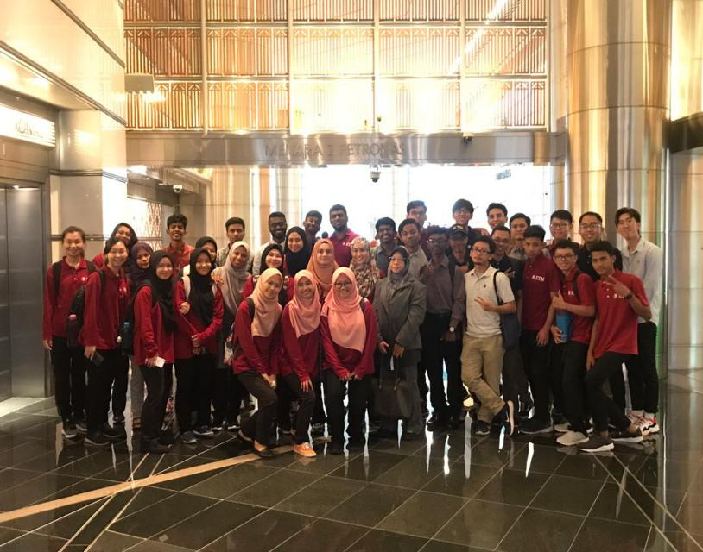
36 students and Dr. Aryati are taking photo insides the Petronas Twin Towers before entering the collaboration hall.
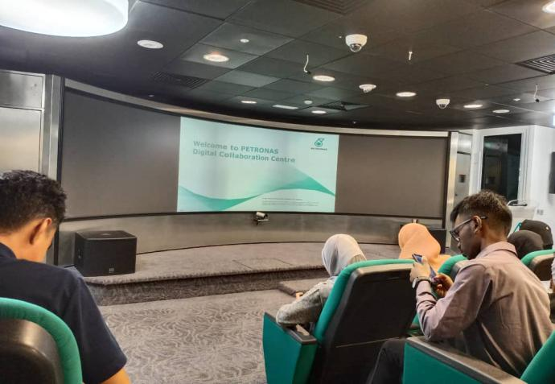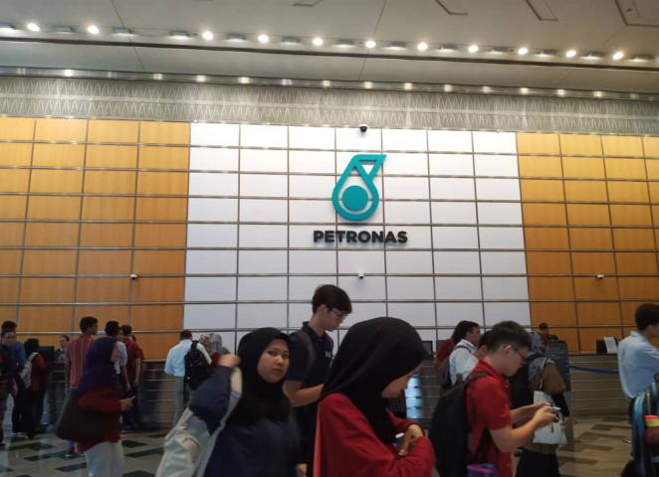
After a long queue at the security check, students manage to enter the collaboration halls.
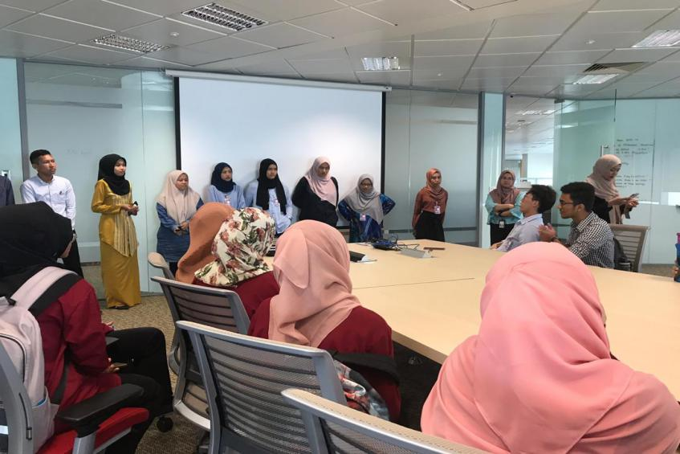
Our seniors who are taking internship in the Petronas are sharing their experiences during their university life.

Detailed Description
Organization Structure
The full name for PETRONAS is Petroliam National Berhad. As a gas and oil company, it was founded on the 17th of August 1974. The government of Malaysia fully controlled it. The countries which Petronas maintains operations in terms of upstream exploration and development are Mexico, Indonesia, Iraq and more. There are 30,000 employees of 38 nationalities are employed to this big company.
Organization structure is the framework of a business in order to show the way in which management is linked together and how authority is transmitted. It will affect the way how the employees communicate and how to establish the goal.
There are four types of organization structure. In this case, PETRONAS uses the functional organization structure. The employees are separated and grouped according to their specific skills and level of knowledge management. Everybody has own tasks and jobs to do and allowing all employees to focus on their respective areas. By the way, they adopt the cross functional bonds too. It contains employees from different functional field working together so that they can gain something differences from people from other fields. It is between the respective divisions and departments. It is the bond and process of specialization that has led to the success of the organization. Team work is powerful and encouraged, all people works together to achieve the company’s goals and targets. The line of authority is clearly drawn, orders are sent from the top most level, the president and the CEO. Lastly, consultants are needed to improve business and organization results.

SERVICES
PETRONAS is a famous Malaysian oil and gas company. But they do not just provide that to the client, there are many other services that they provide. Table 1 shows the services that PETRONAS provide to the consumers.
Table 1
SERVICES | DESCRIPTION
1.Fuels Station | - There around 870 filling stations in Malaysia since 2008 with 5 type of fuels provided.
2.Lubricants | - PETRONAS provide 26 types of lubricants include for car motor, motorcycle and heavy duty vehicles.
3.Cooking Gas | - PETRONAS gas known as Liquefied Petroleum Gas (LPG), made of hydrocarbon gases, comprising mainly of Propane (C3H8) and Butane (C4H10).
4.Cards Services | - Customers can enjoy more convenience and better reward by using CIMB PETRONAS Cards or Maybank PETRONAS Credit Cards.
5.Car Care Services | - Products and services specially provided by PETRONAS for best protection and care for car.

These are just the services that PETRONAS provide to the consumers. But there are many other services that PETRONAS provides for other businesses such as PETRONAS Aviation Services, Technical Advice & Consultation Services and Technical Training Provision.

ACHIEVEMENT
As we all know, PETRONAS is a very prestigious company. It is not surprising when PETRONAS was awarded with many achievements. One of the PETRONAS lubricants, PETRONAS Lubricant International (PLI)’s Arexon Svitol Easy, was awarded as product of the year 2018 in Italy for product innovation. PETRONAS also got the Asia Pacific National Oil Company of The Year in 2018 (Figure 1) shows PETRONAS’ Senior Vice President of Development & Production, Upstream Business, Adif Zulkifli who received the award on behalf of the national oil company (by bernama.com, article on 31st January 2019). Not only 2018 but also in year 2017 and 2016, that made them get the award for the 3 years in a row. Also in 2018, PETRONAS Leadership Centre (PLC) received the Gold Stevie® Award for Managerial Excellence (ME) Leadership Development Journey under the Innovation in Human Resources Management, Planning & Practice Category. The most interesting award is that PETRONAS was crowned as the most attractive employer in Malaysia 2018. This show that many employee or maybe students that choose PETRONAS as their dream job and want to be a part of family members in PETRONAS.
PETRONAS is already 45 years old now and still become among the successful companies in the world. This is proof of the best achievement that PETRONAS had received.
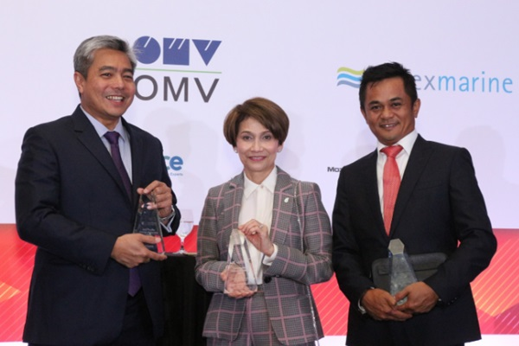
Figure 1: Adif Zulkifli (left) and Emeliana Rice-Oxley (centre) (from BERNAMA.com)

Group Technical Data in Petronas
The group technical data in petronas is under the jurisdiction of Project delivery and technology. This Project and delivery team is incharge of projects, research and technical solutions for their upstream and downstream units. They are strategically positioned to support the company’s growth and strategies. What this means is that they are in a position that influences the company’s decisions and heavily influences where the company is headed in the future. They do this by bringing more value to data. As we all know, data and information is wealth. But wealth is nothing is it is not valued. This team of experts analyze and interpret data that they possess in order to bring some sort of benefit to the company. These data can be obtained in many ways. Sometimes, valuable data are auctioned and bought by companies to give them the upper hand and help them improve the company.

These data also has a custodian. This custodian has access to all petronas technical data. Besides that, the custodian also governs and stores all technical data. Besides that, it is the custodian’s responsibility to guard and safekeep relevant technical data. This is because the data Is so valuable that if it falls on the wrong hands, the whole company may be at stake.

Reflection

This visit has been a remarkable experience as It shed very meaningful insight on what it is and what it takes to be a data engineer. The information given to us on how the industry, at least how Petronas does was a huge motivation to work hard and reap the fruits of it as the job promises many good things with the challenges that come with it. Learning how the industry functions also helped mentally prepare ourselves to anticipate what’s to come in the coming years as well as help us think ahead and be ahead of the curve with the experience little to none have.

Besides that, the personal session with the alumni, although short did give us valuable information about aspects we should look into mastering and fixing. One for example would be the need to master many programming languages namely phyton and C++. mastering many programming languages gives you the upper hand and skill required to solve problems and be an asset to the industry.
By Josiah

From this visit, it give a lot positive impact to us. As a new student of Data Engineering, we still struggling to adapt this course, so we get to know more about this course by this visit, because we get to know how the worker in PETRONAS shows the implements of data usage in PETRONAS during the talks. We also get to meet our course senior and give us words of encouragement and some useful advice to us. I can feel more confident now to always explore and get experience about this industry. I get the chance to know about the working place, also working environment and what did they do in this field. This visit makes the study interesting and I find it excited to get working experience in the future.
The necessary thing for me to improve my potential in the industry is, to gain knowledge about the industry world. I need to research information to increase my knowledge. It also very important for me to find a mentor or senior in Data engineering course to get some advices and their experiences in the industry because learning from the expert was really helpful to make you explore about this field.
By Intan
The visiting to Petronas is very useful to the data engineering students. The beneficial visit to PETRONAS really give me a great impact. The extraction of useful data really brings a lot of profits that can even change a strategy planning of a big company. As a data engineering undergraduate students, I have to work and study harder on this part so that I can be a professional on this field just like what the Petronas staffs said. After visiting to Petronas, I must always think what else can we do with the big data and how to get success in big data, just like how the useful data is analysed to explore more oil and new energy. The staffs that give talks to us are helpful and supportive as they reply the questions asked by students in a powerful and confidence ways. They always make us totally understand what they said by listing a lot of examples. Besides, I really get a lot of new knowledge and experiences after the question and answer part by the seniors who are taking internship in Petronas.
In my view, industrial visit is very important in my university life. It is undeniable that I still new on this data field and I must equip myself with creative and innovative ideas by reading more book and having more discussion with computer scientists. I hope that I can always stay alert, have a clear mind and ready to face all problems related to data. I must think positively and always update myself by learning new software so that I can have an ideal approach and can solve problems with smart solutions.
By Ham Jing Yi

REFERENCES
http://www.bernama.com/en/news.php?id=1690490
https://www.petronas.com/about-us/awards?year=2018
https://www.petronas.com/

