HAM JING YI A19EC0048
PROGRAM 8.4
Example code is uploaded.
Q4)
a i)
Automobile object: BMW makes in 2010. The price is RM 150000.00.
Car with car's make, year model and price ("BMW", 2010, 150000.0) accordingly.
a ii)
Automobile object: Toyota makes in 2014. The price is RM 45000.00.
Toyota's car has 4 doors.
This is the truck with 4WD drive type.
a iii)
An Automobile object has been created but not yet have details.

b)
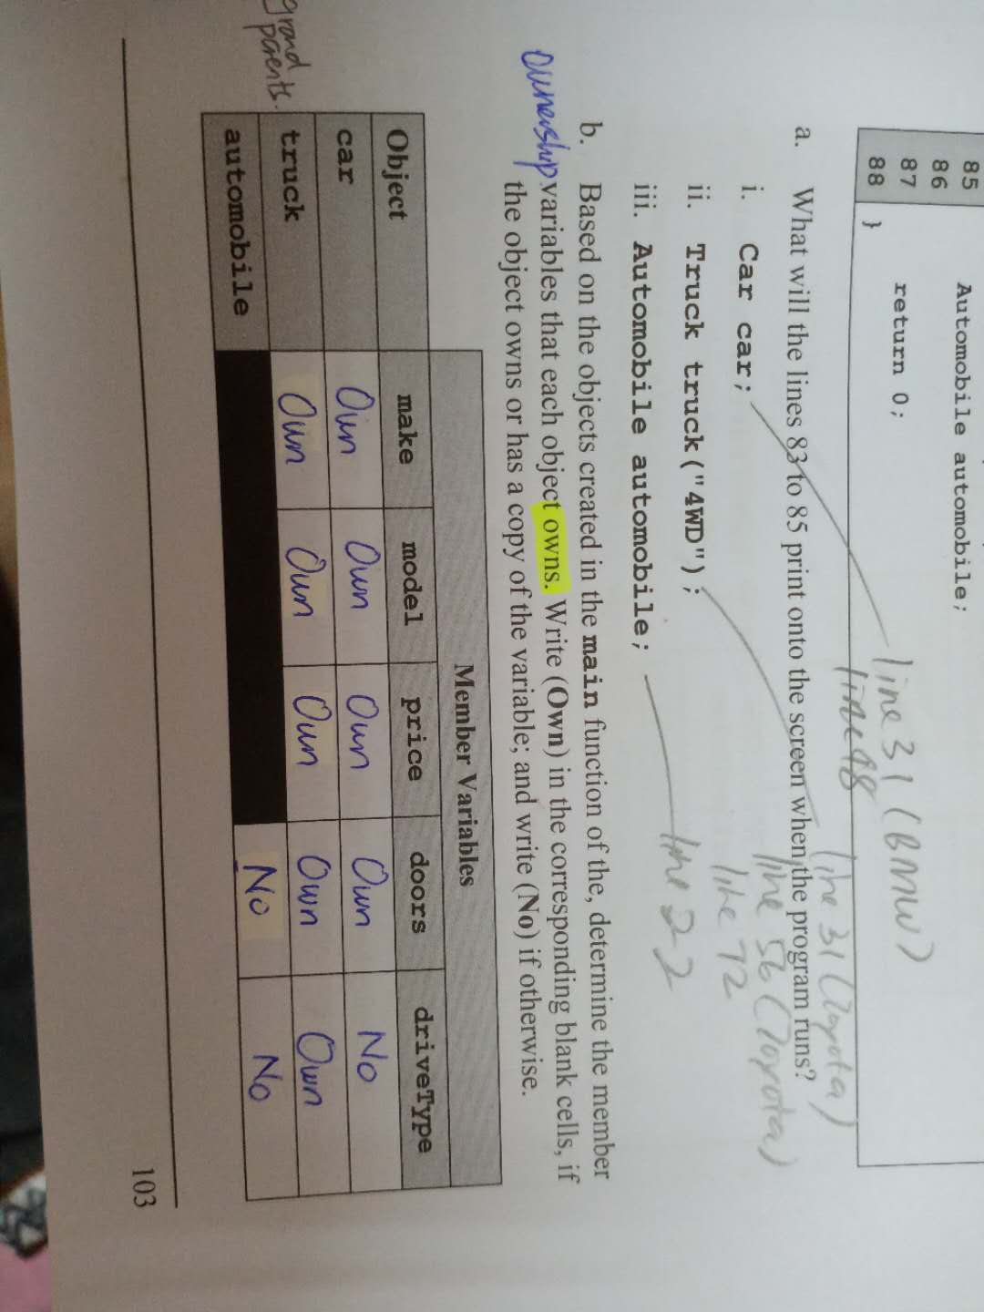

c)
