PG 45
24.
a. Sentinel-Controlled Repitition
b.As a sentinel controlled for the while-loop to be execuated or not. Variables is initialized to 1 so that loop can be run.
c. zero
d.Yes it is.because you can choose to add any weights or not to and it helps you to calculate the average and total weight.

e.
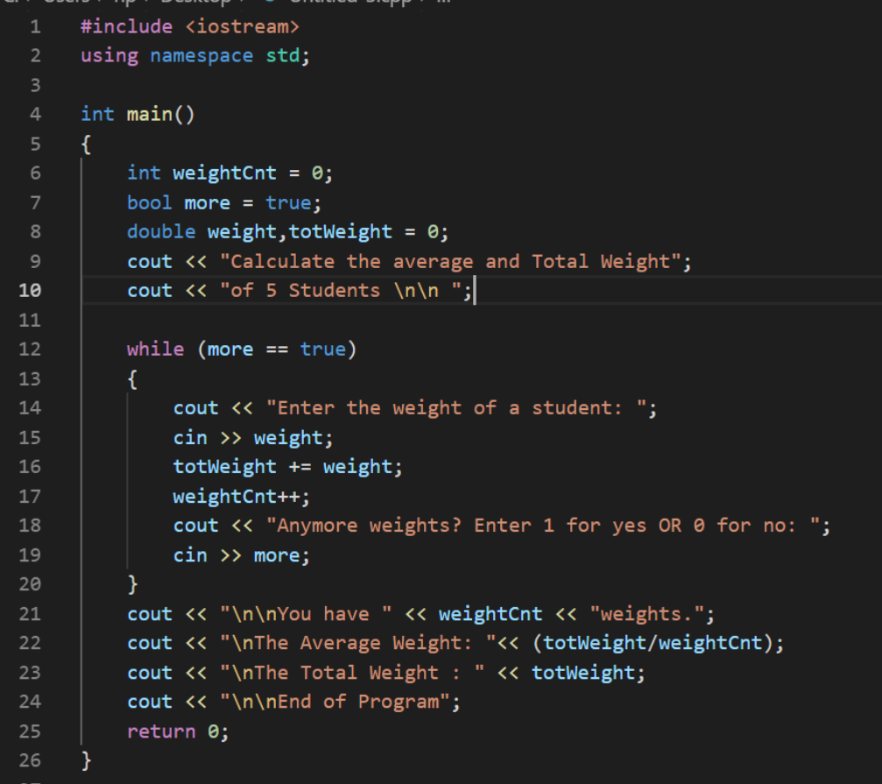

f.