IMPACT PRINTER
MODEL: IBM (4245)

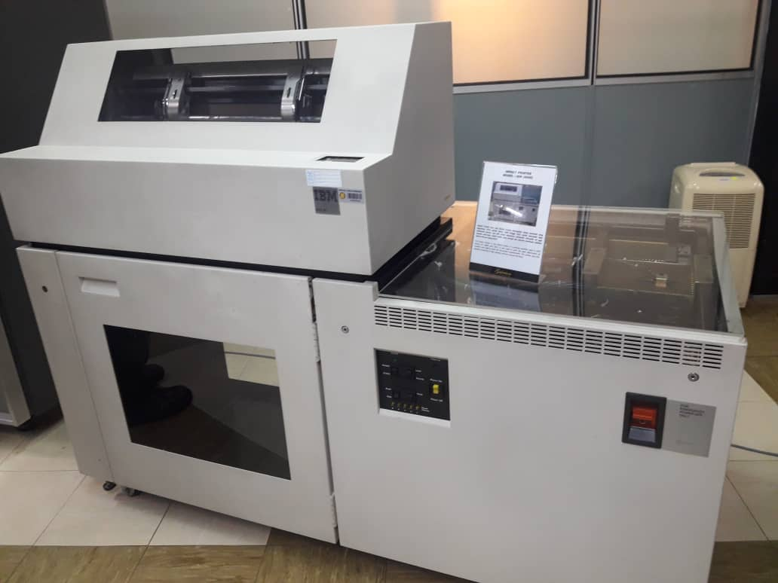

The Impact Printer at Data Matrix Printer is a printing machine used in UTM during the 1990s until 2011. It was used to print the data information of students and staff to meet the University’s requirements. This printer was also capable of printing in high volumes and non-stop for 48 hours.
The Impact Printer using the dot matrix print. In one hour, this printer can printed over ten thousand pieces an very high speed printer.

MAINFRAME DATA STORAGE
MODEL: IBM (9345B22)

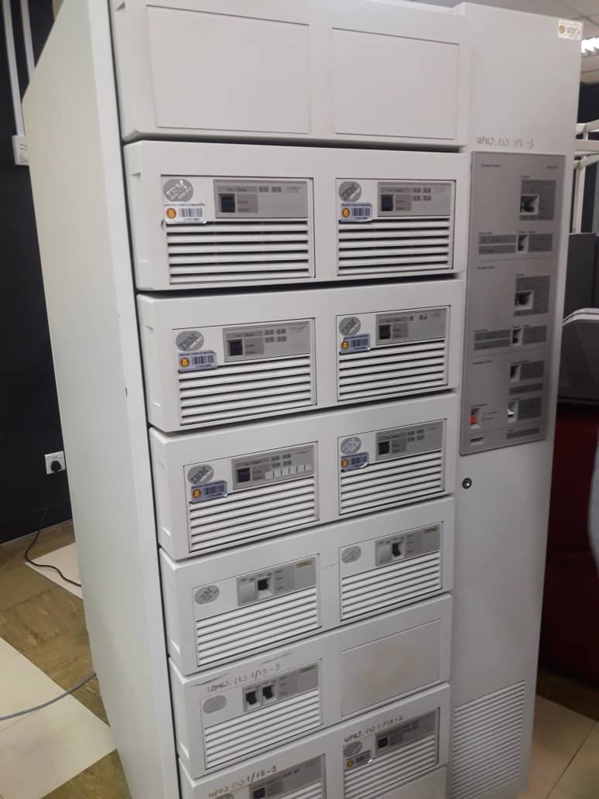

The usage of Mainframe System at UTM began in the 1970s at Computer Office, UTM campus, Kuala Lumpur. It served as a data control of students and the organization.
The mainframe has been used for almost 20 years for various components and functions such as preparing, storing, securing, and printing the University’s information data.
Mainframe is a very big computer after the super computer. In the ICT technology, before we have the computer, we have two area or line for the computer technology. Mainframe is one of the parts of the server. Mainframe have a supercomputer, minicomputer, personal computer and virtual computer.
In our area, mainframe is one set of the computer have a separate equipment. It has backup unit system, terminal, CPU, Hard disk, Network Card and printer.
MAGNETIC TAPE UNIT
MODEL: IBM (3420)

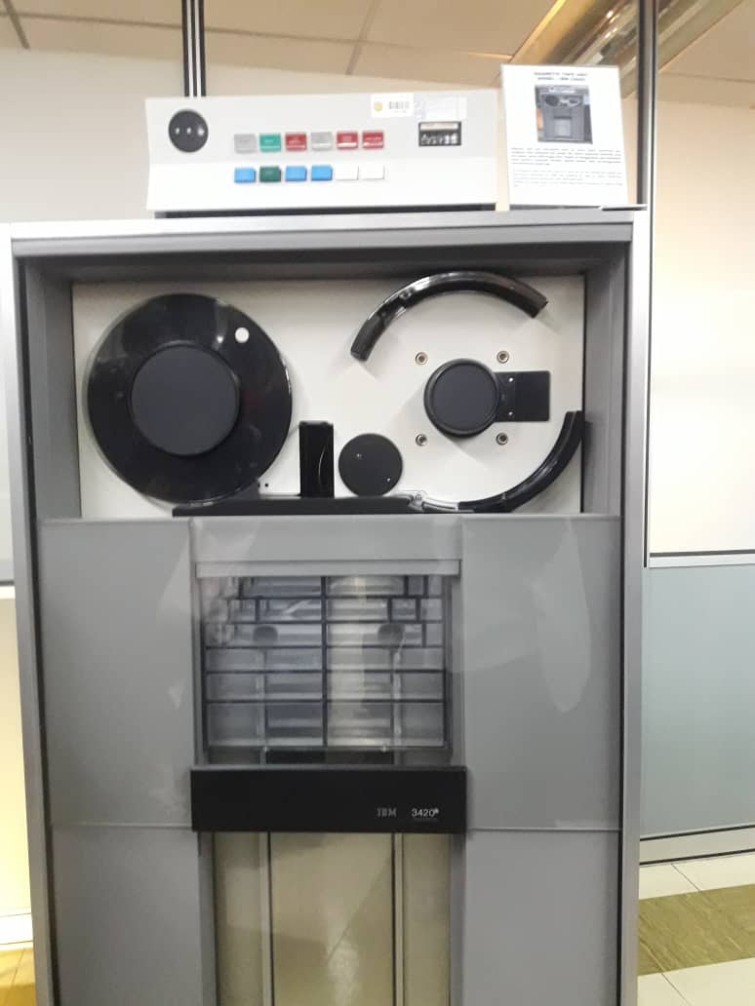

The Magnetic Tape Unit was used as a ‘back up’ for the mainframe system and information database of staff and students as well as other University’s information system during the year 1976 until 2010.
Ignition this model used a round shape tape before converting to square shape tape.

SERVER MOTHERBOARD
MODEL : IBM (5150)

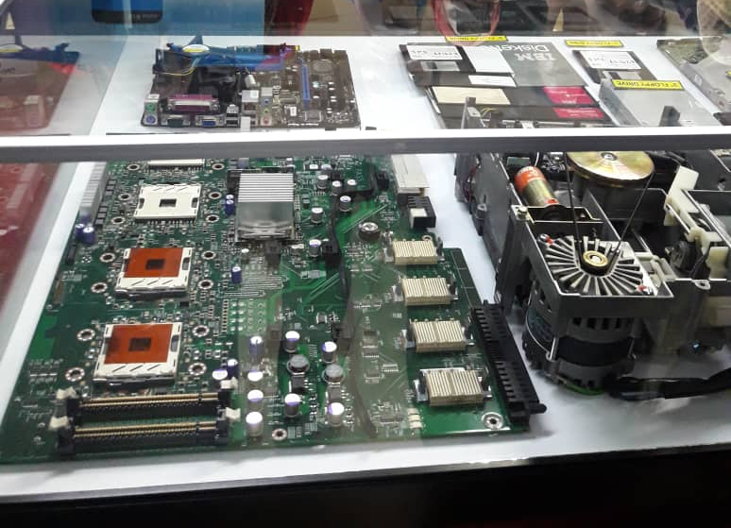

The motherboard for the mainframe have four processor, the reason why server have high device for system application, data analysis and so on. The latest one have 32 processor. For this area, we have cable technology and microfilm technology. UTM has a very big data center compare to other university. UTM have about 700 server.
The floppy disk have 3 type which is 3-inch, 5-inch and 8-inch. In 1997, mainframe using the 3-inch floppy disk but now, the mainframe using the 8-inch floppy disk. The system of mainframe using a disk card.
The hard disk for the mainframe before was very big compare to hard disk now. Before that, the capacity for the storage very small.
Motherboard also has network cable. The orange one is fiber cable and the capacity for the cable is one big above. For the UTP cable is the 100M one big above.Lastly, COX cable is about 10M below. That’s why our network has 10/100/1000. 1000 stand UTP and keysix, 100 stand for the keyfix and 10 stand for the COX. Our technology using mass technology.

