Calendar

Interaction Style:

Instructing

- When students try to Google search the UTM calendar, students can directly get the dates, time of the events and all of the events are stated clearly.
-When students click on one of the columns, there will be a Google map consisting of the venue of the events pointed with a red sign to alert the user. The full name and venue of the event.
-After users click the activity icon they are interested in, a tab will show up. The tab has several commands for users to use. Users can see the details of the event. Users can perform several commands like “ mark it down as favourite”, “add this into my itinerary” and etc etc

Manipulating

-When users open the apps. He can see the calendar of the current month. Inside the calendar, the apps already label down every activity of that month (according to the date). Then users can click on that activity to see detail
-When scrolling down, students will explore more by clicking the source (allevents.in), the students will get the detailed explanation of the event.

Conversing

-In the same time, the title “search by related topic in Johor Bahru” will attract the sight of the students and users and when they click it they can discover more events.

Interface Type:

Data-entry

Users will have an interface that allows them to enter the “Keyword” of activities that they are looking for/interested in. For example, they can key in the date, location and type of activity they are interested in. The apps will search and filter out the events and activities that do not fit the “keyword”. After filtering, it will display out all the activities that fit the “requirement”.
This interface type is suitable because it can reduce the energy needed by Users while using the apps. Users will not waste a lot of energy just to look through every calendar in order to find out the activity they want. This interface type also lets users arrange their schedule more easily. They only look for activities that they are available or have free time to attend.

Graphical

Users will have a graphical interface that just looks like a calendar. Users can click on the date of the calendar. To check whether there is an event on that day or not. users can also check the details of the event in this way. The benefits of having this type of interface is that it simulates what a real calendar looks like. So users will feel comfortable while using the apps. This interface also let the users arrange their schedule better. They can check their availability during the day of the event by just looking at the calendar. Users can also jot down the data of the event and set a reminder
Map
Interaction Style:

Instructing

-The map metaphor like “Grab” and “Google Map” are already labelled a few things such as the event location and dates of that month that allow the user to instruct the systems by selecting options or do the several commands that can give instructions. For example, in Google map apps, we can tell the system to find the basic need for user like finding gas station, groceries, pharmacies and many more by clicking on the button provided so user will not panic if they are at the new places or uncommon places but UTM map can show the location of the UTM event effectively , all they need are clicking the button to find some relevance events on the maps application based on Figure 1. Next, there are 2 buttons that will show the navigation to the user after the user gives commands by clicking that button based on Figure 2. The left-side buttons for showing the details like, how long it will take using car, motorcycle, train and even by walking. Not just that, it can tell the direction path with bright blue color including the time estimation. While the right-side buttons will start the navigation to guide the user. Lastly, based on figure 3 users can give commands to the system to share user direction and also share user real-time location with others so there would be no problem to tell your friend or family members want to find our location.
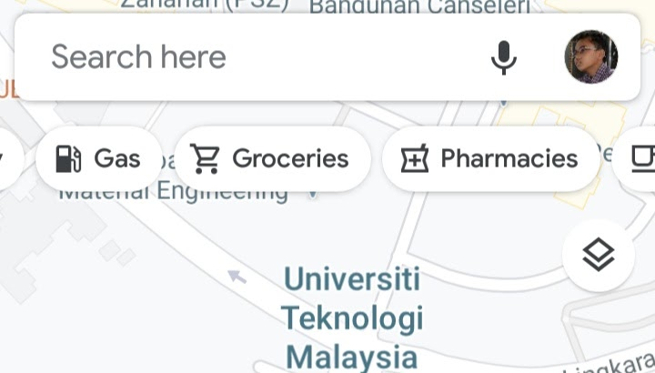
Figure 1: Relevance events/needs nearby detection button
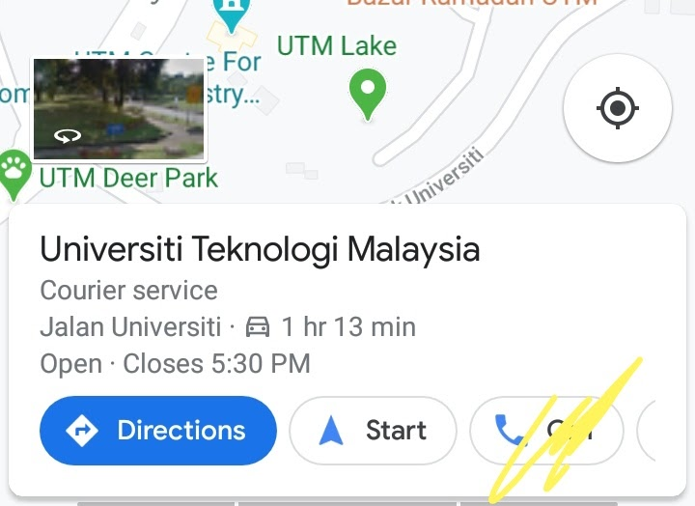
Figure 2:Buttons to show direction and start map navigation
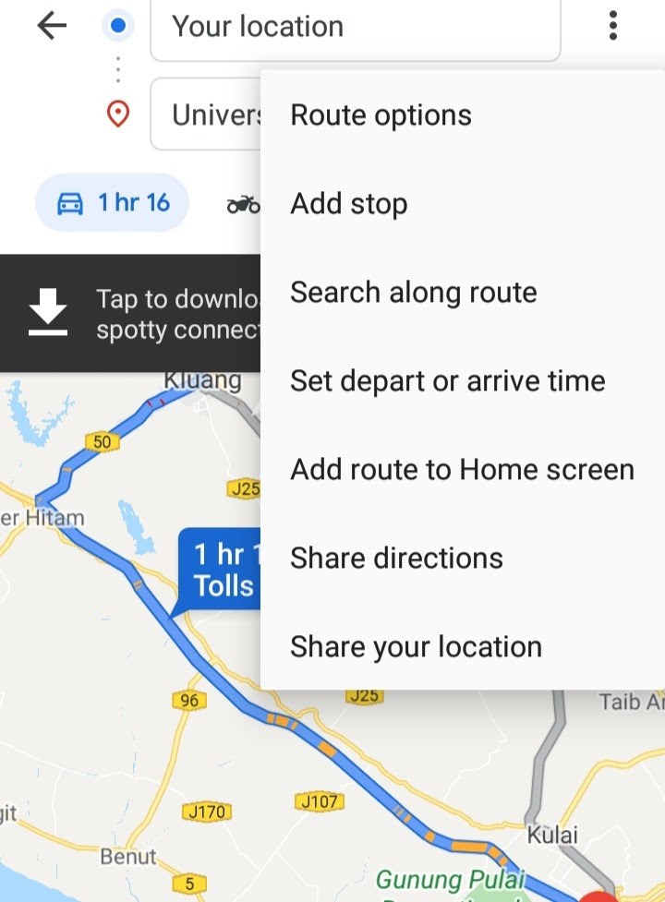
Figure 3: Sharing location instruction

Conversing

It is more like two-way communication in which the system is acting like a partner more friendly rather than a machine that obeys orders. The map system consists of this feature to give a better experience to users. One of the examples is search and filtering. Google maps contains more information and quickly finds what you want by typing in the search box or you can just voice it. Why search and filter is kind of conversing? It is because it can organize results in useful ways like list-based results and the data search in multiple choices to choose. To make it simple, based on Figure 4 when you search the desired location and when you notice that you only press a few letters but then the system displays so many locations that are related when the user enters a minimum number of characters so there is a conversation with the system. UTM students need small steps instead of type the whole location which could not save the time for the user. Same goes to filters, it is more than just an alternative method for searching. Filter allows viewing of groups of related things and finding things that are not easily expressed as keywords. Most filters are implemented such as a checkbox to find predefined categories.
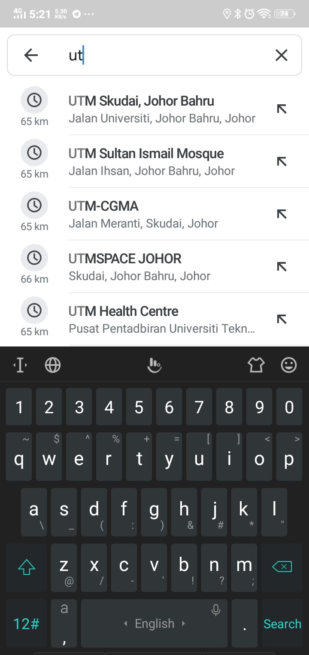
Figure 4: Data search in multiple choice

Manipulating

-This is one of the interactions that is highly motivated to normal uses and they are likely to perform. Basically a map system nowadays is going to support panning and zooming at all. This feature makes UTM students more interactive when using this map to find the location of the UTM events. Map system has selecting, dragging, opening, closing and zooming. We can zoom the map and can see the street names and max zoom can see the actual image of the UTM map. Map is an image. And many people have already gotten used to using applications like google map and grab. They will try to use the UTM event apps based on their previous user experience. So, we believe manipulating by dragging the map and touching the icons on the map is the best interaction style for the UTM event app. After touching/selecting the event icons on the map, Detail of the event and a few commands(like ‘show direction’, ‘add this to your favourite’) will pop up. Users will then know that they just need to press on the button to perform action that they want. Users can drag around to see all events inside utm, users can click on the label to see the detail of the event. Then it will direct the users to a page. Inside the page, there are a lot of commands users can use.

Interface Type:

Graphical

- As humans we are so attractive with visualization, movement objects, and bright color. So this UTM Events app has an attractive map system on work similarly like “Grab” and “Google Map”. We can see that the “Google Map” system also provides small features like a map displayed in night mode but it also can turn to day mode optionally or just automatically when the user turns the setting into default. The map can also rotate automatically when the user or students change their direction to make the user feel more comfortable rather than it remain as a fixed map which is not rotatable and boring. Next, this map system also provides a real rotatable image that can show the exact location just like what “Google Maps” did based on Figure 5.
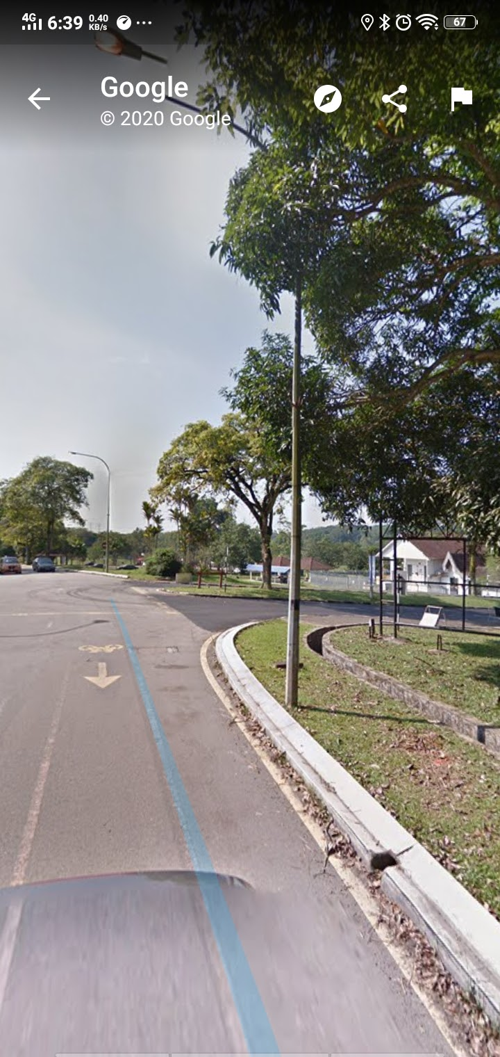
Figure 5: Real rotatable image

Command

-When UTM students or users decide where they want to go. They can give the command easily and effectively to display the direction of the road by clicking the “Direction” icon or even the “Start” icon for instantly the navigation appears. Not just that students or users also can save their location if they want to go there again at another time by simply clicking on the bookmark symbol that represents to save their favorite location. So this would be easier for users to save their time.

Query

-This UTM map system includes the query interface. But why? When the user in case of forget to ask the availability, how the event schedule or any is types of problem with the event organizer or cannot find the contact of organizer in any source. So this is the better solution for those users that want to ask the event organizer by clicking on the phone icon at the pop-up at the down top of the map interface based on the example of “Google Map” in Figure 6.
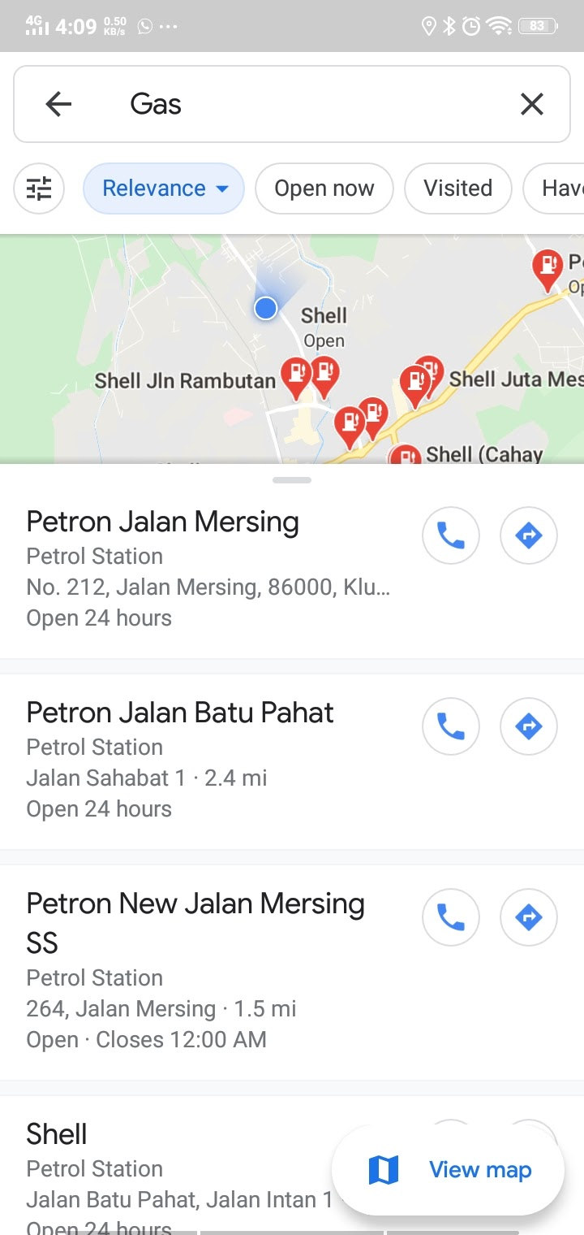
Figure 6: The phone icon refers to contact number

Magazine

Interaction Style:

Exploring

We can interact with the app through exploring whereby we make the interface more of a gesture controlled as if the users are interacting with a real magazine. The events will also be listed and arranged based on their own category, so that users can find out which event is under which category. Moreover, users can easily browse through the category that they like only without having to go through other categories that are not what they prefer. While moving from a page to another, AR can be utilised giving the effects of flipping a real page inside the magazine using virtual hands. Zooming features can also be included with a virtual magnifying glass to help users to read particular details about the event details. Apart from that, with exploring interaction type users are able to watch event teaser videos and pictures to find out more about the event. For example, the magazine contains illustrative pictures.Once users click on it, the picture will pop out and turn it into a teaser video. This type of interaction using the AR capabilities will be much more interactive to be illustrated to the users.

Interface Type:

Menu Driven

In a physical magazine, the arrangement of sections that are categorized accordingly such as entertainment, sports and food, enables users to straight away find their preferences section that they want to read easily and they can just skip the pages that they do not want to read. This will be implemented in the UTM event app, where users can just skip the events that they do not want to know about.

Augmented Reality

In real life, people who have limited vision can just wear a reading glass. As for the UTM event app, to satisfy all users, those who feel the text or font in the app are too small or too big for them can zoom in or out, according to their suitability. The AR technology used in the UTM event app which enables users to flip the page will further help users to feel comfortable while using the app as people would definitely flip the pages while reading books or magazines or in other words, flipping the pages is a must thing to do when reading magazines.

Graphical User Interface

Physical magazines also have teasers-like pictures, usually put at the front page. This is to attract people to find out more about the article and to give a good first impression to them. As for UTM event app, the teasers of events will be in the form of short videos. This will make users feel more excited to join the event as they get to know what activities will be in the event.

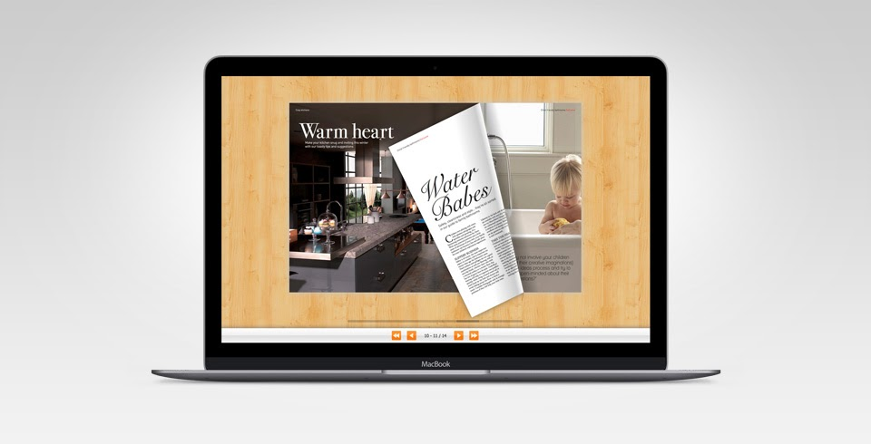
Figure 7 : Virtual Page Flipping

Index
Interaction Style:

Manipulating

Direct manipulation will be a very suitable interaction style for this type of metaphor. This is because users will be able to manipulate by dragging the events and organising them according to their interests or priority. They could also organise them in their most preferred way just like the indexing technique used in books. This will help them to keep track of all the events and does not necessarily miss out on any of them.

Instructing

Furthermore, it will be convenient to be able to instruct the system by selecting options on further action regarding the specific event. For instance, users will be able to share the event with their friends or save the event as a reminder. Able to instruct the system will easily complete the user’s task without any misinterpretation by the system.

Interface Type:

Menu Interface

The interface design will look like the index in any physical notebooks or diaries, where only the title of each event is written on it, and users can see on which page in the book can they find the details about the event. To obtain further information about the event, users have to click on the hyperlink which leads to the specific page where they could learn more about the event including event objective, expected guests of honour, venue, time and many more. This will significantly clear the clutter and enable the users to easily obtain the desired information regarding the event quickly.

Command

The interface should also be based on command from the users through their instructions. This essential for the system to proceed based on the directive of users on what to do next. Command based interface will be a user-friendly system because it can easily understand and follow the orders of the users.
Ask a Question

Interaction Style:

Conversing

-Just like Ava in air Asia, a virtual agent is designed to converse with you to have a better communication when natural language is applied. Give the virtual agent a name like Tava. A chat box will appear when clicking the icon to communicate with Tava. Firstly, there is greeting. Then the user will enter their problems and questions to be asked. Tava will provide some options and the user can get the answers by choosing the options provided.
-Users will feel comfortable and less scared as the message will be seen and replied to in a short time. Things can be solved quickly through conversation in dialogs.
-Users can fill in their name, email address, events interested in a form provided so that UTM understands their interest and it is easier for UTM to send related information for the users.

Interface Type:
- Human talk and ask questions almost everyday to other people. This means that talking and conversing including asking and answering questions are considered as users' daily activities. Asking questions in the UTM event app would be the same as asking questions to someone who is trusted, such as the person working at the customer service in a shopping mall. This will make users feel less anxious, plus it helps to fulfil users' curiosity about an event.

Form fill-in

form fill-in is included. Users normally will fill in their personal information in form so that UTM can know the users well and provide correct information. Filling in the form will make UTM more understand what you want. There are a lot of categories that can be chosen when you are filling in like sports, speech and more. If you are choosing speech, UTM will filter the information and just give you the related information based on your interest. Form fill-on in this UTM event app is just like a user writing down their data in paper fill-in form.

Command line

Tava is a virtual agent who always provides the instruction. When we communicate with Tava, she will ask some personal information and answer your question within 1 second. She will provide users with some options regarding the questions ask and provide an accurate answer for the user. Tava will guide the user what to fill in through the natural language. At the same time, users just follow the instructions given by Tava step by step to solve the users’ problems.

Graphical User Interface

The purpose to have a graphical user interface is that a graphical interface can produce more visual excitement to users. Huaman are humans that heavily rely on their vision. So, a virtual agent with a human look can let users feel more comfortable and enjoyable while using the apps. Users will feel like there is a real human worker ready to provide him help anytime.

Speech

Users can speak to the virtual agents. The virtual agent will process our words through natural language processing and understand what we need.For example, a user said “Show me activity that will be about Technopreneurship”. Then the Virtual Agent will list out all the activity and provide the URL link of each activity. Users can also ask the Virtual Agents to help users perform certain tasks. For example, users can say “Set a reminder of this activity”. Virtual Agent will process the words and then execute the actions.. The advantage of this interface is that users can achieve their needs/execute the tasks by just speaking in a human manner. Users will also feel more comfortable as they will feel like they are talking to real humans.

rs’ problems.

