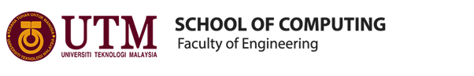
BACHELOR OF COMPUTER SCIENCE
(DATA ENGINEERING)
SEMESTER I 2019/2020

TECHNOLOGY AND INFORMATION SYSTEM
(SECP1513-02)
REPORT
(CICT VISIT)

NAME OF STUDENTS : AINA ALIAH BINTI RUSLAN
NUR HADIRAH MUNAWARAH BINTI ROZMIZAN
SHASITHER A/L SANDRAN
LECTURER : DR. ARYATI BINTI BAKRI
SUBMISSION DATE : 11TH NOVEMBER 2019
SIGNATURE & SCORE :
TABLE OF CONTENT

CONTENTS
Introduction about CICT……………………………………………………………………… 2
Timeline of visit………………………………………………………………………………..3
Organization Structure of CICT………………………………………………………………..3
Services at CICT UTM…………………………………………………………………………4
Detailed description of historical component and appliances……..……………………………5
Reflection……………………………………………………………………………………….17
Task of members………………………………………………………………………………..18

INTRODUCTION OF CICT

Centre for Information and Communications Technology UTM is a support unit providing university staff and students various ICT services, in particular ICT infrastructure, system development and academic / administrative activities to facilitate the teaching and learning process at UTM to be better and technology oriented.
This can also be noticed from their vision which is ‘Digital University Driver’ meanwhile mission is ‘Strengthening academia-centric service delivery through data driven digital ecosystem’.

CICT ORGANISATION STRUCTURE
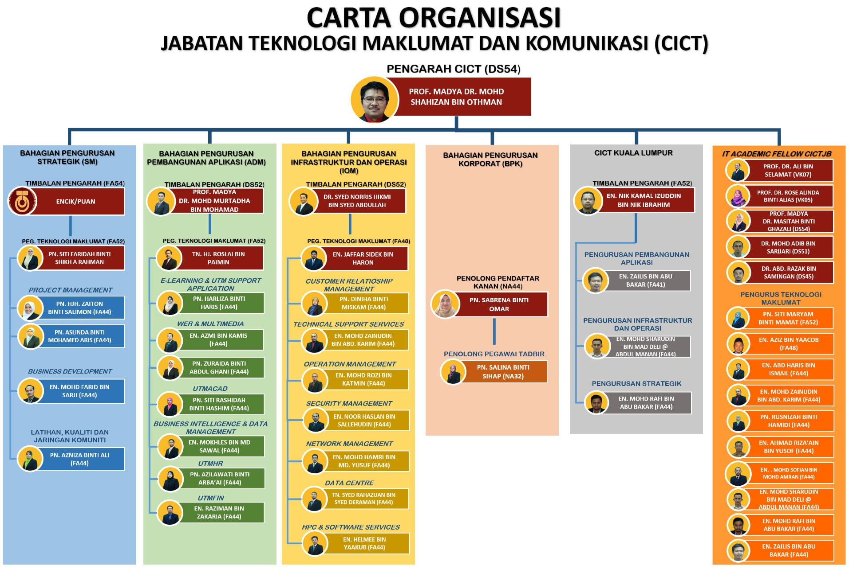
Reference : https://cict.utm.my/organization-structure/

TIMELINE OF VISIT

3.00 pm | Gather at PSZ Foyer, UTM
3.15 pm | Visit to Gallerium CICT in PSZ
3.20pm | Welcoming Speech & Briefing by CICT Representative Mr. Mohd Zahari bin Zainal Abidin
3.30 pm | Tour around Gallerium CICT

SERVICES AT CICT UTM

Centre for Information and Communication Technology (CICT) at UTM plays a premier role as a support constituent that provides various ICT services for the university community which includes UTM Staffs and students. This ICT services consists of Internet & Wifi services, ICT Infrastructure & Security, CRM, Web Management, Application Development as well as ICT Facilities. CICT enable a better experience of ICT Infrastructures and services for the people to facilitate their learning experience in a technological ecosystem.

- INTERNET AND WIFI SERVICES
All the staffs and students in UTM are entitled to use the internet access provided by the university. CICT is responsible to facilitate and ensure all the university community are able to enjoy the access to university internet network. The facilities include dedicated internet access for the residential college users, high speed internet bandwidth allocation, monitor, maintain and manage the networking and many more. The key descriptions about Hotspot@UTM are unified login portal using ACID Account to access internet, enter e-learning webpage and also e-portfolio webpage.

- INFRASTRUCTURE AND SECURITY
ICT Infrastructures provided by CICT are dedicated ACID Account for UTM Students and staffs to access to internet and UTM Web portal. Next, the UTM email which are provided to every student and staff for their academic purposes. The email services is integrated with all Google Cloud Tools and a better reliability since it is powered by Google. Security services by CICT such as firewall policy, URL Filtering, Application Control to reduce the complexity and prevent data breach.

- CUSTOMER RELATIONSHIP MANAGEMENT (CRM)
As part of user engagement and management, they also provide services such as managing university events related to ICT, manage ICT complaints by the users, and also provide services requested by the staffs and students.

- ICT SUPPORT AND SOFTWARES
CICT has dedicated team that is responsible for maintaining and supporting all aspects of ICT within UTM. For example, Business Intelligence Support, Data Management, ICT Consultation and Training. CICT UTM has also been tasked with controlling the Microsoft website for use by all users at UTM. Microsoft softwares is provided for FREE by Malaysia Ministry of Education to all staff and students. The software is available in the Microsoft DreamSpark website where all the information to get the softwares can be obtained at staff email or students’ email.

Reference : https://cict.utm.my/ict-support/
DETAILED DESCRPTION OF HISTORICAL COMPUTER COMPONENTS AND APPLIANCES

PROJECTORS

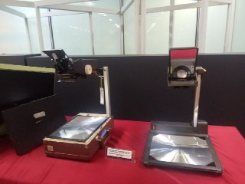

OVERHEAD PROJECTOR (OHP) CABIN-OHP 24F & TRAGBARER OVERHEAD PROJECTOR ANDERS KERN PORTABLE
Made from iron material, glass and plastic. Primarily used back in 1980s and 1990s as a teaching aid during lectures. The projector can be folded and portable to bring along. The projector uses transparencies to project slides.

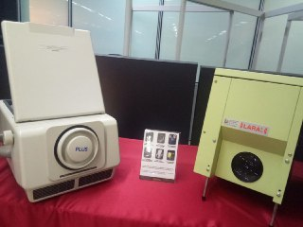

PLUS DIRECT PROJECTOR (DP-10) & PAXISCOPE LARA PROJECTION

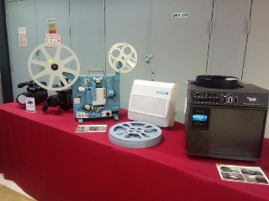

FILM PROJECTOR 16 MM HOKUSHIN

CPU COMPONENTS

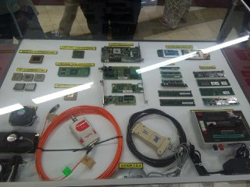

- RAM PC133
- CPU SLOT CARD PGA 370
- BNC NETWORK CARD
- PREPROCESSOR INTEL PREMIUM II
- PREPROCESSOR 386
- PREPROCESSOR INTEL PREMIUM III
- PREPROCESSOR INTEL CELERON
- AMD PREPROCESSOR 486
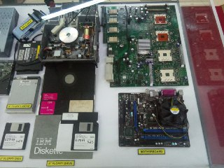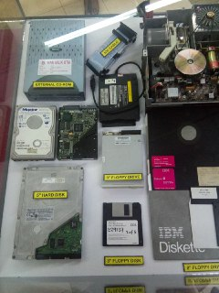

- MOTHERBOARD 5. EXTERNAL CD-ROM
- IDE CABLE 6. 5” HARD DISK
- 3” FLOPPY DRIVE & DISK 7. 3” FLOPPY DISK
- 8” FLOPPY DRIVE

COMPUTERS

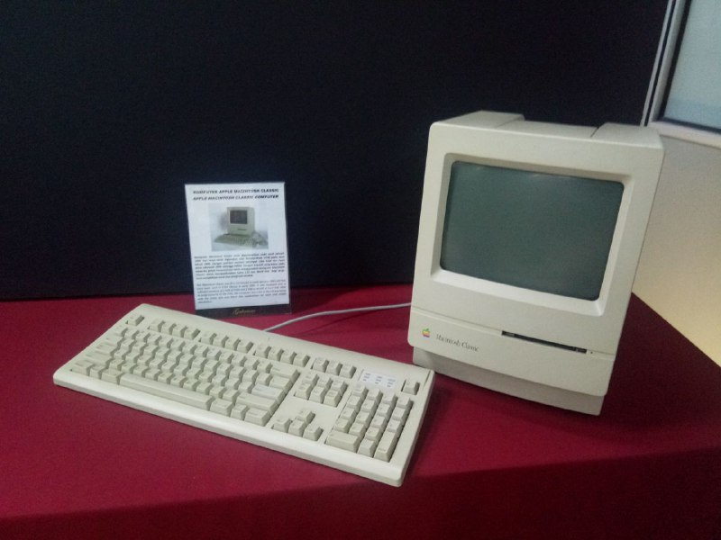

APPLE MACINTOSH CLASSIC COMPUTER
First introduced in January 1984 and been used in UTM Library in early 1990. It has a software memory of 1 MB RAM and 2-40 MB of Hard Disk. The computer was used along with Lotus 123 and Word Star applications for work calculations.
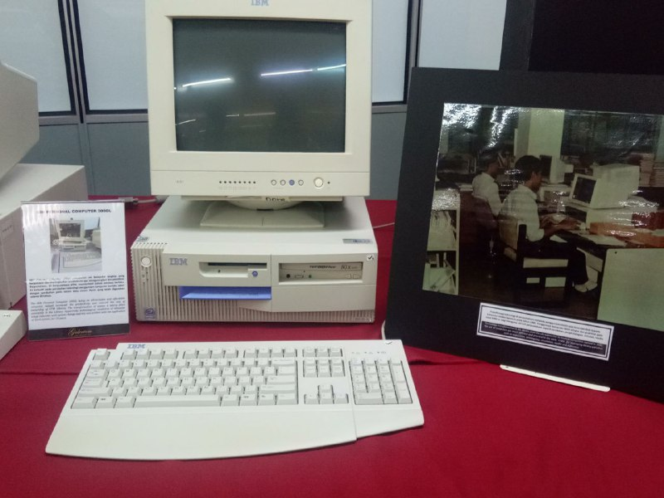

IBM PERSONAL COMPUTER 300GL
It is an all-inclusive and affordable computer, helped increased productivity and reduce costs of UTM Library. Applies application of Dynix System for 10 years.

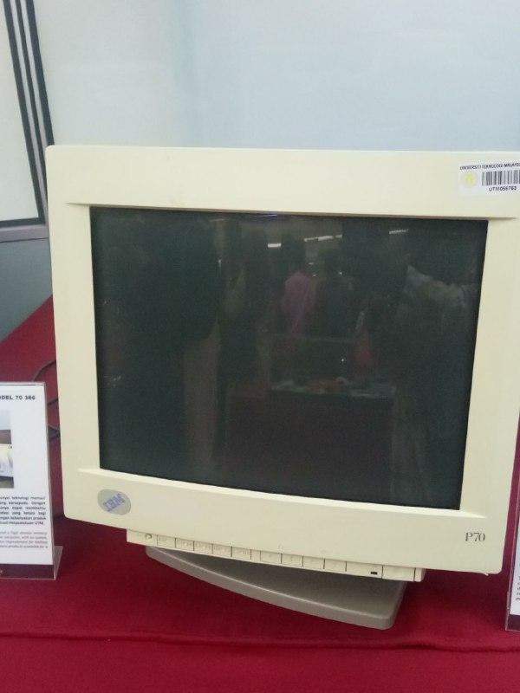

IBM P70 MODEL 6554-673
This model was used at UTM Library in early 1998 mainly contributing to work performance. With its ability to support up to 16 MB on disk storage, the computer system provided a performance improvement on desktop operation.

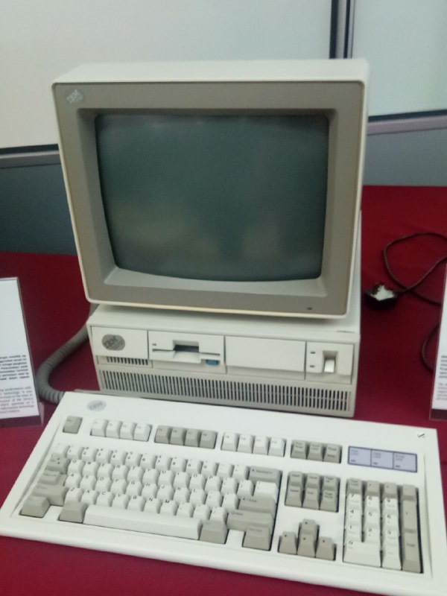

IBM PERSONAL SYSTEM/2 MODEL 70 386
Features a high density memory technology and a range of integrated features. It is also compatible with most software products available at personal computer system in UTM Library.

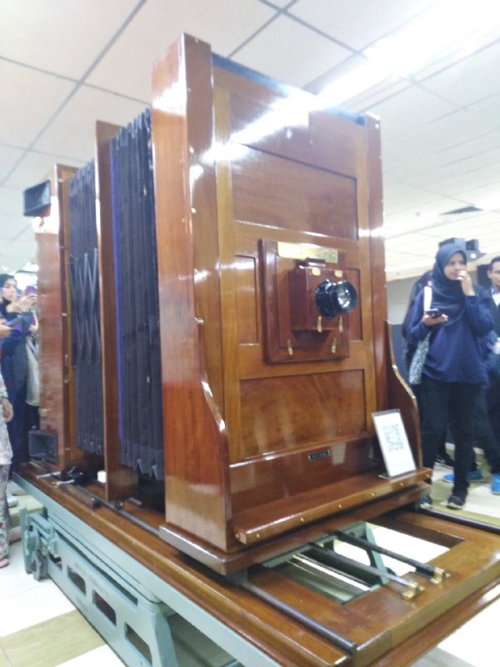

PROCESS CAMERA
A specialized form of camera used for mass reproduction of graphic materials. The original document was photographed and the negatives produced were used to produce printing plates - usually via some kind of process where the negative was put on top of the printing plate and exposed to light.
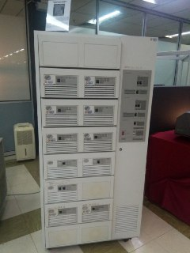

Mainframe Data Storage
Mainframe system was began to be used in UTM in 1970s at UTM Center, KL. It act as for students and staff information. It has been used for almost 20 years in processing University’s information data.

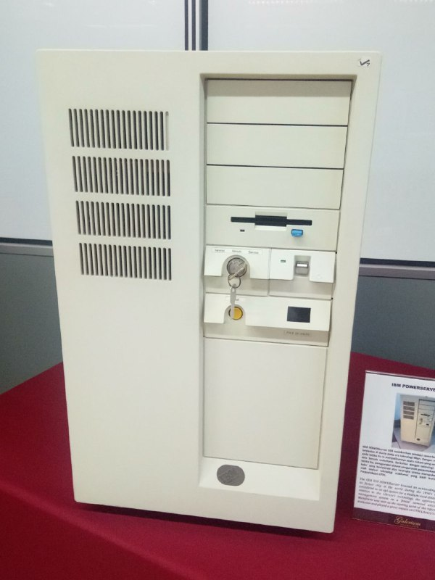

IBM POWERSERVER 550
It had the most powerful and fastest chip in the world during the 1990s. It was considered as an apt system for medium sized-database at the time.
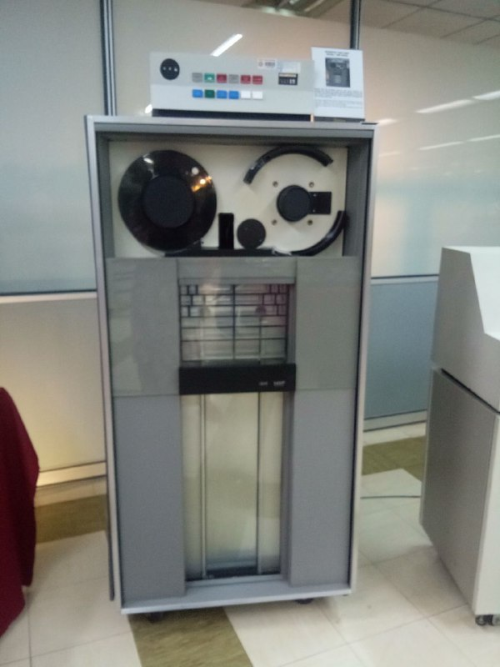

MAGNETIC TAPE UNIT IBM 3420
Used as a ‘back up’ for the mainframe system and information database of staffs and students between 1976 and 2010. Uses a round shape tape.

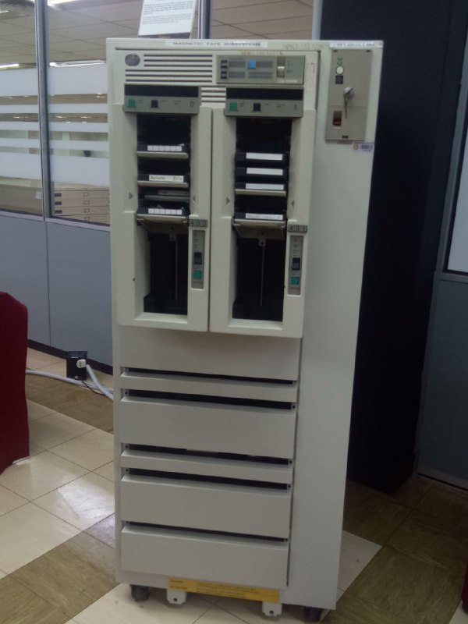

MAINFRAME TAPE SUBSYSTEM IBM 9309
Used as a ‘back up’ for the mainframe system and information database of staffs and students between 1987 and 1995. Uses a square shape tape.

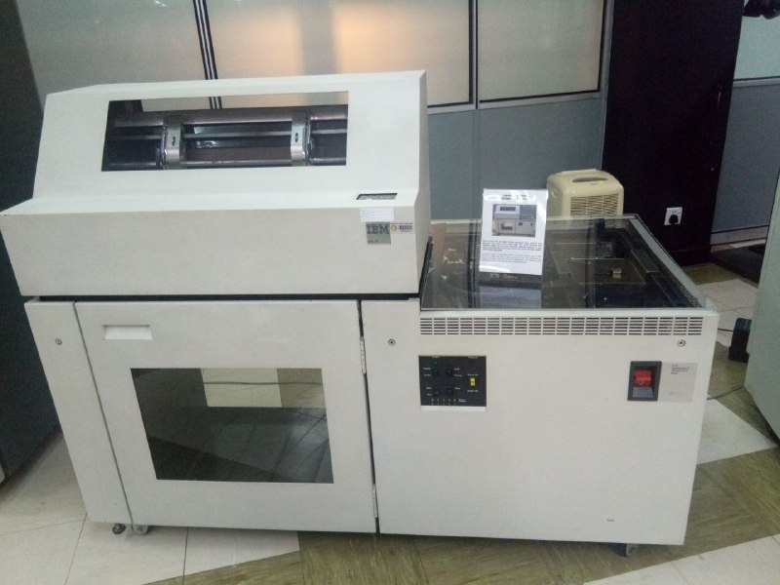

IMPACT PRINTER IBM 4245
Known as Dot Matrix Printer used as printing machine in UTM during 1990s till 2011. Used to print data information of students and staff. Also capable of printing in high volumes and non-stop for 48 hours.

TYPEWRITER

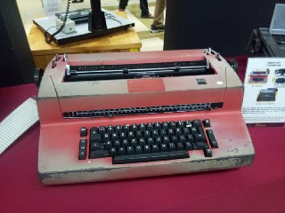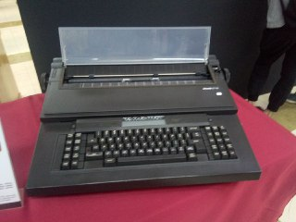

IBM TYPEWRITER & OLIVETTI ET 116 TYPEWRITER
These typewriters are used in UTM Library during 1970s and early 1980s which were used for administrative tasks such as typing letters and memos

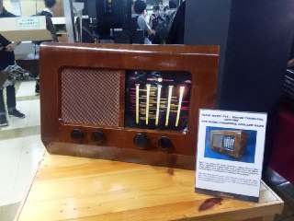

RADIO MODEL PYE - CAMBRIDGE, ENGLAND
This radio was used at Technical College, Kuala Lumpur between 1960s and 1970s. Purpose is to aid the teaching and learning activities as well as a medium of information dissemination.

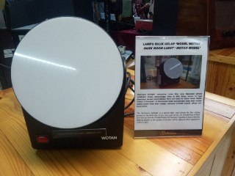

DARK ROOM LIGHT ‘WOTAN MODEL’
Called “Darkroom Safelight” a special light used during the film editing process in the darkroom. Also used during the transferring of films from the box into the “Kodak Prostar II Processor” machine.

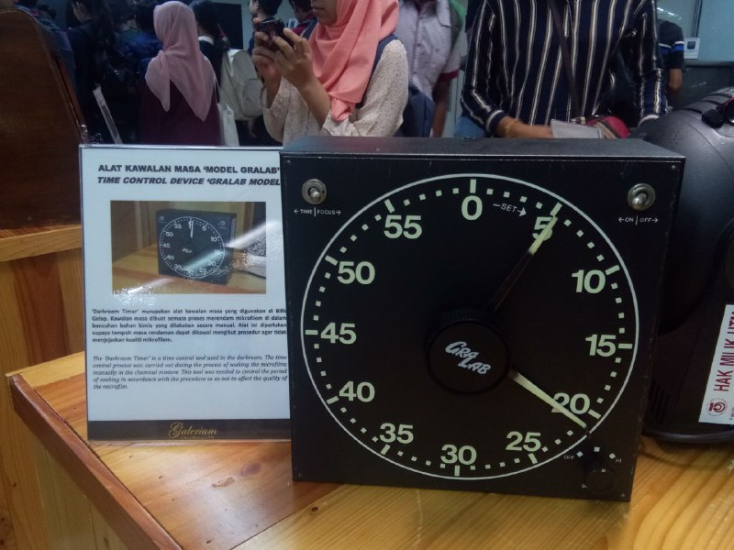

TIME CONTROL DEVICE ”GRALAB MODEL”
Time control tool used in the darkroom. This tool is useful to monitor the period of soaking in accordance with the procedure to not affect the microfilm quality.

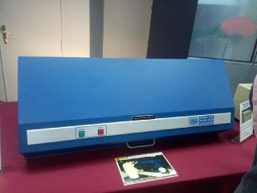

FILM COPY MACHINE “EXTEK 2101 MODEL”
To produce negative to positive microfilm copies. The microfilm negative copies served as references and positive copies are stored in UTM Library collection.

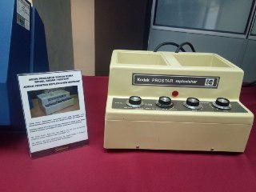

KODAK PROSTAR REPLENISHER MACHINE
To mix two types of chemical components called “Kodak Developer” & “Kodak Mixer”. Then, it will be transferred into Kodak Prostar II Processor to be used during microfilm washing process.

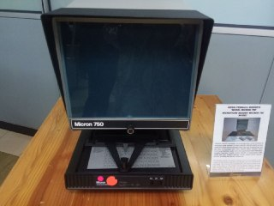

MICROFICHE READER ‘MICRON 750 MODEL’
Used to read the content of Microfiche. It is a source of information in the form of a flat filmed sheet and contained text and images. There are over 500 titles of microfiche available at UTM Library collections covering various sources.

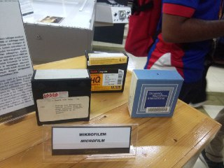

MICROFILM
Media item usually used for learning and reference medium at UTM between 1980s and 2000s.

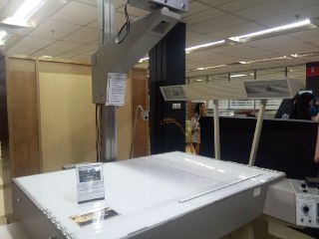

MICROFILM MACHINE “RECORDAK MODEL”
Used primarily to capture small images of UTM theses. The images are then recorded into microfilms or microfiche. First used at UTM Library in early 1980s until 2007.

REFLECTION
What is your goal / dream with regard to your course / program?
This course, which is Data Engineering is a course that we choose to pursue our dream. We want to learn more and gain more knowledge related to this course. We hope that we can get the knowledge about computer, the system inside the computer and other knowledge related to the subject in Data Engineering course and we also hope that we can be a successful data engineer or data scientist in the future. To achieve our dream, we must study smart and apply all the knowledge in our life. Maintain a good result is also one of the keys to be a successful data engineer or data scientist. At the end, we should be able to graduate with a first class degree and secure a career in the data science field.
How does this design thinking impact on your goal/dream with regard to your program?
From this visit, we gained a lot of benefits including tones of information and knowledge. First of all, we can gain more knowledge, especially about the item that was once used before the existence of modern technology. Initially, we just hear from our lecturers about the mainframe, server and so on but during this visit, we can see with our own eyes how the mainframe looks like and also its types and we also can see the other historical components of the computer. Secondly, from this visit we can learn on how the technology has been growing which is from the usage of the computers is very limited until now where everyone can use the computers. It shows the importance of technology nowadays and why we need to be future ready. Before this, not everyone know how to use the computers, only professionals know how to use. But everybody is having their own computers and that’s what makes our life easier. Therefore, we should develop spirit and motivation in our self to study and prepare for the challenges ahead.
What is the action/improvement/plan necessary for you to improve your potential in the industry?
As for the improvement that we can do is we must make sure that we get a good and excellent result so that the industry will recognize our abilities. Aside from the excellent result, our soft skills should also be given equal concern because it is being primarily evaluated by the industries. Good communication skills, writing skills, specializations in various programming languages are vital.

TASK OF MEMBERS

NAME | RESPONSIBILITY
Nur Hadirah Munawarah binti Rozmizan | Cover page, table of contents, introduction, timeline of visit
Shasither A/L Sandran | CICT services & achievement, detailed description
Aina Aliah binti Ruslan | Reflection, task of members

