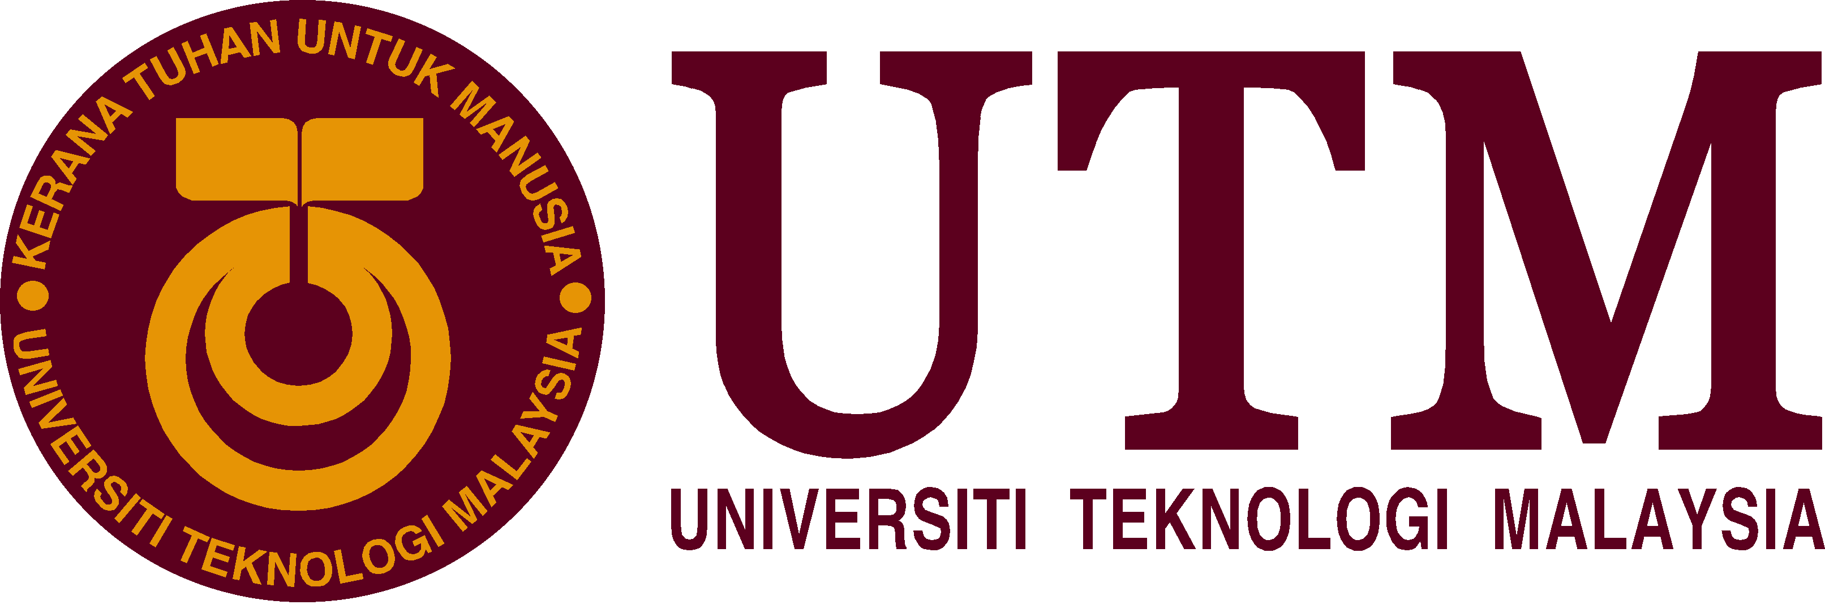

SCSP 1513
SECTION 6
TECHNOLOGY AND INFORMATION SYSTEM

PREPARED FOR:
DR. NORBAHIAH BINTI HAJI AHMAD

( NEW ACEDEMIA LEARNIG INNOVATION) NALI

PREPARED BY:
SUNG SHEAU HUI A18CS0248
NUR FATIN BINTI ROZADIN A18CS0191
SIFRA MANALU A18CS0327
UMI HAIZA BINTI MAHAMUD A18CS0270

Table of Contents

EXECUTIVE SUMMARY 3
INTRODUCTION 3
CONTENT…………………………………………………………………………………………………………………………………………………5
MFRS LAGOON AND THEME PARK: AUGMENTED REALITY + VIRTUAL REALITY 6
WARM UP YOUR BRAIN (WARPUP): A MOBILE APPLICATION EDUCATION FOR ADHD STUDENT YEAR 2 8
PEDAGOGICAL BENEFITS OF YOUTUBE IN IMPROVING HAIR STYLING PERFORMANCE AND INTEREST AMONG LEARNING DISABILITY STUDENTS……………………………………………………………………………………………………………………………..9
TREND IN NALI……………………………………………………………………………………………………………………….……………………………11
REFLECTION………………………………………………………………………………………………………………..…………………………12
REFERENCE……………………………………………………………………………………………………………….…………………………..12

EXECUTIVE SUMMARY
This report is based on the New Academia Learning Innovation (NALI) 2018 that held on 25th and 26th September 2018 at Dewan Sultan Iskandar UTM. NALI is a carnival of innovative and learning practices. We have visited 3 booths among 86 booths. From MFRS Lagoon and Theme Park booth, we knew that it is exploited to an educational game especially for accounting students. It helps the students more understanding on applying the knowledge through the game. Next, Warm Up Your Brain booth has created the application that especially for Attention Deficit Hyperactive Disorder (ADHD). Lastly, YouTube is the way for disabled students to learn hair styling in the booth 17. Trend in NALI is education and playing. Besides, we can see another trend is the digital learning is transform from the conventional learning. Reflection of NALI is we can learn more useful knowledge since NALI is the platform that shared a lot of research and innovation products in teaching and learning methods.

INTRODUCTION
New Academia Learning Innovation (NALI) 2018 was brought by UTM Academic Leadership (UTMlead) that collaborates with School of Education, Faculty of Social Sciences & Humanities UTM and ASIA Technological University Network (ATU-NET). It was held on 25th and 26th September 2018 at Dewan Sultan Iskandar UTM. NALI is basically a carnival of innovative teaching and learning practices. This carnival helps people to observe NALI research and innovation brands in teaching and learning through exhibition and competition.There are about 86 booths that opened for the two days. All booths had its own sharing and presentation sessions about its research findings.

Figure 1 shows the list of booth
CONTENTS
Details of Journey/Work Plan
The three booths that were visited by our group:
Booth 4 | MFRS LAGOON AND THEME PARK: AUGMENTED REALITY + VIRTUAL REALITY
Booth 32 | WARM UP YOUR BRAIN (WARPUP): A MOBILE APPLICATION EDUCATION FOR ATTENTION DEFICIT HYPERACTIVE DISORDER (ADHD) STUDENT YEAR 2
Booth 17 | PEDAGOGICAL BENEFITS OF YOUTUBE IN IMPROVING HAIR STYLING PERFORMANCE AND INTEREST AMONG LEARNING DISABILITY STUDENTS

MFRS Lagoon and Theme Park: Augmented Reality + Virtual Reality
MFRS Lagoon and Theme Park game is an interactive educational game that approach on assets related accounting standards. It helps accounting students in understanding and applying the accounting knowledge.
This game can be played based on the concept of playing monopoly. It is played by 2 to 4 players. It consists of game board and cards which are designed using augmented and virtual reality. By scanning the certain points on the game board and cards, the students will get the instruction to do.
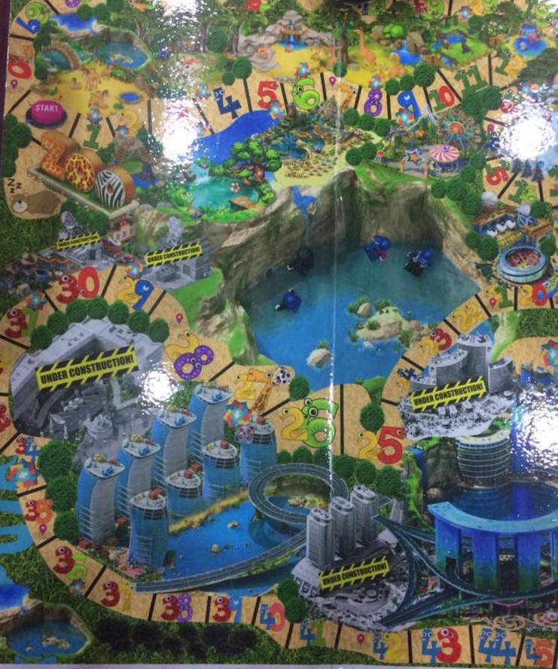
Figure 2 This is the game board look like monopoly game board.

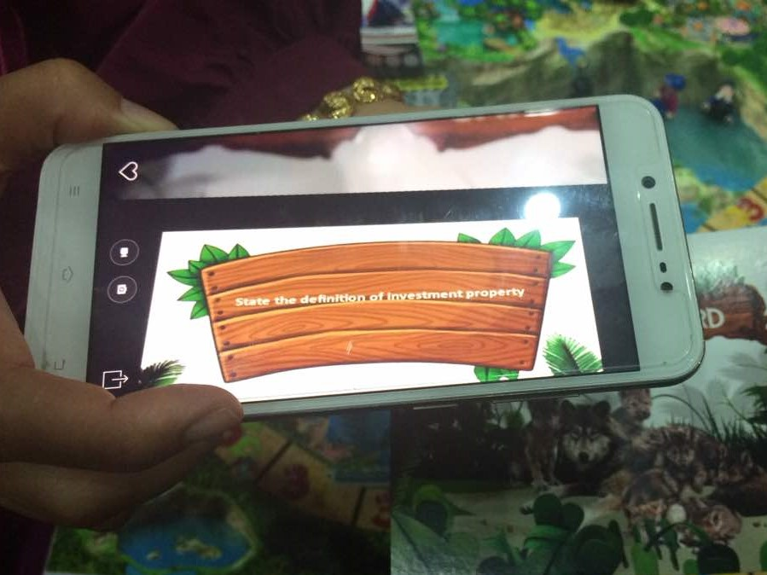
Figure 3 The checkpoint in the MFRS card is scanned and the student needs to answer the question.

After answering the question, the students can buy the assets and earn the money. At the end, one has the highest amount of money and assets will be the winner. This project transforms traditional classroom into digital classroom by using the augmented and virtual reality technology in teaching and learning process. It will enhance students’ academic achievement levels because students will be more interested and motivated. Classes become interactive and thus learning process will proceed faster.

WARM UP YOUR BRAIN (WARPUP): A MOBILE APPLICATION EDUCATION FOR ATTENTION DEFICIT HYPERACTIVE DISORDER (ADHD) STUDENT YEAR 2
Warm Up Your Brain (WARPUP) is a mobile application education to help the ADHD student improved their school achievement especially in term of problem solving, calculation, reading and writing. Attention Deficit Hyperactivity Disorder (ADHD), formerly known as attention deficit disorder, or ADD is a complex syndrome of impairments in developmental unfolding of the unconscious self-management system of the brain. This app can help the students to have fun and excitement while learning besides eliminate the outside distraction and let children engage in a challenging game that help to train their brain.
In this prototype, only four main core subject such as Mathematics, Science, Bahasa Melayu and English are included. When the app started, you will find interesting and colourful front page to begin with. Next, you will be brought to the main page that consist of Bahasa Melayu, English, Mari Mengira, Super Sains and Quiz uji minda. By pressing one of the icon, it will show several topics with simple notes tips that can easily understand by the student and tips and it also contain link of education video based on the syllabus. After studying, the student can test their understanding by pressing the Quiz uji minda icon. In this section, it consists of two types of level which is easy level and KBAT level. There will be a link that directly provided for the student to access the games. In this games, it consists of four different divisions according to the core subject.

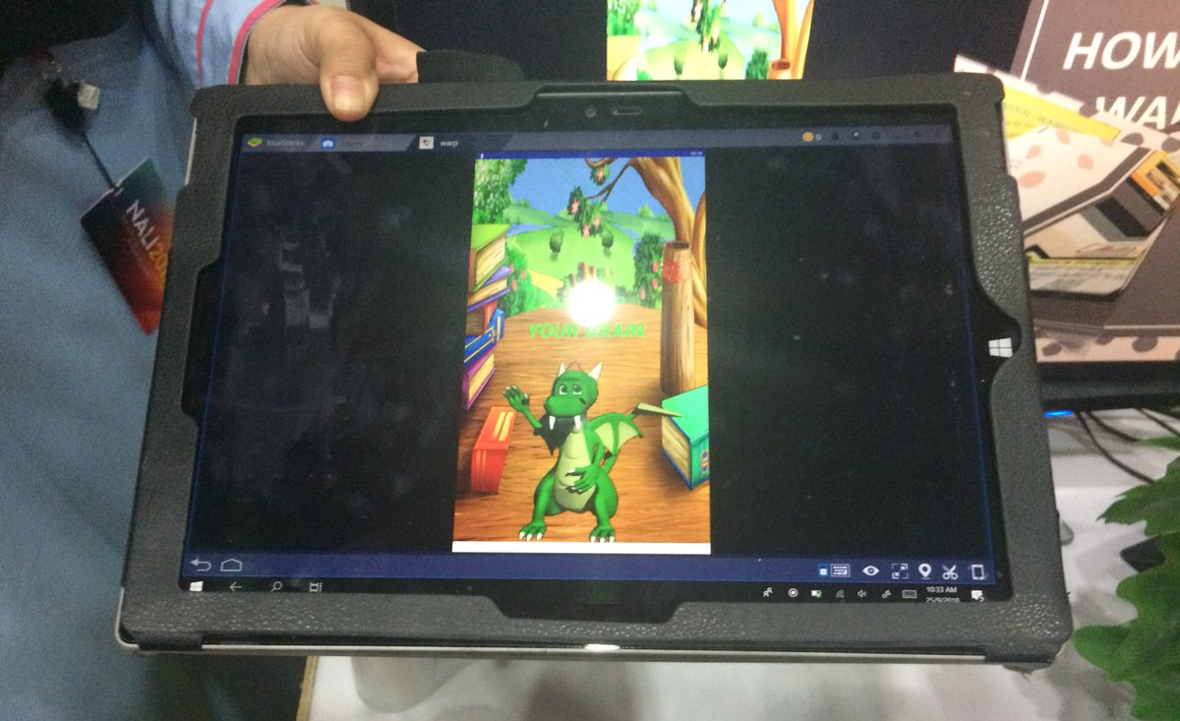
Figure 4 Front page

Figure 5 Main Page
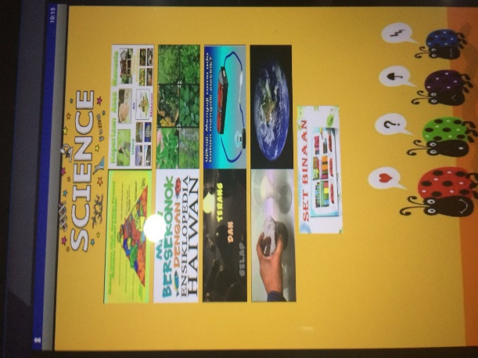
Figure 6 Topics in Science
Pedagogical Benefits of YouTube in Improving Hair Styling Performance and Interest among Learning Disability Students
YouTube has been used in vocational education, which provides online access to vast quantities of free public video in a broad spectrum of topics. Many people especially teacher or lecturer, choose YouTube as a study media. It is because it has a lot of advantages, free, and easy to use. So, this concept is taken by the teachers of SMPK Vokasional Indahpura. They use You Tube to teach their disabled student. They ask their students to watch the given video. And then, they tell the students to imitate what the video show them.
This project is to investigate the difference in hair styling performance after using YouTube among learning disability students and the difference of interest in hair styling after using YouTube among learning disability students.
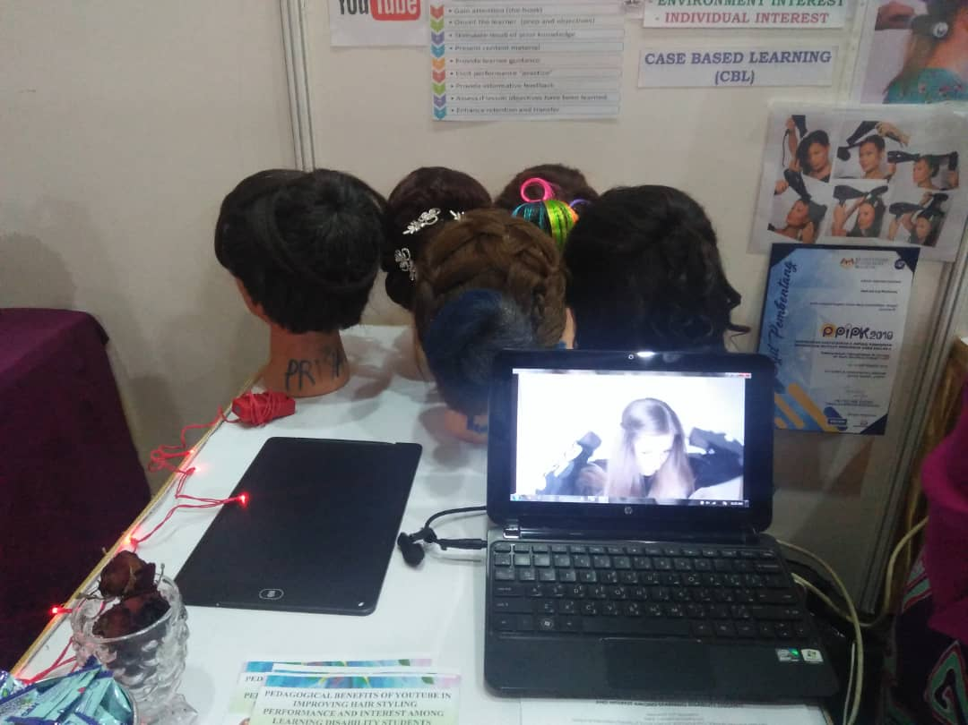
Figure 7 This is one example of student work

This study method got a good effect for the disability student. It is because this method is more efficient. And the students can study more enthusiasts. In addition, the effectiveness of YouTube can be studied to determine its strengths and weaknesses, especially in vocational education for learning disability students. More importantly, the teacher can also use YouTube as an authentic tool for the students to increase their interest and activate the students’ schema to construct the meaning and to provide critical thinking. Students will be more active. The teacher doesn’t need to force them to do something. They will easily do what the teacher says. Related to this, previous studies have shown that there is a positive relation between YouTube and students’ achievement. The findings of this study could also serve as a guide to the Ministry of Education, in particular to the Teacher Training Division, to encourage all language teachers to use YouTube in developing skills among learning disability students.

TRENDS IN NALI
The trend is education and playing. It is because education and playing is basically the main theme between all of the different ideas. This trend is the most common thing we can find in almost all of the booths. As we can see that all three booths visited by us were basically about learning while playing.
Besides, the trend is the digital learning is now transformed from the conventional learning in the previous. For example, the booth 4 is using strategy of the virtual reality and augmented reality. By scanning some certain points on the game board and accompanied cards, the images come to life and students can play the game while applying their knowledge in accounting standards. Next, the strategy of gamification is used in booth 32. The project creates an application that is fun and attractive for children with Attention Deficit Hyperactive Disorder (ADHD). Lastly, the booth 17 is using the strategy of interactive video based learning. That project is carrying out through using YouTube to teach their disabilities students to learn the hair stylin
REFLECTION
NALI’2018 was a very fascinating and interesting exhibition because it presented a lot of useful knowledge for many people. This carnival really helps people to observe NALI research and innovation brands in teaching and learning through exhibition and competition because it came up with a very good explanation by presenter from each booth. It also had been the platform that shared a lot of research and innovation products in teaching and learning methods because there were about 86 booths provided in this exhibition. In addition, this exhibition also promotes STEM awareness among educators in practicing NALI. NALI’2018 definitely gave people a lot of knowledges and ideas on how to be more creative in doing something. For example, it taught us that in learning, we do not always use the books. Sometimes, by playing a game also can give us the knowledge. We will not feel bored easily if we use the playing game method while learning. By being more creative in teaching and learning, many people will feel more excited to learn. It is because not everyone in this world got the same capability to learn, so in order to teach and attract those special people to learn, the educators need to use the right method of teaching. As we can see that in NALI talk series and workshops, all of it provide ways for those educators to improve their proficiency and capability in running through teaching and learning in the 21st Century. It is evident that NALI’2018 was definitely a very good initiative to expose all the teaching and learning practices to people.

REFERENCE
- NALI 2018 Exhibition and Competition. (n.d.). Retrieved from http://ctl.utm.my/nali2018/exhibition/#1536048753220-5bf170df-d03e

