Industrial Exhibition NALI Symposium Day 2019

PREPARED BY GROUP 6:
AARON RYAN SHAMIKA
YU KAH WEI
CHONG HONG LEI
NURSYAFRINA BINTI AHMAD

LECTURER: DR. SARINA SULAIMAN

Technology plays a very important role in our lives in these modern era, especially the generation Z, whose birth year are from mid 1990 to early 2000. Although students can learn theoretically about the technology via the net, they simply do not have the required piece of equipment for better understanding on how to use it and not all university could allocate their budget to provide that specific technology of that particularly field of study. New Academia Learning Innovation (NALI) is a framework designed to make studying interesting to students by using new teaching and learning methods, virtually.

HOLOREAD
Holoread is an augmented reality (AR) based teaching method using hologram. AR shows a 3-dimensional view of the object which provides a more than one viewing angle for people to see the object and allows the user to interact with the object for better understanding about the object. Additionally, by using prism pyramid reflective tool, it provides more than one projection of the object making it practical for teaching or discussion in a group of people. As a result, holoread could be the future tool of teaching in the classroom, providing visual learning in 3D concept for better understanding and a new learning approach with cooperative activity to improve student, especially pre-schoolers engagement in the class.

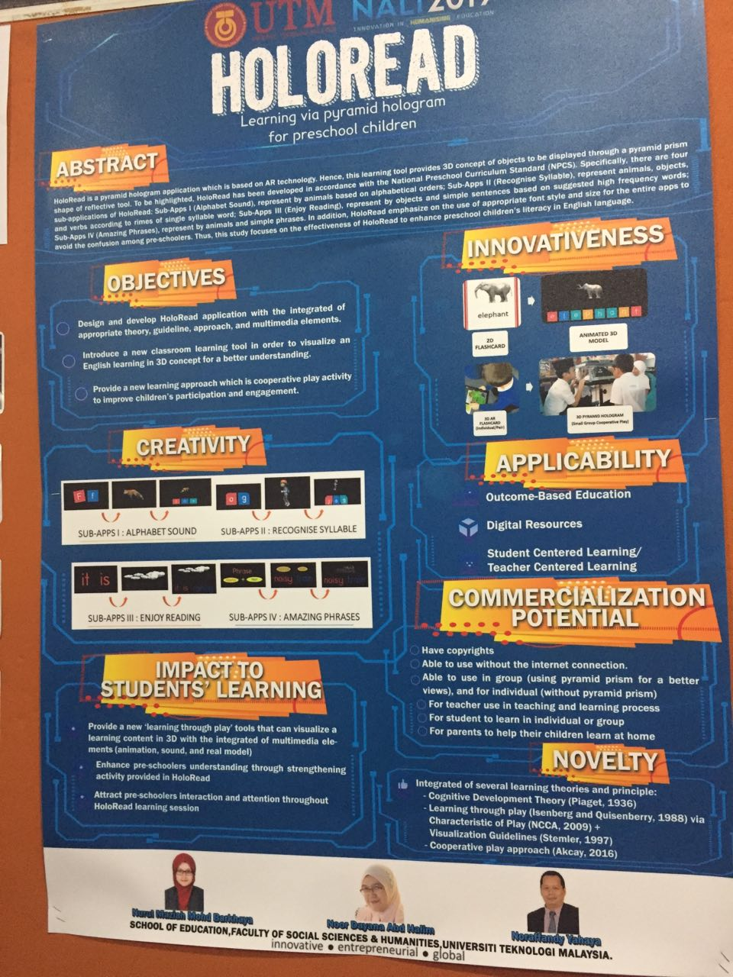

PEER INSTRUCTION LEARNING THROUGH YOUTUBE FOR DISABLE STUDENTS

Peer instruction learning is an instructional strategy, commonly known as active learning that requires students to engage in the class. Peer instruction combines mini-lectures, clicker questions, and small-group discussions to get students actively engaged with concepts to improve their mastery. Peer instruction through Youtube was adopted in teaching and learning activities will helps students have become more productive, creative, and innovative. Students can learn a great duel just by watching videos and learning the thoughts, experiences, and demonstrations of others.[1] Videos can illustrate idea and engage students far more substantially than textbooks, lectures, pictures, or other activities. The videos medium helps students learn by both seeing and hearing, which can be improving their soft skills such as communication and teamwork skills, engaging problem-solvers, as well as continuous and self-directed learners.
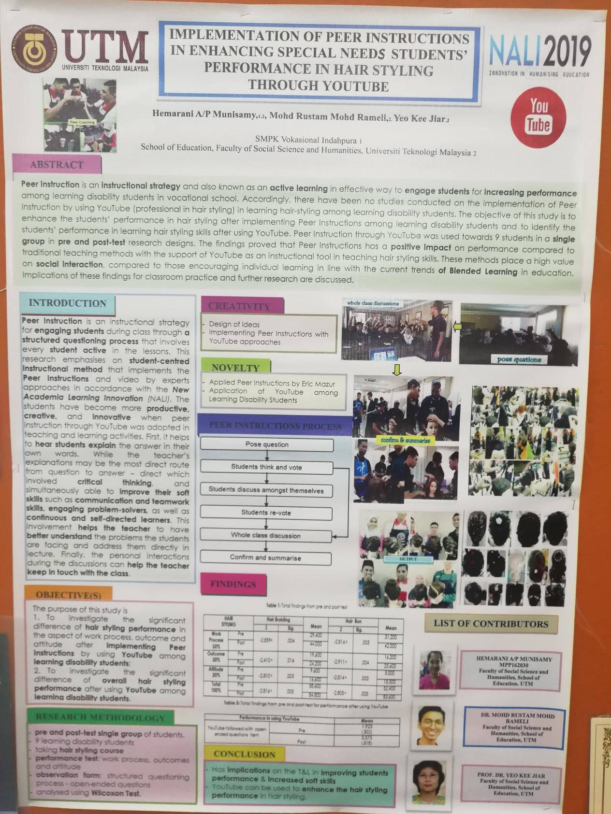

AUTOMOBILE VIRTUAL REALITY MODULE (AVRM)

Automobile Virtual Reality Module (AVRM) is one of the most attractive technologies that we found in NALI exhibition and competition. This project develops a virtual reality (VR) simulation solution for the automobile courses in the vocational education and training area. The virtual reality teaches and trains students about the automobile module. Virtual reality (VR) is defined as a computer-generated simulation of a three-dimensional image or environment that can be interacted with in a seemingly real or physical way by a person using special electronic equipment, such as a helmet with a screen inside or gloves fitted with sensors.[1] It helps a lot in our learning and teaching process.
This automobile virtual reality module has a VR simulation solution relate to automobile servicing and maintenance work processes. Besides, it contains VR program that can train the student to dismantle and assemble a typical automobile system while teaches about components, systems and operations. It is based on academics and industry standards. In this era, robots are replacing humans on assembly lines, more automated systems on production lines and artificial intelligence have been infused into our daily life. As soon, autonomous cars will be a norm and virtual reality will be frequently-used in manufacture cars.
This module can satisfy the needs of all college and university due to its conventional method is associated with high operational cost and insufficient materials. It also a saturated learning method that promoted in IR4.0. To minimize the risk of being replaced by robots, we have to enrich ourselves with the knowledge shown in the diagram below.[2]

Choose a job that robots still can’t do well – focus on jobs that require skills like creativity, problem solving and connecting with people on a human level.

Study data science and/or get a job in data

Keys for human to win a robot

Get familiar with artificial intelligence

Be data savvy – learn how to use data to make decisions and solve problems

With the AVR module, we will know well in current technology development and make ourselves more competitive with others. The application likes product and service training in industry just as a scenario-based approach, trains students to solve major industry problems. Not only this, but the module also encourages students’ edutainment and provide interactive learning platform for them. Academic e-learning for automobile students can be successfully done by having the AVR module especially in the risen of the global e-learning market.
With this approach, students will gain lots of benefits in this automobile virtual reality module. It helps students to discover more local talents and automobile knowledges that are useful for future careers. Moreover, AVRM is cost-effective and it has longer life cycle compare to real automobile components. AVRM also provides minimum safety risk and supervision for students. Unlike the real-life gadgets which are heavier and difficult to handle, AVRM furnishes a medium for students to design and build the automobile system easily. In addition, AVRM is environmentally friendly since it does not produce any pollutants that harm our nature.
Compare to other learning materials such as books and videos, an automotive virtual reality module provides much more on manual operation. Students could be hand-on building the automobile system and yet, it will ensure students to have more real and exciting experience on the field.
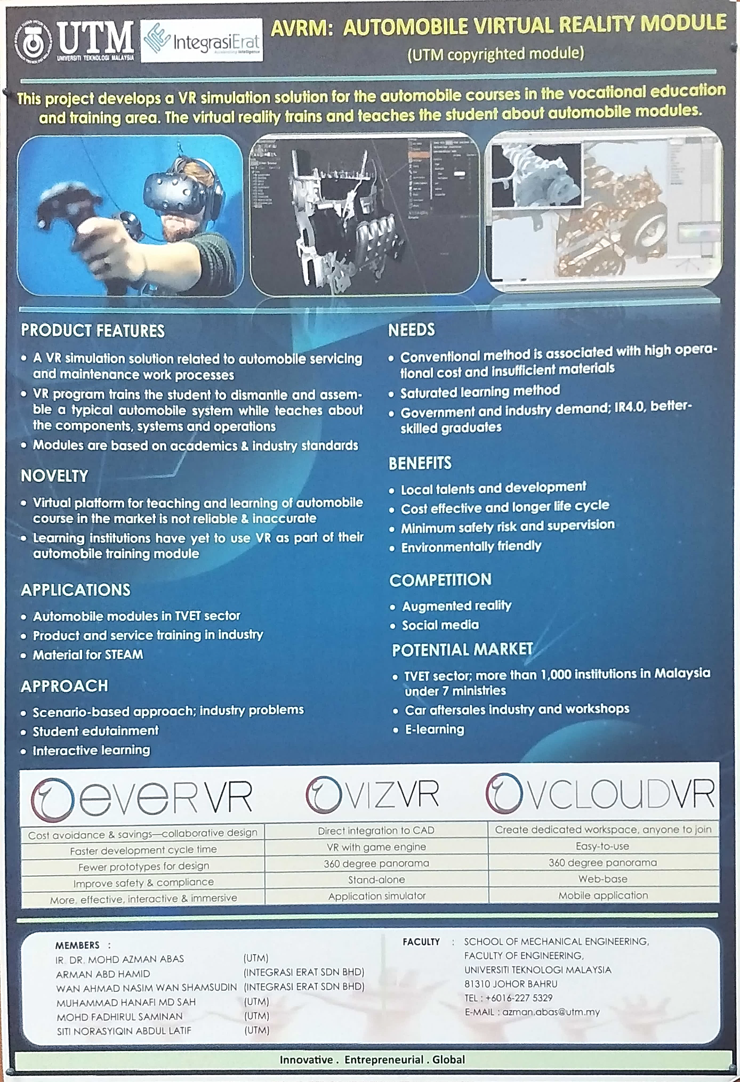

TREND AND REFLECTION
NALI is one of the platforms for sharing ideas and research in teaching and learning with the implementation of technology. Learning strategy such as Critical thinking learning strategy (Cthink) has its effectiveness in enhancing student problem in Integral Calculus. This is not only solution for Integral Calculus, however, it also a guideline for students to develop their own thinking and become more focus on study.
There is also some interesting program, for example, Service-Learning Project that helps to build awareness on impact of image myth toward society. Furthermore, the program empowers us through improving body confident and increasing self-esteem. Through the technique given in this program, students can improve their self-esteem and it is important as it is the key to develop
leadership and communication skills.

REFERENCE
Catapano, J. (2019). Technology in Classroom: Using Youtube. Retrieved from https://www.teachhub.com/technology-classroom-using-youtube
Emilia Mihaylova, editor. Holography-Basic Principles and Contemporary Applications. InTech, 2013.

“The Fourth Industrial Revolution (IR 4.0) and what it means for students like you” (2018, May 2). Retrieved from https://studymalaysia.com/education/top-stories/the-fourth-industrial-revolution-ir-4.0-and-what-it-means-for-students-like-you

