SCSP 1513
SECTION 07

GROUP REPORT:
INDUSTRIAL VISIT TO SENAI AIRPORT

SCHOOL OF COMPUTING

NAME: | MATRIC NUMBER:
MUHAMMAD FIRDAUS BIN NOR AZMAN | A18CS0149
TOON SHU HUI | A18CS0268
CHOY WAN LING | A18CS0049
IDZNI BIN MOHAMED RASHID | A18CS0075

LECTURER:
SIR HAIRUDIN BIN ABDUL MAJID

Table of Content
No | Description | Pages
1.0 | Introduction | 3 – 4
2.0 | Work Plan | 5
3.0 | Content
3.1 | Mission | 6
3.2 | Vision | 6
3.3 | Organization Chart for IT Department of Senai Airport | 6
3.4 | Working Scope of IT Technician in Senai Airport | 7 – 9
3.5 | IT Service Coverage in Senai Airport | 9 – 11
3.6 | Compliance of Senai Airport | 11 – 12
3.7 | Applications and System in SATSSB | 13
3.8 | Data Bases in Senai Airport | 14
3.9 | Challenge Faced | 14
4.0 | Job Specification for IT In Data Science | 15 – 16
5.0 | What Are the Initiatives by The MAB Airlines | 16
6.0 | Conclusion & Reflection | 17 – 18
7.0 | Reference | 19

1.0 Introduction
Senai International Airport^{[1]}, formerly known as Sultan Ismail International Airport is an international airport in the town of Senai, Kulai District, Johor, Malaysia. The airport is located approximately 32 km north-west of the Johor Bahru city centre. In 2017, Senai International Airport reached a total of 3,124,799 passengers and 7,614 tons of freight with a combination of 42,744 schedule and non-schedule commercial aircraft movements The airport is a hub for AirAsia.
History of this airport is by when it opened in 1974, it serves the state of Johor as well as people from the southern states of Peninsular Malaysia. Senai International Airport is the hub of AirAsia.
Today, the airport is managed by Senai Airport Terminal Services Sdn Bhd, one of the subsidiary company hold by MMC Group which took over the operations from Malaysia Airports Holdings Berhad (MAHB) in 2003. Senai International Airport is the only commercial airport that run by private company. Senai International Airport is capable to handle up to 3.5 million passengers and 80,000 tonnes of cargo per annum. There are plans to increase the capacity of the airport to 10 million passengers in the long term and turn the airport into a cargo hub. Recent expansions and upgrades include lengthening of the runway to 3800m and building a parallel taxiway to increase runway capacity.
There are several airlines that serve in this airport in local and international airline such Malaysia Airline Berhad (MAB), Airasia, Jin Air (Subsidiary by Korean Air), Firefly and more that serve passengers for domestic or international flight. This airport also serve flight a cargo to send or received by MASkargo and Raya Airways. Firefly also serve in this airport flight to Subang Airport.
Senai International Airport provide a convenient lobby to waiting the time of departure. It also has a high security to prevent any accident happen. On 26 May 2008, SATS announced a MYR 70 million plan to build an Aero Mall, a stand-alone and external airport mall. The mall will have a retail space of 10,000 square feet (930 m²). Due to be completed in the late 2009 / early 2010 time frame the Aero Mall was officially opened in July 2010.It also hold the hangar for Sultan Johor private jet.

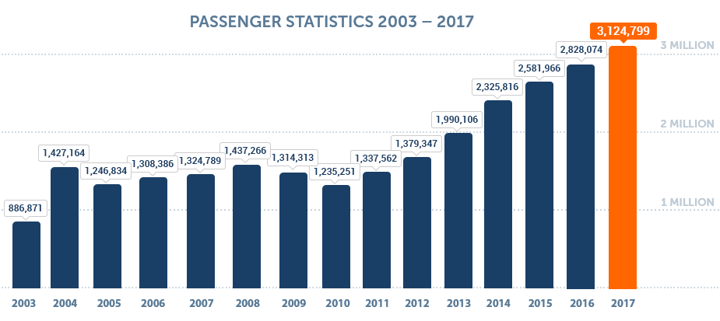

Statistic from Senai Official Website^{[2]}
2.0 Work Plan
On the 7th of December, our TIS subject has organized an industrial visit to Senai International Airport, Johor Bahru. On that day, the bus departed from UTM at 8am and arrived the airport at 8.30am. Upon arrival, we were welcomed to the convocation room and our speaker Ms Fatin has gave us a briefing on the Senai Airport history. Later Ms Mazwa who are one of the IT technicians has explained the IT regarding system and management in Senai Airport. Later Ms Fatin has brought us to visit the airport including the SAFIZ (Senai Airport Free Industrial Zone) and departure hall. The visit ended around 10.30am and the bus depart back to UTM at 11am.
Our group photo taken during the visit to Senai Airport
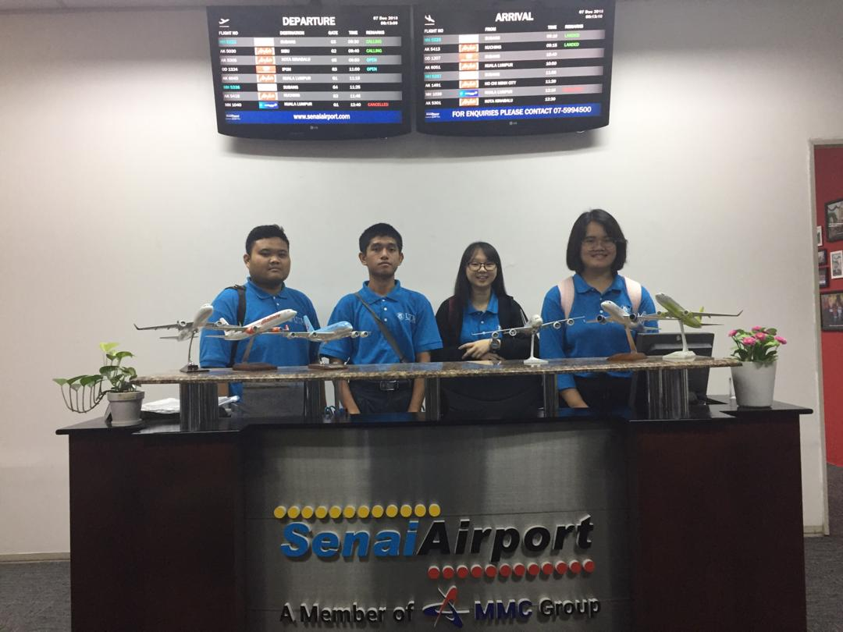

3.0 Content
3.1 Mission:
To deliver the technology and information services to respective department and needed to fulfil the requirements from business needs.

3.2 Vision:
We are dedicated to ensuring the integrity of data, improving the delivery of information, and fostering a bright technological future.

3.3 Organization Chart for IT Department of Senai Airport

3.4 Working Scope of IT Technician in Senai Airport

- Unifi & Wi-Fi
The primary speed of the Wi-Fi in the airport is 100Mbps and a secondary Wi-Fi of speed 100Mbps is also set up in the airport. The Wi-Fi is a service provided by the airport for office use, SBAT (Senai Business Aviation Terminal) and also passengers.

- PC & Notebook
The IT technician are in charge in maintaining all the PCs and notebooks in the airport

- Email
The IT technicians are in charge of the Microsoft Exchange Cloud system which support all the official email of all staff.

- System and Software
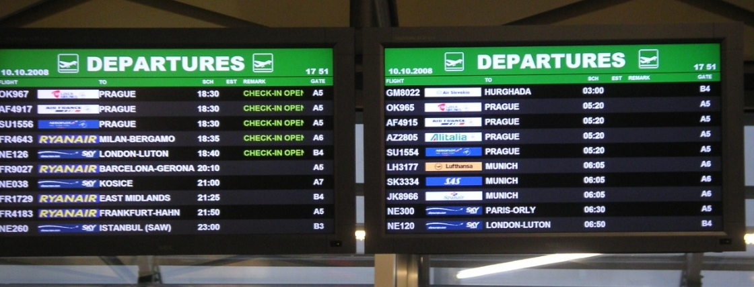
- eFIDS
eFIDS in airport to illustrate flight information

eFIDS is a Flight Information Display System which it is use to manage the flight information system for display and update by customer service or information center. For the ease of passenger, there are plenty eFIDS display in the airport.

- Access Door System
The Access door system in the airport is based on the IBSS.web system. IBSS.web^{[1]} is a browser-based security management system software that provides scalability from access control only applications to a comprehensive suite of fully integrated security solutions.

- CCTV
IT technicians in Senai Airport are also in charge of controlling all the CCTV in the airport. There can control all the CCTV access for the airport security purpose. CCTV is system is very important in maintaining the airport in a secure environment.

- SITATEX
SITATEX® IP^{[2]} is the leading operational mail service in the air transport industry (ATI). It generates and receives ATI-specific Type B messages through an intuitive mail interface. Designed for all airlines, airports and ATI-related businesses, SITATEX IP facilitates both person-to-person and application-to-person responses.

- Maintenance of IT Hardware
- PC
- Notebook
- UPS
- Printer & photocopier

- Network and Cabling
- Switched and router in airports
- Coaxial and fiber
- UTP CAT6^{[3]} which is the unshielded twisted pair category 6 cable which is a standardized twisted pair cable for Ethernet

- Server
- The server in Senai Airport is hosted by Synergy Centric Sdn. Bhd. and managed by SATSSB (Senai Airport Terminal Service Sdn. Bhd.). The server is to collect passenger and cargo data including total passenger and service charged on passenger and cargo.
- The other server example managed by IT technician in Senai is the CCTV. The CCTV record based on NVR which is the network video recorder which required a server for recording.

3.5 IT Service Coverage in Senai Airport
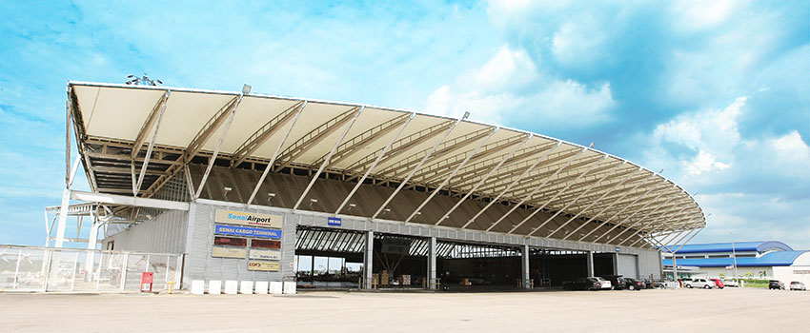
- Cargo Terminal

Senai Airport Cargo Terminal, photo from senaiairport.com

- PCs and UPS
- Printer and photocopier
- CCTV and access door
- Core and distribution switch
- Cabling include fiber and UTP
- Wi-Fi

- SBAT (Senai Business Aviation Terminal)
- PCs and UPS
- Printer
- CCTV
- Wi-Fi

- Passenger Terminal
- PCs and UPS
- Data center
- Core and distribution switch
- Cabling
- CCTV ad access door
- FIDS (Flight Display Information System)
- Astro Screen
- Wi-Fi

- AFRS (Airport Fire Rescue Services) Building
- PCs and UPS
- Printer

- SAEC (this terminal controls the engineering, electrical and mechanical part of the airport)
- PCs and UPS
- Printer
- Distribution switch
- Cabling
- CCTV

- SAFIZ (Senai Airport Free Industrial Zone) Building
- PCs and UPS
- Photocopy
- CCTV
- Distribution Switch
- Cabling

3.6 Compliance of Senai Airport
The airport is complied with ISO27001 Information Security Management System and ISO9001 Quality Management System.

ISO27001^{[4]} was developed to provide a model for establishing, implementing, operating, monitoring, reviewing, maintaining and improving an information security management system. The specification defines a six-part planning process which include
- Define a security policy.
- Define the scope of the ISMS.
- Conduct a risk assessment.
- Manage identified risks.
- Select control objectives and controls to be implemented.
- Prepare a statement of applicability.

ISO9001 is the international standard that specifies requirements for a quality management system (QMS). Organizations use the standard to demonstrate the ability to consistently provide products and services that meet customer and regulatory requirements.

Beside that Senai Airport also has a few policies as demonstrated below:

3.7 Applications and System in SATSSB
3.8 Data Bases in Senai Airport
There are two types of data base used by the airport IT team. One is the Microsoft SQL Server which control Microsoft Dynamics NAV 2009, FIDS and Passenger and Cargo Data System. The other data base is the MySQL which in charge of internal use system such as the CWorks CMMS, ePro HRMS and the attendance system.

3.9 Challenge Faced
During the visit, Ms Mazna has explained that the greatest challenge faced by them right now is that they are short of manpower. Ms Mazna mentioned that she is the only programmer working in Senai Airport hence it is very difficult for her when she needed to take leave or when she is on MC. Ms Mazna also mentioned that she will need to rush back to the company if anything happened to the system regardless of time.

4.0 Job Specification for IT In Data Science
Data science is one of the discipline blends of data inference, algorithm development and technology in case to solve any complex problems. Data scientists are people who expert in technical skills to solve complex problems. They are part mathematician, and part computer scientist. The data scientist role also includes academic origins such as a lecturer and etc.

For this case, no matter what type of company did you work for; you’re likely going to use the tools of the trade. That is mean you need to pro in programming skills.

A good understanding of statistics is vital as a data scientist. You should be familiar with statistical tests, distributions, maximum likelihood estimators, etc. This will also be the case for machine learning, but one of the more important aspects of your statistics knowledge will be understanding when different techniques are (or aren’t) a valid approach. Statistics is important at all company types, but especially data-driven companies where stakeholders will depend on your help to make decisions and design / evaluate experiments.

Understanding these concepts is most important at companies where the product is defined by the data, and small improvements in predictive performance or algorithm optimization can lead to huge wins for the company. This specification needs multivariable calculus and algebra.

It is clear that analytical skills are of huge importance in data scientist. These skills refer to the ability to gather, view and analyse all forms of information in details. Data scientist also means the ability to view a challenge or situation from different perspectives.

These skills are major data scientist skills that make it possible for you to address problems by making decisions in the most appropriate way. Hence, you need to acquire and improve your analytical skills and thinking if you wish to become a successful data scientist.
If you’re interviewing at a smaller company and are one of the first data science hires, it can be important to have a strong software engineering background. You’ll be responsible for handling a lot of data logging, and potentially the development of data-driven products.

5.0 What Are the Initiatives by The MAB Airlines
MAB not only provide employment to become a pilot to fly but we take for example in Senai International Airport also provides services to students. For example, is like providing expert service internships to students.
In Senai, they provide its scope of work. For example, they must ensure that all hardware in proper condition and not damaged if used. Among the hardware that needs to be protected are the personal computer, notebook, UPS, and the printer together with the photocopier.
In addition, they also need to take care of the server frequently. This is because if a server is not functioning properly it can cause a problem data loss either customers or employees. In addition, the server is hosted by synergy centric.
Networking and cabling are also one of the jobs that are available for student internships in working with Senai Airport.

6.0 Conclusion & Reflection

As a conclusion, technology has advanced sophisticatedly from time to time. Senai International Airport used technology information systems and computer systems in conducting the flight progress. From the way of the passengers buy the tickets, until they are safely arrived to their destination, the progresses are all involved with technology information systems and computer systems. These systems are very convenience for people to use and provided a systematic flight progress to allow people having a safe and enjoyable trip.

Reflection in this report, this industrial visit impacts our goals regarding to our course in line with the mission of the Senai International Airport is to deliver the technology and information systems to respective department and fulfil the requirements from business needs. We want to produce excellence IT professionals that will fulfil the need of industry in Information Technology because all the companies nowadays need IT professionals to handle their computer and systems. Once we had the technology skills and ability to solve the IT problems, we can satisfy the business needs.

Our goals also include building a special program that encourages all ages to learn IT and promote IT culture to citizen and society. Through this program we can, invite the community to participate in entrepreneurship in terms of shaping the business using technology and at the same time promote innovation in design technology. Thus, our country will be more comparable in global and fostering a bright technological future.

The actions that necessary for us to improve our potential in the industry is that firstly, we must able to work together with colleagues, respect each other, able to receive advices and give opinion to each member of the group. From here, we can have a good relationship with group members and hence can conduct the group activities smoothly because we can communicate well during discussion.

Secondly, we must always be alert to the growth of technology so that we are always updated and always know the user and business needs and can develop solvation accordingly. This action is very important because the technology is getting improved and we must be able to handle all the technology skills in terms of improving ourselves.

Thirdly, we must always identify the problems frequently faced by an industry in terms of computer technology in order to make a thoughtful problem solving. We must assume that the problems are challenges in our life which we can learn something during we solve the problems.
Lastly, always be active in class and participate in all activities organized by the university. Thus, as a result we are able to build self-confidence and better thinking skills and build smooth communication to communicate with colleagues.

7.0 Reference
- https://en.wikipedia.org/wiki/Senai_International_Airport, last surveyed on 08/12/2018.

- https://www.senaiairport.com/Corporate/Airport-Operations/Commercial-Airlines-Passenger, last surveyed on 08/12/2018.

- http://www.asis-technologies.com/products.aspx?cid=2&tid=78, last surveyed on 09/12/2018.

- https://www.sita.aero/solutions-and-services/products/sitatex-ip, last surveyed on 09/12/2018.

- https://en.wikipedia.org/wiki/Category_6_cable, last surveyed on 09/12/2018.

- https://whatis.techtarget.com/definition/ISO-27001, last surveyed on 09/12/2018.

- https://blog.udacity.com/2014/11/data-science-job-skills.html, last surveyed on 10/12/2018.

- https://www.malaysiaairlines.com/my/en.html, last surveyed on 10/12/2018.

- https://www.coursera.org/specializations/jhu-data-science, last surveyed on 10/12/2018.

