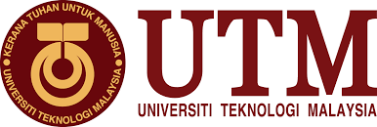

TECHNOLOGY & INFORMATION SYSTEMS (SECP 1513)

INDUSTRIAL VISIT 1: PETRONAS

PREPARED BY
NAME: | MATRIX NUMBER:
THANNEERMALAI A/L UDAYAPPAN | AI9EC0171
FATIMA AZ DZIKRUN BINTI SAHROL NIZAM | A19EC0046
ALVIN HEE JUN SHEUNG | A19EC0015

LECTURE NAME: DR. ARYATI BT BAKRI
SUBMISSION DATE:
Table of Contents
Introduction 3
TENTATIVE 4
ORGANIZATION STRUCTURE 5
ACHIEVEMENT FROM 1974-2019 6
AWARDS OF PETRONAS 8
SERVICES OF PETRONAS 8
WHAT IS GROUP TECHNICAL DATA? 9
REFLECTION 10
FATIMA AZ DZIKRUN BINTI SAHROL NIZAM 10
THANNEERMALAI A/L UDAYAPPAN 11
ALVIN HEE JUN SHEUNG 12
CONCLUSION 13
REFERENCE 13

Introduction

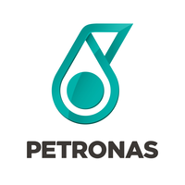
Petronas was established in 1974 and was the largest corporation to date on Fortune Global 500 and the focus was on the upcoming Oil and Gas industry.
Humans are in constant need of energy to carry out their daily activity. Hence the demand for energy is always there and increasing from day to day. Therefore, Petronas is in constant search for energy (Oil & Gas). As a result, Petronas is looking for new solution and are always in search of sustainable energy. Petronas currently has established over 50 facilities all over the world and is still increasing steadily.

TENTATIVE
10 September 2019  2200: | -Gathered at Dataran Resak  -Made a head count  -Boarded the bus  -Departure to UTMKL
11 September 2019  0300 : | -Arrived at UTMKL  -Had a short nap in the mosque  -Got ready  -Had breakfast at the cafeteria
0730: | -Gather and Depart to Petronas Tower
0800: | -Register to visit Petronas Tower
0815: | -Had some light refreshment and prepared for sharing about Petronas Digital Collaboration
0830: | -Talk about Petronas Digital Collaboration Centre
0945: | -Visiting workplace of Group Technical Data in Petronas
1000: | -Sharing session with Senior 4th year in Data Engineering that working in Petronas

ORGANIZATION STRUCTURE

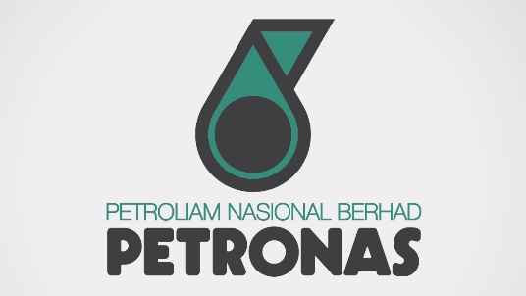
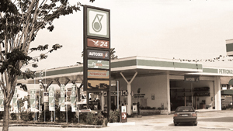
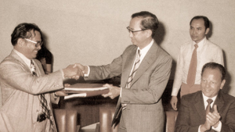
ACHIEVEMENT FROM 1974-2019
1981
Petronas established their first service station in Taman Tun Dr Ismail, Kuala Lumpur, which is still in service and one of many other stations throughout Malaysia.

1976
In the year of 1976, Petronas signed their first Production Sharing Contract (PSC), which led to the creation of PETRONAS Carigali Sdn Bhd.
1974
PETRONAS’S logo was introduced in the year 1974 and was the embodiment of dynamism & forward movement.
1992
César Pelli, the designer of the twin tower, which can be referred to a national treasure of Malaysia was a very important event for Petronas and remains the tallest twin tower currently in the GUINNESS BOOK OF RECORD.
2002
The PETRONAS Petroleum Industry Complex has a world class petroleum based manufacturing facilities with over 41 current installations.
1999
The twin tower was officially opened by our current Prime Minister, Tun. Dr Mahathir bin Mohamad.
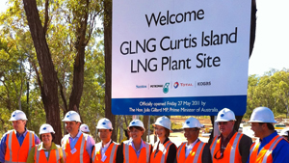
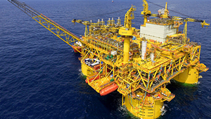
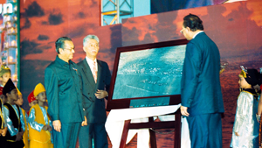
2017
The Malikai field just off the shore of SABAH is the fourth deep water project implemented in MALAYSIA which is 1640 feet (500 meters).
2010
Petronas has invested in Gladstone LNG and Progress Energy, which will strengthen Petronas’s position as global LNG players and this investment, will act as a good and strategic investment in the future.

2019

AWARDS OF PETRONAS

SERVICES OF PETRONAS

WHAT IS GROUP TECHNICAL DATA?
Group Data is a custodian of Petronas Technical Data. This group can access all technical data to devise a strategy on how to filter the mass amount of accumulated data. They also govern and steer technical data including architecture. They also guard and safe keep all vital data to minimize loss of data. An example of data where data engineers and data analyst handle are core samples that were gained from the observation in certain sites. Group Technical Data also does data analytic insights standards and solution development. They also do data services of business units and diagnose original knowledge captured and replication of best practices.

They also have several pledges for 2019 & beyond which are fortify data governance, be brilliant at basics, develop value, co-create analytics solutions, repost knowledge management and enable machine and human data interconnectivity of the future. There is lots of data category that GTD conduct. As an example, geoscience, petroleum engineering, production, operation, MPM data and operation data.

GTD has 70 petabyte of data, which is valued at a staggering RM 80 billion. They successfully curated physical data with their oldest core in service. They also acquire data from 22 partners through technical application. There are roughly 150 staffs currently working in GTD. There are nine staff in management, 33 manager, 85 executives and 7 secretaries. Due to the increase of workload, increment of staffs has happened every consecutive year.

Other than that, there is a small department named as Data OPS. What is their task in Petronas? They do data capture which collects all the data from the observation that Petronas has done from the sample core. They also deliver data inventory and quality from time to time. A data inventory is a fully described record of the data assets maintained by a city. The inventory records basic information about a data asset including its name, contents, update frequency, license, owner/maintainer, privacy considerations, data source, and other relevant details.

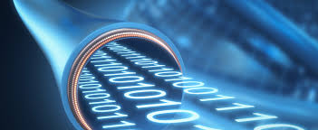
Data OPS also play an important role in Data delivery. Data delivery is the process of transferring campaign data out of the Oracle Data Cloud platform and into your cookie or profile store or to a partner.

Data OPS also do data and technology forecasting. Forecasting methods vary in the way they collect and analyze data and draw conclusions. The methods used for a technology forecast are typically determined by the availability of data and experts, the context in which the forecast will be used and the needs of the expected users

REFLECTION

FATIMA AZ DZIKRUN BINTI SAHROL NIZAM
How this industry visits give impact on my dream/goal?
Through this industry visit, I gain lot of new knowledge that some of it gave me an impact on how to achieve my dreams. One of them is the revolution that Petronas did to improve their achievement year by year. For an example, the invention that Petronas makes to improve their profit really inspired me to always do improvement to make yourselves better. By that, I had planned to keep on improving and repair all my weakness during studies so I will always be aware and not going to do the same mistakes.

Other than that, this industry visit gave me an impact about how to face all the challenges and make it worth it. Like an example, Petronas was collaborated with Group Technical Data to solve the problems about how to restore and keep all the data in this company since the first year they were built. The effort that Petronas did to improve their security of data had opened up my mind to not giving up and there were a lot of alternative to solve the problems. Therefore, I will explore more when I have to study something that are not in my syllabuses since to fit in this industry; I have to be more prepared with unexpected thing.
Moreover, Petronas’ journey gave me big impact on how they try the best to maintain their achievement until now.

THANNEERMALAI A/L UDAYAPPAN
As a data engineering student my dream in life down the road is to start a start-up business in this field, because my interest lies in data and programming, hence I have a dream more focused on business.
I have learnt a few things through this visit to PETRONAS. First, it taught me what kinds of employees PETRONAS is always on the lookout for. So, I hope within the next 4 years. I will be able to acquire skills that will help me be employed and gain experience before I set out to begin my own start-up.

This might give me a head start when I’m trying to start my own start-up, in which I hope it will prevent me from doing some of the silliest, simplest and common mistakes many start-ups do due to lack of experience. Next, it also showed me how a multi-billion dollar company sets up its hierarchy, in other words, its organization structure.
In a company, its hierarchy is very important backbone to the company thus learning about PETRONAS’s organization structure will prepare me for the future and help me with my journey.
​In my humble opinion, there are quite a few things for me to work on before entering the industry for my internship and so on .First of all, I believe that it is necessary for me to master PYTHON as per my seniors suggestion whom are currently interning at PETRONAS. In this tech savvy world, I can easily learn this programming language through the help of Internet.

ALVIN HEE JUN SHEUNG
First, I am feeling glad to have a chance, paying a visit to Petronas. Throughout the whole sharing sessions done by the Petronas staffs, I understand that how big data can play a vital role in the oil and gas company. One thing that impacts me the most regarding my goal from this visit is to never settle enough of what I currently possess in terms of knowledge, because it will never be enough until the time I realize it, so when the opportunities come to me, I am fully prepared to accept whatever it takes to become a good student in, or even a good employee in the industry.

Next, in order to make myself a better person that fits in the industry well, one way is to master all the skills required by the industry. From the visit, I know that computer languages like python, java script are the languages that are used frequently in the industry. Hence, by mastering skills mentioned, it will greatly elevate the chances of being hired by a big company. Apart from that, having a good attitude matters the most because one’s attitude will determine the altitude in the future. Having good attitude in work covers many aspects including time management towards handling a project.

CONCLUSION
In a nutshell, we truly appreciate for having a chance to visit PETRONAS klcc, although it lasts within 2 hours, but overall the insights, experiences that we have gained from the sharing sessions done by PETRONAS staffs were precious enough and I sincerely believe it will greatly benefit us upon when we graduate from UTM, step inside the real life working environment. As a data engineering student from UTM, we promise to put lots of effort in our academic not only getting flying colours in every exam but also actively participating events that are closely related to our field. Day after day, I believe we will be an all-rounder of data engineer, continue contributing something bigger in the field of big data and AI thus making our country shines bright at the stage of international.

REFERENCE
Essays, UK. (November, 2018). Introduction Of Company Petronas Commerce Essay. Retrieved from https://www.ukessays.com/essays/commerce/introduction-of-company-petronas-commerce-essay.php
Petroliam Nasional Berhad (PETRONAS) . (2019). Abou us MILESTONES. Retrieved from PETRONAS: https://www.petronas.com/about-us/milestones
Petroliam Nasional Berhad (PETRONAS) . (2019). AWARDS & ACCOLADES. Retrieved from PETRONAS : https://www.petronas.com/about-us/awards
PETRONAS Dagangan Berhad. (2018). TECHINICAL SERVICES. Retrieved from PETRONAS: https://www.mymesra.com.my/PETRONAS_Aviation-@-Our_Services_-%E2%97%98-_Other_Offerings.aspx

