SECP1513-TECHNOLOGY AND INFORMATION SYSTEM
SEMESTER 1 2019/2020
_____________________________________________
Industrial Visit 1 – CICT UTM
REPORT
NO. | NAME | Student ID
1. | ABIR BIN RAHMAN BHUIYAN | A19EC4025
2. | EYU SI XIONG | A19EC0044
3. | MUHAMMAD NAZREEN BIN MUBIN | A19EC0104
4. | TENG JIA JING | A19EC0208

LECTURER’S NAME: Dr.Haswadi bin Hasan
SUBMISSION DATE: 13rd November 2019

INTRODUCTION

A regard and appreciation for Dr. Haswadi bin Hasan and Centre for Information and Communication Technology (CICT) for the opportunity to join the industrial visit that was on 20th of October 2019 that should be carried out at CICT but instead was held at level 2, UTM Gallerium, Perpustakaan Sultanah Zanariah (PSZ), Universiti Teknologi Malaysia (UTM) because of some circumstances.
CICT is one of the units in Universiti Teknologi Malaysia. CICT plays the roles by offering and delivering ICT services for the staff and students in university especially in ICT infrastructure, system development, and academic or administrative activities. For example, Internet and Wifi, infrastructure, security and so on.
In the galerium, we saw a lot of IT gadgets and components used by UTM before. These are a lot of historical collections in the galerium. The staff gave the description and told us the history of the devices.

Film Copy Machine ‘ EXTEK 2102 Model’  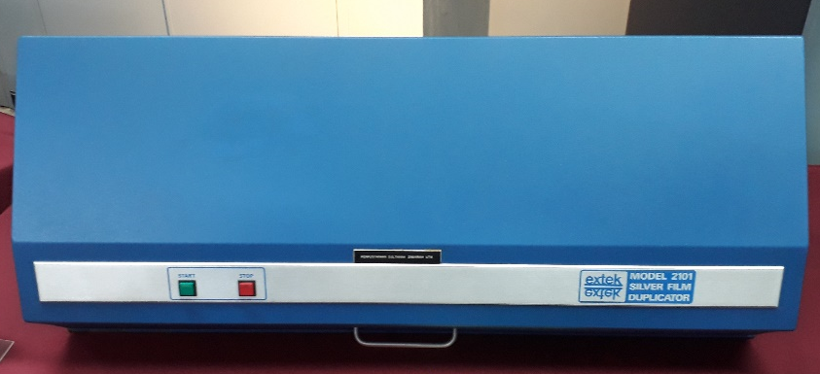 | The ‘Silver film Duplicator’ is a machine used to generate negative to positive microfilm copies ( basically a machine that makes copies of documents and other visual images onto paper or plastic film ). The negative microfilm copies served as references to users while the positive copies were shared in UTM library exception collection. The aim of this copies done was to make sure the preservation for original copy of UTM thesis and do not lose from UTM library collection.
Microfilm Machine ‘Recordak model’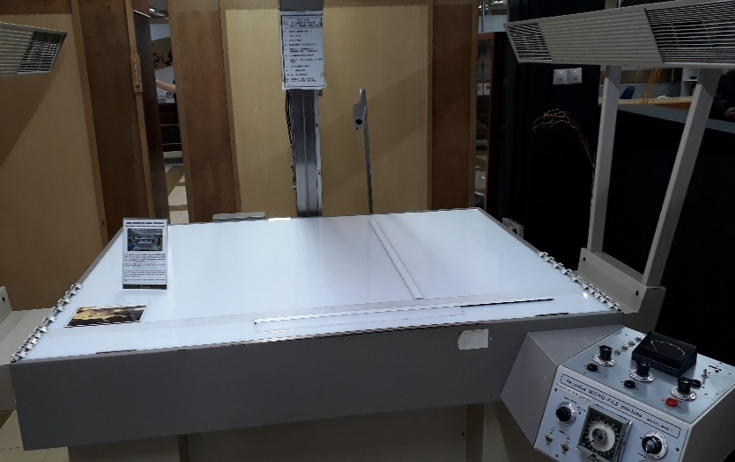 | The ‘Recordak Micro-File’ machine was used to capture small images of UTM theses. The images were recorded into microfilms or microfiche. It ultilised a special film; the ‘Kodak Ektacrhrome’ which was 35mm in size, and with a capacity of 100 feet per film roll. The machine was first used in UTM library around early 1980’s until around 2007.

Microfilm Camera Zeutshel OK 102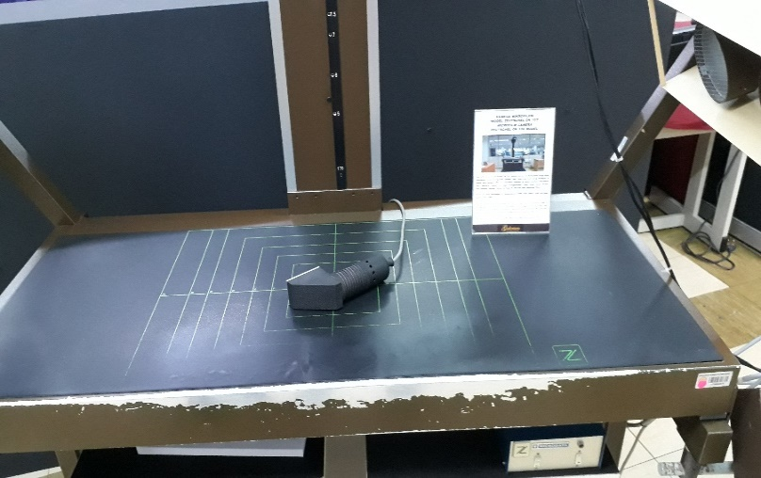 | The ‘Microfilm Camera Zeutschel OK 102’ function is the same as ‘Recordak Micro-Film’ but high accuracy camera was used to photograph a small image of UTM theses. Then, the images were also recorded into microfilms or microfiche. It also utilized a special film; the ‘Kodak Ektacrhrome’ which was 35mm in size, and with a capacity of 100 feet per film roll. The machine was first used after ‘Recordak Micro-File’ since 1986 until 2007 in UTM library.
Kodak Prostar Replenisher Machine | ‘Kodak Prostar Replenisher’ is a machine that only function is to prepare a chemical compound mixture to be used during the microfilm washing process. How does it work? First, the machine will mix two types of chemical compound which are ‘Kodak Developer’ and ‘Kodak Fixer’. The mixture is then capable to be used during microfilm washing process by transfer it into the ‘Kodak Prostar II Processor’ machine.
Microfilm Processor ‘ Kodak Prostar Model’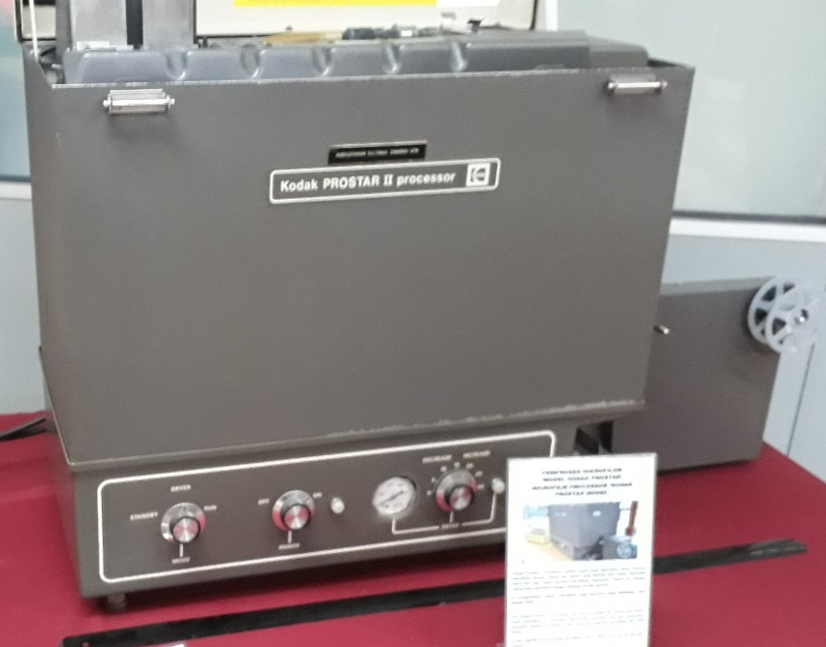 | The function of ‘Kodak Prostar II Processor’ was to cleanse the 16 and 35mm sized microfilm which utilized from either ‘Recordak Micro-file’ machine or the ‘Zeutshel’ microfilm camera machine. It enables us to process microfilm with a speed up to 10 feet per minute. It also produced negatives microfilm for thesis made up by UTM students.
Image Magnifying Machine ‘DUNCO 67C Model’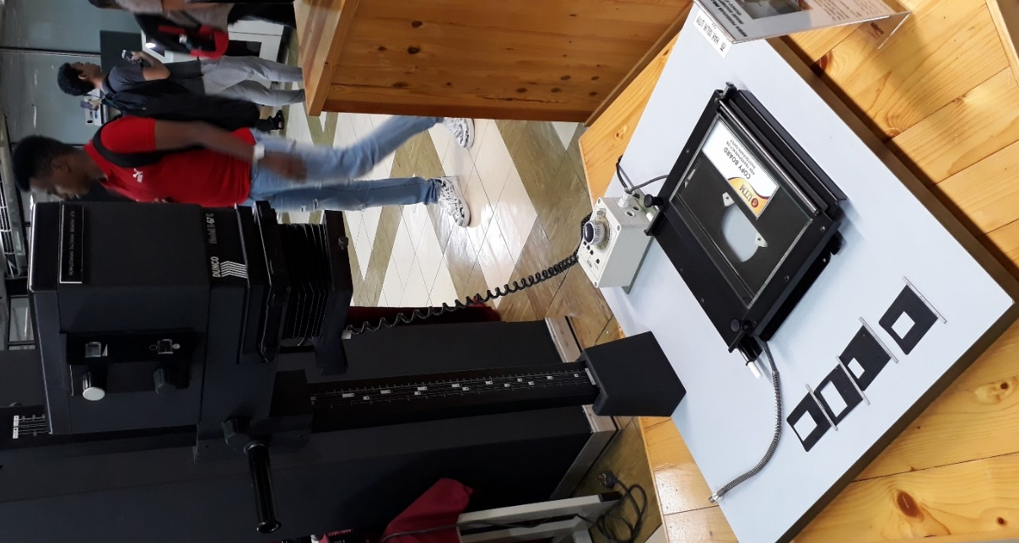 | ‘Film Enlarger’ is a tool used to enlarge images to produce photo prints from negative films. While today we can edit image size anytime anywhere using portable and light device such as smartphone and laptop but UTM students once used ‘Film Enlarger’ to modified according to a preferred image size. The film magnifier has other disadvantages. For example, it can only be used in the darkroom to prevent light from entering. It was used in UTM library around 1985 until 2007.

Block Hot Stamping
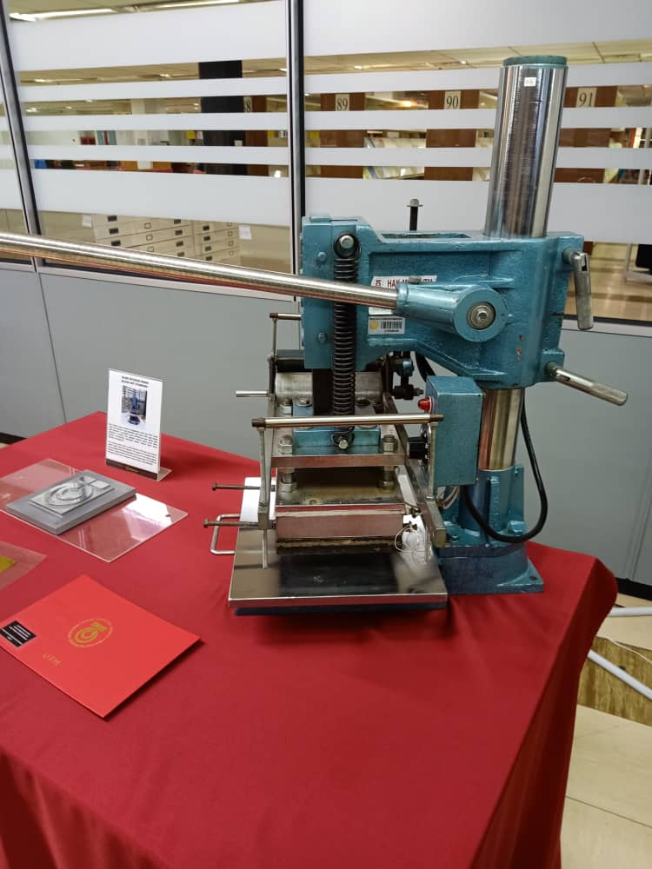
Block hot stamping is used to print out a product where it will be stamped on a surface by using pre-dried ink. This is the first block hot stamping that used in 1978 to feature the UTM logo with the original moto ‘Untuk Tuhan Dan Manusia’. The UTM logo is plated with gold and it used on all the university official documents or publications. It can be seen clearly on the surface of buckram which is a type of cloth commonly used as the book covers. After that, the original motto on the UTM logo had changed to a new motto ‘Kerana Tuhan Untuk Manusia’.
Impact Printing Model: IBM (4245)
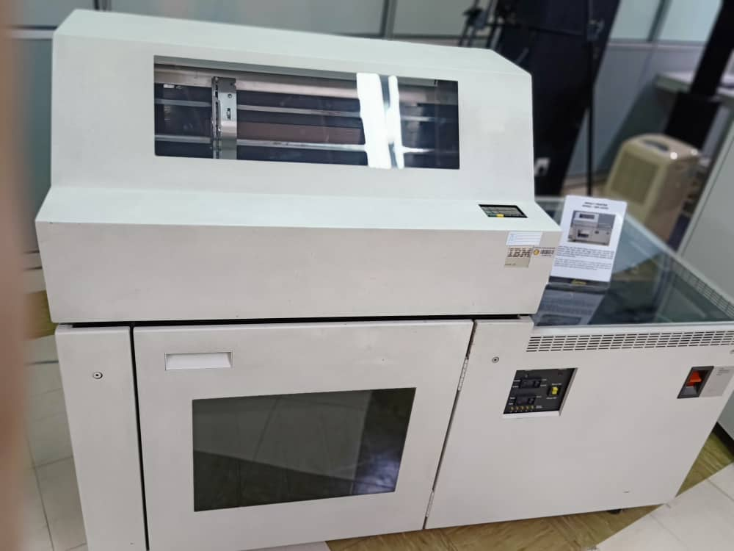
The function of Impact Printing or Dot Matrix Printing is printing multi-page documents by using a scroll of paper instead of single pages. It used to print out the data information of university students and staff for the university’s needs in Universiti Teknologi Malaysia. This Printer is used in UTM from 1990 to 2011 and it could work non-stop for about 48 hours and it also capable to print out the papers in high volumes.
Projector
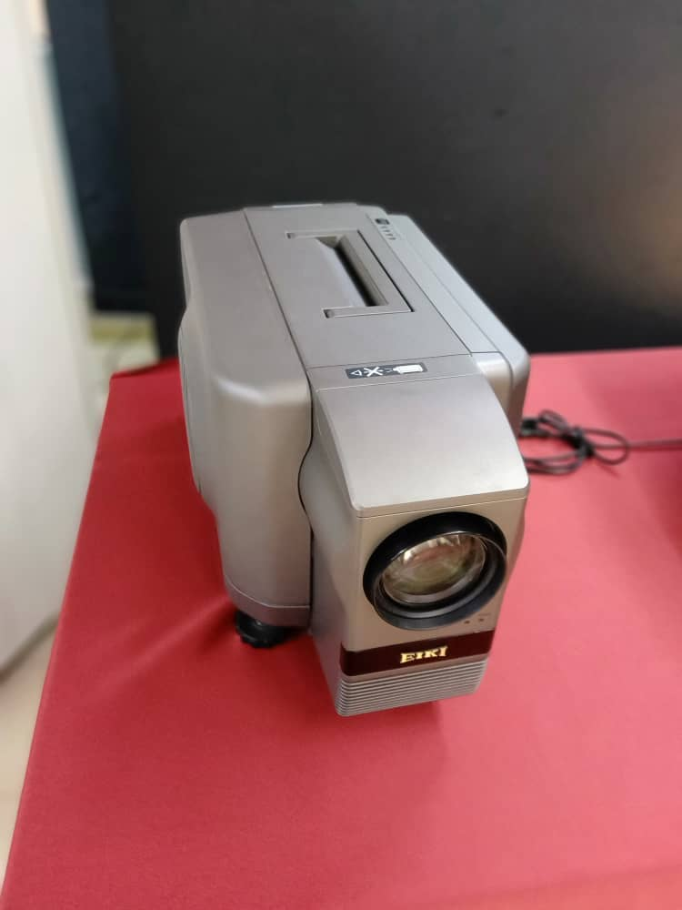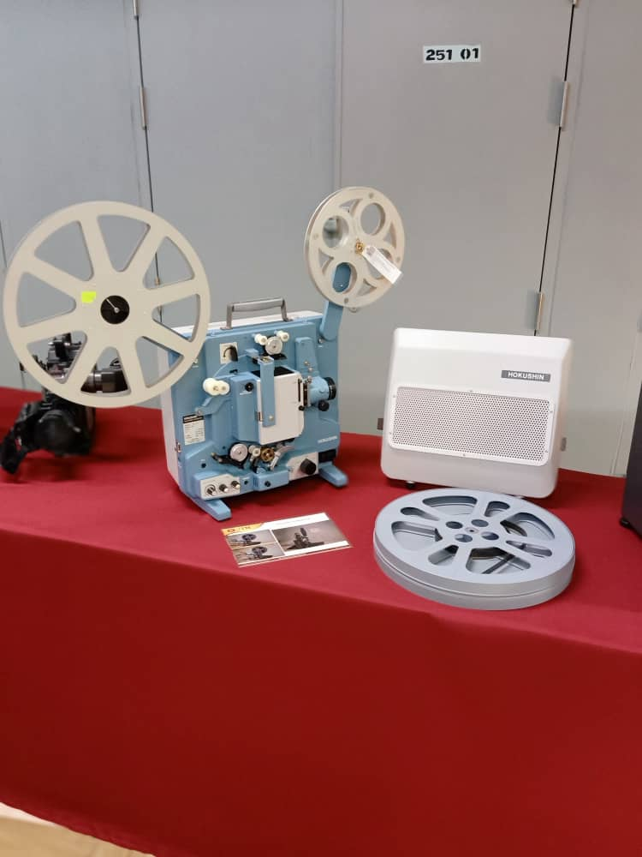
From the 1980s to the 1990s, our UTM library staff used many types of projectors to do the learning and teaching activities in the library. The model of projectors that have been used by library staff were Eiki LC Data-Grade Projector LC-5200, Overhead Projector (OHP) Cabin-OHP 24F, Film Projector 16mm Hokushin, Tragbarer Overhead Projector Anders Kern Portable, Plus Direct Projector (DP-10) and Paxiscope Lara Projection.
Slide projector
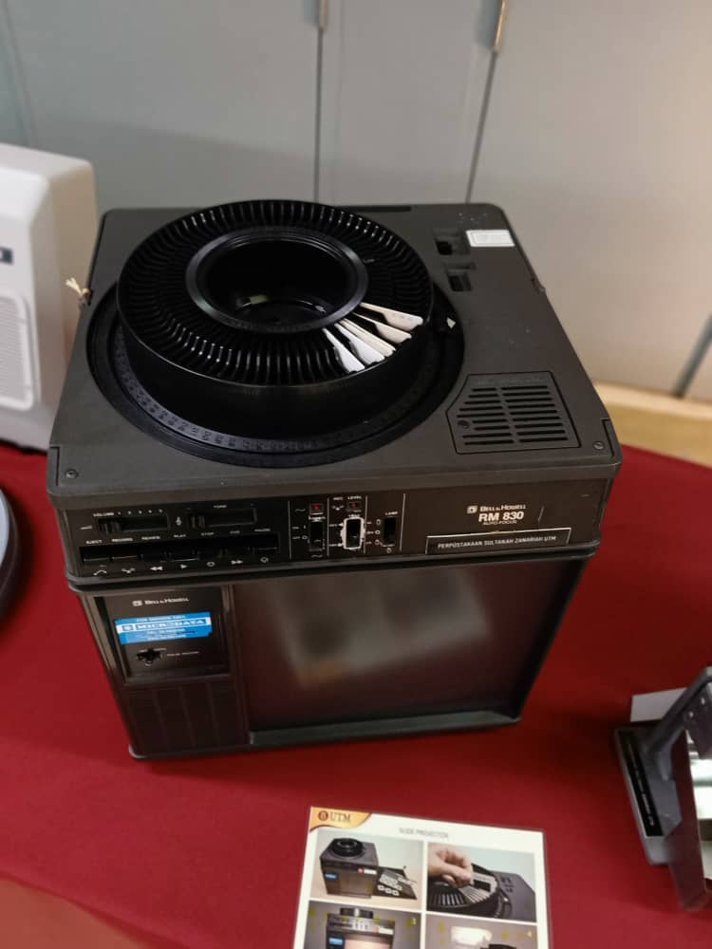
The slide projector function is to show photographic slides by using the optical and mechanical theory and ways. During the 1970s- 1990s, this slide projector was used to display the slide shows or some pictures in the library. This projector used a rotary tray to store the slides and when it started to rotate, the slideshow will be created.
Time Control Device ‘Gralab Model’
This device is also called as ‘Darkroom Timer’. In the darkroom, this device acts as a time control tool during the process of soaking the microfilms. This process is done manually in the chemical mixture. This device is very important in controlling the period of soaking according to the procedure so that the quality of the microfilm will not be affected.
System Unit
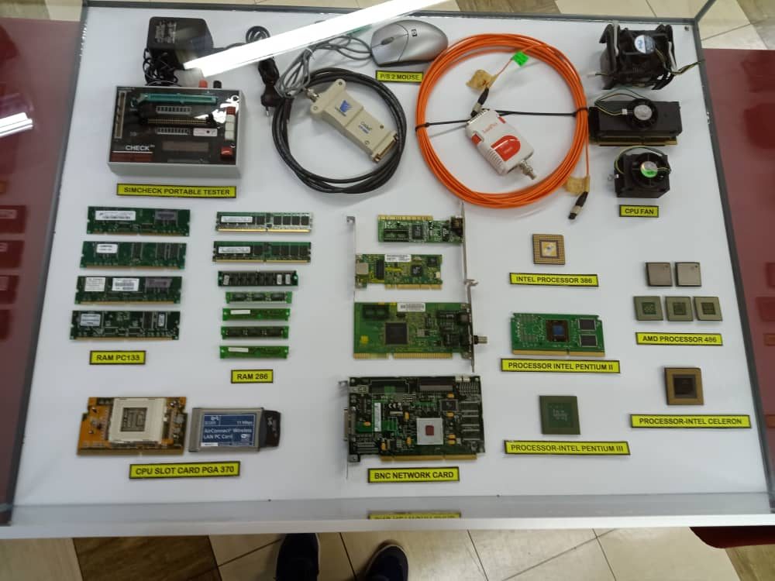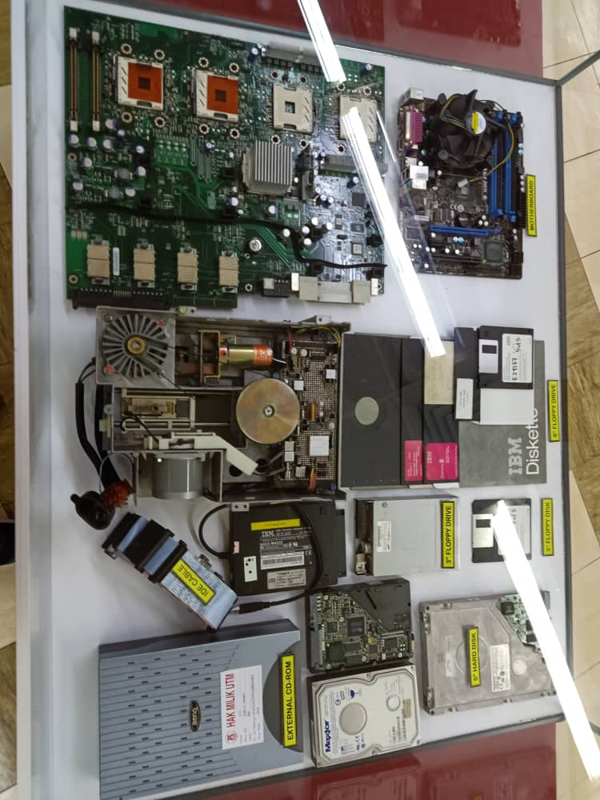
There are some RAM, processor, network card, CPU slot card, and hard disk that have been used that shown in the picture. RAM is used to keep the application programs, operating system and data in current used. Then, the processor is important to interpret most of the computer commands. Moreover, the network card is a device to make a connection between computer and computer network such as LAN. A hard disk is used to store and retrieve the data in digital form.

IBM POWERSERVER 550
During the 1990’s technology, the IBM 550 Power server boasted an outstanding performance with its fastest chip in the world. It was considered as the most suitable system for a medium-sized database at the time. The model 550 offers up to 64 GB of memory, powerful, symmetric multiprocessing. It also played a great impact on the library’s technology since the application of the library management system on a ‘freeze’ terminal which operated on a Mainframe was seen as the starting point of the information technology evolution.
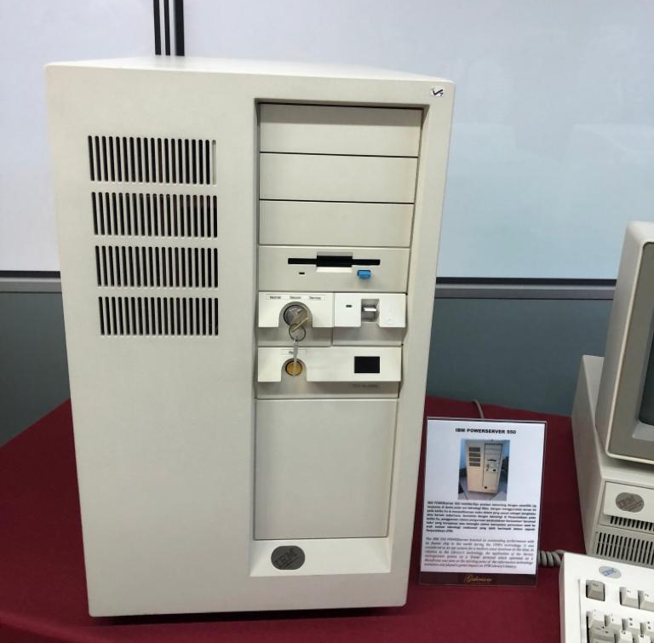
Magnetic Tape Unit Model: IBM (3420)
The Magnetic Tape Unit was used as a ‘back up’ for the mainframe system and information database of staff and students as well as other University’s Information systems during the year 1976 until 2010. Initially, this model used a round shape tape before converting to square shape tape. A computer device that moves reels of the magnetic tape past read-write heads so that data can be transferred from or to the computer.
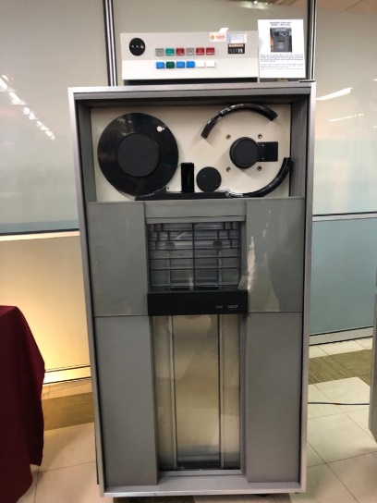
Mainframe Data Storage Model: IBM (9345B22)
In the 1970s at Computer Centre, UTM campus, Kuala Lumpur, the usage of mainframe system at UTM had begun. It served as a data control of students and staff information. The mainframe has been used for almost 20 years for various components and functions such as processing, storing, securing and printing the University’s information data.
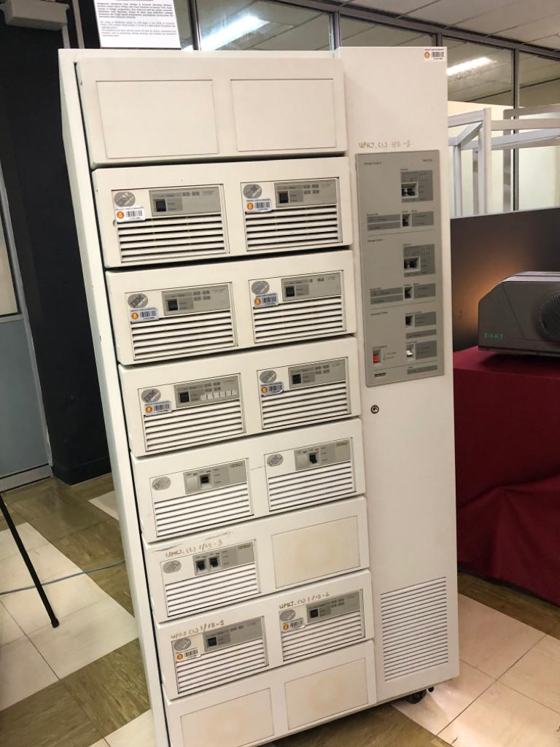
Microfilm Reader ‘Allen Micro Model’
Around the early 1980s and early 2000s, the microfilm reader was first used in UTM Library. It was used for reading thesis content (text and images) which was stored in microfilms and displayed on the machine’s screen. The online information development was very limited and it gave an impact to the user’s reference approach at that time. As such, microfilm became one of the main sources of information in the UTM Library. Microfilm is often used as a way
to store a large number of documents in a small space using open reels or cassettes that’s why the microfilm was considered essential in the Library’s collection.
Microfiche Reader ‘Micron 750 Model’
The Microfiche Reader is similar to the microfilm, used to read the content of microfiche. It was a source of information in the form of a flat film sheet and contained text and images. The content of the microfiche film was read according to the order of the letters on the machine and the display could be expanded when needed. Microfiche was widely used by government, academics, and many business institutions due to its low-cost creation, easy to use and the small space that needed to store it. A total of 500 titles of microfiche are available in UTM Library collection covering various sources such as journals, technical reports, proceedings, and other general references.

REFLECTION
Our goal towards this course is to learn how to become a multi-functional programmer and clearly understand the need of network security nowadays. Apart from that, we also wish that we can involve ourselves into a job that related to our course program so that we can put the knowledge in the future.
From this visit, we know clearly that the devices nowadays become more advanced and high-technology from year to year. Almost all things are digital so it is an advantage for computer science students to find the job easier than other courses. So, we will take the opportunity to learn more about computer networking and security by learning, studying and attending some clubs that relate to my course. Besides, the visit to UTM galleries have benefit us in making a step toward our goal which give us a realization that a very foundation can be evolved to the complex but yet advanced tools of multi-purpose uses. To improve our potential in the industry, we have to know our weakness and improve ourselves by equipping knowledge because the trend nowadays keep changing.
Task for each member
During the industrial visit session, Muhammad Nazreen Bin Mubin and Teng Jia Jng took the responsibility on captured the photos of those history components in CICT and understand the funtions of those device. On the other hand, Eyu Si Xiong and Abir bin Rahman Bhuiyan took the notes from the staff when he was giving the talk. Each of us searched the information of those device and we shared together.
REFERENCE
https://itstillworks.com/about-5076656-microfiche-reader.html

