TECHNOLOGY AND INFORMATION SYSTEM
SEMESTER I 2019/2020
SECP1513-01
DESIGN THINKING REPORT GROUP 1
NAME OF STUDENTS | MATRIC NO.
TAN LI MIN | A19EC0169
MUHAMMAD NAJIB FIQRI BIN SULAIMAN | A19EC0103
NURUL EZZATI BINTI HARUDIN | A19EC0142
MA SIRUI | X19EC0024
TASNIA HOQUE NIDHI | A18CS9010

LECTURER : DR. ZURAINI BINTI ALI SHAH
SUBMISSION DATE : 20th OCTOBER 2019

Table of Contents
- Introduction ------------------------------------------------------ pg3
- Detailed Description
  - MAGICX background introduction --------------------pg4
  - Exhibition on 3D printer -------------------------------- pg4
  - Driving Car Simulator ----------------------------------- pg5
  - Explanation on Kinect Interactive Wall --------------- pg6
  - Demo on Virtual Reality of Oculus Quest ------------ pg7
- Reflection
  - What is your goal/dream with regard to your course/program? ----------------------------------------- pg8
  - How does this visit impact on your goal/dream with regard to your program?----------------------------------------- pg8
  - What is the action/improvement/plan necessary for you to improve your potential in the industry? -------------- pg8
- Task for Each Member ---------------------------------------- pg9

1.0 Introduction
Information Technology (abbreviated IT) is the general term for various technologies mainly used to manage and process Information.It mainly applies computer science and communication technology to design, develop, install and implement information system and application software.It mainly includes sensing technology, computer and intelligence technology, communication technology and control technology.
The application of information technology includes computer hardware and software, network and communication technology, application software development tools and so on.Since the popularization of computers and the Internet, it has become increasingly common for people to use computers to produce, process, exchange and disseminate various forms of information (such as books, business documents, newspapers, records, movies, TV programs, voice, graphics, images, etc.).
In order to better understand the requirements and work specifications of IT profession, our group will have an industry tour.We will visit the media and games innovation center (MAGICX) UTM and introduce their facilities and programs to you.
During this industrial visit, we learned about organization structure, services, achievements, projects that have been developed or maintained by MAGICX. Specifically, it includes :Exhibition on 3D printer, Driving car Simulation, Explanation on Kinect Interactive wall, Demo on Virtual Reality of Oculus Quest and other projects.
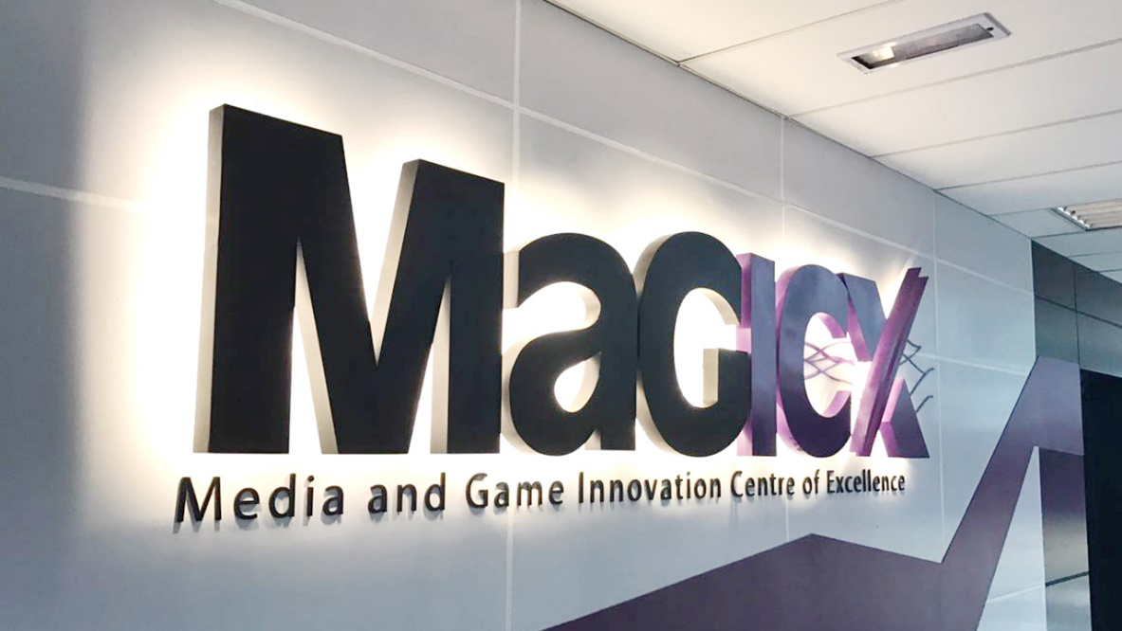
Figure 1: MaGICX

2.0 Detailed Description
2.1 MAGICX background introduction by the MAGICX Managers
Media and Game Innovation Centre of Excellence (MaGICX) is a strategic cooperation between Universiti Teknologi Malaysia (UTM) and Iskandar Regional Development Authority (IRDA) to support and promote the development and ecosystem of creative industry that focuses on gamification and enrichment of digital content. MaGICX will play an integral part as the anchor for the Iskandar Malaysia Innovation Valley envisioned to offer industry players/SMEs/clients technical expertise/consultation, research/product development, business development, publishing, marketing and/or training in producing commercially.
Established in 2013, aspires to create an environment that contributes toward talent development, industry promotion, knowledge-sharing, and international collaboration. Their vision is to be the anchor for Games and Gamification industry & the nucleus for Iskandar Malaysia Innovation Valley. MaGICX has a mission to provide necessary support and technical expertise in research, business development, publishing, marketing and training for industry players to develop commercially viable products and services.
MaGICX had partnered with dozens of business over years such as City University London, Institusi Teknologi Petroleum Petronas, Kementerian Pendidikan Malaysia, Animonsta, Driving Transformation and others.

2.2 Exhibition on 3D printer
3D printer is a machine that can print or manufacture a three-dimensional object from digital file by depositing materials layer by layer in accordance to the object’s 3D digital model. However, the person in charge said that the printer cannot be connected directly by your computer but only can read the digital file from the memory card. There are many types of 3D printer filament, all of them made from different material to satisfy the requirement of user, such as PLA, ABS, TPU and Nylon. According to the person in charge, PLA is easy to print because it required a lower temperature than ABS, and it does not require a heating bed. Moreover, it is more environment-friendly since it is a biodegradable thermoplastic. But the object printed by PLA is non-elastic as TPU does. ABS is also a popular 3D printer filament. In contrast, it need a higher temperature than PLA, but this means that the product of ABS can withstand a higher temperature and higher durability than PLA. 3D printing require a long time to finish the printing process, they often take one day to finish a small printing project.
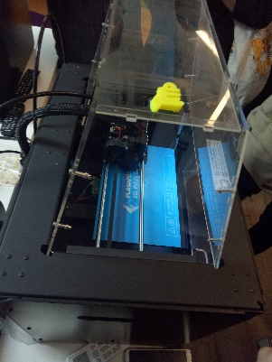
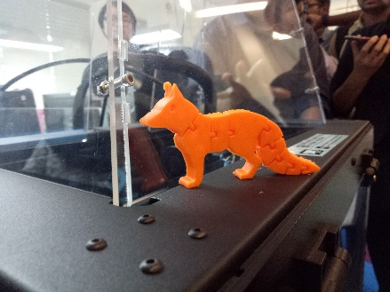

Figure 2: The project of 3D printer Figure 3: The process of printing
2.3 Driving Car Simulation
Driving car simulation is build with high realism and real-time interactive
Three-dimensional (3D) virtual environment (VE). It is a training device which is used in the basic driver training in an automotive driving simulation. The software that is being used in order to manufacture is Unity. The virtual environment has green sceneries, buildings, roadways and terrains that show the real map of a place. The main idea of automotive driving simulation is to forecast the future behavior of a system, and determine what the user can do to influence that future behavior. Driver’s behavior can be study for instance under the influence alcohol and drugs. The weather condition is taken into this matter. Driving car simulation provides a safe environment for testing in which repeated measurements are controlled as well as cost-effectively.

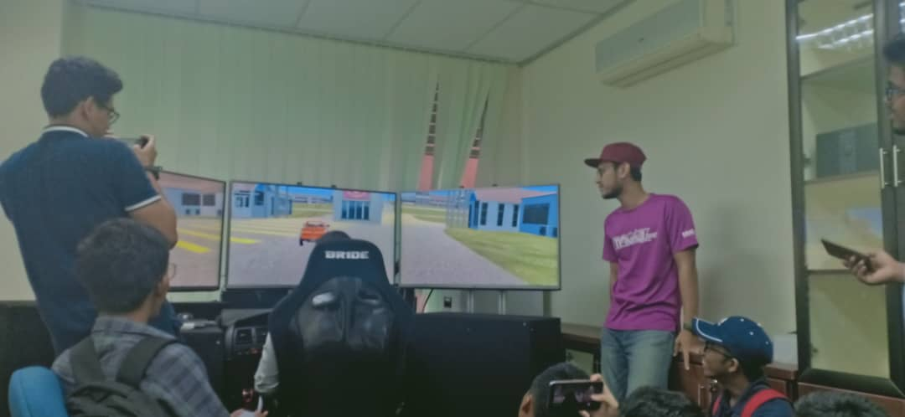
Figure 4: The driving car simulator

2.4 Explanation on Kinect Interactive Wall
The main definition of an interactive wall is a very large, high-resolution display which can be touch-sensitive. The content displayed on these interactive screens is generally the same that could be found on a desktop computer but magnified onto a larger area. The “touch” functionality may be extremely reduced to standard elements (like buttons, images, links, etc...) or extended to a complete user control. In this case, user is able to interact with the wall by accomplishing dynamic actions. The second inherent definition is to consider an interactive wall as a collaborative tool due to the fact that it moves the interaction space from the desktop to a wall. This use case requires that the content has been specially designed to take advantage of large interactive displays.
We are surprised by the gesture sensor of the Interactive Wall that can control the monitor just by some simple gesture without touching the screen. The gesture sensor will detect the user which is the person that stand in front of the monitor. Although there were many students stand in front of the monitor, the gesture sensor is sensitive and accurate enough to detect the user.
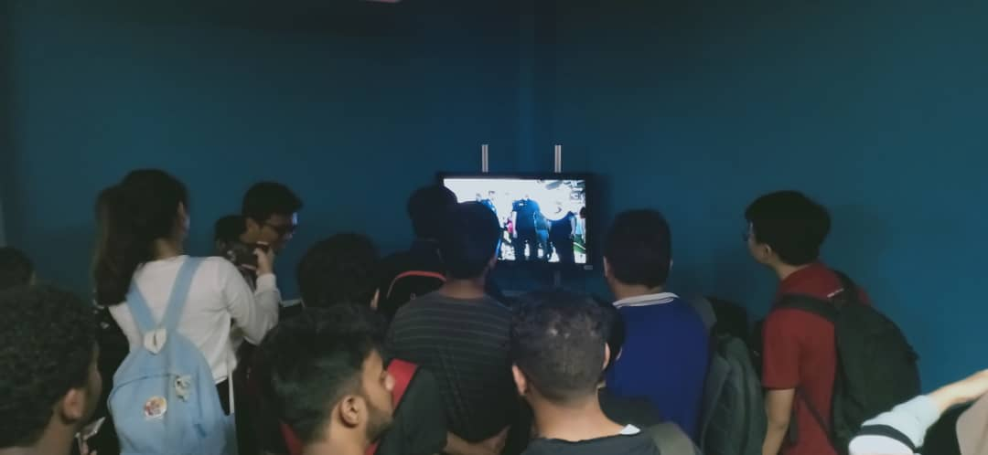
Figure 5: The Kinect Interactive Wall

2.5 Demo on Virtual Reality of Oculus Quest
Oculus Quest is a gaming system built which allows user to glimpse the real world in
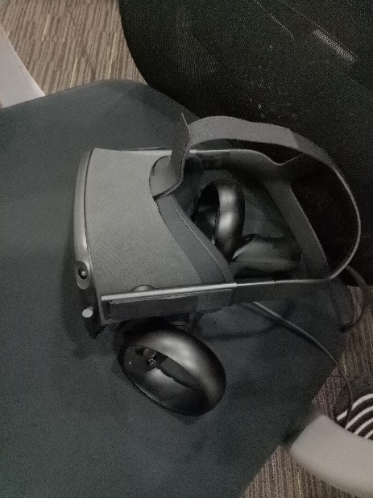
monoscopic black and white through the integral cameras. This virtual reality (VR) gaming is basically a headset that is portable and you just need a cable or USB to plug it into your personal computer or anywhere you desired. Once you wear it, you can walk around the virtual setting and when you move your virtual arms, it felt responsive with no distinct lag. Oculus Quest is a great and pleasurable for those that like to play games because you can experience yourself surrounded by the gaming coordination.
Figure 6: The Virtual Reality Mask

3.0 Reflection
3.1 What is your goal/dream with regard to your course/program?
Technology and Information System open our eyes and let us explore to the new technologies once we have visiting a new exhibition. We hope that we can learn a lot while we enjoying ourselves in the course. We would like to use the knowledge that we learnt from those exhibitions to be more competitive than others when we looking for jobs after graduate. We hope that we can gain more knowledge and more experiences in technology field. This will helping us understand more deeply in this course.

3.2 How does this visit impact on your goal/dream with regard to your program?
This visit give us many positives impact especially in how to improve our skills to develop this industry in our course. First of all, MaGICX teaches us how to expert in our own skills and learn the new things by joining their training and professional courses, workshops and seminars. What i like about this program is they provide various training courses that focuses on game’s development, mobile and web development which varies from junior to professional level.The visit helps to open our eyes and realise that technology has growing up rapidly nowadays. To meet the vision of our country, we as a students should work harder and smarter to inovate something with creativity from what we learned throughout the universities years.

3.3 What is the action/improvement/plan necessary for you to improve your potential in the industry?
To improve my potential in the industry, we should know a lot about technology and at the same time be very powerful in programming, so that we can be qualified to join MAGICX. Furthermore, we should be enthusiasm in technology, so we will put all of my effort in MAGIXC. So that, we should set a goal and plan to achieve my goal that can make me more excellent to be accepted by MAGICX. To meet the vision of our country, we as a students should work harder and smarter to inovate something with creativity from what we learned throughout the universities years.

4.0 The task for each member
- MUHAMMAD NAJIB FIQRI BIN SULAIMAN
- Visit all the exhibits.
- Asked and sorted out all information of Exhibition on 3D printer in detail, and wrote relative report contents.

- NURUL EZZATI BINTI HARUDIN
- Visit all the exhibits.
- Asked and sorted out all information of Driving Car Simulation in detail, and wrote relative report contents.

- TASNIA HOQUE NIDHI
- Visit all the exhibits.
- Asked and sorted out all information of Explanation on Kinect Interactive Wall in detail, and wrote relative report contents.

- MA SIRUI
- Visit all the exhibits.
- Asked and sorted out all information of Demo on Virtual Reality of Oculus Quest in detail, and wrote relative report contents.

- TAN LI MIN
- Visit all the exhibits.
- Organize all the content and integrate it into the final report.
- Detailed descriptions include organization structure, services, achievements, projects that have been developed or maintained by MAGICX.

