

FACULTY OF COMPUTING

COURSE: UHMT1012 (SECTION 24)

(GRADUATE SUCCESS ATTRIBUTE)



|  |  |
| --- | --- |
| AMJAD BIN RUSHDAN | A19EC0021 |
| MUHAMMAD FIKRI BIN ABDULAMIN | A19EC0096 |
| NADIAH BINTI MOHD HANIM | A19EC0111 |
| SYAFA ILYAS AL MUZANI | A19EC0288 |
| ANIKA RAHMAN ANTU |  |

Table of Contents

INTRODUCTION 2

OBJECTIVES 3

PROBLEM STATEMENT 4

ORGANIZATION STRUCTURE 5

DUTY AND RESPONSIBILITY OF COMMITTEE MEMBERS 6

BUDGET AND SPONSORSHIP 8

PERMISSION LETTER 13

ESTIMATED DATE, TIME, VENUE 14

PROGRAMME SCHEDULE 15

CONCLUSION 16

SELF REFLECTION 17

REFERENCE 24

APPENDIX 25

MINUTE-MEETING 26

# INTRODUCTION

Smoking is dangerous to every one of us, smokers and non-smokers. We sometimes forget that smoking kills for both short term and long term. Although students are prohibited to smoke in residential area in UTM, there are still countless report from students about smell of smoke near their college. If this case not treated right away, the addiction will lead the student or person to problematic and unhealthy lifestyles thus there will born non-charismatic graduate from UTM.

Among dangers of smoking :

1. The chemicals in the cigarette can give a person lung cancer, heart disease, diabetes, liver cancer, stroke, and the list go on.
2. The smoking combust from the cigarette will affect every person near the smokers, making them passive smokers and killing them in silence no matter the age
3. The smoke will also harm the already-contaminated environment and making the air breathless especially in area full or people.

Therefore, we as a student, community and as responsible person must act and try using power given to us to tackle the smoking issue in our place.

# OBJECTIVES

The main objective of this programme is to cultivate awareness regarding danger of smoking especially among students in UTM. As we all know smoking threaten the health not only the smokers but also people surrounding. Hopefully from this programme people will understand and stop others from smoking and provide a healthier community in UTM.

Besides, the objective of smoking awareness programme is it can provide help and encourage to those in need particularly smokers that wants to stop the addiction in themselves. They maybe want to stop smoking but did not find help and scared actions will be taken upon them by university’s higher ups . We also would like to provide health check to check how their body condition right now and counselling session for those who in needs for help.

Furthermore, this programme’s objective is also to help UTM transform into non-smoking area coincide with the enactment of the Tobacco Control Regulations 2004 which was published on September 23, 2004 (PU (A) 324). / 2004 and thus making the environment and air cleaner to breath.

Health is crucial to everyone more than wealth, and saving our life can be start with saving, helping and caring for others that are in need out there mainly smokers. We also share the same air, the same place, the same planet and by reducing numbers of smokers we will improve the quality of air near us.

# PROBLEM STATEMENT

The problem that we faced during advocating this smoking awareness campaign is we have problem with finding health-related organization to help us out especially from hospital. This is because we need help from them to handle health counselling session which is helping the smokers who want to stop smoking. We also needed help from health organization to advise us regarding giving out free anti-smoking medicine. Thus, being unable to seek help from hospital or health organization will severely affect this program.

Besides, the problem that we have is transportation. Many students especially year 1 student does not have vehicle to go to our program’s venue which is at Dewan Sultan Iskandar located far from their college. Moreover, the bus in UTM are unavailable during our programme date which is on weekend. Therefore, lack of transportation is a problem for students to reach us.

Furthermore, we did not have enough the material for the exhibition such as infographic display. The information from the internet and doctor is enough but we want to have exhibit such as lung that are being effect by smoke, as display. Thus, without material to be shown students may find that this event uninteresting and provide them with only little knowledge about smoking.

Last but not least, we have a problem with financial that is finding sponsorship. We need a lot of money for this program to work out. We also do not know how to invite the food truck to come to our event. Therefore, money is a problem to this program that can cause some difficulty and lack of food truck will lower the number of students that will come to this smoking awareness campaign.

# ORGANIZATION STRUCTURE

Member of the executive committee

Program Manager : Amjad Bin Rushdan

Secretary : Nadiah Binti Mohd Hanim

Treasurer : Anika Rahman Antu

Ordinary Committee Member

OCM Venue/Technical : Syafa Ilyas Al Muzani

Cheong Chien Li

OCM Registration : Siti Najwa Binti Apandi

Yasmeen Binti Abu Bakar

OCM Food and Drinks : Nur Adilah Syaza Binti Mohamad Najib

Nuriffatish Shima Binti Norazmi

OCM Certificate : Rakesh A/L Kannapathy

Husny Musharraf Bin Shamsul

OCM Multimedia : Muhammad Fikri Bin Abdulamin

Amirul Syafiq Bin Mohd Qisti

# DUTY AND RESPONSIBILITY OF COMMITTEE MEMBERS

*Program Manager*

* Organizing the program and activities.
* Meeting with the committee members to organize the tasks for the programs.
* Making sure the committee members did the assigned tasks according to the expectations.
* Manage the problems and limitations occurred during the making of the program proposal.

*Secretary*

* Take notes during the minute meeting to make sure the tasks can be done by the committee members accordingly
* Prepare the proposal of the program
* Prepare the documents and letters needed for the program

*Treasurer*

* Prepare the budget of the program
* Manage and control all the spending that have to be used for the program
* Find the sponsor for the program
* Prepare the financial report of the program

*OCM Venue*

* Decide on the suitable venue for the program
* Rent the venue from the related department
* Make sure the venue is clean during and after the program
* Organize the tables, chairs needed for the program
* Organize the booths that will be opened during the program

*OCM Registration*

* Register all participants especially the students for the talk show in the program to provide merit
* Register the participants that will take part in lucky draw

*OCM Certificate*

* Prepare the certificate for all participants and the sponsor

*OCM Multimedia*

* Design the perfect poster for the program
* Promote the program to the students and outsiders
* Record the video and take pictures during the program

# BUDGET AND SPONSORSHIP

**ESTIMATED INCOME**

|  |  |
| --- | --- |
| **Sponsorship** | **Amount (RM)** |
| **Cash Sponsorship**   * Pusat Kesihatan UTM * BIG Pharmacy | 800  2000 |
| **Products Sponsorship**   * Abu Hassan Catering * Boost Juice * Eco Print JB * JB Gift & Souvenir * BIG Pharmacy | 2600  1500  1800  660  500 |
| **Total Income** | **9,400** |

**ESTIMATED EXPENDITURE**

|  |  |
| --- | --- |
| **Activity** | **Amount (RM)** |
| * **Food & Beverage** * For VIP & Speakers (RM15*6 persons) * For Committee members (RM7*13 persons) * For Participators for the talk (RM5*800 persons) | 90  91  4,000 |
| * **Program** * Activities equipment * Closing ceremony * Venue rental fees | 200  100  0 |
| * **Gift & Souvenir** * For VIP & Speakers (RM10*6 persons) * For quiz and lucky draw winners (RM150*4 persons) | 60  600 |
| * **Certificate** * (RM 2*800 person) | 1,600 |
| * **Publicity** * Banner (RM20 per piece *6) * Bunting (RM50 per piece *2) * Leaflet (RM0.05 per piece *500) | 120  100  25 |
| **Total Expenditures** | **6,986** |

**SPONSORSHIP PACKAGE**

1. **Pre-Event**

**Marketing Communication**

* Include the sponsor’s logo on our poster and any social sites promoting the event such as Instagram page.
* Provide social media shout outs to promote sponsors

1. **On-Site**

**Venue Design**

* Logo of the sponsors will be printed on the banner, bunting and leaflet. It will be advertised around UTM campus.

**Giveaway Design**

* Logo of the company who sponsors the gift & souvenirs will be printed on the souvenirs
* Promotes sponsors giveaways that can be included in quizzes and lucky draw.
* Food & beverage sponsors can use their own packaging to promote their products

1. **Post-Event**

* The company will receive an appreciate certificate as a form of acknowledgement

**SAMPLE OF SPONSORSHIP LETTER**

Date: 12/12/2019

Program “Smoking Kills”,

School of Computing, Faculty of Engineering,

Universiti Teknologi Malaysia, Johor Bahru.

Dear, (recipient name),

Warm greetings from Universiti Teknologi Malaysia (UTM). I hope this message finds you well.

Firstly, I would like to introduce myself. My name is Anika Rahman Antu, the treasurer of this “Smoking Kills” event. It is a great pleasure for us to offer your organization a great opportunity to collaborate with usand become a valuable sponsor of the event, which will be happening on the (date).

For your information, “Smoking Kills” is a two-day event of creating awareness which takes place in (venue). There will be a lot of activities that will be carried out during this event such as exhibition, health counselling session and many more.

We would dearly invite you to come forward and contribute not only in terms of monetary funds, but also by items and food and beverages as well. We would be really grateful if you could collaborate with us in order to make this event a success. It would be an honor to be associated with a reputed company such as yours.

We look forward to an affirmative response of collaboration from you, as we believe that your contribution would be a valuable addition to the event. By this, I have included some related documents of this program. Please do not hesitate to contact us if you have any inquiries.

Thank you so much for your time, and we look forward to hear from you!

Sincerely,

----------------------

ANIKA RAHMAN ANTU

Treasurer of program “Smoking Kills”

# PERMISSION LETTER

Date: 12/12/2019

From

Committee of “Smoking Kills” programme,

Universiti Teknologi Malaysia

To

UTM Administration Office

Universiti Teknologi Malaysia

Johor Bahru, Malaysia

Subject: Application for Permission to Hold a Danger of Smoking Awareness Campaign Program

Dear Sir/Madam,

This is a humble request for permission to hold an event at Dewan Sultan Iskandar hall (DSI). The event is a Danger of Smoking Awareness Campaign Program that will involve all of UTM students.

Danger of Smoking Awareness Campaign Program Committee has put all the arrangements in place and that includes the guests we intend to invite and the date of the event which will be held on 14th – 15th February 2020, should you give us to go ahead about this event. These guests include all of UTM students.

The committee is looking forward for your permission on this, so that we can go ahead with the rest of the plans. The committee will highly appreciate if you allow this event to take place for this event at Dewan Sultan Iskandar hall (DSI).

Kind regards,

SYAFA ILYAS AL MUZANI

From committee of program “Smoking Kills”

Universiti Teknologi Malaysia

# ESTIMATED DATE, TIME, VENUE

Date: 14th February 2020 (Friday) – 15th February 2020 (Saturday)

Time: 9.00 a.m – 4.00 p.m

Venue: Dewan Sultan Iskandar, UTM Skudai, Johor Bahru

UTM Students Encouraged Participating in Smoking Kills Campaign Program. This program is open to all students of UTM, Skudai especially for those who wants to stop smoking and they are strongly encouraged to get involved in this program. This is because the program aims to increase the awareness among UTM students about danger of smoking by talk session program and exhibition.

Next, this campaign program encourages smokers who wants to stop smoking to join because it has a health counseling session program. Those who are not a smoker can also be involved in this program to raise their knowledge about danger of smoking and how to prevent it.

In addition, this campaign program can also help UTM become free-smoking area. Not only that, this program increases UTM students’ participation.

# PROGRAMME SCHEDULE

|  |  |  |
| --- | --- | --- |
| **Date and Time** | **Activity** | **Venue** |
| **14 FEBRUARY 2020 (FRIDAY)**  9.00 am – 4.00pm  9.30 a.m  10.15 a.m  10.30 a.m  10.50  11.00 a.m  4.00 p.m | Exhibition, health counselling session and food truck  Arrival of guest of honor  Speech from head director  Talk from Dr Lee Boon Chye  -Deputy Minister of Health of Malaysia  Quiz and Lucky Draw (for quiz participant only)  VIP Banquet  End | Dewan Sultan Iskandar, UTM Skudai, Johor Bahru |
| **15 FEBRUARY 2020 (SATURDAY)**  9.00 am – 4.00pm  10.00 a.m  12.00 p.m  3.00 p.m  4.00 p.m | Exhibition, health counselling session and food truck  Quiz and Lucky draw (for quiz participant only)  Free Lunch  Closing Ceremony  End | Dewan Sultan Iskandar, UTM Skudai, Johor Bahru |

# CONCLUSION

The main objective of this programme is to raise awareness among students in UTM to stop and stay away from smoking. Smoking Kills programme is one of the beneficial programs to be advocate in UTM because of many reasons. One of them is it can help students to prolong their life and help people surrounding them to feel better. This programme also can help any students that are smokers that want to stop smoking by providing health counselling session and anti-smoking medicine. Besides it can help the environment in UTM to become better and have cleaner air for all of us to breath.

We hope that this programme will be supported from many authorities involved which is the university, clinic, hospital and health organization. By doing this program we also hope to provide better environment to the community in UTM and can help the students that are in need and save their life.

SELF REFLECTION **(AMJAD BIN RUSHDAN)**

As a leader it was a difficult task for me because usually, I am following others but now it is me who is in charge. I am not a person that can push others to do their job. But responsibility is a responsibility. The first meeting that we held is did not go well because one of group members was absent. But after that we discussed, and each member contributed their ideas and lastly, we picked smoking awareness campaign as our proposal’s topic. This is because us as students has notice a rise of number in smoking occur at our college no matter male or female. This is concerning because rules and regulations clearly stated that smoking is prohibited in UTM.

As a responsible community members and students in UTM, we conduct this programme with a hope to wake the smokers and make them realise they are putting themselves and everyone surrounding them in danger. I am myself usually a lazy and not a so committed member in doing task, but this programme had changed my perspective and attitude towards other people in group project. I learned how to lead other people and I also learned various information regarding smoking by researching it online. I greatly appreciated every person who contributed towards succeeding this programme especially my team members, the university official and of course health officer that conduct the health counselling session.

Of course, I did not forget to thank every participant in this programme primarily smokers that want to change their lifestyle and lead towards a healthier life. This smoking issue maybe will not be eliminated completely but by advocating this programme it surely will help to solve this issue bit by bit.

**SELF REFLECTION (MUHAMMAD FIKRI BIN ABDULAMIN)**

Through finishing this proposal, I have learned a lot of thing. One of it is related to my department which is OCM Multimedia. I had been given a task to create an eye-catching poster to attract audience to our campaign and sponsorship package. Throughout my lifetime, I have never created a poster before, so I don’t know how to create one. I know I got to start somewhere in order to finish my task. So, I decided to watch YouTube on how to create a poster. Luckily, I found so many videos that help me to finish my poster. So, from this project I not only learned how to create a proposal but I also learned how to create a beautiful poster. Surely the knowledge I gained can be useful in the future where it might help me.

Other than that, I learned that we have to be brave to challenge our self to learn a new thing in order for us to grow. This is because if we stay in the same level as we are, we will never get to move forward. That’s why when the leader asked all of us to take one position, I took Multimedia department even though I don’t have a creative mind and experience before this. After a few weeks of brainstorming and endless effort, I manage to finish all my task and I feel great about it since it is my first time doing something that I never done before. It was a worth taking risk.

Lastly, I learned how to work as a team. Before the proposal start, our group leader has distributed the task evenly to our group member. This is important as we don’t want our group member with the most task feel unfair as he/she has to carry the burden of the team. Apart from that, during the making of this proposal, one of our members got sick, so she didn’t manage to continue her work. Instead of pushing her, we as a team give a whatever help that we can in order for her to finish her task in time.

Last but not least, I would like to thank my group member because they helped each other and worked as a team when carrying out the Smoking Kills Campaign Program. I would also like to thank my lecturer Dr Muhammad Abd Hadi Bunyamin who gave us a lot of information and instruction when carry out the proposal.

**SELF REFLECTION (NADIAH BINTI MOHD HANIM)**

After some discussions with the group members, finally we choose to do a campaign that is related to danger of smoking awareness. We named our program Smoking Kills Campaign. The main reason why we decided to do this program is because we saw so many people still smokes, even the educated ones. We saw many students here in UTM smoke around the campus. This situation will give a bad impression towards the outsiders who expect the students to know a lot better. Other than that, we noticed that nowadays a lot of companies tried to gain profits by selling a device that can apparently help people to stop smoking and it is not helping. This is because their device does not stop people from smoking and worse, people who don’t smoke become addicted to it. Therefore, by doing this program, we can share the right way on how to stop smoking through talk, exhibition and health counseling session.

As a secretary, I did face some challenges even though my task was mainly writing the proposal and taking notes during the minute-meeting. Firstly, I have my own schedule and I like to finish my work in one go. The group members were given the task and each of them have to send their work to me so that I can compile it. Since one of the group members got sick, my work got delayed. However, I understood her situation and gave her time to finish it. I was hesitant to be the secretary at first since the burden is just too much especially since we’re approaching the final exam, but I believe in myself that I can do it with the help of my group members.

I learned a lot during the making of this proposal. One of them is I learned how to write a better proposal. I have done a couple of proposals before and none of them were this detailed. Dr.Hadi’s explanation on the proposal was very clear and he helped a lot. The proposals that I’ve done before were only five pages maximum. I’ve never done a proposal this detailed and clear in my student life. This knowledge that I gained will be very useful in the future when I have to write another proposal.

**SELF REFLECTION (SYAFA ILYAS AL MUZANI)**

First, we had chosen NAFIA as our group name and Amjad as our group leader. Secondly, we had chosen our proposal topic for this group assignment. There are some suggestion topics for this proposal topic, such as, Danger of Smoking, Safe The Enviroment, Fast-Fashion Awareness and Teaching Children. Finally, we had decided Danger of Smoking Awareness Campaign as our proposal topic for this group assignment. This program is to increase the awareness of danger of smoking among students in UTM by talk and exhibition session, provide help for smokers who want to stop smoking by health counseling session and help UTM become free-smoking area.

However, in the next meeting we had changed Phoenix as our group name. After that, we discussed about our program, our position and our tasks. For mine, I am in charge of technical and I control for certificate, venue, food and drink.

In my opinion, I have learnt many things from this group assignment. Firstly, it challenges us to solve the problem in a group or a team by discussing together. Secondly, it challenges us to do the teamwork in a group or a team, such as giving a lot of opinions and suggestions, doing a lot of contributions and caring or working in a group or a team.

Last but not least, I would like to thank our group member because they could do the teamwork in a group when carrying out the Smoking Kills Campaign Program. I would also like to thank our lecturer Dr. Muhammad Abd Hadi Bunyamin who give us a lot of informations and instructions when carry out the proposal for this group assignment.

**SELF REFLECTION (ANIKA RAHMAN ANTU)**

My group name is Phoenix, which had changed from NAFIA. Amjad is our group leader. We had decided **“Smoking Kills Campaign”** as our proposal topic for this group assignment with a lot of other suggestions for the topic.

The purpose of this campaign is to raise the awareness of danger of smoking among the UTM students, making UTM smoke-free zone and for the rehabilitation of smokers.

I worked as a treasurer in this campaign. I had to manage budget, arrange sponsorship and to make financial report. I already did this back in my country, Bangladesh. I used to do such type of campaigns. It was not very difficult for me to manage all this because I had to organize all the things according to our budget.

We had faced a lot of problems during this campaign, but we all put our best and worked as a team to cope with all the difficulties during our campaign.

Lastly, I was a great opportunity for me to be a part of such campaign again here in Malaysia. And I am thankful to Dr.Hadi who gave me this opportunity.

Prepared by,

________________________

Amjad Bin Rushdan

Program Manager

Program “Smoking Kills”

Universiti Teknologi Malaysia.

Verified by,

_______________________

Dr. Muhammad Abd Hadi Bunyamin

Advisor of Program “Smoking Kills”

Universiti Teknologi Malaysia.

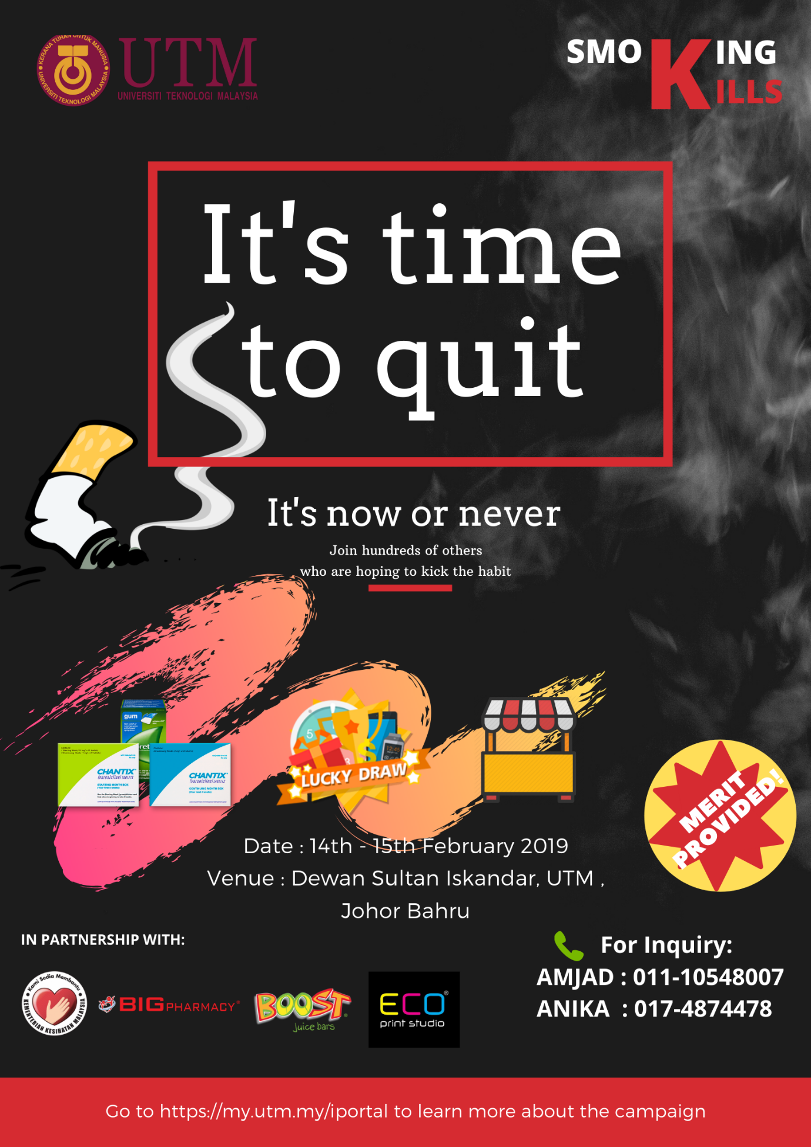

# 

# REFERENCE

* Source of cigarettes among youth smokers in Malaysia: Findings from the tobacco and e-cigarette survey among Malaysian school adolescents (TECMA) <http://www.tobaccoinduceddiseases.org/Source-of-cigarettes-among-youth-smokers-in-Malaysia-nFindings-from-the-tobacco-and,96297,0,2.html>
* Health Effects of Cigarette Smoking (January 17, 2018)

<https://www.cdc.gov/tobacco/data_statistics/fact_sheets/health_effects/effects_cig_smoking/index.htm>

* Study: Teens don’t find smoking fun but do it out of ‘boredom’ ( 25 Jul 2017 ) retrieved from Malay Mail.

<https://www.malaymail.com/news/malaysia/2017/07/25/study-teens-dont-find-smoking-fun-but-do-it-out-of-boredom/1428745>

* Tom Seymour ( July 27, 2017) The reasons why smoking is bad for you . Retrieved from Medical News Today

<https://www.medicalnewstoday.com/articles/10566.php>

* Malaysia pushes for strict law to regulate vapes, e-cigarettes (Oct 2019)

. Retrieved from The Star Online

<https://www.thestar.com.my/news/nation/2019/10/01/malaysia-pushes-for-strict-law-to-police-vapes-e-cigarettes>

* WANI MUTHIAH, MUGUNTAN VANAR, MANJIT KAUR, ONG HAN SEAN, R. SEKARAN, LO TERN CHERN, INTAN AMALINA MOHD ALI, FATIMAH ZAINAL, CLARISSA CHUNG, VENESA DEVI, WONG ZHI YONG, JESSIE GAN ZE XIN and YEOH CHENG JIN ( 01 Jan 2019 ) Smoking ban starts today . Retrieved from The Star Online

<https://www.thestar.com.my/news/nation/2019/01/01/smoking-ban-starts-today>

# APPENDIX

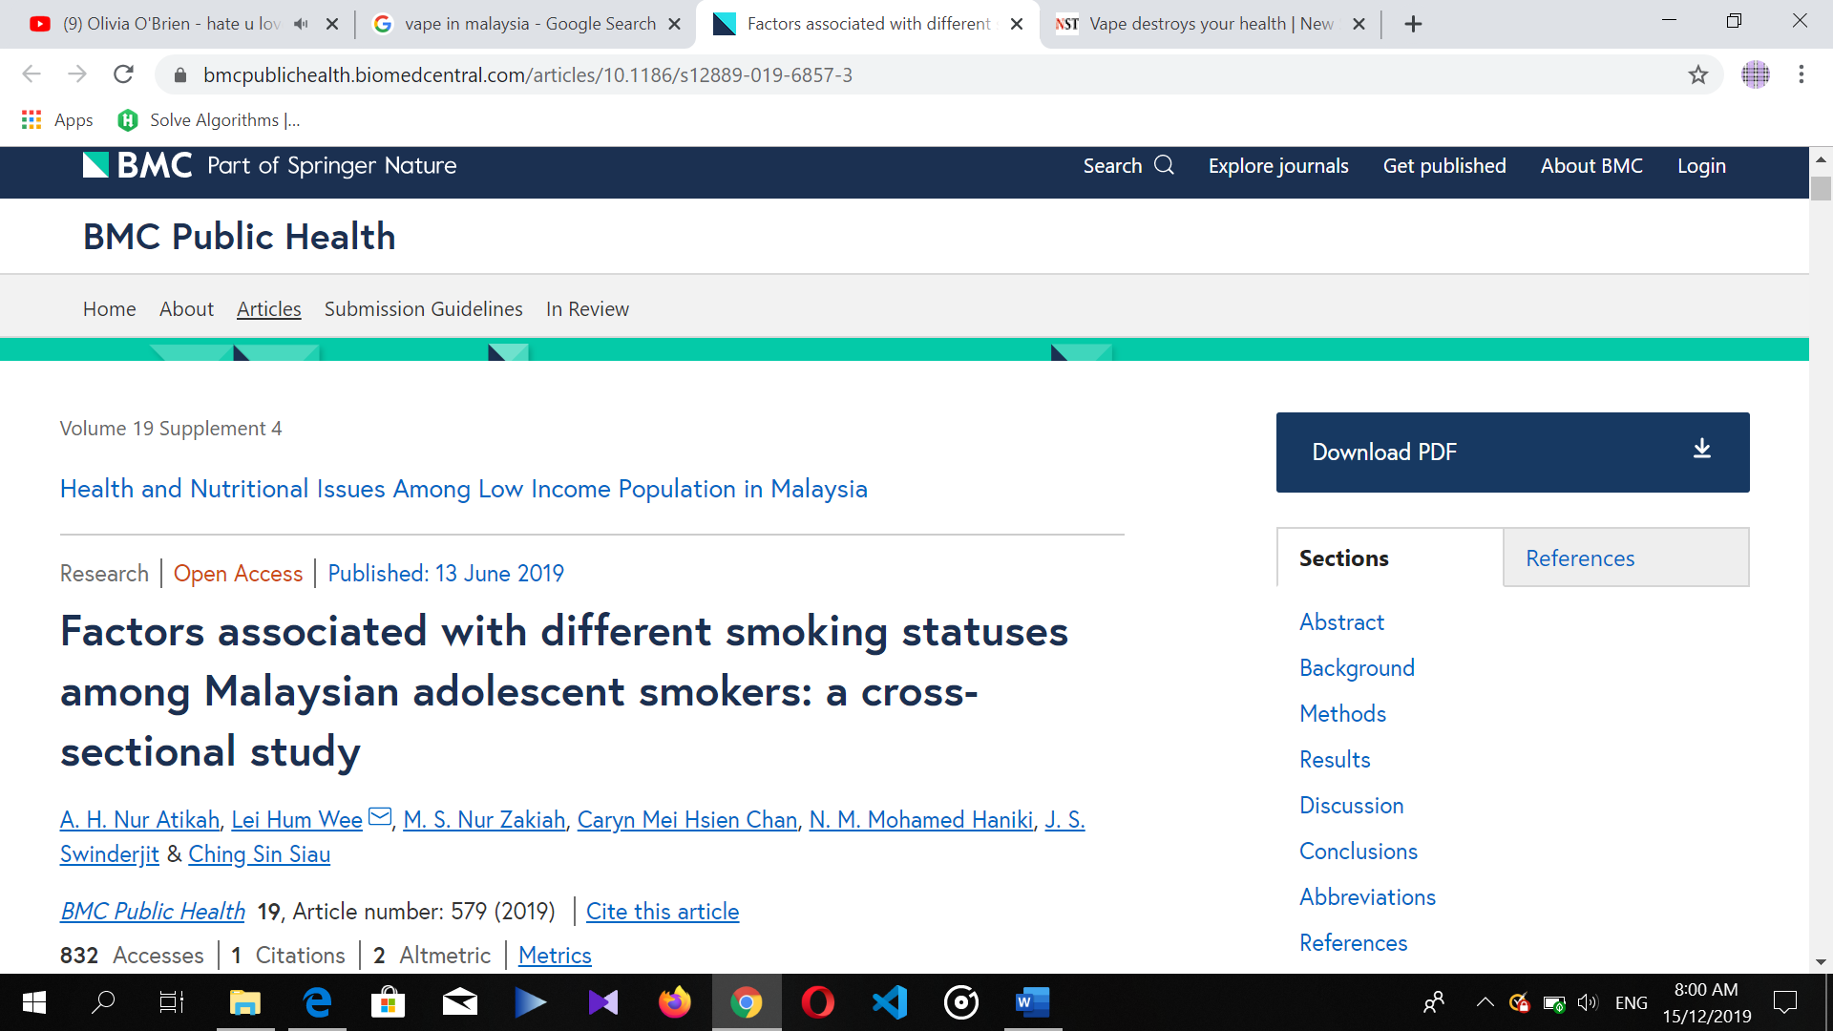

<https://bmcpublichealth.biomedcentral.com/articles/10.1186/s12889-019-6857-3>

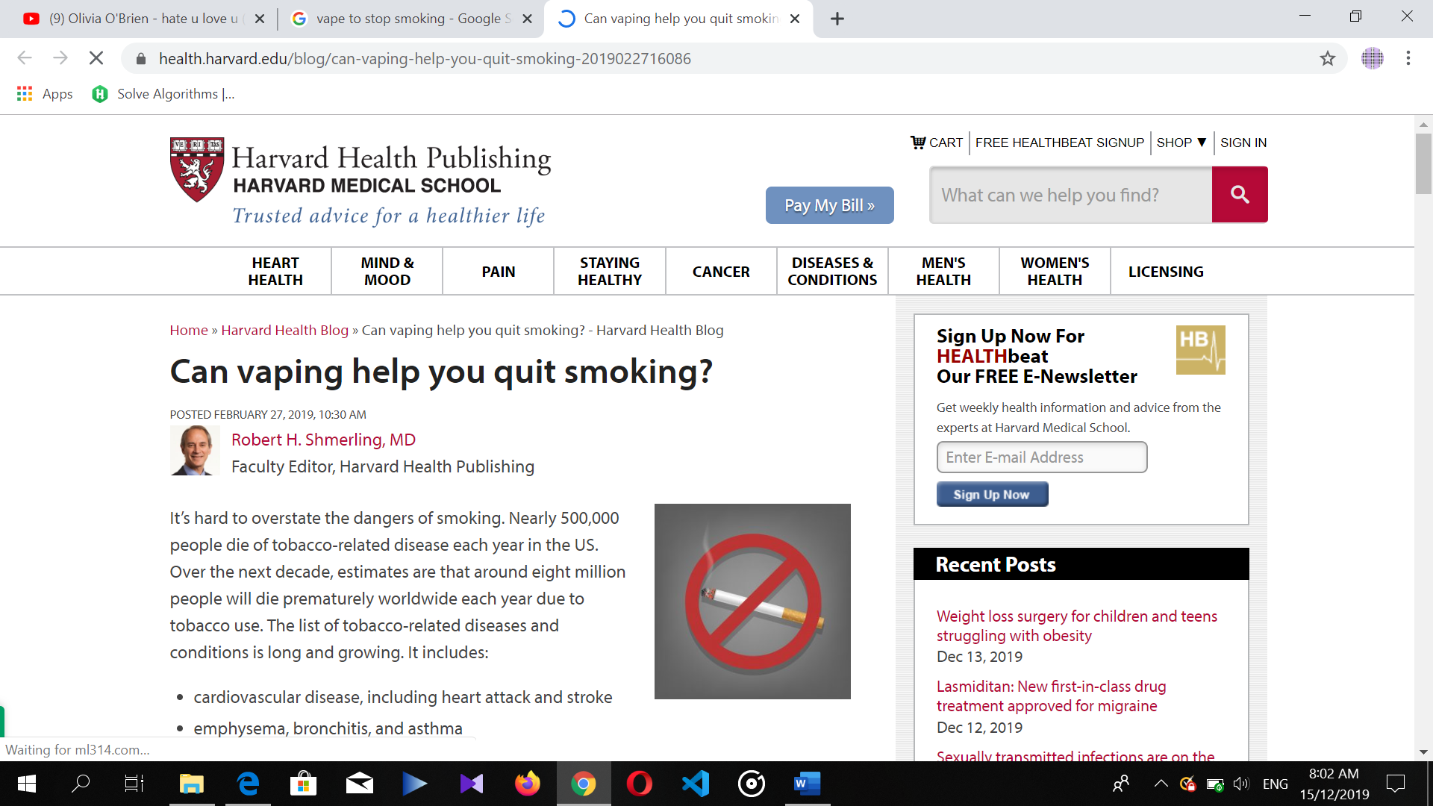

<https://www.health.harvard.edu/blog/can-vaping-help-you-quit-smoking-2019022716086>

# MINUTE-MEETING

MEETING AGENDA

First Meeting

Date/Time: 26th November 2019 / 11 a.m. – 12 p.m.

|  |  |  |  |
| --- | --- | --- | --- |
| No. | Group Member | Group Meeting Agenda | Other Remarks/ Limitations |
| 1. | Amjad | * Lead the discussion by starting with the issue of the proposal. * Getting program ideas from each of the group member * Gave ideas on doing a program on smoking which is the issue chosen for this program | Difficult to find more activities to be done for this program |
| Fikri | * Gave ideas on doing a program related to e-sports games | Not many programs like these have been done before, limited resources. |
| Nadiah | * Gave ideas on doing a program related to sustainable lifestyle. * Took notes on the minute meeting. |  |
| Syafa Ilyas | * Gave ideas on doing a program related to charity work. |  |
| Anika | * Searched more information on program related to smoking. |  |

Second Meeting

Date/Time: 3rd December 2019 / 10 a.m. – 11 a.m.

|  |  |  |  |
| --- | --- | --- | --- |
| No. | Group Member | Group Meeting Agenda | Other Remarks/ Limitations |
| 1. | Amjad | * Lead the discussion by starting with assigning tasks to every group member fairly * Searched more information on programs related to smoking awareness |  |
| Fikri | * Given the task to be in charge of the multimedia and publicity work * Given the task to design a poster for the program * Searched more information on how to promote the program | Difficult to find a unique way on promoting the program besides using a poster. |
| Nadiah | * Given the task to be the secretary, that is to make sure the proposal is properly written * Took notes on the minute-meeting |  |
| Syafa Ilyas | * Given the task to be in charge of the technical work * Searched more information on the certificate and the venue * Searched information on the preparation of food and drink for the visitors | Difficult to find the perfect food trucks company that can sell during the event |
| Anika | * Given the task to be the treasurer * Searched information on suitable companies that can sponsor the program | Difficult to find authorities like hospital to support the program |

Third Meeting

Date/Time: 10th December 2019 / 11 a.m. – 12 p.m.

|  |  |  |  |
| --- | --- | --- | --- |
| No. | Group Member | Group Meeting Agenda | Other Remarks/ Limitations |
| 1. | Amjad | * Lead the discussion by asking the progress of each group member’s tasks * Discussed about the perfect activities that can be done for the event * Deciding which member to be presenting the program proposal | Difficult to find interesting activities related to “no smoking” campaign that can attract people |
| Fikri | * Given the task to do the slides for the presentation * Given the role to be the second presenter | Difficult to make a perfect content in the slides to be presented within 10 minutes |
| Nadiah | * Took notes on the minute-meeting * Given the role to be the first presenter | Difficult to decide on which parts to be presented within 10 minutes |
| Syafa Ilyas | * Given the task to create a program tentative based on the list of activities | Difficult to arrange the activities to be fit into a two days event |
| Anika | * Preparing budget needed for the activities that will be held |  |