**FOR MORE INFORMATIONS:**

[Marina Binti Md Arshad](http://comp.utm.my/marinama/)

Programme Coordinator

Room: N28-347-08

Email : marina@fc.utm.my

Contact No. : 07-5532369

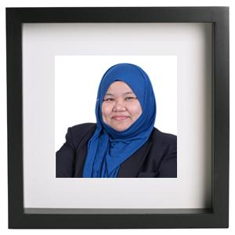

**CONTACT US AT:**







**SCHOOL OF COMPUTING**

Faculty of Engineering



**BACHELOR OF COMPUTER SCIENCE**

**COMPUTER NETWORK AND SECURITY (SCSR)**



**WHAT IS COMPUTER NETWORK AND SECURITY (SCSR)?**

In this digital era, most of life, entertainment and business activities are conducted online, either in cyberspace or mobile applications. Examples of these activities are banking, learning, socializing and buying merchandises like books, gadgets and even groceries.

Network and information security issues are important issues that influence the smooth running of these activities. Knowledge workers in network and security are needed to ensure that these activities can be conducted in an efficient and secure manner.

The Bachelor of Computer Science specializing in Computer Network and Security is an academic program specially tailored to produce Computer Scientist who is able to utilize Computer Science techniques in managing, analysing, modelling, monitoring, developing and solving problems in the field of network and computer security.

**LEARNING OUTCOMES:**

* The ability to design, implement, and test a network system using the latest standards and technology.
* The skills to manage and monitor network performance, while able to predict and plan the future growth of computer networks.
* The skills to design and implement a highly trusted security policy.
* The capability to apply logical and analytical thinking and scientific approach to problem solving.



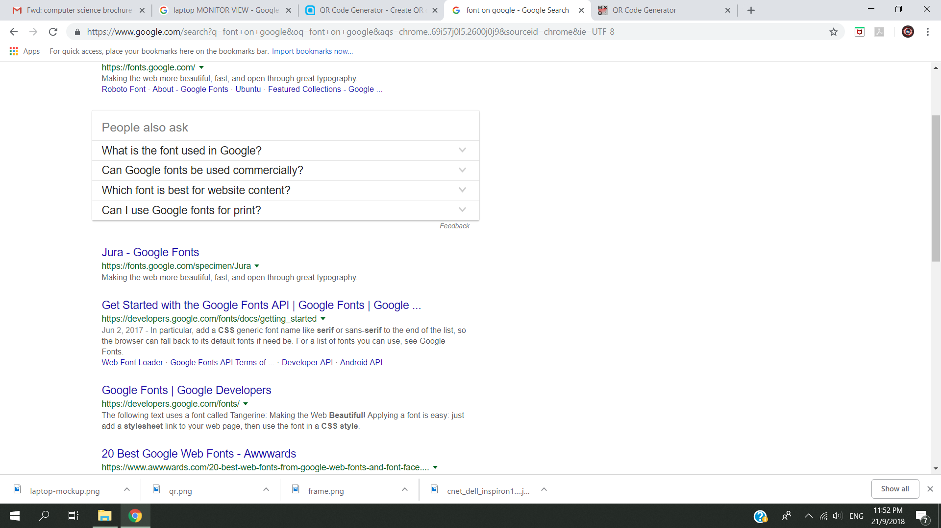



**Vision : To be a recognised world-class centre of academic and technological excellence in Information and Communication Technology.**

**Mission : To be a leader in the development of high quality human capital, innovation and services in ICT that will contribute to the wealth creation.**

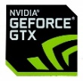



**CAREER PROSPECTS:**

* **Network Engineer ● Network Programmer**
* **Network Administrator ● Computer Security Engineer**
* **Network and Security Research Scientist ● Computer Auditor**
* **Network and Security Policy Manager ● Security Analyst**
* **Computer forensics analyst ● System Analyst**
* **System Engineer ● Academician**