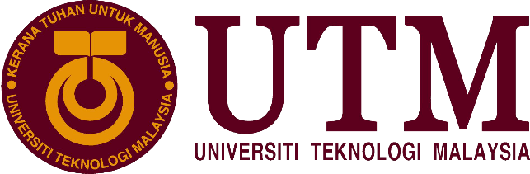

Technology and Information Systems (SCSP1513)

SEMESTER1 (2018/2019)

|  |  |
| --- | --- |
| Group | 13 |
| Name | RISSHE A/L PETER  FATHI MOAHMED FATHI REZQ BEKHIT  HABIB HADMY ZULKAFFLI  HARIES HASHEMEEN ALIAS |
| MATRIC NO | A18CS0241  A18CS0301  A18CS0067  A18CS0070 |
| LECTURER | DR. ARYATI BINTI BAKRI |
| SECTION | Section 9 |

“UTM SANJUNGAN BANGSA”

Table of Contents

1 NALI INTRODUCTION AND THE TREND 2

2 CONTENT OF THE EXHIBITION 2

2.1 BOOTH 9 2

2.2 BOOTH 10 3

2.3 BOOTH 11 3

2.4 BOOTH 12 4

2.5 BOOTH 13 4

2.6 BOOTH 14 4

2.7 BOOTH 15 5

3 TASK DISTRIBUTION 6

4 REFLECTION 6

5 SUMMARY 7

6 BIBLIOGRAPHY 7

Table of Figure

Figure 1 NALI participants’ booths 2

Figure 2: Booth 13's information poster 4

Figure 3 : TEG Demos 5

Figure 4 : Model for the landscape 6

# NALI INTRODUCTION AND THE TREND

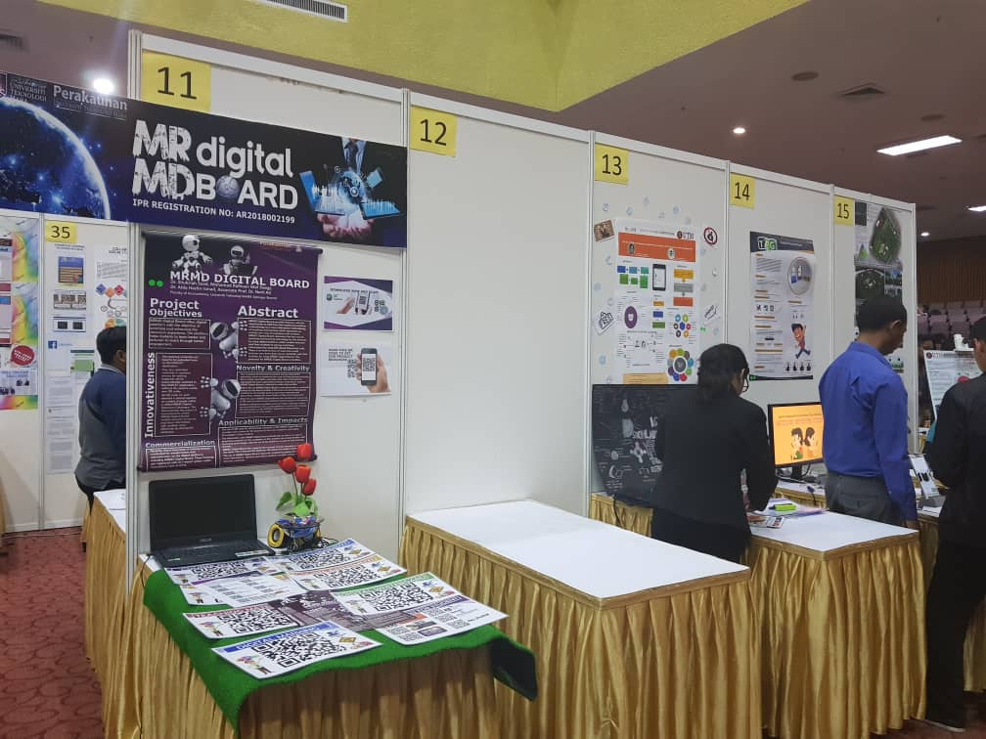NALI or also known as New Academic Learning Innovation is a UTM program held on 25th September 2018, all School of Computing students need to make reports regard the event based on group that already divided into booths for each group. We are supposed to visit booth 9 until booth 15. We divided booths among our self to visit. NALI was organized by the Centre for Teaching and Learning (CTL). It is a new way of learning for students that emulates best ways of to study in achieving entrepreneur aspect. NALI mainly focusing on improving the quality of learning and teaching that can embrace students to take these chances to improve their way of learning and motivated them to create something new beyond our imagination that can increase the accessibility about new way of life. By improving this, better quality of learning and teaching can easily be achieved by the community especially students in universities.

Figure 1 NALI participants’ booths

# CONTENT OF THE EXHIBITION

## BOOTH 9

What’s AERIS 4.0? **AERIS 4.0: ACCOUNTING EDUCATORS 4.0 BDCC READINESS IDENTIFICATION SYSTEM,** is innovated to measure the education willingness to adopt and integrate educational technology and digital tools for the teaching - learning process in the classroom it helps to identify educate requiring more attention ,hence further action to be formulated to find and improve their approach, AERIS also has the potential to be used by the other background and field of education because the measurement can be generalized, adopted and modified to suit a given context. Since the measurement used based on universal theories, it can be generalized to other field of education, different faculty, school teacher and even administration staff.

There are some features of AERIS which are designed in the form of computerized database assessment system that can be accessed electronically, educators can evaluate their readiness level towards the adoption of educational technology and it helps the teacher to deliver the information to the student easier. It also helps to identify educators requiring more attention. Why we need AERIS? The primary object for the creation of AERIS 4.0 is to to measure the accounting education readiness level of integrating and adopting the educational technology, to ease the process of formulating the necessary action which not only increase the readiness level but also encourage educators to adopt technology in their classroom activities.

## BOOTH 10

There was nothing at booth 10 even we were going there for two days.

## BOOTH 11

At booth 11**(Figure 1)**, the innovation that was set up for exhibition was MRMD Digital Board. It is an innovation that was created by the collaboration of Dr. Shukriah Saad, Mohamad Ridhuan Mat Dangi, Dr. Aida Hazlin Ismail and Associate Prof. Dr. Norli Ali. They are from the Faculty of Accountancy, Universiti Teknologi MARA Selangor. The objective of MRMD Digital Board project is to enrich and enhance the classroom experience of students and lectures alike. This platform enables students to learn better and help the teachers to engage with the students.

MRMD Digital Board is a digital platform that can provide lectures the opportunity to upgrade their way of teaching to the upcoming trend of teaching which involves the digital world. It represents the new era of teaching and learning of the 21st century by allowing lectures and students to share information through Quick Response code which is more popularly known as QR code. There is no limit for how much information is shared on this platform. This shows the limitless potential of the MRMD Digital Board. The emerging industrial revolution 4.0 has influenced the education system to undergo another evolution. The education sector has reexamined the way of education. Universities had been given the resposibility of creating new and inovative ideas from the younger generation. To help this the MRMD Digital Board is formed. Before this, documents and materials were tacked on the board outside. Because of the insufficient space, the board will end up messy but by using the MRMD Digital Board, one only need to paste the QR code of the involving courses. Not only that the students can get immediate access to the courses, the board will look organised as all the information is shared through the QR code.

The use of QR code in the process of teaching on the MRMD Digital Board gives the chance for lectures to give their knowledge to the students in a more creative and interactive way. The student’s interaction with the MRMD Digital Board also prepares the students for workplace as they need to adapt to the new ways of technology in the field of learning. The MRMD Digital Board also supports the concept of green learning and save the Earth as it can help to reduce the use of paper. The students also will be interested in studying because the MRMD Digital Board introduces a new way of studying. As for commercialization of MRMD Digital Board, there have been 9 training sessions held for academicians and administrators on digital platforms including MRMD Digital Board. The trainings are registered with an I-expert under the Consultancy Unit of UiTM.

## BOOTH 12

At booth 12 also was nothing there during the NALI event.

## BOOTH 13

‘Improve your oral presentation skills’ is the theme at Booth 13. By using the video via Telegram application, Jagjit Kaur Gian Singh who is the developer of this project said that we can use the application as an effective tool to improve our oral presentation skill without any fees because the application was free to install and just need the connection to the Internet. She found this idea after she notices the most student still doesn’t have the presentation skill even they already in Degree level and students cannot find the platform to improve their skills or as preparation before their do the presentation.

User just needs to upload their presentation video then the viewer will put the comment about their presentation below the video. Through the comment, users will know what their need to improve and also the mistake when presenting. Their objectives are to provide practice of presentation frequently, enable self-observation via Telegram Application to improve students’ oral presentation skill, and demonstrate the ability to engage in lifelong learning activities. In addition, this project will bring a lot of benefit to student such as a starter kit for student prepare for the workplace, rich communication due to one to one communication, reduce inhibition, interactions collaborative and more. Plus, it will save cost since students no need to go any workshop to improve and it also will save time for student because they just need to record their video then upload it in Telegram and lastly, just wait the comment about their presentation. It will help to rise their confident level on their presentation.

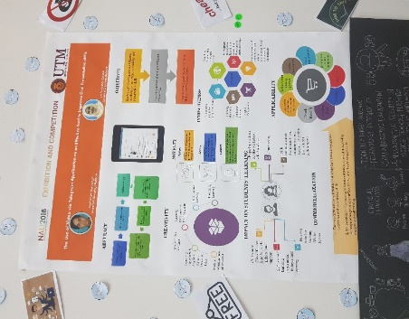

Figure 2: Booth 13's information poster

## BOOTH 14

Booth 14 is about ‘Tangible Educational Game ‘also known as (TEG). TEG is a physical play set that integrates tangible objects with mobile application with a concept that allow kids to play beyond screen. TEG uses Augmented Reality engine as core of the mobile-based games application that combines with mobile devices as display, reflector mirror, stand and set of tangible objects as tracking and interaction technology. TEG sees a vision of the future where technology is greatly used to create boundless interaction, while still embodying the concept of play to learn. This work can be an alternative platform for kids to learn by plays collaboratively with more various games design for educations. The project objectives are to design tangible object interaction using AR engine, mobile-based games using play beyond the screen concept.

TEG is relevant to NALI framework which integrate collaborative learning as learning mode and edutainment mobile games as learning materials by introducing collaborative mobile games that enable blending learning concept implemented to student in order to support student centred learning. This will help the children to use their imaginary and creative thinking to solve the problems using interactive and fun ways in this work. It also will encourage children to work as a team where they can play the game in a group instead of playing alone. TEG also can help kindergarten’s teachers to expose new ways of learning to students which can help in their cognition enhancement.

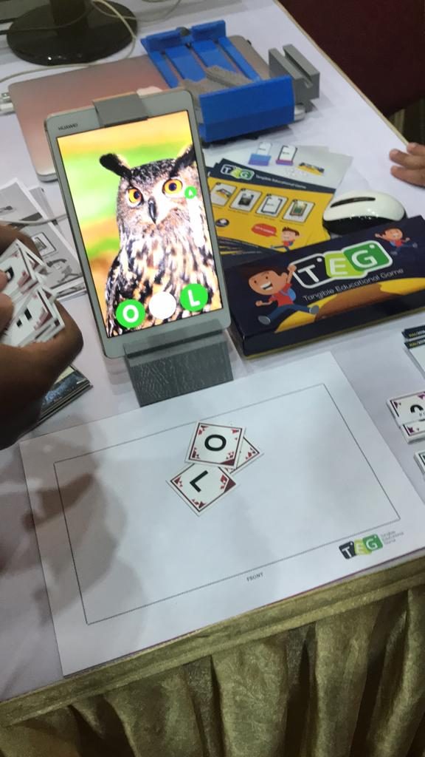The commercialization potential for TEG is early education market size more than 800,000 children between 4 to 6 years old that attend kindergarten in Malaysia. The price estimated for 1 set of TEG is about 30 Malaysian Ringgit.

Figure 3 : TEG Demos

## BOOTH 15

Booth 15 is about ‘LANDSCAPE ARCHITECTURE DESIGN STUDIO. Landscape architecture (LA) education in the 21st century is becoming more challenging which requires integration and innovation. In line with the transformation of higher education to meet the challenges for the 21st century teaching and learning, NALI framework has been implemented in LA programme. The Recreational Park Design (SBEL 2425) course is designed for second-year Bachelor of Landscape Architecture students in UTM.

The course offers opportunities for University-Industry networking. The engagement is between the local authority, community and university students for Nusa Damai Community Park, Pasir Gudang. Project-based learning is applied whereby students conducted the site inventory, data collection, interviews and observation towards producing a Landscape Master Plan. Series of focus group discussions and design critique sessions were also conducted within the community to choose the best design idea to be implemented at the community park which also enhances students’ technical and generic skills. This project is highly aim to design a liveable eco-community park at Nusa Damai, Pasir Gudang. This is to integrate students and community participation throughout the whole project exercises that in line with the Key Focus Area 2 of Pelan Global UTM 2012-2020 (PGU3).

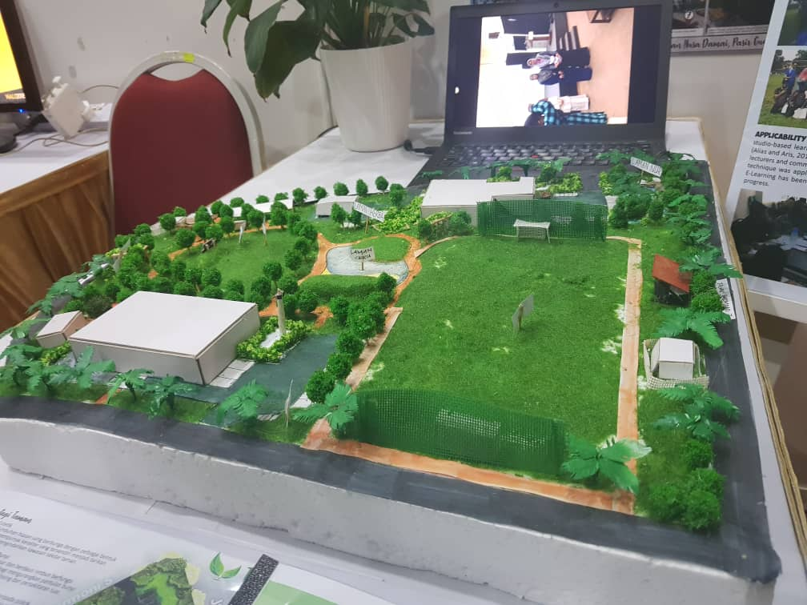Integration of teaching and learning experience in cooperating with eco-community landscape design expose students learning outcome in creating a sustainable landscape master plan. Students learning process reveal their hands-on actual learning experiences in cognitive knowledge, entrepreneurship, design and built. Indeed, integrating studio-based learning with

Figure : Model for the landscape

NALI Blended learning enhance the visibility of project-based learning via design analysis, site issue evaluation and design concept application. This practice enables the students to meet on-site client.

# TASK DISTRIBUTION

Our group are consisting to 4 members so we decide split it into 2 group since we are from different section which was our time available to go to NALI talk was different. Group 1 is Haries and Habib and Group 2 is Fathi and Risshe. Each group had one interviewer who was need to ask the presenter for information and another member needs to capture some pictures and collect the brochure. Since we need to survey at least six booths (9 to 15) so, we divided it to 2. Group 1 went to the NALI talk on 25th September while another group went it on 26th September. After that, all the members do the report together but we submit the report separately.

# REFLECTION

By going to New Academia Learning Innovation (NALI), I managed to get new and important knowledge about the evolution that the process of teaching and learning is undergoing. The industrial revolution 4.0 has impacted many changes in many fields, one of them is the education field. Nowdays, the education field has started to implement digital platform in the process of teaching and learning.

What I managed to learn from NALI is that the digital world will be mixed in education. Many presenters had presented their innovative work on implementing the digital world in the world of education. Aeries BDCC 4.0 from booth 9, MRMD Digital Board from booth 11, Improve Presentation Skill via Telegram from booth 13, Tangible Education Game from booth 14 and Landscape Architecture Design Studio from booth 15 has given me the idea of using things like QR code and mobile apps in the field of education. Unfortunately, we feel upset with empty booths which are Booth 10 and Booth 12 because we lose opportunity to know two more Malaysian innovation ideas.

Moreover, I also realised that these innovations have the potential to ease up the burden of lectures as they can use blended learning to teach the students. They don’t need to prepare and carry the teaching materials everywhere as they are stored digitally and the students can have access to it anytime. Blended learning which is emphasized in NALI is a combination of active and systematic strategy that is used in class with the help of digital teaching materials. This also can let the students experience a tip of the future education.

# SUMMARY

NALI program surely is a futuristic program that going to change the way of learning which means every aspect is learning will have their own way for students to follow that can enable high quality learning can be achieve and benefits both students and lecturers. We should focus more on the outcome by undergo NALI program because outcomes in learning are actually what learners can demonstrate at the end of learning experience. These outcomes should provide clear guidance for the planning and development of the teaching process which includes the creativity, rationality and the way of thinking, so that the best method for teaching can be select to be use in future. NALI program need to be spread throughout whole country, this can improve our education level and increase the number of high grade students to be sent to overseas especially in engineering course so that we can apply in Malaysia’s industries for better future 2020. All the booth explain above will help and create new way of learning through creativity.

Lastly, from all the booth we visited we get to know that to change effectively new way of learning, we don’t need to change the way on how the lecturers interact with students but we can improve on how students can interact with the information of what they learned by using technology, creativity, activities and others. This will show efficiency the changes of the way to learn new thing especially among university students that each one of them have different personalities. We all hope that NALI can change whole way of learning so that we as students can find new way of interesting way to learn in lectures and achieve our own goals in university life.

# BIBLIOGRAPHY

New Academia Learning Innovation (NALI). (2017). URL

<http://utmlead.utm.my/new-academia-learning-innovation/>

NALI book montage | Youtube video. (2017, Jun 10). URL

<https://youtu.be/8YKaMTqcGME>