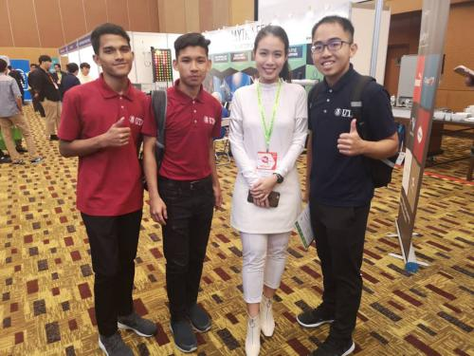

perfectly on our face. WISE AI claimed that machine learning need to have at least 100 faces or samples to have higher prediction accuracy. Furthermore, they are still developing Car Plate recognition and Emotion detection. They are now available in Beta edition. In addition, we visited MyTraffic City Solution that does traffic analytics. The procedures explained was at first, information from the traffic will be collected by the camera (CCTV) and send it to the GPU server. Their GPU can process up to 30 cameras. The info that collected will be stored in the database and the data in GPU will be erased within 24 hours. From the video, they capture vehicle type, how long the vehicle is, how long is the queue at the traffic lights, traffic condition and even the vehicle id (car plate recognition). From the GPU server, the data processed and send to Traffic light control centre then it will send the instructions to traffic light.

regarding big data and how it works. The usage of IoT and Cloud computing can be seen used by some companies as a way to enhance their systems such as smart city and customer service. Upon going inside of the hall, we first visited the AccelTeam which over the past two decades has been helping in enabling business related to data analytics. They mainly focus on Business Analytics related project delivery. Their mission is to help find solutions on how their customers can move forward in their business journey. AccelTeam’s services including data-driven analytics solution, enterprise data warehouse automation and data preparation related solution, advanced analytics on location intelligence and automated machine learning related solutions, big data analytics and converged big data platform solutions. AccelTeam has been working for years in finding solutions using technologies for the enhancement of their customers’ businesses. This has been proven when they received a lot of good feedback from their customers.

The AccelTeam is working very hard to help new IT companies in expanding their businesses. In addition, AccelTeam is open in accepting internship for all IT undergraduates who wants to go data analytics and data management. They will

who is looking or seeking some information about data and how it works in industries. During the Big Data Week exhibition in KLCC, a lot of companies had come to help those who are in need of some information

verification purposes. Face recognition like in our smartphone is nothing new but the advanced technology due to artificial intelligence created a revolutionized facial recognition system. This also applied in Snapchat and Instagram filters work

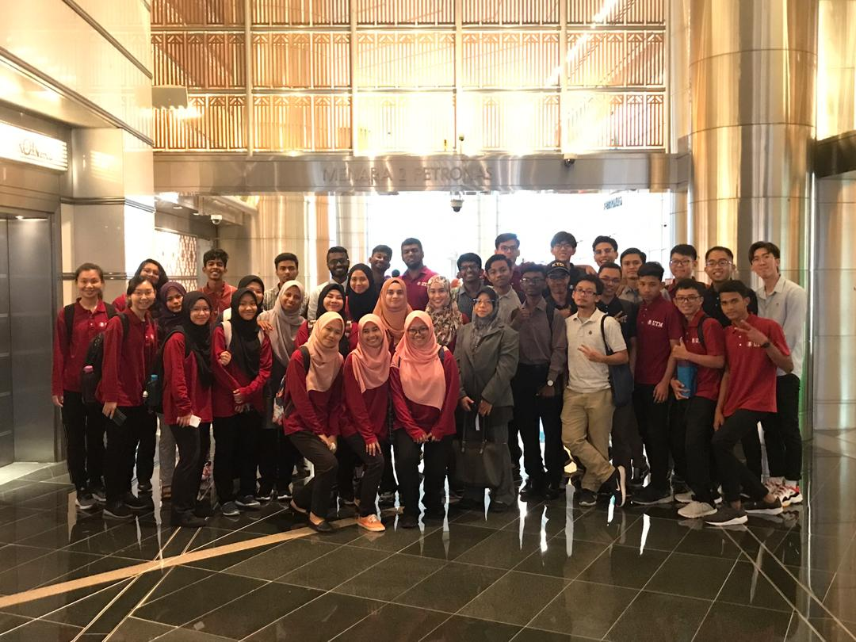

help the students in developing their skills and knowledge on how to find solutions for data analytics. Next, we went to WISE AI. They specialized in face detection that can extract facial data from sample. AI will learn those facial data and start to differentiate age, gender and facial structure. One of the representatives said that the more samples that AI have, the more comparisons between samples AI can do to make the next predictions with high accuracy. The samples they got will be stored in the database for future references. A big AI model occupied with camera and screen was provided in front of their booth for visitors to try their technology. After the camera snap our face picture, AI will synchronize our face with the closest celebrity face. It also shows the accuracy percentage with the celebrity face. Before they developed the system, AI started with scanning thousands of celebrities faces, extract and collect many data as much as possible so they can match, compare and find out which celebrity’s face has the higher compatibility with us. In real life, this AI features are used in security and identity

Big Data Week is an exhibition held annually at various places around the globe and founded by Steward Townsend and Andrew Gregson. It is a way on how the community of data can connect with each other through a locally hosted big data conferences and events. The main purposes of Big Data Week are to give exposure to the necessity of database in industries and how data influences the modernization of technologies in today’s world. Many companies had come to share information about big data and to promote their latest inventions such as smart city and AI face recognition to all visitors. Some companies like FUSIONEX had explained the future of data like how the concept of Internet of Things (IoT) collects a explained the future of data like how the concept of Internet of Things (IoT) collects all data and connect them through a cloud for display and to help produce the best decision for an organization. In addition, some exhibitors also can give some tips on how to survive in the data world to students who came to the exhibition. In brief, Big Data Week can be a great platform for everyone

Discovering *BIG DATA WEEK* in KLCC

Trends In Artificial Intelligence and Big Data

Data is the “new oil”. We can no longer deny the fact that data has its own value and is dominating the industry rapidly. Organizations that can discover the answers to data challenges will be in a better place in terms of economy as they can benefit more from the adaptation of digital technologies in today’s world. As data governance begin to expand, demand for this sector will also rise. Data engineers who have skills and experience with the tools like database can surely take this as an advantage for them to grow further in the data society. You can also expect to see demand for machine learning engineers accelerate. This is because the same thing is happening with Artificial Intelligence (AI) where nowadays, we can observe a major change in industry and public sector as the technologies of AI and machine learning are widely being used in services, business, etc. Most organizations are starting to invest more on AI-related projects as they believe AI can increase the quality of product or services that can benefit them more. In fact, data as a connector for the trade of information between companies is becoming a serial model for many consumer services like Facebook, Amazon and Spotify

Group Reflection

We have gained a lot of things from the visit to Big Data Week exhibition at Kuala Lumpur Convention Centre. From collecting information regarding our course to receiving tips and motivation from all representatives of each company. For us, all companies are trying their best to create and produce something that could fit with the modernization of technologies that will never stop. From the visit, we have learned that data engineering is a high demand sector because industries nowadays are implying big data on their inventions. This made us realize that the roles of data engineers in today's technology world are big as they have to design, build, develop and manage an enormous amount of data for the program installed to the system beside ensuring a big profit for the company.In addition, through this visit, we managed to ask some companies about their opinion on a one-year internship program. Surprisingly, all companies that we asked are open to accept any students from this program. Big Data plays a big role in inventions such as smart city and artificial intelligence. One of the companies there is Wise AI. This company is an artificial intelligence company specializing in face recognition. We were so excited when the exhibitor explained about a website they developed. The website will scan your face then will give you one celebrity that has the same face features as you. To build this kind of website or applications will have to involve a lot of data stored and we were so amazed with how the website works. To sum up, this AI and Big Data exhibition has inspired us a lot in becoming a better data engineer so that we could contribute something in the future.

