ASSIGNMENT 1 (MASS ENERGY BALANCE)

SUGAR CANE PRODUCTION PROCESS:

The residues from sugar are part of the natural products. Sugarcane is normally harvested manually, which eliminates the carrying of soil and trash to the factory along with the Sugarcanes.

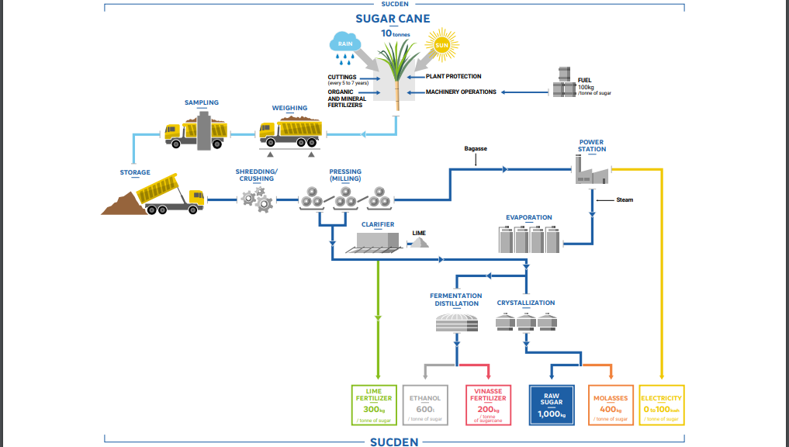

UNIT OPERATIONS INVOLVED AND CHEMICAL SUBSTANCE AT EACH SINGLE UNIT OPERATION:

*Step 1: Harvesting*

* Harvesting (of both cane and sugar beet) is done primarily by machine, although in some states it is also done by hand. The harvested cane stalks are loaded mechanically into trucks or railroad cars and taken to mills for processing into raw sugar.

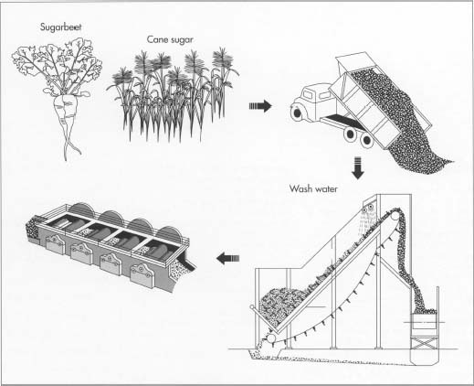

Step 2: *Preparation and processing*

* After the cane arrives at the mill yards, it is mechanically unload, and excessive soil and rocks are removed. The cane is cleaned by flooding the carrier with warm water (in the case of sparse rock and trash clutter) or by spreading the cane on agitating conveyors that pass through strong jets of water and combing drums (to remove larger amounts of rocks, trash, and leaves, etc.). At this point, the cane is clean and ready to be milled.
* When the beets are delivered at the refinery, they are first washed and then cut into strips. Next, they are put into diffusion cells with water at about 175 degrees Fahrenheit (79.4 degrees Celsius) and sprayed with hot water counter currently to remove the sucrose.

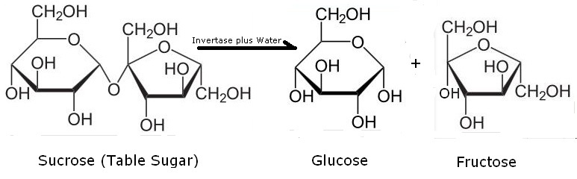

*Step 3: Juice extraction pressing (Splitter-Mechanical Processes-Crushing/Milling)*

* Two or three heavily grooved crusher rollers break the cane and extract a large part of the juice, or swing-hammer type shredders, shred the cane without extracting the juice. Revolving knives cutting the stalks into chips are supplementary to the crushers. The pressing process involves crushing the stalks between the heavy and grooved metal rollers to separate the fiber *(bagasse)*from the juice that contains the sugar.

FIBER (BAGASSE)

SPLITTER

SUGARCANE

JUICE (CONTAIN THE SUGAR)

* As the cane is crushed, hot water (or a combination of hot water and recovered impure juice) is sprayed onto the crushed cane counter currently as it leaves each mill for diluting. The extracted juice contains 95 percent or more of the sucrose present. The mass is then diffused, a process that involves finely cutting or shredding the stalks. Next, the sugar is separated from the cut stalks by dissolving it in hot water or hot juice. This process is called leaching process (liquid-solid extraction).

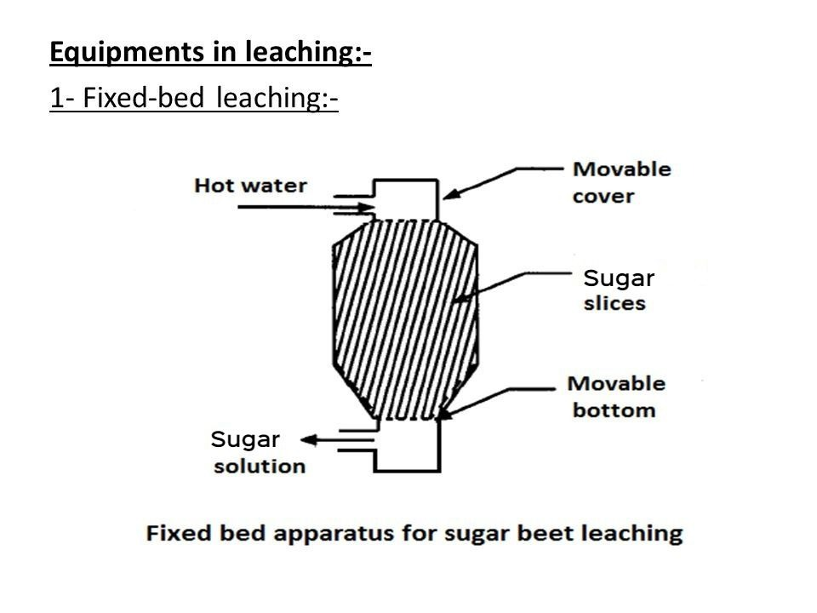

*Step 4: Purification of juice — clarification and evaporation (Reactor-Heat Transfer and Fluid Flow Processes)*

* The juice from the mills, a dark green color, is acid and turbid. The clarification (or defecation) process is designed to remove both soluble and insoluble impurities (such as sand, soil, and ground rock) that have not been removed by preliminary screening. The process employs lime and heat as the clarifying agents. Milk of lime neutralizes the natural acidity of the juice, forming insoluble lime salts. Heating the lime juice to boiling coagulates the albumin and some of the fats, waxes, and gums, and the precipitate formed entraps suspended solids as well as the minute particles. The sugar solution, on the other hand, is purified by precipitating calcium carbonate, calcium sulfite, or both in it repeatedly. Impurities become entangled in the growing crystals of precipitate and are removed by continuous filtration.
* The muds separate from the clear juice through sedimentation. The non-sugar impurities are removed by continuous filtration. Before the juice is processed for evaporation, sulfur dioxide is mixed with the cane juice to literally cause a bleaching effect on the mixture. With this procedure alone, the sugar crystals that will be produced will be white.
* To concentrate this juice, about two-thirds of the water is removed through vacuum evaporation. Generally, four vacuum-boiling cells or bodies are arranged in series so that each succeeding body has a higher vacuum (and therefore boils at a lower temperature). The vapors from one body can thus boil the juice in the next one—the steam introduced into the first cell does what is called multiple-effect evaporation. The vapor from the last cell goes to a condenser. The syrup leaves the last body continuously with about 65 percent solids and 35 percent water. The sugar sucrose solution, at this point, is also nearly colorless, and it likewise undergoes multiple-effect vacuum evaporation. The syrup is seeded, cooled, and put in a centrifuge machine. The finished crystals are washed with water and dried.

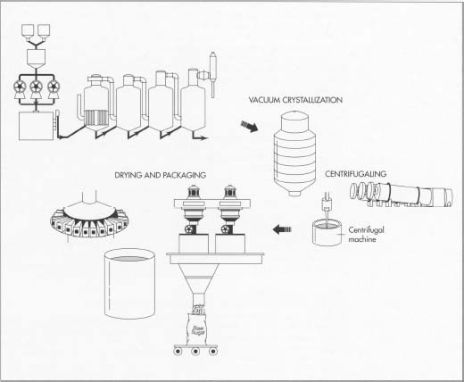

*Step 5: Crystallization (Mixer)*

* Crystallization takes place in a single-stage vacuum pan. The syrup is evaporated until saturated with sugar. As soon as the saturation point has been exceeded, small grains of sugar are added to the pan. These small grains, called *seed,*serve as nuclei for the formation of sugar crystals. Additional syrup is added to the strike and evaporated so that the original crystals that were formed are allowed to grow in size until it’s full. When sucrose concentration reaches the desired level, the dense mixture of syrup and sugar crystals, called *massecuite,*is discharged into large containers known as crystallizers. Crystallization continues in the crystallizers as the massecuite is slowly stirred and cooled.
* Massecuite from the mixers is allowed to flow into centrifugals, where the thick syrup, or molasses, is separated from the raw sugar by centrifugal force.

EVAPORATED SYRUP

MIXER

SUGAR CRYSTAL

SMALL GRAIN (SEED)

*Step 6: Centrifuging (Separator by force field)*

* The high-speed centrifugal action used to separate the massecuite into raw sugar crystals and molasses. The raw sugar is retained in the centrifuge basket because the perforated lining retains the sugar crystals. The mother liquor, or molasses, passes through the lining (due to the centrifugal force exerted). The final molasses containing sucrose, reducing sugars, organic non-sugars, ash, and water, is sent to large storage tanks. Once the sugar is centrifuged, it is "cut down" and sent to a granulator for drying.

RAW SUGAR CRYSTAL

SEPARATOR

MASSECUITE

MOLASSES

*Step 7: Drying and packaging*

* Damp sugar crystals are dried by being tumbled through heated air in a granulator. The dry sugar crystals are then sorted by size through vibrating screens and placed into storage bins. Sugar is then sent to be packed in the familiar packaging we see in grocery stores, in bulk packaging, or in liquid form for industrial use.