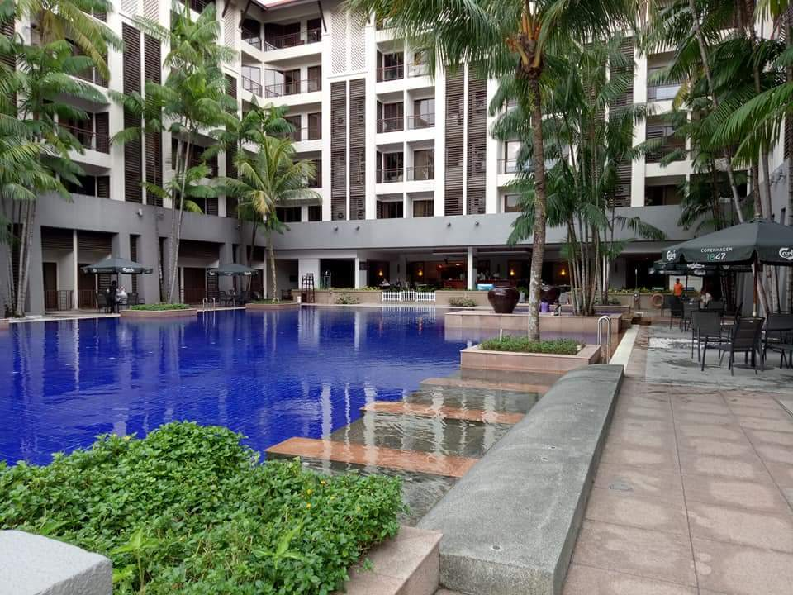
homestay

We have your landscape needs covered
owner NAME:  Azurah  Contact no:  012-7856650 | - Resort apartment – fully furnished 2 bedrooms, 1 bathroom, living room, kitchen and balcony  - Location: Cinta Ayu apartment, Pulai Springs Resort, 20 km Jalan Pontian Lama, 81110 Pulai, Johor Malaysia  - Rate: RM 200 per night  - WIFI  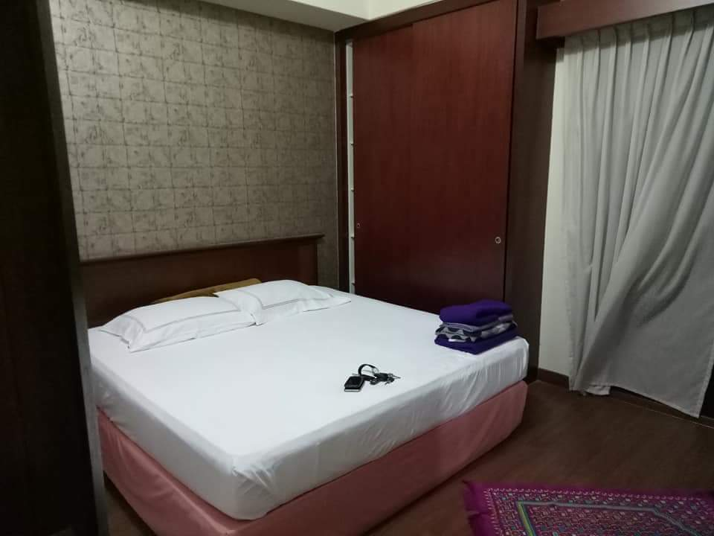
BILL PAYMENT RECEIPT  INVOICE / 18-09-2018 | Pulai Springs Resort

Bablu Das  Address: Patangan,4024, Chittagong, Bangladesh. | BALANCE DUE  Upon Receipt  RM:150

Thank you for visiting our resort.

Item Description | Quantity | Price Per | Total
Resort apartment: Master bed | 2 | 200 | 400
 |  | Subtotal | RM400.00
 |  | Tax - 0% | RM0.00
 |  | TOTAL | RM400.00

