GROUP REPORT

MINI PROJECT

PHOTOCOPYING (XEROX) MACHINE

DIGITAL LOGIC
SCSR-1013/10
Dr. Zuriahati binti Mohd Yunos

SECTION : 01
Course : Bachelors of Computer Science (Data Engineering )

GROUP MEMBERS:
- CHIA WEI HONG (A19EC0033)
- RAGU (A19EC0152)

DEDICATION AND ACKNOWLEDGEMENT

First and foremost, we would like to extend our gratitude to our Digital Logic teacher, Dr Zuriahati binti Mohd Yunos, for teaching us Digital Logic and supporting us by equipping us with the knowledge we needed to complete this project completely.
We also would like to thank madam for giving us advice and guidance, so that we were able to complete this mini-project completely. We also would like to take this opportunity to thank our friends and family for helping us and giving us wonderful insights by lending a hand, or giving us new ideas, which made the project successful.
We also would like to show our appreciation to the staffs that helped and guided us throughout the project. For any mistakes or shortcomings, we would like to express our apologise and gratitude. We also would like to say thank you for guiding us in this project .
To end this, I hope that this project can bring benefits to others . We also hope that lecturer abled to identify our potentials and guide us for betterment .
Thank you very much .

Contents
MINI PROJECT 1
PHOTOCOPYING (XEROX) MACHINE 1
SECTION : 01 1
GROUP MEMBERS: 1
DEDICATION AND ACKNOWLEDGEMENT 2
REPORT CONTENT 4
A. BACKGROUND 4
B. PROBLEM 4
C. OBJECTIVE 4
D. FLOWCHART 5
E. COMPONENT 7
F. MATERIAL & SOFTWARE USED 8
G. CIRCUIT IMPLEMENTATION 9
H. PHYSICAL SYSTEM IMPLEMENTATION 10
I. DISCUSSION 11
J. .CONCLUSION 12
REFERENCE 12
• Digital Logic, Fifth Edition, Department of Computer Science, Faculty of Engineering UTM. 12
APPENDIX 13
A)2 BIT 13
B)3 BIT 14

REPORT CONTENT

BACKGROUND
In this mini-project we are tasked with recreating this invention (XEROX machine) using the knowledge that we have gained from learning Digital Logic throughout semester 1.
This mini-project implement 3 different component on a single GAL device. Those components are:
- 3-bit count up counter
- 3-bit comparator
- Clock disabler

PROBLEM
The main problem in this project is to gain the understanding of how a Xerox machine works. We were required to use our skill and knowledge in Digital Logic to form the basic function of a Xerox machine. To do that, the user will initially enter the amount of copies, the counter will counter the number of copies that has been photocopied. The machine will stop once the required number of copies is produced.

OBJECTIVE
The objective of this laboratory are to introduce the students:
- The development of a PLD device.
- A simple Hardware Description Language

FLOWCHART

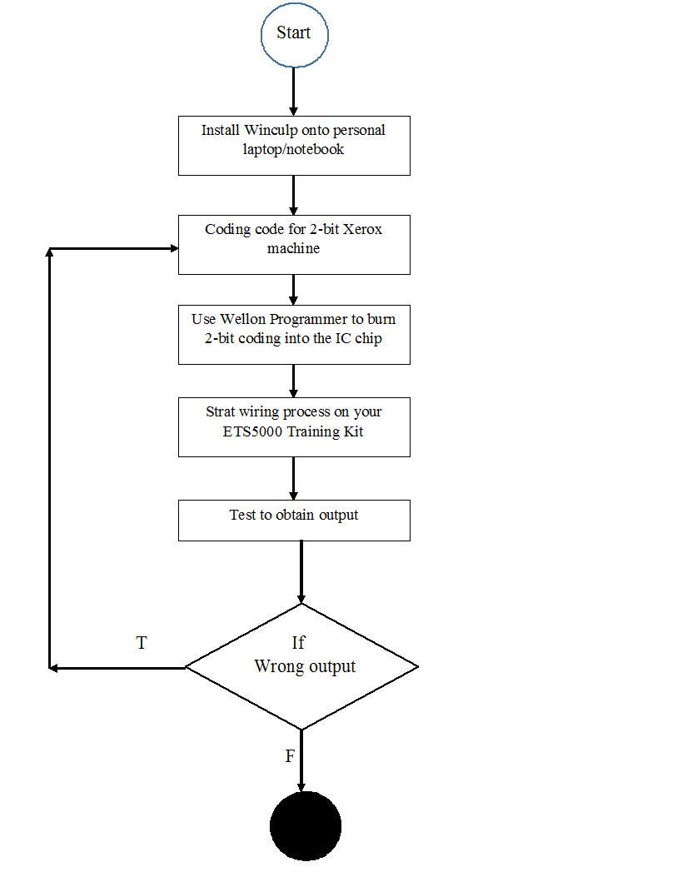
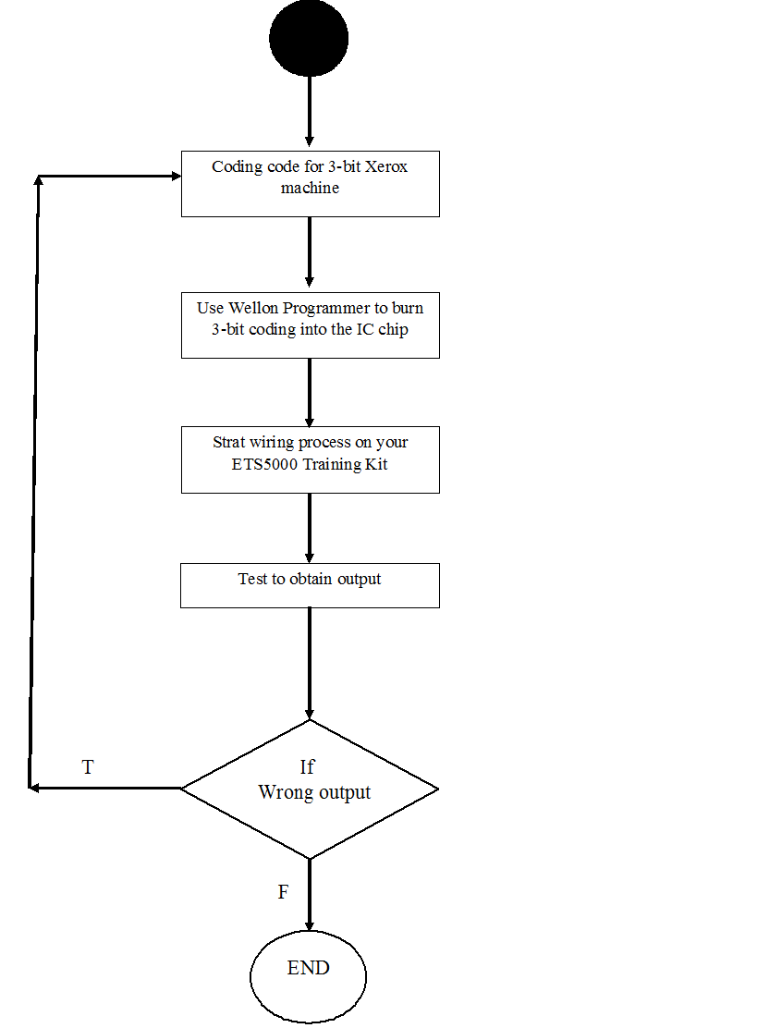

COMPONENT

- Switches | to set the required number of copies
- Synchronous counters | to count the number of copies that had been made
- Comparator | to compare the number of copies required and number of copies produced
- Clock enabler | to start the operation of the counter.  If copies produced < required copies, counter will count up, else counter will stop counting

MATERIAL & SOFTWARE USED

PLD | A programming logic device (PLD) is an electronic component used to build reconfigurable digital circuit. In this project, it is used to test out the programming file of the project.
 | ATMEL also known as Atmel Corporation design and manufacture semiconductors and many more. They make a lot of products and one of them is the microcontrollers being the biggest factor in sales. In this project, their PLD is used in this
Breadboard | A breadboard is a solderless device for temporary prototype with electronics and test circuit designs
GAL 22V10 | - The GAL22V10 has 12 input pins, and 10 pins that can be configured as either inputs or outputs. The GAL22V10 is a series of programmable-logic devices, implemented as CMOS-based generic array logic ICs.
ETS-5000 Digital Training Kit | The ETS-5000 Advanced Digital Training System is designed for the beginners to enhance the comprehension of advance digital theory
Wellon Universal Programmer & Tester | A software used to burn the coding into a Programmable Logic Device (PLD).
WinCUPL 5.0 Software | A software used to do coding which will be used to program a PLD.

CIRCUIT IMPLEMENTATION

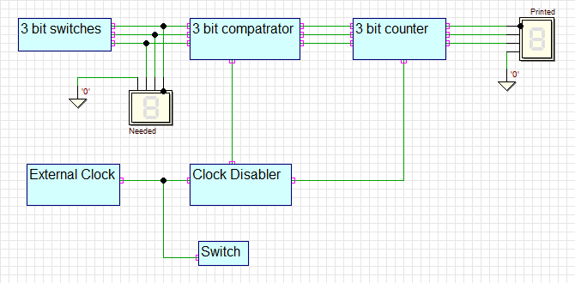

The figure above is a block diagram of the components used to build the Xerox machine. The counter, comparator and clock enabler are the important parts in this machine. The counter is used to calculate the number of copies that has finished copying while the comparator is used to check whether the number of copies is sufficient or not.
Next, the clock enabler functions to start the machine when the number of copies that are copied match the number of copies asked. Finally, the machine will display the required number of copies and the number of copies printed.
Other than that, a 3-bit switch is used, so that users can enter number of copies from 0 to 7. To compare the copies required and printed, 3-bit comparator is used because it is compatible with 3-bit switch. The machine will continue to function and only will cease function only when the required number of copies matches with number of copies printed. The machine will only function only when the user on the switch.

PHYSICAL SYSTEM IMPLEMENTATION

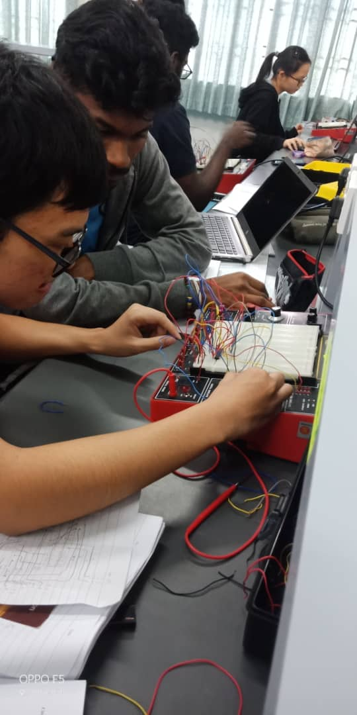

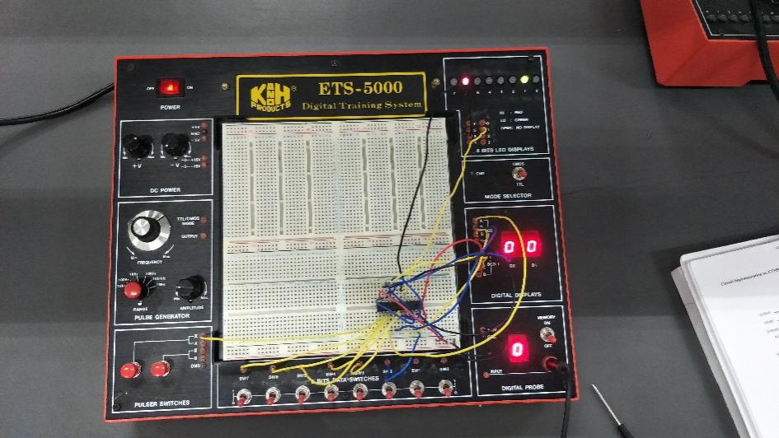

DISCUSSION
First and foremost we done the coding of PLD programming and wiring the IC on ETS5000 training kit. For that overwrite the generated code in WinCUPL. Then we compiled it and brought the XXXJED file to the lab and programmed the code into GAL22V10 IC. After programming the IC, we tested our circuit as we wiring the IC on ETS5000 training kit. Secondly , we created our own Xerox machine on DEEDS program with the components provided in the lab .
In the making of this project we learnt to communicate and carry out the project as a team . We did the mistake when we forgot to program the XXXJED file to the IC and so the 7-segment display nothing . Thus by communicating with the team member we abled to identify the mistake and rectify it to make sure our functionality of our project .
We able to create our own working PLD device by writing the code in WinCUPL and program the IC in Wellon and we see this as our biggest achievement in this project that stood as the the core of the project . Apart from that , we also able to learn and implement a simple Hardware Description Languages to code our logic function for our mini project, which is Xerox machine.
Finally , we conclude here that our project is a success since we are abled to create our own XEROX and able to run it . We suggest that , we should be more careful in programming the code needed for the project and also be more careful while wiring .

.CONCLUSION

From this project, we learned a lot of new things . We learnt how to use the Wellon Universal Programmer and how to open a file in PLD . We learnt to do wrk as a team and communicate with team member to do the work . We learnt how to program the logic gate and we also learnt some important coding for that purpose . We understand that Digital Logic is one of the main subject that offer us countless knowledge regarding the computer science field.

REFERENCE

Digital Logic, Fifth Edition, Department of Computer Science, Faculty of Engineering UTM.
- Micro, T. (2017, October 26). All You Need To Know About Universal Programmer. Retrieved from Tribal Mirco: https://www.tribalmicro.com/tribalmicro-com/know-about-universal-programmer/
- Perez, J. C. (2001). Programmable Logic Device. Retrieved from https://www.eng.mu.edu/~perezjc/eece143/Handout04.pdf
- Wikipedia. (2019, September 19). Atmel. Retrieved from Wikipedia: https://en.wikipedia.org/wiki/Atmel#Microcontrollers
- Wikipedia. (2019, November 23). Programmable logic device. Retrieved from Wikipedia: https://en.wikipedia.org/wiki/Programmable_logic_device

APPENDIX

A)2 BIT
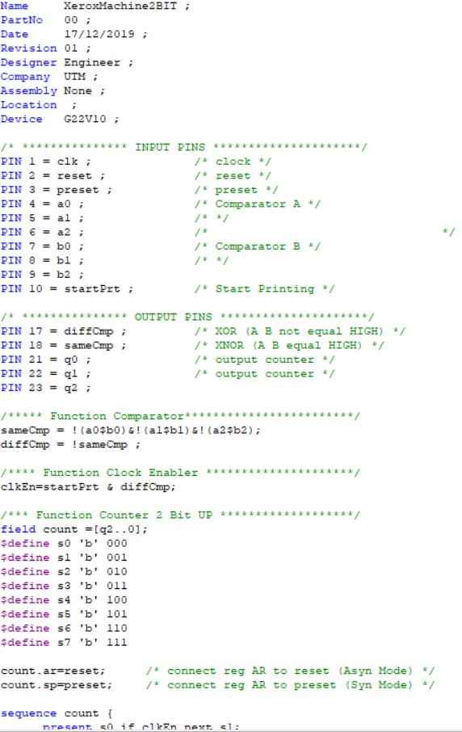

B)3 BIT
