

**1 SCSR, FACULTY OF COMPUTING**

**UNIVERSITI TEKNOLOGI MALAYSIA, 81310 UTM JOHOR BAHRU, JOHOR MALAYSIA.**

**Semester I 2018/2019**

**MALAYSIAN AIRPORT BERHAD (MAB)**

NAME : MUHAMMAD FAKHRUL HADI BIN NORAINI

MUHAMMAD SHUKRI BIN WAGIMAN

FAREL RIVALDO

AIN AFIQAH BINTI AGUS SALIM

SUBJECT : Technology and Information Systems (SCSP1513)

SECTION : 07 – Dr. Hairudin A. Majid

TASK : Industrial Visit 3 – MAB

DUE : 12th December 2018

Contents

**MALAYSIAN AIRPORT BERHAD (MAB) / SENAI INTERNATIONAL AIRPORT** 2

**INTRODUCTION TO SENAI INTERNATIONAL AIRPORT** 3

**DETAILS OF JOURNEY** 4

**ORGANIZATION STRUCTURE** 6

**SERVICE THAT AVAILABLE ON SENAI INTERNATIONAL AIRPORT AND ITS ACHIEVEMENT** 8

**REQUIREMENTS AND JOB SPECIFICATIONS NEEDED FOR A CAREER IN IT BY MALAYSIA GOVERNMENT** 9

**programs / INITIATIVE OFFERED BY MAB** 10

**REFLECTION** 11

HOW DOES THE VISIT IMPACT YOUR GOALS? 11

WHAT ACTION THAT NECESSARY TO IMPROVE YOUR POTENTIAL IN THE INDUStrY? 12

**CONCLUSION** 13

# **MALAYSIAN AIRPORT BERHAD (MAB) / SENAI INTERNATIONAL AIRPORT**

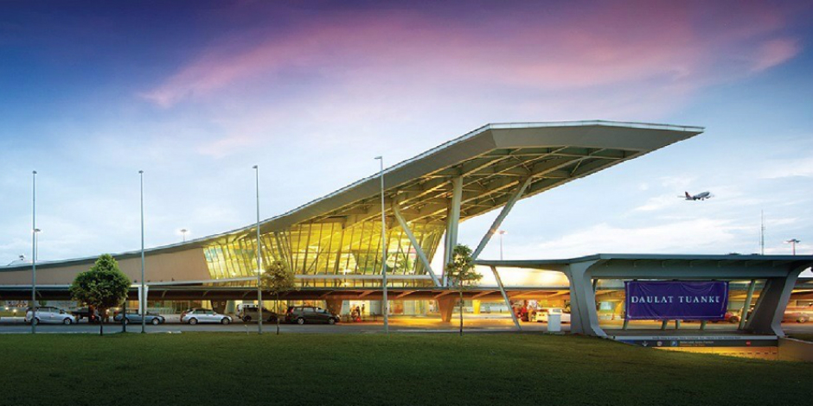

*Figure 1:* ***Senai International Airport***

# **INTRODUCTION TO SENAI INTERNATIONAL AIRPORT**

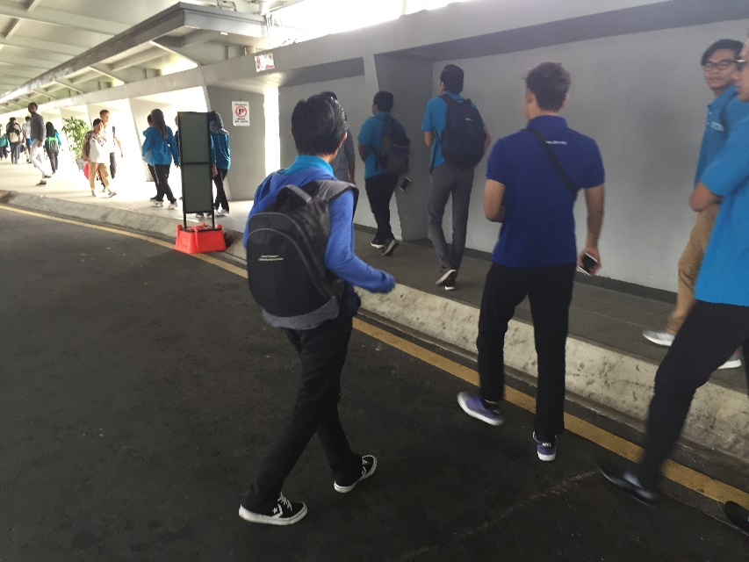

On 7 December 2018, students from section 07 under Sir Hairudin Abd Majid 1 SCSR, school of computing were attended to the third Industrial visit that held on Senai International Airport. Basically, Senai Airport Terminal Services Sdn Bhd is a member of the MMC Group Companies that owns

*Figure 2:* ***Students were arrived at Senai International Airport***

and manages the operation of Senai International Airport. Before the Senai International Airport get its name, they were formerly known as Sultan Ismail International Airport and it is a domestic international airport that serve the southern region of Peninsular Malaysia. Senai International Airport was built in 1974 and operated by Malaysia Airports Holdings Berhad until the November 2003 because the management and operation were developed by Senai Airport Terminal Services Sdn.Bhd. It is strategically located in one of Malaysia’s most strategic development zones which is Iskandar Malaysia. The airport is well connected to nations major highways and railway network which distances across the Peninsular Malaysia. SATSSB also has financed over RM600 millions to upgrade and improve the facilities and organization for the Airport and Land operations.

# **DETAILS OF JOURNEY**

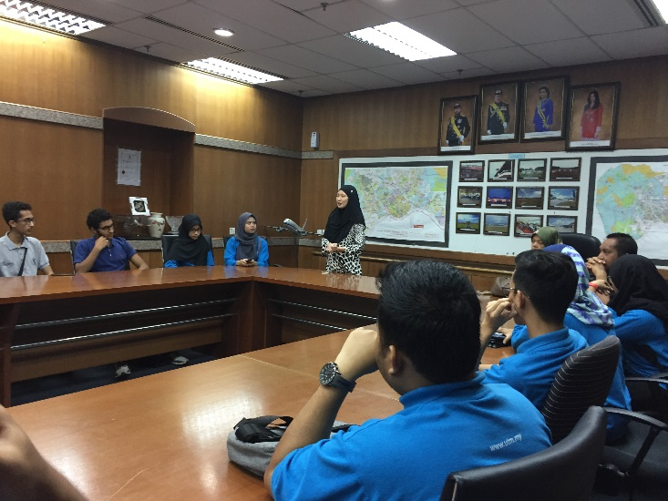The visits start around 9 in the morning with us arriving to the airport. As soon as we enter the airport, we are guided by Miss Fatin to the seminar room inside the management office. Miss gives us a short briefing about the visit and telling us about the management system of the Senai Airport Terminal Service Sdn. Bhd.

*Figure 3:* ***Miss Fatin giving a speech about the Senai International Airport***

Then, Miss Fatin introduced us to Miss Mazwa, which is one of the Programmers in IT Department to tell us about the IT usage that being used in the airport. She said that the IT Department is the one that being used to communicate with the passenger the most since the department provide the FISD system, which is a system that displays the passenger’s boarding time and other info of the flight.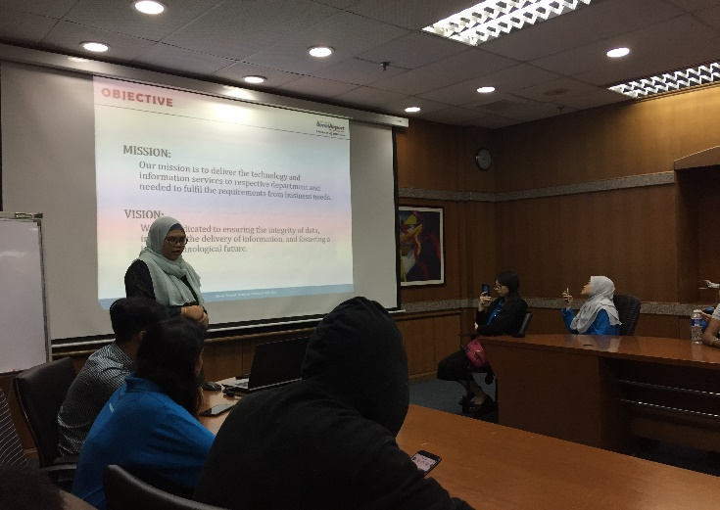

*Figure 4:* ***Miss Mazwa giving an introduction about the MMC.***

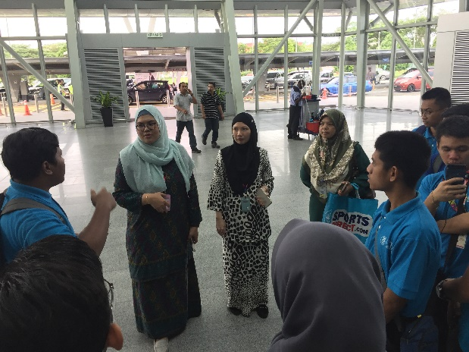After the talk, we go to the main entrance of the airport to see the information center that placed right in front of the main entrance door. Apparently, the information center not only acted as a guide for the passenger, but also the one that maintain the FISD system. Next, we go to a place where passenger could buy the flight ticket using the monitor that being provided by each airlines company to ease the passenger. Then, we go to the to the departure hall to see the usage of the IT to assist the passenger to their flight.

*Figure 5: Students* ***are arriving at the main entrance of airport.***

When we arrived to the departure hall, we have to go through the metal detection gate and our stuff has to go through the scanner.

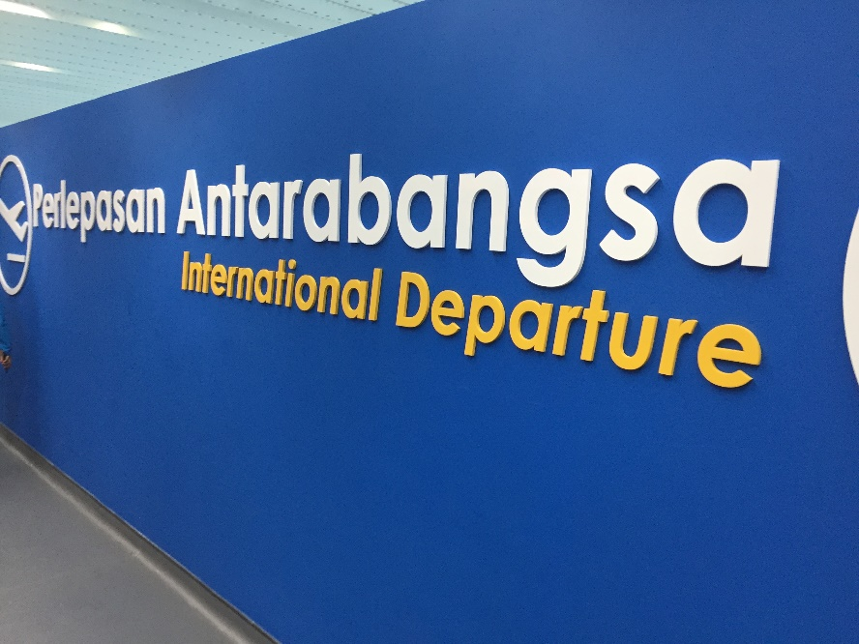Next, we go to the departure gate for international destination to see one of system that only being used by this airport which is the face recognition that placed on the door to the departure gate. This system allows the customs to cut down the time needed to identify the passenger before entering the flight. Then, we go to the arrival hall to see the baggage handling system that being used by the airport. The visit end around 11 after we have finished touring the whole airport with their guidance.

*Figure 6: International Departure*

# **ORGANIZATION STRUCTURE**

Senai International Airport, formerly known as Sultan Ismail International Airport is fully owned Senai Airport Terminal Service Sdn. Bhd. This means that the airport has become a private agency funded by MMC Group after the Senai Airport Terminal Service Sdn. Bhd. decided to buy the airport from Malaysian Airport Berhad (MAB) last year. This is important for them as becoming a private agency is easier since they did not bound any connection to government as it will allow them to make to make a decision on something without having to get approval from the government.

Senai Airport Terminal Service Sdn Bhd is managed by Md Derick Basir as their Chief Executive Officer (CEO) since 09 November 2015. Before he became what he is now, he works as Manager in a lot of places that offer transportation services like Penang Port Bhd. and Johor Port Bhd. Next,he is helped by Noor Safura Suib as Chief Operations Officer (COO) and Kennedy Ayu as General Manager Operations. To help them manage the airport better, they recruited a few people as the head of division to help them in specific types of things; Syarizal Abdul Halim for Airport Services, Gunasegeren A/L Sangoo for Aviation Security & Airport Fire Rescue Services, Syed Yusuf Syed Zaid for Legal Services, Norshidah Abdul Rashid for Human Resources & Administration, Anuar Ahmad for Finance & Procurement, Mohd Sofie Abdul Rahman for Corporate & Information Technology Services and Md Azmani Syah Muhamad Ali for Compliance & Process Improvement.

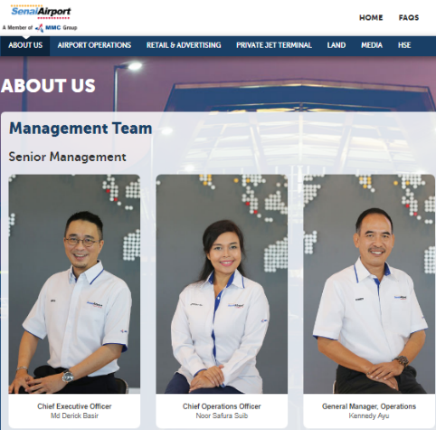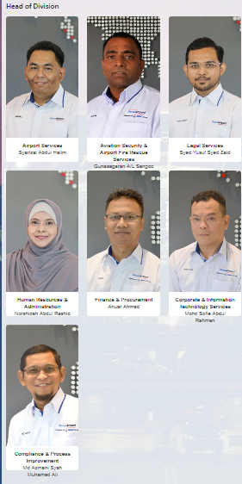

*Figure 8: Management Team of Senai International Airport*

*Figure 7: Head of Division of Senai International Airport*

# **SERVICE THAT AVAILABLE ON SENAI INTERNATIONAL AIRPORT AND ITS ACHIEVEMENT**

Just like any other airport, Senai International Airport provides commercial airlines for domestic flight like Kuala Lumpur, Penang, Langkawi and even West Malaysia like Kota Kinabalu and Miri. Senai International Airport also provides international flight to Ho Chi Minh, Surabaya, Bangkok and Incheon. The flight is provided by a few major airlines companies like Malaysia Airlines, Firefly, Air Asia and even a division of Korean Air, Jin Air. Other than commercial flight, the airport also provides cargo services by using cargo aircraft. This is a great decision made by Senai International Airport since it will be the only one in Johor to provide cargo services. This will also bring a huge benefit to MMC Group since the location of the airport is not that far from Johor Port, which also funded by MMC Group and making sure that most of the cargo that will be send to Johor have to use their services.

Senai International Airport also being uses as private jet terminal that include many facilities that can be used for client who use their services. The terminal equipped with executive lounge, few board rooms and meeting room and easy access to all facilities for medical evacuation flights in order to make sure the passenger is safe and secure. The airport also act as a place for the Royal Family of Johor keep their planes in their own hangar named Johor Royal Hangar. All of this service is possible because of its huge runaways that stretch as long as 1.5 kilometer to make sure even the biggest plane could land in Senai International Airport.

One of many achievements that been achieved by Senai International Airport is reaching its three millionth passengers in 2017, which is a huge achievement since the airport did not run by the government. Recent achievement is Senai Airport Terminal Service Sdn. Bhd. had bought Kerteh Airport which is located in Terengganu as an initiative to expand their business in other state.

# **REQUIREMENTS AND JOB SPECIFICATIONS NEEDED FOR A CAREER IN IT BY MALAYSIA GOVERNMENT**

From the visit to the Senai Airport, we can see that technology and information system are widely used in management department. From the briefing that was delivered by one of the staffs in Senai Airport, we were told that programming and network security is very important in this sector. This is because they need to create systems that will help them to observe all the activities that happening in the terminal and flights. They also need to use a strong firewall that protect all the confidential information about the company, flights and personal information of the staffs and the flights users. Like what that have been mentioned earlier, having a strong programming skills and network security education are the main skills that need to have in all computing students in order to work under the Malaysian Airport Berhad.

# **programs / INITIATIVE OFFERED BY MAB**

With that, there are scholarship programs that being offered by Malaysian Airport Berhad (MAHB) to facilitate the candidates financially to help the expand their professional knowledge and skills. There are a few degrees’ discipline that have become a high demand in this sector. Some of them are management, engineering and information technology. In information technology also included data science data and network security. After graduating, all the candidates will be hired to work under MAB according to the profession that they took in their degree. Some of the job specification in IT are programmer, network security officer and data officer.

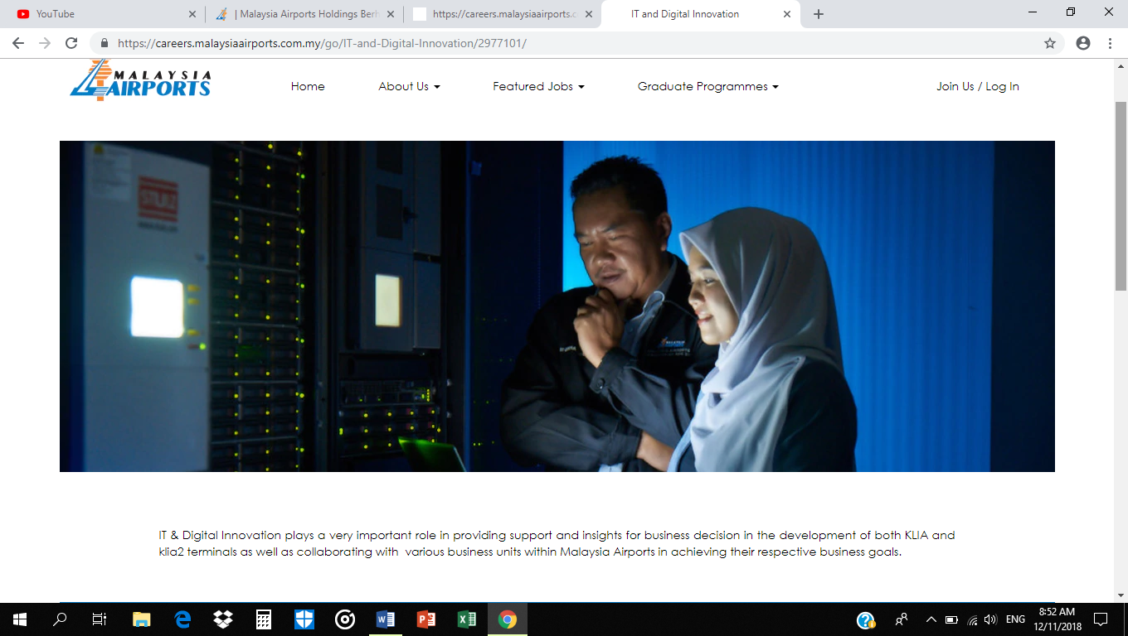

# **REFLECTION**

# HOW DOES THE VISIT IMPACT YOUR GOALS?

During these visit, students are exposed to many things such as the Senai International Airport networks and security. The security and firewall of the Senai International Airport are very though and it is very hard to break through. For our goals as a Network and Security students and to become a future network and security expert, it is a wakeup call for us to learn more about the technology of security because it is very important to take care of it. It is important to know this as a knowledge because we can learn their experience.

Furthermore, it will give some impact for student who want to get more information about the network and security. Many experiences were gain after the MAB visits as they give a lot of information to us. It will give some motivation to keep growing technology by ourselves. By improving the networks and security of the airport, we can make our live easier than before and it will make the system flow smoothly. It is also will be useful when the student already graduated and they want to compete each other in worldwide to get a job. We can decide our goal and focus on it after we graduated. For example, we can compare a lot of job after we graduate the university and achieve our goals and become a successful person one day.

# WHAT ACTION THAT NECESSARY TO IMPROVE YOUR POTENTIAL IN THE INDUStrY?

For jobseekers who want to remain a step ahead of the pack, it’s important to know what the most wanted skills are in today’s workplace.

Nowadays, employers and recruiters have realised that it is much easier to train smart individuals how to perform the specifics of any role. This is as long as they have already learned a much harder-to-teach skill set. This skill set comprises the likes of critical thinking, soft skills, and some basic competency in a few areas of expertise.If you want to get the job of your dreams consequently, or excel in the career you are already following, have a look at the skills below, assess where you stand, and find a way to polish the areas you are not doing so well in.

Communication skills are possibly the first set of skills that potential employers will notice. From the initial moment you get in touch with them, the employer will be scrutinising the way you behave.Make sure that you proof read any form of written communication you send them, and takings your time to listen to what they ask you (or read their instructions carefully), and answer in well-thought out, grammatically correct sentences. The way you communicate your thoughts should be impeccable, as this is the way they expect you to communicate with colleagues and clients alike throughout your tenure in their organisation.

The ability to cope with people is a very powerful skill. Not only can you inspire individuals to do what is right, you can guide them along the way, and you can monitor their progress in every step.

# **CONCLUSION**

We can conclude that the industry visits to Senai International Airport has become an eye opener to the students about the development of technology and information system and also the network and security used in the Senai International Airport. During the visit, there were many information delivered by the speaker regarding the technology and network about the Malaysian Airport and the system for Senai International Airport especially. Not to forget the rapid development of technologies used in the Malaysian Airport Berhad gave many inspirations to the students to work hard so that they also get the chance to contribute for the progression of technology in the Malaysian airport.

