**1.0 INTRODUCTION**

Ever wonder how the future of education will be look like? We can predict this norm thanks to an event that was being held for the first time by Universiti Teknologi Malaysia (UTM). Named as New Academia Learning Innovation (NALI), this event specifically is a celebration for innovative teaching and learning practices. It was conducted at Dewan Sultan Iskandar, UTM JB for 2 days which on 25th and 26th of September 2018. The participation for NALI came from both inside and outside the country. The layout of exhibition was in booth-style. As the pioneer of the event, UTM definitely target to reach their objectives which were to make a paradigm shift in the learning system that would be applicable and suitable in the 21st century technology era. Entrepreneurial Academia is one another thing that expected to be NALI outcome by means the key entrepreneurial disciplines and “codes of honour” adaptable for a university in addressing challenges of financial sustainability head on, and in achieving its strategic goal (Prof. Dr. Mohd Zainuddin Abd Manan, 2018) Therefore, through this report, we will tell you about the exhibition content, trends in NALI 2018 and also our opinion about this event.

We reached the venue at 9 am on 25th September. As it was a bit early, we just took a group photo and wait for a while to give the contestants space to setting up their booth. Around 9.45 am, we started approaching the participators to collect the information about NALI 2018. So that we did not miss out a point, we use the recording method while we interviewed them. After spending for 2 hours there, we went back home.

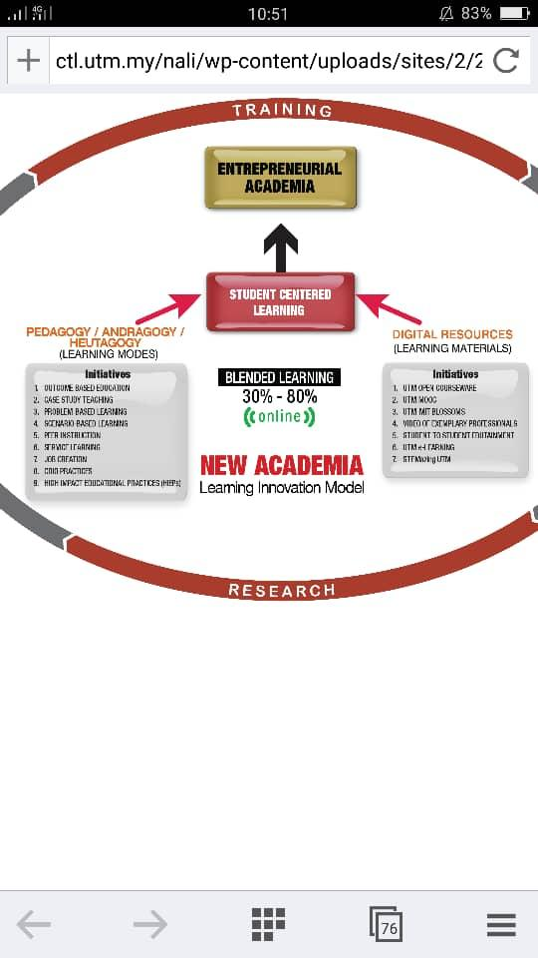

Diagram 1

Diagram 1 shows Model of New Academia Learning Innovation (NALI)

**2.0 CONTENT**

Here we'll include the information of the best three booth that their ideas were amazing.

2.1 MULTIVISUALISOR

Multivisualisor is an invention from SMK Dato’ Undang Musa Al-Haj. Students always face problems in solving Mathematics question which involves visualising the diagram or feature of a complicated circle geometric. Visualiser would help a lot in this situation, but older version of visualiser occupies a huge space in the classroom.

Therefore, Multivisualisor is invented to solve this problem. The basic operation of this invention is to record two slides and display it on a screen. The components of Multivisualisor consist of two webcams, USB port, Open Broadcaster Software (OBS) and a steel base. The OBS software is an open source application for video recording and live streaming. Multivisualisor is powered by USB connection to laptop or PC only. In other words, Multivisualisor is actually a DIY product with innovation and creativity. It is very convenient, low cost and user friendly.

This product brings a lot of advantages to learning institution. During teaching session, teacher or lecturer can show the students the comparison between two different diagrams so that students can spot and differentiate the odd part of the diagram. With this teaching method, students can understand and memorize easily because the object is visualized on the screen. Besides, students can present their project with a mind map simultaneously by using Multivisualisor. Marking or comment can be done on the spot without ruining the mind map. In addition, it can encourage paperless environment because editing can be done with the help of the OBS.

In my opinion, Multivisualisor is a invention that can inspired us to be more innovative and creative. Multivisualisor can actually increase the variation of teaching method and therefore increase the interaction between students and teacher. The Multivisualisor is being use practically in class after some upgrade so I believe that it can be more advance in the future. Multivisualisor will be a necessity in every classroom because it is low in cost thus it will not be a burden for the school to install it. With mass production, I believe that Multivisualisor can be widely use in whole Malaysia.

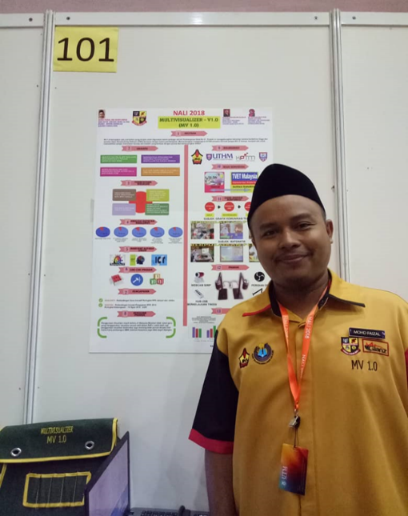 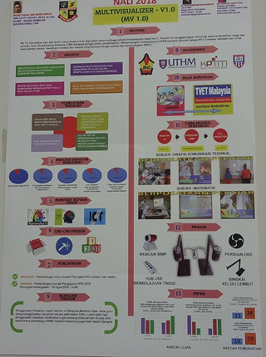

Picture 2.1.1

2.2 WARM UP YOUR BRAIN (WARPUP)

Warm Up Your Brain (WARPUP) is a mobile application specially designed for Attention Deficit Hyperactive Disorder (ADHD) student. The main objective of this project is to create an application that is fun, attractive and easy as a learning tool for children with ADHD. Apart from that, this application aims to eliminate the outside distraction and let children engage in a challenging game that help to train their brain.

Currently, a prototype is built which is applicable for elementary school in Year 2. This mobile application function as a learning tools, which consists of notes with melody, tree note map and also the fun part, game hunter. This application provides learning material for subjects such as English, Bahasa Malaysia, Mathematics and Science. This application not only focus on notes and learning from games, it also provides quiz for the students. The quiz can be classified into two categories, which are Lower Order Thinking Skills Questions (LOTS) and Higher Order Thinking Skill Questions (HOTS). LOTS question are more towards objective questions, where students have to choose the correct answer from the options provided by the application. For HOTS questions, students have to fill in the blanks with the correct answer. Time limit is given for both type of questions mode in order to train students to act faster.

According to the booth supervisor, Nurul Syafiqah binti Suhaimi, from Faculty of Education, Universiti Teknologi Malaysia, this prototype is tested by her student who is diagnosed with ADHD, and it shows positive result, where her student was attracted by this application and enjoyed learning by using this application. In addition, this application not only suitable for ADHD students, but also can be utilised by normal elementary school students. If this application can be upgraded to the secondary level or even higher, more ADHD students will have chance to enjoy learning by using this fun and easier alternative.

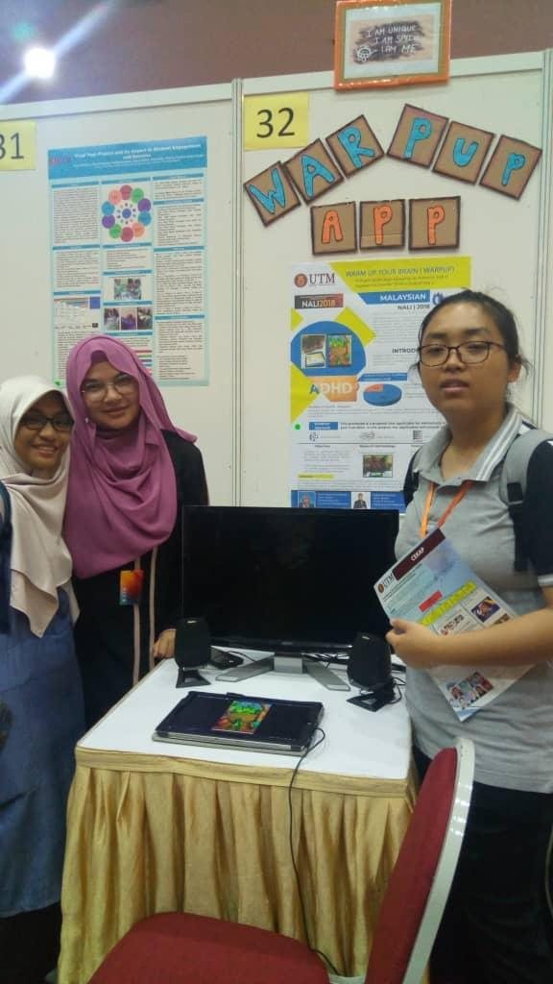

Picture 2.2.1

2.3 GEOAR

Nowadays, learning environment always change due to the development of Industrial Revolution 4.0. The most advanced technology used in the education field is Augmented Reality(AR). This technology brings the elements from the virtual world into our real world which can enhance the things we see, hear and feel.

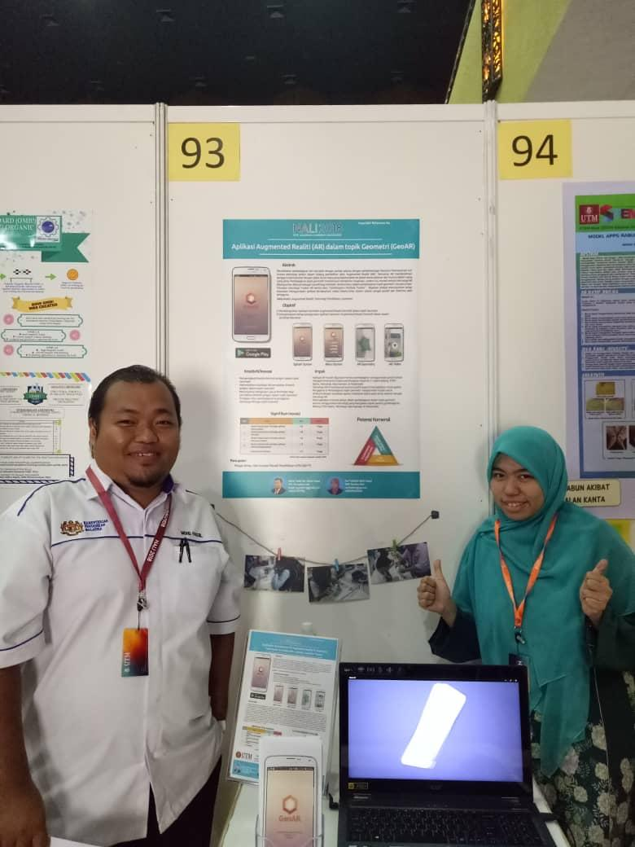

Picture 2.3.1

Picture 2.3.1 shows the developer of GeoAR, Mr. Mohd Fadzil and his wife, Mrs. Nur Fadhilah binti Zakari.

The invention of GeoAR is based on this theory. Actually, GeoAR is a free online application which can download from the Google Play Store. The application is developed by Mr. Mohd Fadzil bin Abdul Hanid. The purpose to develop GeoAR is to enable the students imagine the shapes of the geometry which they will learn this topic in secondary school. According to Mr. Mohd Fadzil, he noticed that most of the students cannot understand this topic because the students cannot imagine the geometry shape properly. Technique of visualisation is needed to understand the topic. So, he invented this application to settle this problem.

Apart from knowing the geometry shape in the application, GeoAR can also show the calculation of perimeter and area of the geometry shape. The students can also watch the related topic videos to enhance their memories. This will ensure them to cope this topic well.

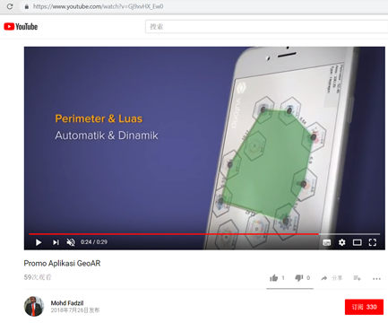

Picture 2.3.2

Picture 2.3.2 shows the geometry shape formed on the printed Google map when using the token

In order to use this application correctly, the users need to download the application from Google Play Store. The users need to buy the tokens from the person-in-charge. After paying, the users can print out the token and cut out the token. The users can arrange the token on the printed Google Map according to the shape of the polygon. Then the users can use the scanner in the application to scan the arranged token. The users can see a green colour geometry shape form on the map through their smartphones. Apart from that, the area and the perimeter of the shape form on the paper will also be shown clearly in the application. This provides a platform for a student to imagine the geometry shapes correctly through this technology.

The application of AR really brings a great impact to the education field. This is because it becomes a new trend in teaching the Science, Technology, Engineering and Mathematics (STEM) subjects. It also has a positive potential to increase the ability of spatial visualization which means the ability to manipulate the two and three-dimensional objects. The most important thing is that it can motivates the students to learn the geometry topic because the usage of technology during the process of learning is the most important aspect in this era of technology.

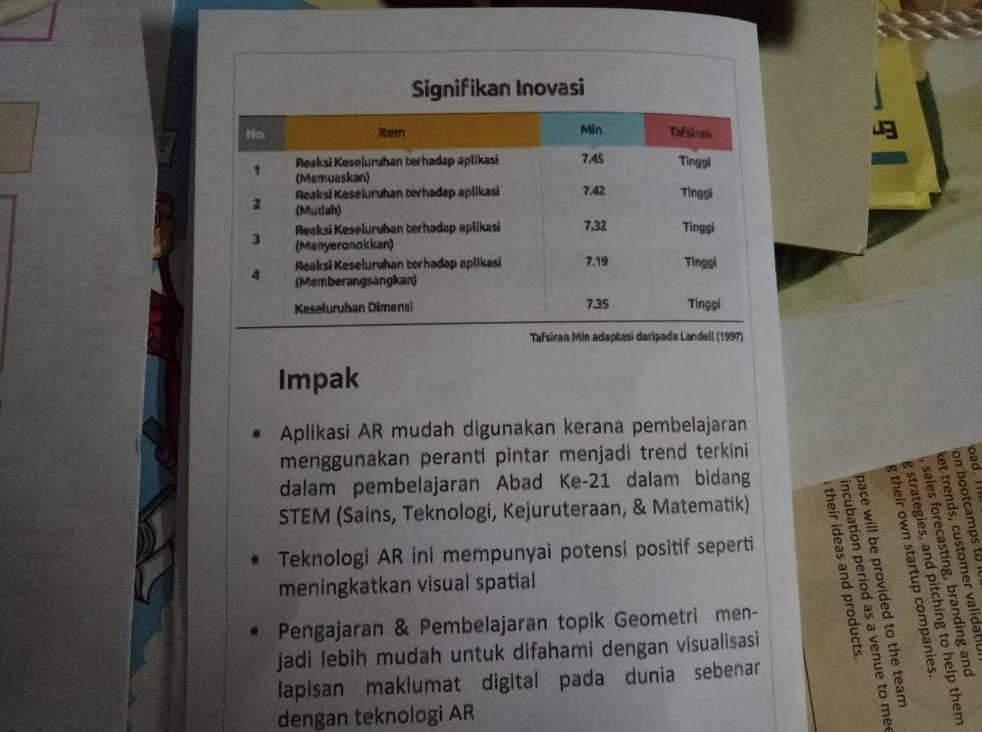

Picture 2.3.3

Diagram 2 shows the data collected from Landell which indicate the respond of students after using GeoAR.

**3.0 TRENDS IN NALI**

Since this is the first time NALI was held, so we do not have the real information about the trends as we can’t compare it to the year before. However, in this event, we spotted 2 different types of preparation for the future in education. Those are first, through digital technologies, and second, development of soft skills. Using the digital technologies to make our learning process more attractive and interactive, some of the competitors apply the knowledge by creating a game that involved augmented reality. Toy bricks also used by other competitors to attract the students’ interaction. Thus, the students will not feel boring during the classes and keep their focuses. While, for the second, developing soft skills element in oneself is a must as high ethic became one of the civilization requirement. Awaken from this condition, other contestants made frameworks that can lead the students in improving their soft skills. Hence, the used of these frameworks will produce graduates who are competitive and marketable.

**4.0 REFLECTION OF NALI 2018**

In this era of modern technologies, almost everything related to technologies including the field of education. Using technology in the classroom is not just about the using of electronic devices in class, however it also facilitates the interaction between teacher and students.

Application of technology in education field brings a lot of benefits for us. Firstly, it unlocks the educational boundaries between the teacher and students as technology supports online learning. Online learning is more flexible and the students from different countries can attend the same class without travelling from those places. Virtual technology also supports face-to-face communication between students and teachers in the virtual world. This makes the students can ask their questions easily by using the virtual communication tools such as Facebook, Skype and WeChat.

The technology used in education can also motivates students to learn. Students will find it easy to learn by using computers because it is more patient compared to human beings. The teachers can also post some educational instructions on the school’s portal and this gives time for students to study on their own. The usage of gamification technology in education can increase the interest of students in the process of learning as the teachers can use some video games or educational puzzle to educate students on how to solve the problems given. These processes will make the students love to learn.

However, the usage of technology in education also brings some negative issues for us. It will transform the learners into the insufficient learners. Nowadays, most of the lessons can be easily accessed by the students through different websites in their computers. This will cause them inattentive in the class during the process of learning. Besides, it will make the students always browsing the websites to find the shortest way in order to solve the problems in Mathematics instead of using a traditional way to solve the problems. This shows that the relying of students on computer will create poor studying habits.

In conclusion, everything is a double-edged sword. Technology can make us success, but it can even ruin our lives with its negative impact. Thus, even though technology is a necessity in today’s world, but we still need to use it wisely in order to achieve the aims that we set.

**5.0 CONCLUSION**

A visit to NALI 2018 really opens our eyes and widen our view about what the future will be look like. The contested innovation here can be the starting point to a greater advance project in the future. The inventions such as Multivisualisor where it can enhance students’ understanding faster using the visualized diagram on screen, despite the low cost to install it, and Geo AR which the user can saw the geometry shape formed on the paper by looking through their smartphone. And another one is specially designed for ADHD students, WARPUP application is a sign that humanity is crucial for inventor to create something useful. Their innovations for education system can keep us on track along with today exponentially developing technologies. It is also fill us with enthusiasm in our study so that we can make a lot more better for the world we live in.

**REFERENCE**

Mohd Fadzil. (26 July, 2018). *Promo Aplikasi GeoAR*. Retrieved from Youtube: https://www.youtube.com/watch?v=Gj9xvHX_Ew0

Prof. Dr. Mohd Zainuddin Abd Manan. (1 January, 2018). *Entrepreneurial Academia*. Retrieved from Universiti Teknologi Malaysia: http://civil.utm.my/nursyamimi/entrepreneurial-academia-by-prof-dr-mohd-zainuddin-abd-manan/

Professor Dr. Rose Alinda Alias, Professor Dr. Baharuddin Aris,. (2016). *A Guide to New Academia Learning Innovation.* Johor Bahru: UTM ACADEMIC LEADERSHIP (UTMLead).