

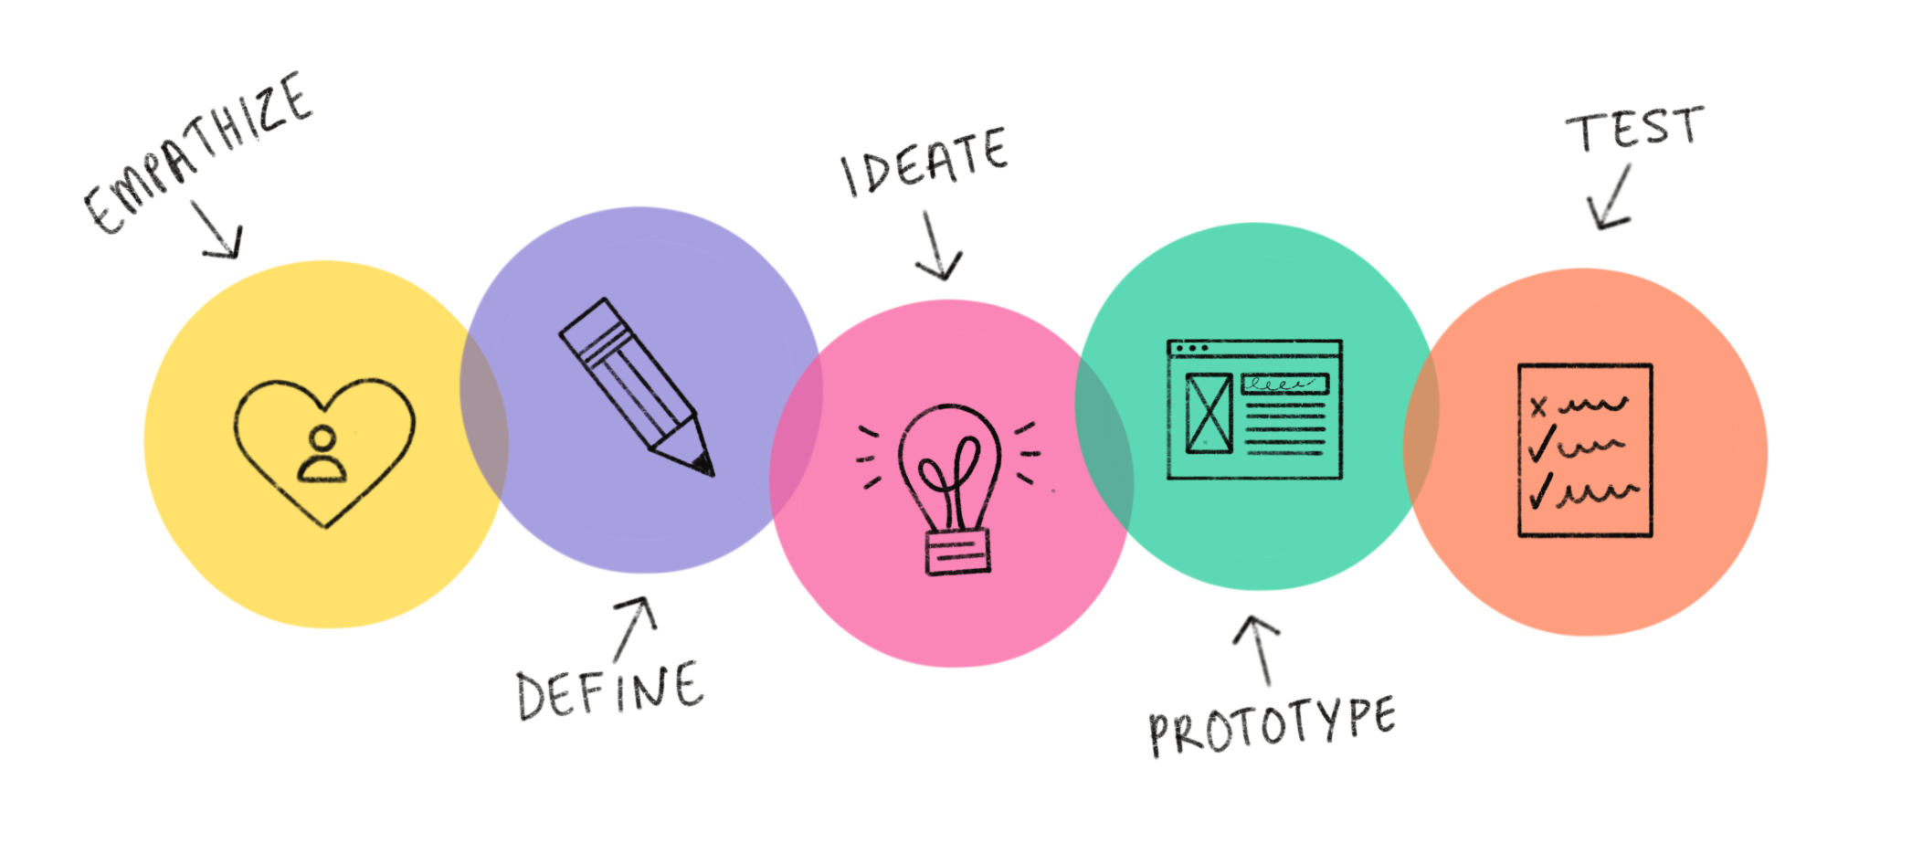

Design Thinking

Chapter 9: Privacy, Security and Ethics

|  |  |  |  |
| --- | --- | --- | --- |
| **No.** | **Group Members** | **Matric No.** | **Role** |
| 1. | Amirul Shafiq Bin Amirrullah | A20EC0013 | Leader |
| 2. | Natasya Nadhira Binti Ahmad Nazrain | A20EC0103 | Member |
| 3. | Hafiz Surya Nugraha | A20EC0304 | Member |

Lecturer : Dr Sarina Binti Sulaiman

School : Computing

Faculty : Engineering

Subject : Technology and Information System

Subject Code : SECP1513 – 09

# Table of Content

**Table of Content** **1**

**1.0 Introduction** **2**

**2.0 Detail Steps in Design Thinking** **3**

2.1 Phase 1: Empathize 3

2.2 Phase 2: Define Problem 3

2.3 Phase 3: Ideate 3

2.4 Phase 4: Prototype 3

2.5 Phase 5: Testing 4

**3.0 Detail Description of Design Thinking** **5**

3.1 Problem 5

3.2 Solution 5

3.3 Team Working 5

**4.0 Design Thinking Evidence** **6**

4.1 Activity Log 6

4.2 Project Record 7

**5.0 Reflections** **10**

5.1 Goals and dreams of our team towards this course 10

5.2 Design thinking impact on our goal or dream in this program 11

5.3 Potential Improvement plan in the industry 11

**6.0 Task of Team Members** **12**

**7.0 Video** **13**

Design Thinking Video Presentation 13

Chapter 9 Video Presentation 13

# 1.0 Introduction

Design thinking is an innovative method and approach that is mainly used in creative problem-solving for various types of skills. Basically, design thinking is a user-specified approach to innovation that is popped out by the designer’s mind set and ideas to integrate and adapt that depends on the needs of people. This method has been used by various companies in order to satisfy the needs of its customers or users in many types of backgrounds such as in technology, banking, business and in education as well.

Our group believes that creativity and productivity should never be only kept to ourselves. It has to be lured, spread ideas of creativity and innovations to help the needs of others. Think “outside the box”. By applying the Design Thinking approach, it is easier for us to convey information, deliver as well as brainstorming new ideas and be adaptable of the user’s needs, all in one table. After all, it is cognitive and practical processes by which design concepts of communications, machines and products.

There are 5 fundamental phases of Design Thinking, which are empathize, define, ideate, prototype and test. Design Thinking phases are non-linear, as it can be worked on simultaneously. It is important to do each phase as it can tackle unknown problems by focusing on what is most important for users. The team can do a brainstorming session to generate impactful solutions. That is why design thinking is essential for creative problem solving, and it is for everybody, not just designers and business organization.

# 2.0 Detail Steps in Design Thinking

## 2.1 Phase 1: Empathize

In this phase, it is important for us to understand what is the problem from the users. So, we asked them some questions related to our topic, hoping that we would get to meet the demands of the users. We have to gain insights of the users and their needs by doing surveys and interviews. By their responses towards our survey, it could help us in defining the issues before creating a solution.

## 

## 2.2 Phase 2: Define Problem

After gaining some responses from the users, we can analyze what is the core problem that users mainly experience. And from there, we managed to study what were the demands of the users and what were the outcomes. By defining problems properly it will make them easier to solve, which means saving time, money and resources.

## 

## 2.3 Phase 3: Ideate

We were brainstorming our ideas on online meetings using social messaging apps such as Whatsapp and Google Meet. Things were a bit tough as we cannot arrange the meeting physically by ourselves because of current issues regarding Covid-19 in our country that requires people to stay at home. However, we divided our tasks among our group members equally, so we managed to do our tasks efficiently with proper timing to get it done.

## 

## 2.4 Phase 4: Prototype

This phase plays a crucial role as we have to build a prototype by finding the proper materials to visualize our ideas. We built this prototype and see how we can solve the user's problems based on our ideas. This method saves our time and cost to illustrate our ideas and find the solution. The outcome of the prototype is that we were hoping to determine whether or not the prototype had solved the user's problems.

## 2.5 Phase 5: Testing

As we had successfully built our prototype, we decided to share our prototype to a certain number of users. We explained the extra security features applied on our prototype and asked a few questions regarding our prototype and we were expecting feedback from them. We were happy that all users reviewed that our prototype had explained all of the security holes and the solutions to fix them.

Basically, the extra security features that we added about the prototype was about the ideas that we implemented so that the public will be aware of the security characteristics that need to be considered to be added in the future so that people no need to worry about privacy leaks, breached security as well as to improve the firewall that is protective from any virus threats. We were hoping that the social media app developers will take these things into consideration to improve people’s data safely.

# 3.0 Detail Description of Design Thinking

## 3.1 Problem

Based on our survey, we found problems in the privacy of some people, some social media users do not want to know their privacy by strangers, for example on WhatsApp an unknown person takes a photo on someone's profile without the owner knowing it and uses it for a profile on his account. We totally understand this situation so we analyzed the problem and brainstormed our ideas of solving it.

## 3.2 Solution

Based on our problems, we discussed together and exchanged opinions, finally we knew what we had to do to solve this problem, namely making the PRIVACY SECURITY application as a problem solver so that criminal acts of theft of personal data without being noticed can be handled and social media users no longer need to be afraid of strangers trying to take their personal data.

## 3.3 Team Working

In doing this assessment, we exchange opinions with each other to solve a problem together and we also share our respective tasks. All of the group members do a part of presentation slides and report writing. For specific tasks, Amirul is in charge of finalising the report. Natasya is in charge of formatting the report, video editing and uploading videos to YouTube. Lastly, Hafiz is in charge of making the prototype and demonstrating on how the prototype will work.

# 

# 4.0 Design Thinking Evidence

## 4.1 Activity Log

|  |  |
| --- | --- |
| **DATE** | **ACTIVITIES** |
| 29 October 2020 | Group formed by lecturer |
| 2 November 2020 | Whatsapp Group formed  Choosing a group leader  Preparing questions for interview sessions |
| 3 November 2020 | Online interview with staffs through webex application |
| 5 November 2020 | Brainstorming idea from the interview sessions |
| 6 November 2020 | Meeting online through whatsapp video call  Distributing and planning work for the assignment  Start making video for chapter presentation |
| 7 November 2020 | Start making google form surveys  Distribute surveys for user enquiry |
| 8 November 2020 | Defining problems  Ideate a few solutions  Brainstorming prototype |
| 9 November 2020 | Making prototype  Making Video for Design Thinking  Finalised report and rechecking for spelling or grammar error |
| 10 November 2020 | Video presentation completed  Design thinking report and video completed  Submission day |

## 

## 4.2 Project Record

**Empathy**

Webex online interview with Mr. Nik Kamal Izuddin on Tuesday, 3rd November 2020 at 2:30 p.m., and Mr. Mohd Farid & PM Dr Murtadha at 9:00 p.m.

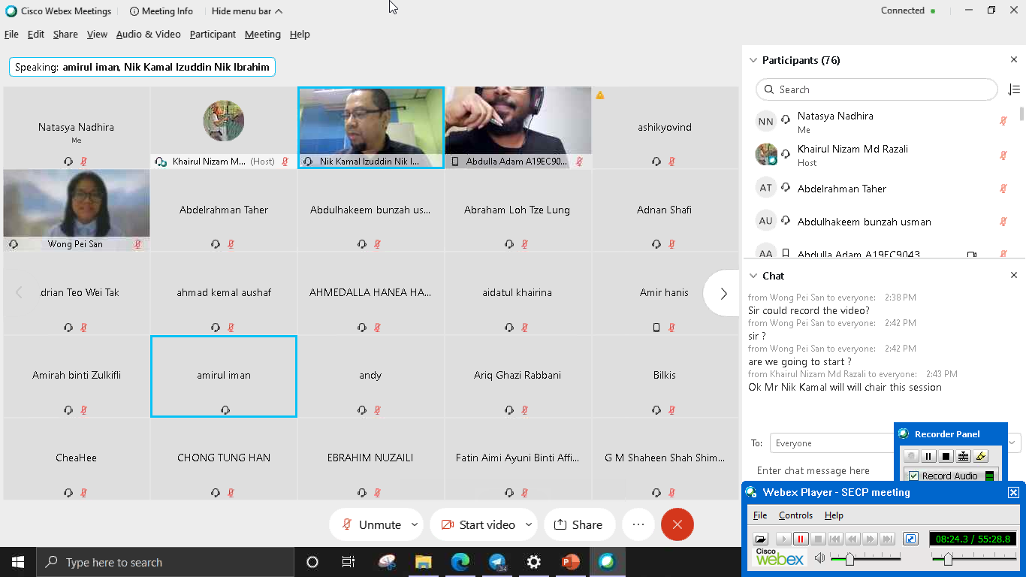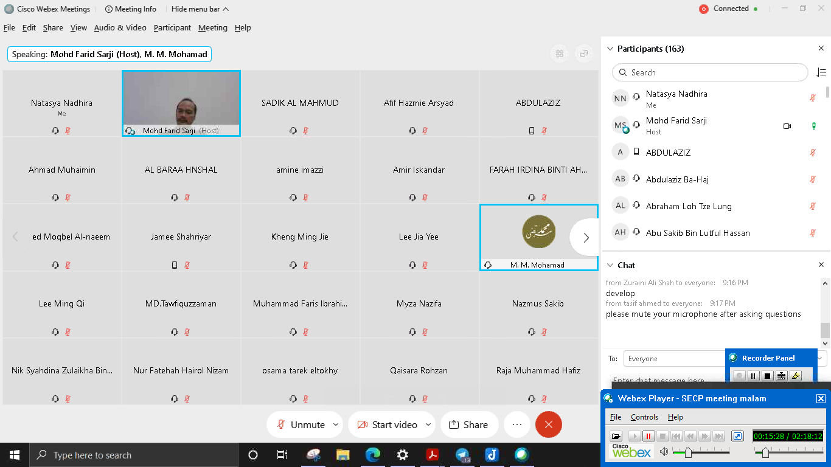

Google Form Surveys handed out on Saturday, 7th November 2020.

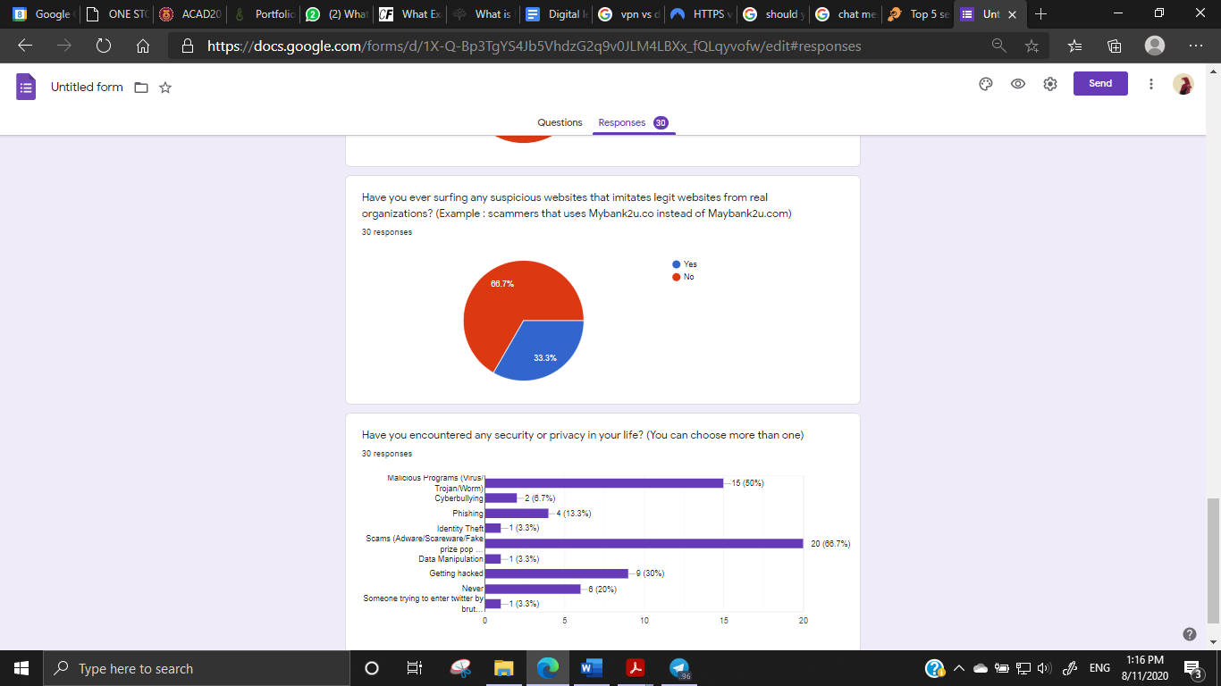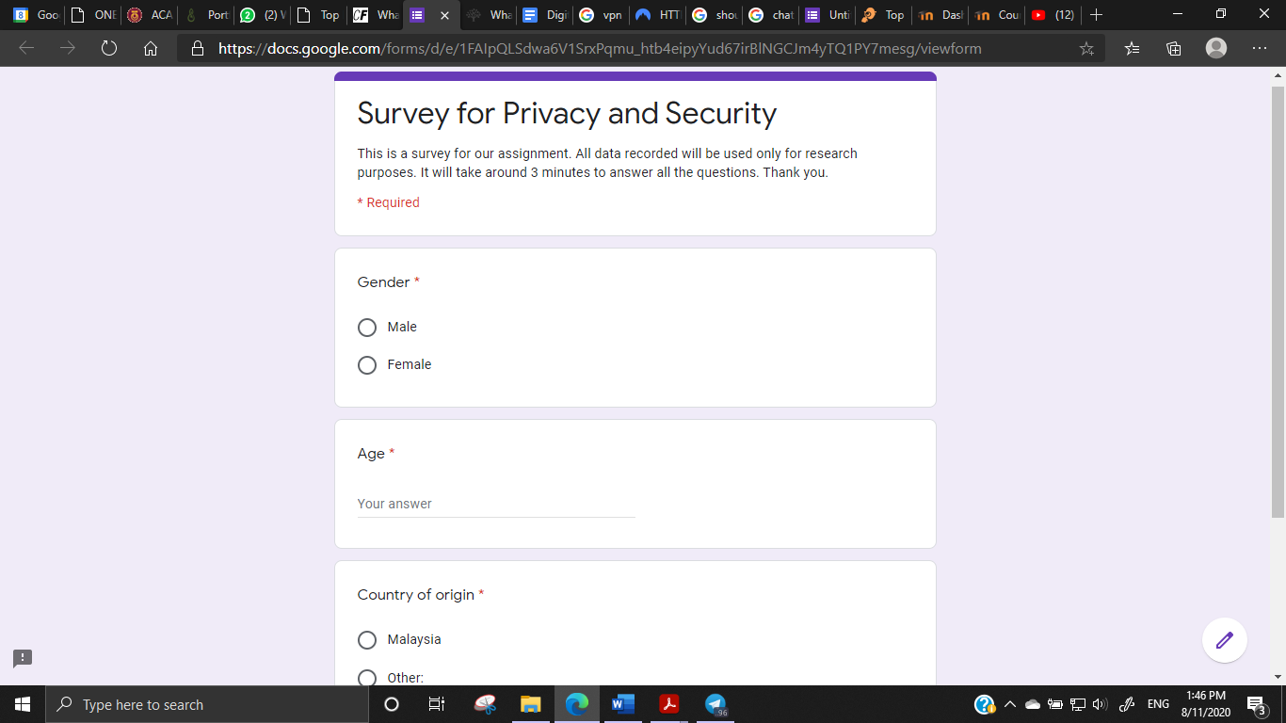

**Define Problem**

Online discussion with group members through Google Meet and Whatsapp Messaging.

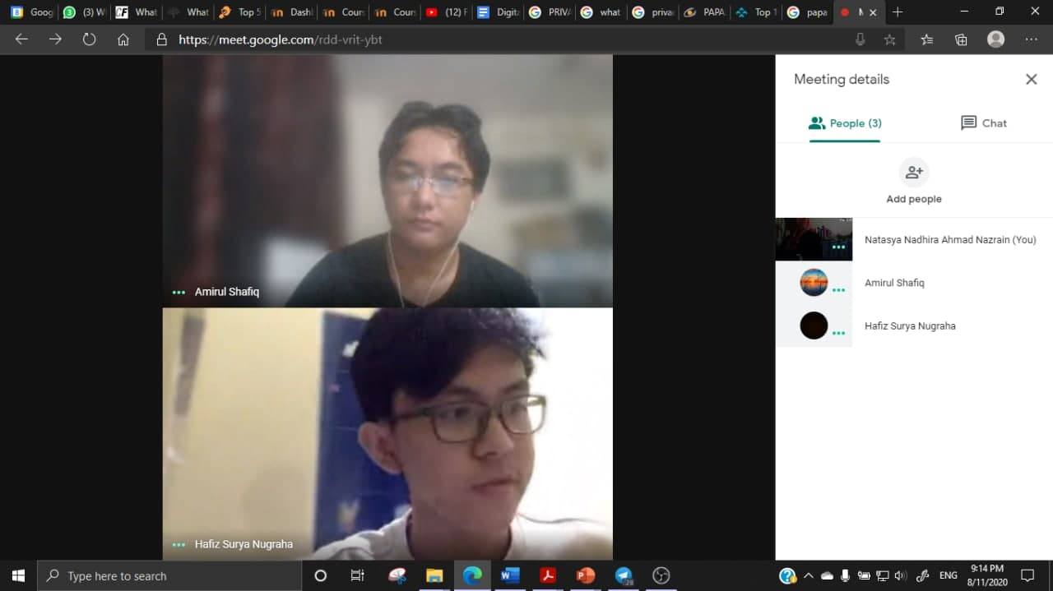 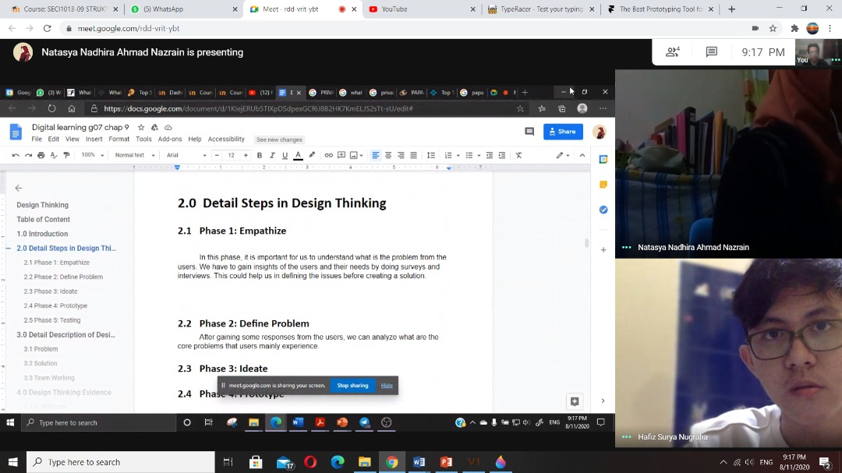

**Ideate**

We discuss solving this problem,we take the opinion of each of us and we get a solution which is the PRIVACY SECURITY program

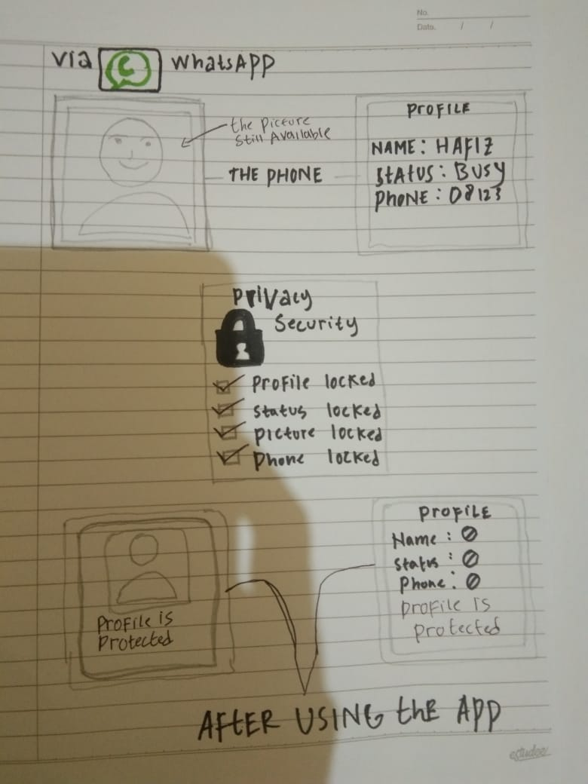

**Prototype**

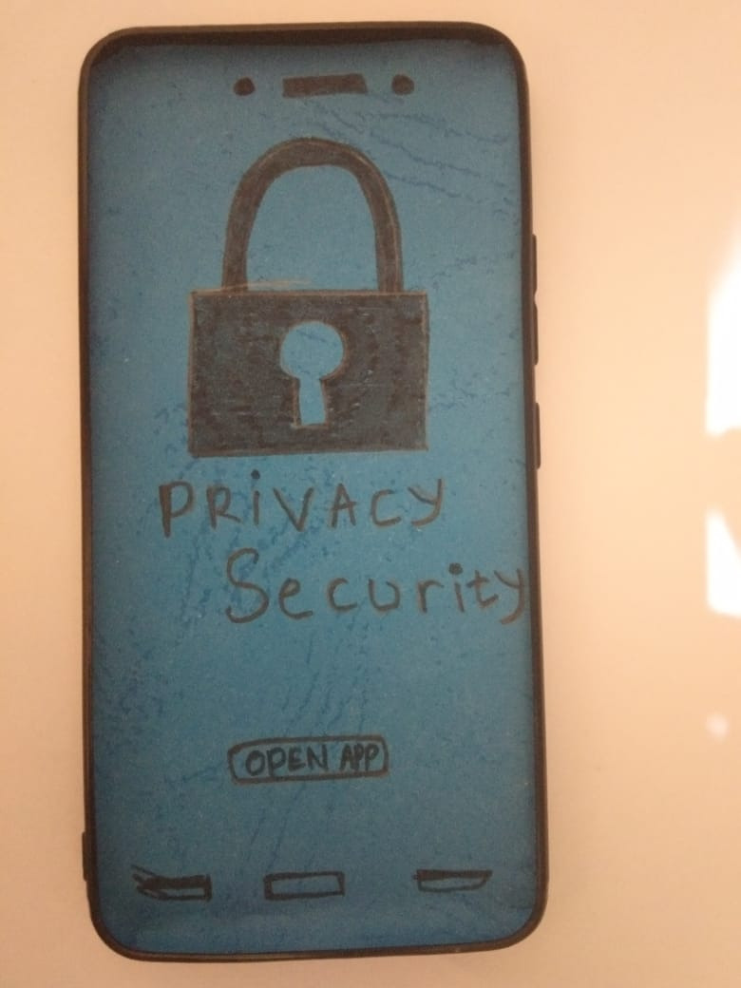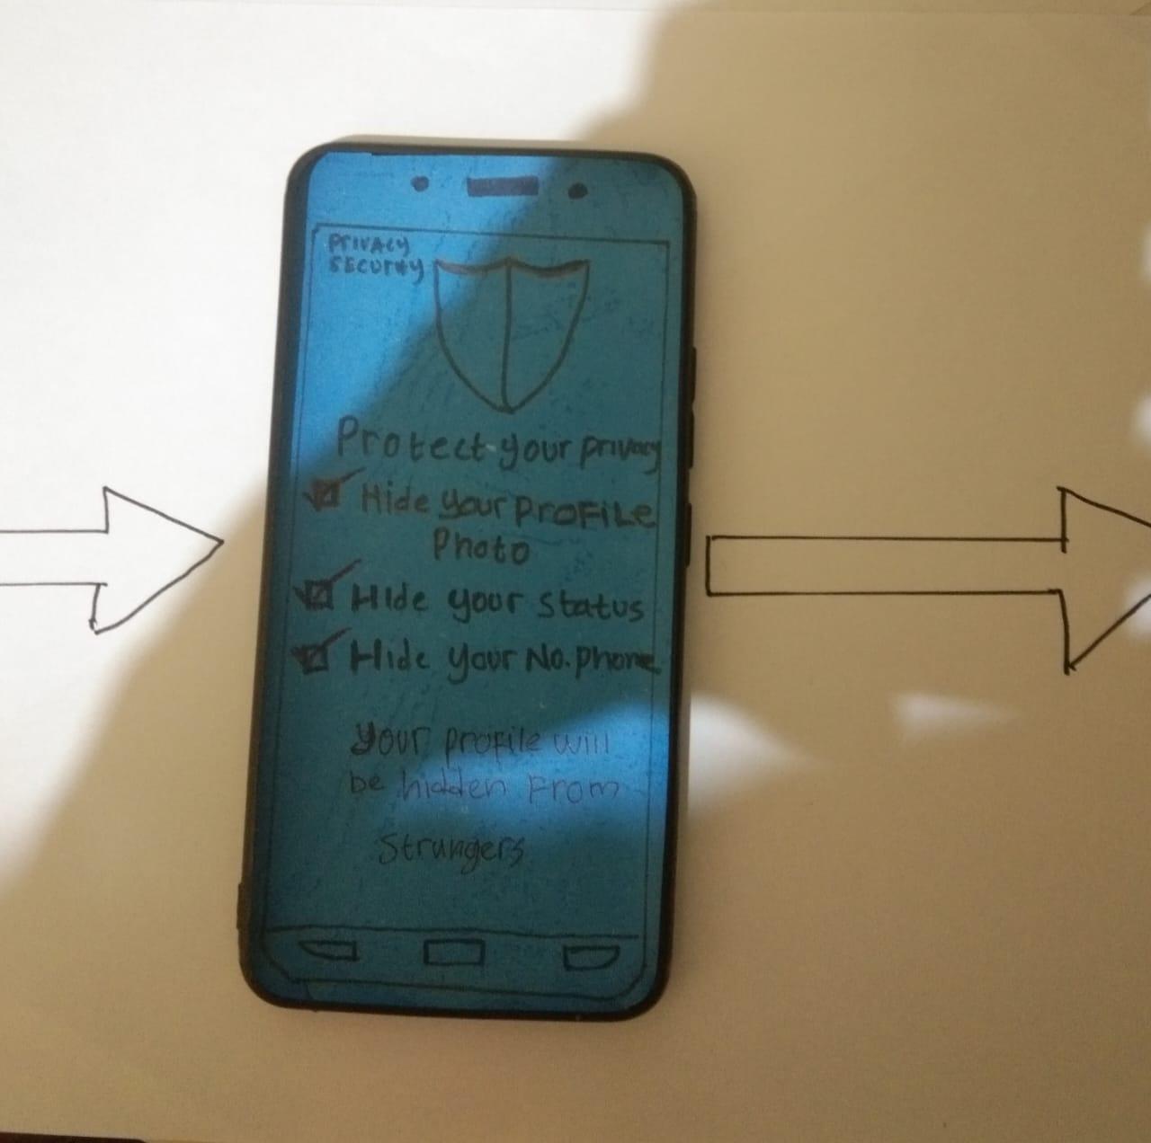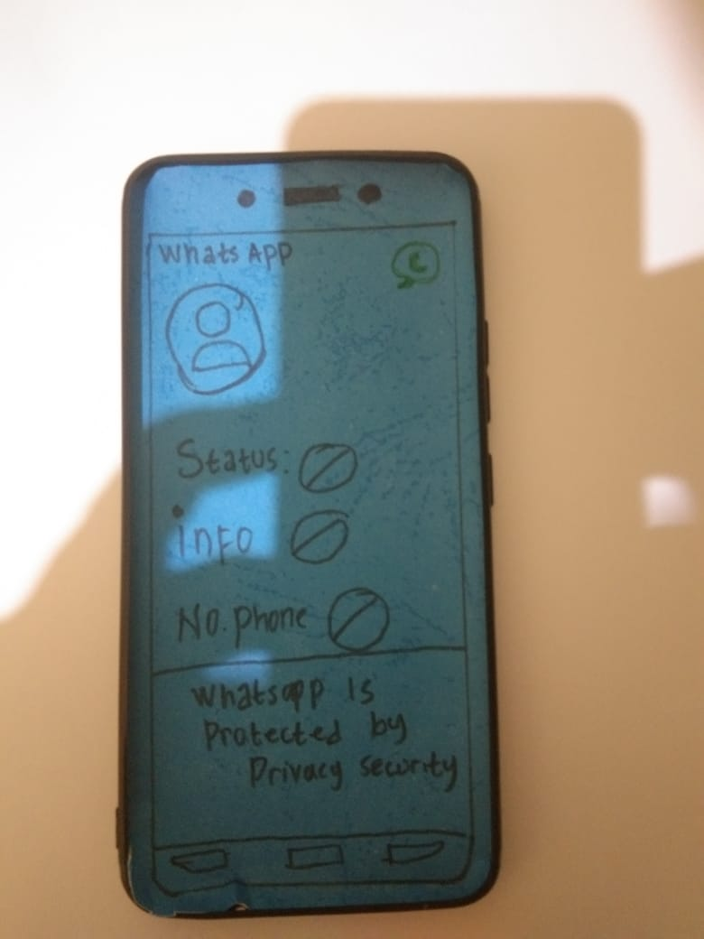

Based on the solution we found, we made a PRIVACY SECURITY App prototype by using a phone case and paper, this app serves to secure personal information from strangers who want to take someone's personal information and use it for crimes without the owner knowing it. We are trying to make the most suitable prototype that can solve user problems.

**Test**

After the prototype was finished, we did a trial run to seek user feedback. We describe each part and function of this app. Besides that, we also show you the very interesting design of this app and also the advantages of our application.

# 

# 5.0 Reflections

## 5.1 Goals and dreams of our team towards this course

First of all, we are glad that we are the students of UTM as UTM is one of the top universities in Malaysia with their latest technology and infrastructures, with helpful lecturers as well as creative and innovative students. Learning here has become a complete new level as we are learning and discovering more aspects of technology. Therefore, we are more than happy to study more about Technology and Information Systems as nowadays technology concerns regarding this topic are currently debatable right now .

Our goals and dreams for this course is to provide extra security and privacy for people as people need to always beware that they could never share their personal information towards other people that they barely know. We constructed this prototype so that people will be notified on how many security improvements can be done by constructing the prototype. Our group believes that people’s life will be much more convenient and safe as we added some minor security improvement on our prototype.

Time management also plays an important part in our assignment as we have a limited time on completing this assignment. Therefore, we divided our tasks among our group members in which way the assigned task will be done earlier than expected. Of course as a student, we have a lot of other tasks that need to be done and at the same time, we need to catch up with the progress of the class, which is why work management is our key point. We assigned our tasks and homeworks in sort of deadlines, for example, homework that had the earliest deadline will be prioritised first. Time management helps in scheduling and tabulating our work activities and brings balance towards the academic progress and to submit work on time.

## 

## 5.2 Design thinking impact on our goal or dream in this program

Our goal regarding this course is to provide extra security for people, as if people will be feeling more secure about their life as the Internet is an open world communication in which there will always be irresponsible people that will try to steal our information. Before we start building the prototype, design thinking had really helped us on developing the ideas on how to understand people’s problems with their different backgrounds, and then we study more about a certain problem that struggles us with ease, made ideas on how to solve the issue, how to construct a prototype and finally, we let the public know how they felt about our prototype by testing and reviewing our prototype. With Design Thinking as our method, our work is a lot easier, more creative and innovative as well as easy to handle and be done with it.

## 5.3 Potential Improvement plan in the industry

As for now, usage for technology around the world is rapidly increasing. Even for us, we can easily use technology by only using our fingers. With the improvement of security that we applied to our prototype, people will no longer have to be afraid of getting hacked by hackers, getting scammed, being a victim of identity theft, etc as we will never compromise with hackers, criminals of the Internet. We will study more about new features as technology will be always improving from time to time. We will be looking forward and try our best to improve more about our methods so that people will feel safe with their personal information in the future.

# 

# 

# 

# 6.0 Task of Team Members

|  |  |
| --- | --- |
| **NAME** | **TASKS** |
| Amirul Shafiq Bin Amirrullah | * Slide presentation * Interviewer * Report * Plan for meeting * Preparing survey questions and Interview questions |
| Natasya Nadhira Binti Ahmad Nazrain | * Slide presentation * Video editor and video combiner * Report * Activity logger * Uploading video to YouTube |
| Hafiz Surya Nugraha | * Slide Presentation * Report * Making prototype * Demonstrating the functionality of prototype |

# 

# 7.0 Video

## Design Thinking Video Presentation

Youtube: <https://www.youtube.com/watch?v=s_XYH2VtvN0>

## Chapter 9 Video Presentation

Youtube: <https://www.youtube.com/watch?v=ltdwIYyrmVw>