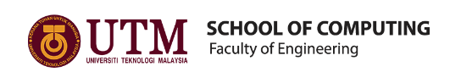

TECHNOLOGY AND INFORMATION SYSTEMS

(SECP1513)

**INDUSTRIAL VISIT – PETRONAS**

|  |  |
| --- | --- |
| NAME | MATRIC’S NUMBER |
| NURUL ALIS ALIA BINTI MOHAMAD ZAMRI | A19EC0141 |
| SAHARULNIZAM HAKIMY BIN SHOBRI | A19EC0205 |
| JEGGEAN A/L RAJENDRAN | A19EC0059 |

LECTURER’S NAME: DR. ARYATI BINTI BAKRI

SUBMISSION DATE: 29 SEPT 2019

# Table of Contents

Table of Contents i

Table of Figures ii

Table of Tables ii

1.0 Introduction 1

2.0 History 1

3.0 Organisation Structure 2

4.0 Services 2

5.0 Achievements 3

6.0 Details of Visit 3

6.1 Group Technical Data (GTD) 4

6.2 Sharing Session with UTM 4th Year Students 5

7.0 Reflections 6

7.1 Nurul Alis Alia Binti Mohamad Zamri 6

7.2 Saharulnizam Hakimy Bin Shobri 6

7.3 Jeggean A/L Rajendran 7

8.0 References 8

# Table of Figures

Figure 1: PETRONAS Twin Towers 1

Figure 2 : Petronas Organisation Structure. 2

Figure 3: 7 out of 10 4th year Data Engineering students. 5

Figure 4: A pictcure with Miss Niza(second from left) and the speakers. 5

# Table of Tables

Table 1: Itinerary at Petronas 3

# 1.0 Introduction

This industrial visit was organized by Petronas Group Technical Data to inform us with more in depth information about the industry. The visit was coordinated by Miss Niza Adila Binti Hamzah. A total of 37 students from Bachelor of Computer Science(Data Engineering) from Engineering Faculty, School of Computing Universiti Teknologi Malaysia (UTM) participated in this visit. We were accompanied by our fellow lecturers Dr. Aryati and Dr. Iqbal. The purpose of this visit is to learn more about the industry directly from its organisation’s headquarter and how does it is related to our course.

# 2.0 History

Petronas Carigali Sdn. Bhd. was founded in year 1976. In 1981, their first service station was opened in Taman Tun Dr. Ismail in Kuala Lumpur and their first learning institution Petroleum Industrial Training Institute (INSTEP) was established.[1] Petronas Dagangan Berhad was established the next year to market their oil and gas products leading to the opening of more than 1000 service stations up until now.[1] They had a major breakthrough when they first ventured into F1 with their partnership with the Red Bull Sauber Racing Team and their fuel and lubricants gain a lot of exposure.[1] The headquarter is located at Tower 1, PETRONAS Twin Towers (Figure 1) which was officially opened on Malaysia's 42nd Independence Day.[1]

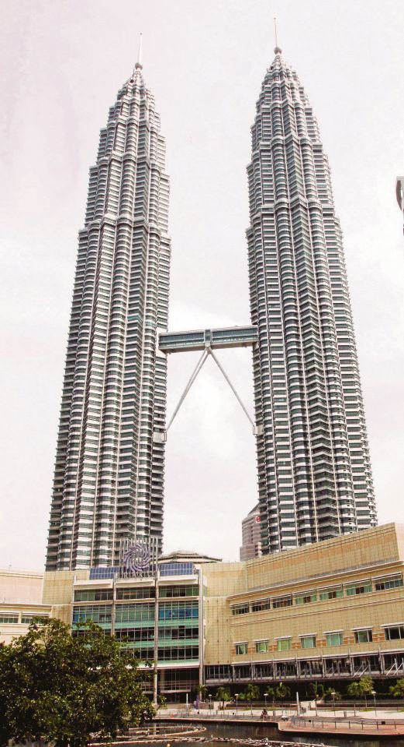

Figure : PETRONAS Twin Towers

# 3.0 Organisation Structure

The management of Petronas is closely linked to the Government of Malaysia.[3] The Chairman and Board of Directors of Petronas report directly to the Prime Minister of Malaysia.[3] Positions serve under the board of directors are shown in Figure 2.

Figure 2 : Petronas Organisation Structure. From *About Us : Our Leaders*. (n.d.). Retrieved from Petronas: https://www.petronas.com/about-us/our-leaders

# 4.0 Services

Petronas provide wide range of services in 3 major areas such as Oil & Gas, Education and Motorsports. For Oil & Gas, Petronas distributes and sell finished petroleum products through their service stations. The organisation also provides scholarships for eligible Malaysian and international students. Petronas also has its own research university which is University Technology Petronas (UTP). They also provide internship for fresh graduates. Petronas also provide their service towards motorsport by sponsoring lubricant and fuel to F1 teams.[2]

# 5.0 Achievements

In Malaysia, Petronas is the most profitable state owned oil corporation and ranked in the Fortune 500 list as one of the biggest corporation in the world.[5] They are one of the developers of KLCC complex which is a world famous twin towers. Petronas had also won a few awards throughout the years like 2018 Top 10 Company by Jobstreet.com, ICHEME Global Awards, Asia-Pacific Stevie Awards and more.[6]

# 6.0 Details of Visit

We departed from UTM at 10 in the evening and arrived in Kuala Lumpur at 3 in the morning. After resting and eating breakfast at UTM Kuala Lumpur campus, we departed for Petronas Twin Towers at 7:00 am. We went up to Petronas Digital Collaboration Centre (PDCC) after registering. During the welcoming remarks, they showed us a safety briefing video and montage of PDCC. The full itinerary at Petronas is illustrated in Table 1.

Table 1: Itinerary at Petronas

|  |  |  |
| --- | --- | --- |
| TIME | VENUE | AGENDA |
| 8.00-8.30 am | Pantry Area, PDCC | Light refreshment |
| 8.30-8.45 am | VIZ 2, Level 22 PDCC | Welcoming remarks & overview of GTD |
| 8.45-9.40 am | VIZ 2, Level 22 PDCC | Experience sharing by GTD Data Operation |
| 9.40-10.00 am | VIZ 2, Level 22 PDCC | Q&A |
| 10.00-11.00 am | Visit to Level 44, Tower 3 | Walk around and meeting with current 10 UTM 4th year students |

## 6.1 Group Technical Data (GTD)

This group technical data is located under Project Delivery and Technology (PD&T). They performed data analytics and gather information to improve operational efficiency and drive business development. They also provide data services for business units. GTD is the custodian for Petronas technical data. They provide access to technical data which is fundamental for strategic technical decision. They also govern and steer technical data. Not to mention, they are responsible for safeguarding relevant technical data to minimize the loss of useful data.

Data operations in Petronas are divide into two which are surface and subsurface. Surface data includes geological and structural information while for subsurface data, it includes information about gravity, magnetic and 2D seismic data.[7] Mr Akmal who is in charge of surface data operations (DataOps) shared that his department is responsible of data capture which involved capturing unstructured data, data inventory and quality, data delivery and lastly data and technology forecasting.

In their dimension, GTD manage over 70 petabytes of data which worth about RM 80 billion.

During the Q&A session, we were informed that 98% of processed personal data of the company and the data that bought from out are stored inside the server. Meanwhile, only 2% of the data are being stored in cloud because it is expensive hard to retrieve. Miss Niza Adila also answered our question about security issues surrounding data storage. She mentioned that there are many layers of security that are preventing unauthorized access, although data breach is possible no matter how tight the security is, it is highly unlikely for that to happen at Petronas.

## 6.2 Sharing Session with UTM 4th Year Students

At the end of our visit, we were brought to Tower 3 to meet with 10 4th year Data Engineering students who are currently doing their industrial training at Petronas. One of the students, Siti (Figure 3) said that their job requires them to be working in a group at all time, so it is very crucial for us to have teamwork and social skills. They also urged us to master several programming languages like Python and SQL and to pay attention class. They also gave us job interview tips such as employers usually evaluate your personality the most before hiring you.

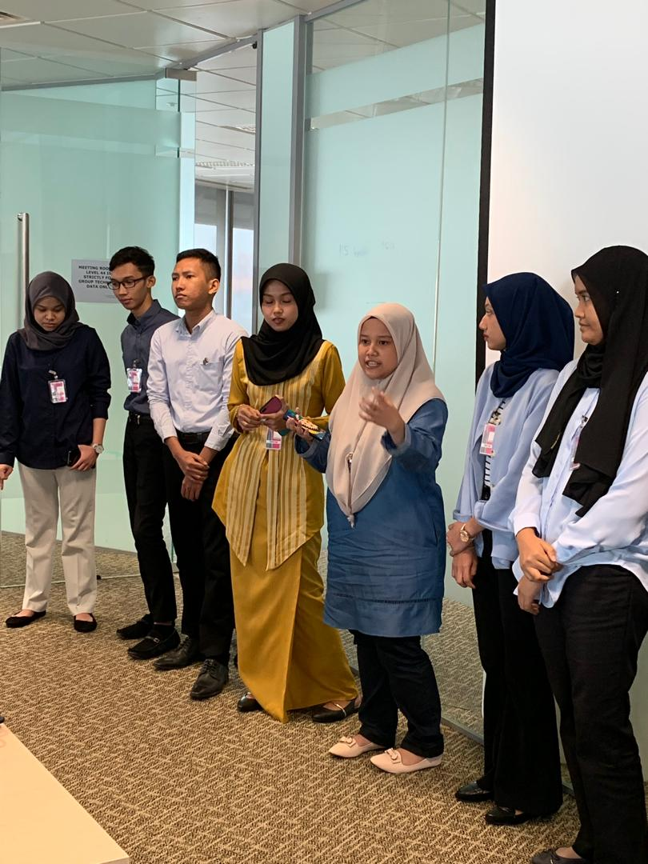

Figure : Siti (third from right) giving us advices.

After that, Miss Niza toured us around the Group Technical Data department. Lastly, we took a picture with Miss Niza and all the speakers (Figure 4).

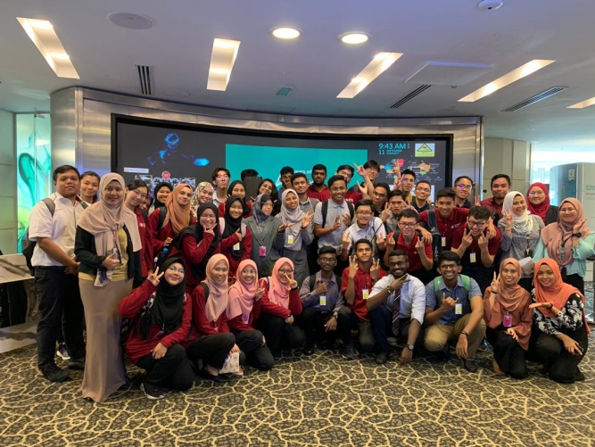

Figure : A pictcure with Miss Niza (standing, second from left) and the speakers.

# 7.0 Reflections

We learnt a lot from this trip. Our individual reflections are as below:

## 7.1 Nurul Alis Alia Binti Mohamad Zamri

From this industrial visit, I learned so much about the industry that I am going to dive into after finishing undergraduate studies. Although I only understand a small part of what was presented during the visit as I am only a first year student, it really fascinates me how a large company like Petronas interpret and store their data. It makes me want to do my best in what I am doing so that I can work in international companies after this. With my degree, I hope that I can contribute to the development of big data technology and perhaps solve some challenges that are faced by big companies now.What I learn in the classroom might not be the latest technology available now. I plan to follow blogs regarding big data to keep myself updated about new inventions as technology are developing at a very fast pace. I will equip myself with all necessary programming language like Python and Java.

## 7.2 Saharulnizam Hakimy Bin Shobri

From the visit, I got to learn how important Data Science is for technology development in future. What I learn during the lecture is not enough and I need to learn more on my own if I really want to be successful in this field. I am quite familiar with C++ and Python programming language but the knowledge I have about programming still inadequate for me to thrive in this field. I also learnt that academic achievement itself is not enough to secure a tenancy in career, nowadays the employees are seeking for those who have great soft skills, strong leadership, good teamworking and great discipline in time management. After the visit, I try to keep more updated about data science, I started to follow more Data Analyst, Data Scientist, and those who have relationship towards Data Science in order to expand more my knowledge about Data Science itself. I also try to learn more programming language that is popular in Data Science such as SQL and R programming language. I use online platform such as Datacamp and _Codeacademy. I am very serious toward this course because I wish to excel in this field and bring more development of technology for a better humankind.

## 7.3 Jeggean A/L Rajendran

From this visit, I was able to learn many new things about the carrier that I choose. The Petronas company representative gives us some talk about their job in data sector called GTD. I was shocked with the way of them handling the data to bring profit for their company because 70 petabytes of data is not a small number. I was fascinated by the facts that how systematically they handle the data without wasting any of them. The seniors who were in the internship at the Petronas Twin Tower shared us many their experience in working at one of the most largest and influenced company in Malaysia, Petronas . From their experience I was able to realize that I am only a small stone in the deep sea compared to them. The gives us many advises like not to sleep in class, finished the assignment in the time given and etc. The also tells us to learn Phyton and R because the both of the language are playing major in the data industries in these days. So in a nutshell, I think it was an important experience for me as a first year to be able to experience and understand the type of the course that I had choose for my degree.

# 8.0 References

[1] *About Us : Milestones*. (n.d.). Retrieved 24 September, 2019 from Petronas: https://www.petronas.com/about-us/milestones

[2] Aziz, A. (15 September, 2017). *Petronas continues to reap benefits from F1 participation*. Retrieved 24 September, 2019 from The Edge Markets: https://www.theedgemarkets.com/article/petronas-continues-reap-benefits-f1-participation

[3] Von Der Mehden, D. R. (2007). Petronas: A National Oil Company with International Vison. 16-17.

[4] *About Us : Our Leaders*. (n.d.). Retrieved 24 September, 2019 from Petronas https://www.petronas.com/about -us/our-leaders

[5] *About Us : Overview*. (n.d.). Retrieved 24 September, 2019 from Petronas:

https://www.petronas.com/about-us/overview

[6] *About Us : Awards and Accolades*. (n.d.). Retrieved 24 September, 2019 from Petronas:

https://www.petronas.com/about-us/awards

[7] Kumar, R., Ainampud, S. B., & Subramanian, S. (24 October, 2010). *Integration of Surface and Subsurface Data Optimizes Hydrocarbon Exploration*. Retrieved 25 September, 2019 from Sensors and Systems: https://sensorsandsystems.com/integration-of-surface-and-subsurface-data-optimizes-hydrocarbon-exploration/