Lab 6 Group 3:
1. Chang Min Xuan A20EC0024
2. Keshiniy A/P Mogan A20EC0057
3. Mek Zhi Qing A20EC0077
4. Zereen Teo Huey Huey A20EC0173
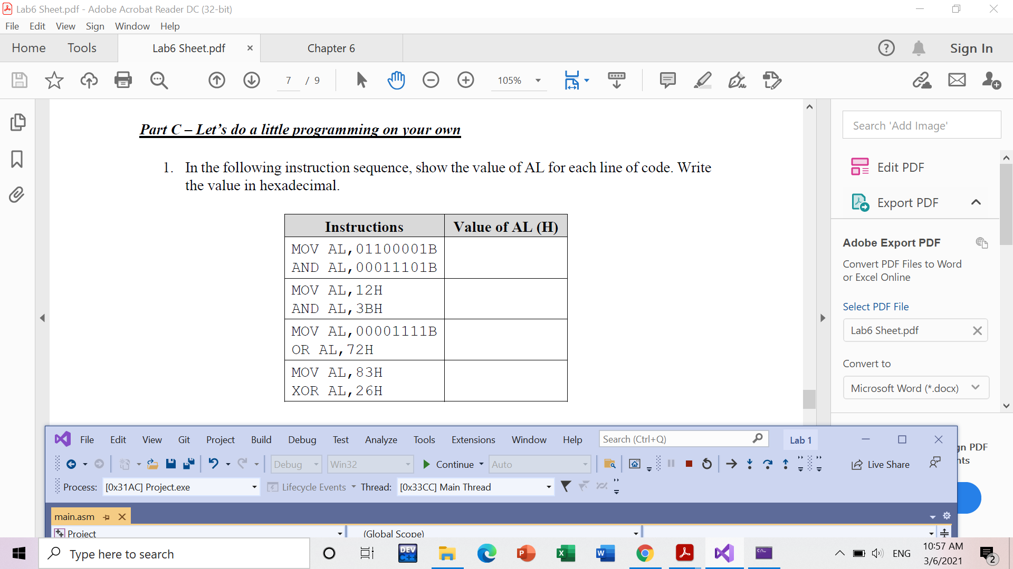
0A5H

7FH

12H

01H

2.a) test BL, 01110000B
jnz L1
b) and BL, 01110000B
cmp BL, 01110000B
je L1
c) or AL, AL
jp L2
d) cmp EAX,0
jl L3
e) sub EBX, ECX
cmp EBX,0
jg L4
3. a) The conditional jump JG L1 is taken as 25 is larger than 20. The final value of EBX is 1.
b) The JMP OUTT is needed to prevent the program from continuing the execution of loop 2 when loop 1 is finished.

