7.
Start
Print “Welcome to our PetrolUpHere station.”
Read num, liters, gallon, price
Display”Press 0 for unleaded and 1 diesel”
While (num!=9999)
If (num==0)
Display"Enter the liters wish to purchase "
gallon=liters/3.785
price=2.70*gallon
Display "price for unleaded petrol”
Else if (num ==1)
Display "Enter the liters wish to purchase”
gallon=liters/3.785
price=2.58*gallon
Display "price for diesel petrol "
End_while
End
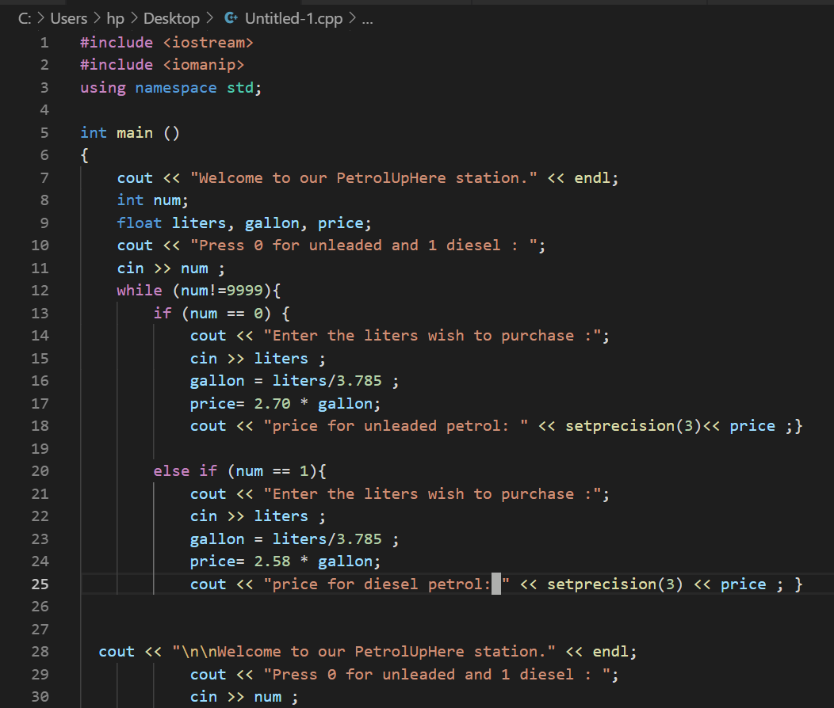

8.
Start
Read paragraph, count,i
Count=0
Display "The words in paragraph: ”

For(i=0; paragraph[i] != ‘\0’; i++)
If (paragraph[i] == ‘ ‘)
Count ++

Display "Number of words in the paragraph are: "
End
