

**TECHNOLOGY AND INFORMATION SYSTEM**

**-**

**DESIGN THINKING**

**PROGRAMMING LANGUAGES**

LECTURER : DR. SARINA BINTI SULAIMAN

PRESENTED BY :

1. LEE QING REN (LEADER)
2. ARVIND
3. QHAIRUL HEEDAYAH BINTI TAMSOR
4. RAGHID MUHAMMAD THAREQ

**Content**

|  |  |  |
| --- | --- | --- |
| No | Title | Page |
| i | Cover Page | 1 |
| ii | Content | 2 |
| 1. | Introduction | 3 |
| 2. | Activity Records | 4 |
| 3. | Detail Steps and Description of Design Thinking | 5 |
| 4. | Assessment point | 6 |
| 5. | Detailed Description of Design Thinking | 7-10 |
| 6. | Reflection | 11 |
| 7. | Task of Team Members and Reference | 12 |

**Introduction**

Design thinking is crucial for solving problems in the humankind. Oneself must have design thinking to think out of the box in order to find innovative ways to solve the problems encountered and fulfill the human needs. It is important not only to implant users’ interest into the products designed and also for producers to have better understanding what consumers’ need to produce a better products to fulfill their demand. Always having a consideration about the current issues of society is the only way to begin design thinking as it helps to identify problems they are facing.

There are 5 phases of design thinking :

1. Empathize
2. Define
3. Ideate
4. Prototype
5. Test

Programming language is a collection of instruction for computer to carry out specific task based on the command it gets. There are two main kinds of programming language. They are high level language and low level language. High level language is often used by programmers in writing codes as it is easy understandable by human. There are many types of high level language used in programming, for example Java, C，and C++ . Meanwhile, low level language is referred to machine language, specially used for machine as they only understand binary numbers. Normal people will find that machine language is hard to understand.

Each different type of CPU has its own unique machine language.[1] Depending on the type of computer, high level languages are translated into machine language to perform tasks with the assistance of compiler and interpreter. It is well used by programmers in their daily task in software development. Game software development, application apps, website development and artificial intelligence are nothing without programming languages. We cannot deny that programming language is definitely essential in digital world. Evolution of programming language is still in the process for better programming experience and faster programming speed. Hence, we cannot stop to investigate programming language, to create more simple and faster commands language to promote it into higher level. Yet, translating high level language into machine language is another issue for us to overcome for executing commands successfully.

**Activity Records**

|  |  |
| --- | --- |
| Date | Description |
| 2 November 2020 | * Lecturer’s brief on design thinking. * Creating WhatsApp group. * Discussion about the topic of programming language. * Identify the possible problems encountered in programming language. * Split members into different sessions of interviews for the next day. |
| 3 November 2020 | * Interview lecturers in Webex / Google Meet * **Mr. Aris Arifin** * **Mr. Mohd Zahari** * Mr. Khairul Nizam, Mr. Jaffar, Mr. Haslan & Mr. Rozi * **Mr. Mohd Farid & AP Dr. Murtadha** * Asking about challenges in programming, opinion about without programming language and suggestions. * Preparation of online survey on C language. |
| 4-5 November 2020 | * Meet up in Google Meet for group discussion. * Discussion about respond from lecturers and brainstorming solutions. * Sorting responds from lecturer and concluding. * Plan on making report, videos, slides presentation and prototyping. * Distributing tasks to each members. * Record the meeting as an evidence. |
| 6-8 November 2020 | In the process of making report, videos, slides and prototype. |
| 9 November 2020 | Testing the prototype and do improvement where necessary. |
| 10 November 2020 | Ready to submit. |

**Detail Steps and Description of the Design Thinking**

The topic given to our group is Programming Language. We created a group in WhatsApp to discuss about the design thinking on programming language and to help us to proceed the stages of design thinking smoothly.

* **Phase 1 : Empathize**

At this phase, we looked into problems of users and listened to their needs and requirements. We had prepared an online survey to find out what the problems were in C language. We also had few online interviews with lecturers to ask queries about programming languages and ask some suggestions on improving C language.

* **Phase 2 : Define**

After knowing the problems of users faced, we defined the problems. There were some unavailability features in C language caused the problems. For example, the inline function, Object-Oriented Programming support, long run-time checking, information hiding and namespace feature.

* **Phase 3 : Ideate**

After defining all the problems in C language, we decided on having an online meeting through Google Meet to brainstorm ideas and exchanged ideas to find the solutions. After discussions,we had the idea to make an update for C language. We kept the original feature of C language and added new features to fulfill the users’ requirements.

* **Phase 4 : Prototype**

Having the idea, we developed a prototype virtually to demonstrate the updated version C language on the screen the laptop. We explained and did presentation through making a video on it, hoping that users can get the idea of the product we made.

* **Phase 5 : Testing**

We proceeded the testing process through getting the reviews and the feedback of users after watching the presentation video on the prototype. After analyzing all the feedback, we refined our prototype to make it a better product in programming language if it was necessary.

**ASSESMENT POINT**

Assessment point helps us to review our progress during the transition between the five stages in design thinking. Looking back our progress, we eventually will learn one or two lessons from the different design thinking stages.

* + Empathize Phase

We had interviews with lecturers in different sessions and asked questions that had been prepared to get more information and knowledge about programming language as they have more experience and intelligence than us. It is always wise to ask someone who is knowledgeable and well studied in specified field. We got to know the users’ problems better.

* Define Phase

We had to identify the problems after knowing the problems of the users, and define it. During this phase, we collected all the problems and figured out what their needs are and concluded what final result they are expecting.

* + Ideate Phase

We had our group discussion in WhatsApp and also Google Meet in order to think of the solution to fulfill user needs. We had intense exchange of opinions on the solutions and finally, the conclusion was made in the solution that should be taken to solve the problems. We decided to make a update of C language.

* Prototype Phase

Prototyping with all groups members was hard to achieve. But eventually, we managed to discuss in WhatsApp how to create the prototype. We decided on creating the prototype virtually, which displaying coding in updated C language on the screen, during the pandemic period. We hoped that the prototype will help users to have a better understanding in our updated version of C.

At the end, we learn that design thinking helps us to know more about the problems in programming language faced by users. On top of that, we know how a problem is solved efficiently steps by steps in design thinking process. Moreover, we learn that prototyping is important too in product demonstrations.

**Detailed Description in Design Thinking**

**Step 1 : Empathy**

We did an online survey, specially for IT students and lecturers through Google Forms about C language to empathize their problems. Link below is the survey link :

<https://forms.gle/cB6MgBzUG5Yka8vC7>

From the survey, we have known that there are 75.0% respondents had used C language in programming beforehand. 62.5% of them found troubles in programming with C language in the absence of the inline function. 57.5% believed that C language was not securer language compared to other languages. 65.0% found that the unavailability of namespace feature, which will prevent name collision in coding, caused troubles. 67.5% found out that checking codes and debugging after programming a large program took them a lot of time.

Moreover, we had also asked interviewers and lecturers about the problems faced in programming, and some suggestions in programming language. One of the interviewers, **Mr. Mohd Farid & AP Dr. Murtadha answered that the problem faced in programming was to fulfill the requirement of the users’ needs when we asked what the challenges were programmers currently facing.**

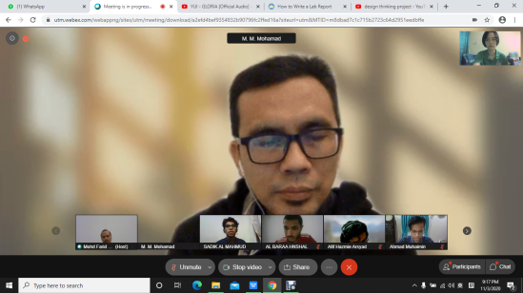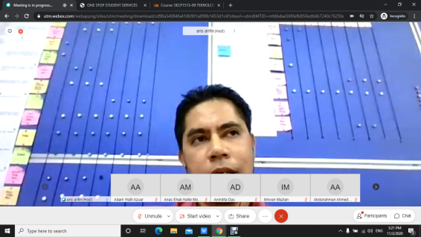

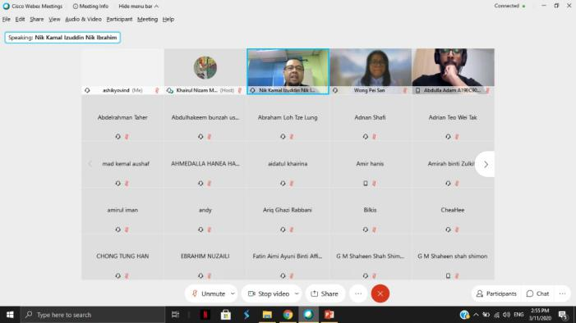

****Step 2 : Define****

In this phase, we collected all the feedback in the survey and defined the problems they had in C language. These problems and their description are shown in the table below:

|  |  |
| --- | --- |
| Unavailable features in C language | Description |
| Inline function | C language doesn’t have inline function. It may cause overhead when program executes small function call. Thus, the efficiency is low without inline function. |
| Information hiding | Codes written in C language are not hid by the Encapsulation, which is the process of combining data and function, to protect data structures and operators. |
| Namespace features | Without namespace feature, codes written cannot be categorised into logical group. Meanwhile, name collisions may occur when code base consists multiple libraries. |
| Object-Oriented Programming (OOP) feature support | It cannot be used in Object-Oriented programming. C language only focuses on procedural programming. OOP is modular because it sorts tasks in programming development. So, with OOP, the productivity of software development will eventually rise. |
| Long run-time checking | The errors and bugs are not detected while writing codes. After writing the program, only the compiler will show all the errors. This takes lots of time to fix. |

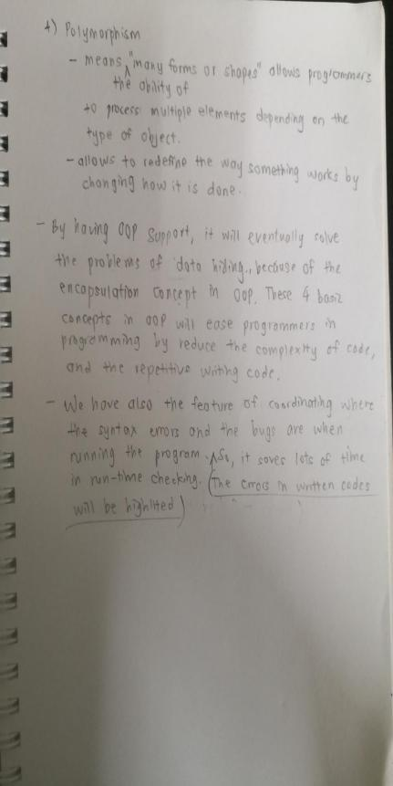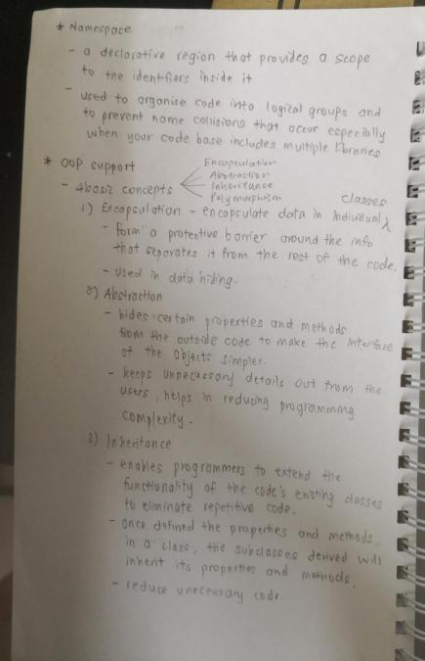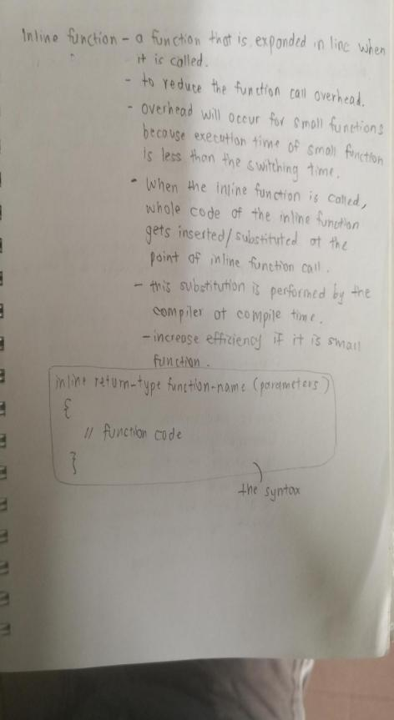

**Step 3 : Ideate**

After defining all the problems in C language, we decided on having an online meeting through Google Meet to brainstorm and exchange ideas to find the solutions.

After and intense discussion, we had the idea for the solution and finalized to make an update for C language. The original feature of C language will be kept and new features were installed to fulfill the users’ requirements. Our goal in the updated language is to have all the features that C language lack of, and more onto general purpose programming.

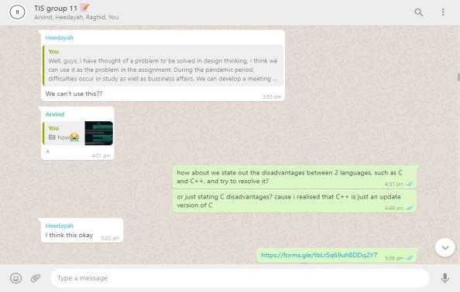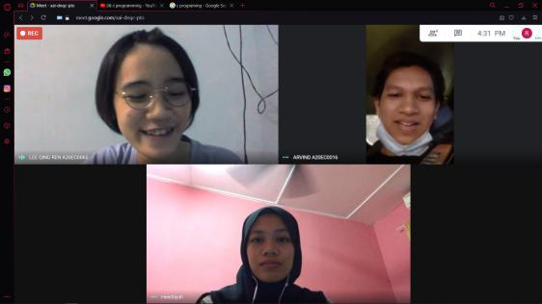

**Step 4 : Prototype**

We made a prototype to demonstrate the updated version of C language for better promotion in front of users. Likewise, users will have better apprehension of the updated version of C language. We developed an abstract laptop with the updated version of C language displayed on the screen. The main components used in the prototype are papers and waste boxes.

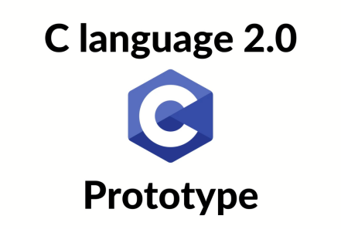

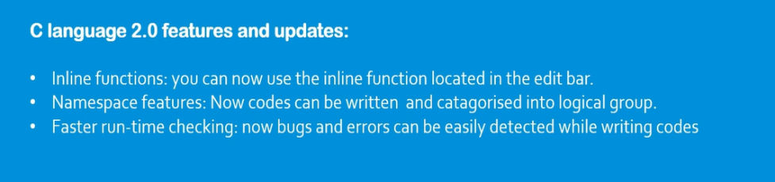

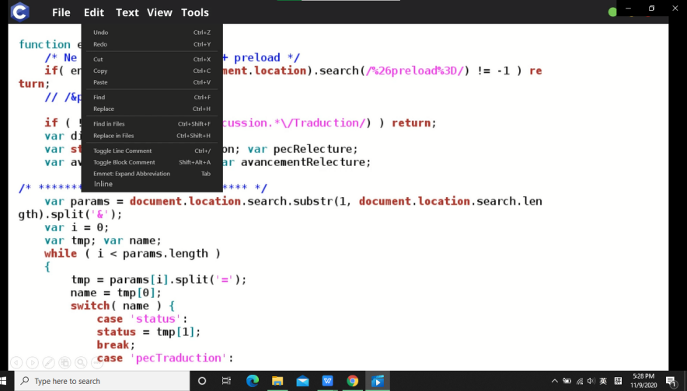

**Step 5 : Testing**

After the prototype was created, we prepared to introduce it to the users. We did a small presentation about the prototype in a video. We explained all the new features in C language via the video and asked their feedback through online survey.

**REFLECTIONS**

Our goal and dream with regard to this course is to enrich our knowledge about system and technology, and create inventions for the benefits of the world. This is not an easy task, but it is our big heart to be beneficial for humankind. In addition, we seek for an opportunity to enhance our communication skills as communication between people is crucial for us to understand each other well. From this assignment, we, as a group, learned how to communicate well and practiced teamwork by discussions and completing task given to each other. We also longed for presenting products to people as it helps us to build up presentation skills.

Design thinking implanted a great impact in us. It deeply infected us in the process of creating items. It helps us to think creatively on how to create a new item, depending on the users needs. In other words, items created which are not solving problems of users, will remain unworthy. Thus, design thinking is important for us to learn in the path of success .It taught us to empathize users and define the problems faced by users. Then, we brainstorm and ideate solutions, and pick the best solution. A prototype is good in demonstration and a good media to explain the features of the products produced. Testing the prototype to users is important to get feedback and do improvement. Design thinking change our normal cogitation into an innovative one.

Improvement should be taken to keep our potential among superb IT technicians. We need to pay attention to the news about new programming languages introduced to the world, getting know the functionality. We need to learn types of programming languages, such as python, MATLAB and PASCAL, to widen our vocabulary in programming language. In this case, companies are more likely to employ us because of the amount of the vocabulary in programming language, as they need programmers who know lots of programming language for programming. We also plan to go lots of seminar about programming language in our university to improve our knowledge. Participating in computer science clubs and practicing programming in the activities organized are a big help in improving our potential too.

**TASK OF EACH MEMBERS**

|  |  |
| --- | --- |
| Name | Task |
| LEE QING REN  (LEADER) | * Host discussion * Prepare slides and presentation video * Give ideas on design thinking * Complete report of design thinking * Interview with lecturers and ask questions |
| ARVIND | * Prepare slides and presentation video * Compile all presentation videos * Give ideas on design thinking * Interview with lecturers and ask questions |
| QHAIRUL HEEDAYAH BINTI TAMSOR | * Record meeting in group discussion * Give ideas on design thinking * Interview with lecturers and ask questions * Prepare the video of design thinking * Prepare slides and presentation video |
| RAGHID MUHAMMAD THAREQ | * Give ideas on design thinking * Interview with lecturers and ask questions * Create the prototype * Prepare the video of the prototype * Prepare online survey for the reviews on the video of the prototype * Prepare slides and presentation video |

**Reference**

1. [Vangie Beal](https://www.webopedia.com/author/Vangie-Beal). (2017). *Programming Language Definition*. Retrieved from <https://www.webopedia.com/TERM/P/programming_language.html>