

**SUBJECT : SCSR1013 DIGITAL LOGIC**

**SESSION/SEM : 2018/2019 / 1**

**LAB 4 : MINI PROJECT**

**PHOTOCOPYING (XEROX) MACHINE**

|  |  |
| --- | --- |
| NAME | MATRIC NUMBER |
| Muhammad Ayman bin Mohyedin | A18CS0128 |
| Nik Amirah Firzanah binti Nik Mustapa | A18CS0174 |

**DUE DATE : 13TH DECEMBER 2018**

**LECTURER’S NAME : DR RAJA ZAHILAH RAJA MOHD RADZI**

**DEDICATION**

We wish to express our sincere appreciation to our Digital Logic lecturer, Dr Raja Zahilah Raja Mohd Radzi for her keen and endless guidance, encouragement, critics and inspiration till the success and completion of this work.

Also thanks to our friends for giving us some ideas that inspired us to do this project. This study is also wholeheartedly dedicated to our beloved parents, who have been our source of inspiration and gave us strength when we thought of giving up, who continually provide their moral, spiritual, emotional, and financial support. To our brothers, sisters, relatives, mentor, friends, and classmates who shared their words of advice and encouragement to finish this work.

And lastly, we dedicated this project to the Almighty God, thank you for the guidance, strength, power of mind, protection and skills and for giving us a healthy life. All of these, we offer to you.

**ACKNOWLEDGEMENT**

We wish to express our sincere gratitude to Dr Raja Zahilah Raja Mohd Radzi, our Digital Logic’s lecturer for providing us an opportunity to do our mini project of “Photocopying (XEROX) Machine”.

We sincerely thank to our lab assistant and our lecturer for their guidance and encouragement in carrying out this project work. I also wish to express my gratitude to our friends who rendered their help during the period of my project work.

**CONTENTS**

|  |  |  |
| --- | --- | --- |
| No. | Contents | Page |
| 1. | Design of the 3-bit Xerox Machine in Deeds | 4 |
| 2. | Enhancement of the Xerox Machine  2.1 The background  2.2 The problem  2.3 Suggested solution  2.4 The requirement  2.5 System implementation | 5 - 9 |
| 3. | Conclusion | 10 |
| 4. | Reference | 11 |
| 5. | Appendix | 12 - 13 |

**DESIGN OF THE 3-BIT XEROX MACHINE IN DEEDS**

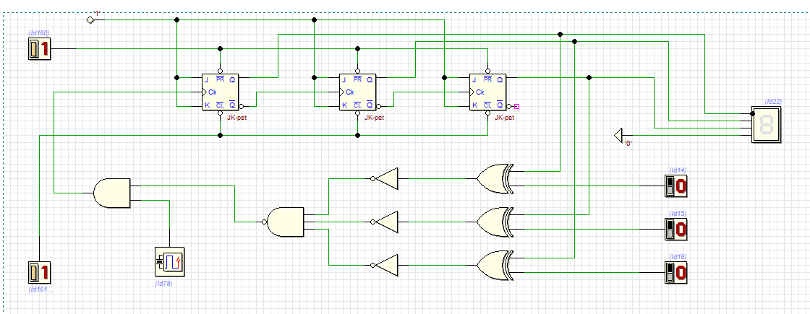

* Switches : to set the required size of paper
* Counter : to count the size of paper that has been selected
* Comparator : to compare the size of paper required with the selected size
* Clock Disabler : to stop the operation of the counter

**ENHANCEMENT OF THE XEROX MACHINE**

THE BACKGROUND

The objectives of this lab work are to introduce the development of a PLD device and a simple Hardware Description Language (HDL). This mini project will implement 3 different components on a single GAL device. Those components are 3-bit Count Up Counter, 3-bit Comparator and Clock Disabler. We are also exposed by way of use WinCUPL and Wellon Programmer.

THE PROBLEM

User want to copy based on different size of paper. However, the machine does not detect the size of paper as it does not appear as a choice for user.

SUGGESTED SOLUTION

A block diagram of a component required is shown in Figure 1. Three core components are counter, comparator and multiplexer. Mux will determine the size of paper that has been used while comparator will determine whether the required size of paper has been met. Once the size of paper has been met, the machine will display the required size of paper.

To implement this, the user has to key in the required size of paper by using 3 switches, which allow the required size from A1 to A7. He/she will reset the counter (assuming pressing a START button), the counter will selected and it’s output will be compared with the value of the switches, if the value is not the same it will stop. A mux function as a data selector where the output will depend on the value of selector.

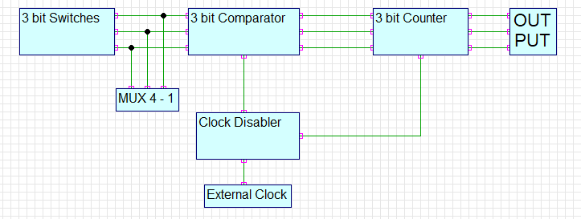

THE REQUIREMENT

* Switches : to set the required size of paper
* Counter : to count the size of paper that has been selected
* Comparator : to compare the size of paper required with the selected size
* Clock Disabler : to stop the operation of the counter
* Multiplexer : to select size of paper from the input

If size of paper = the selected one, the counter will stop

Else,

Counter will stop operating

THE IMPLEMENTATION

Switches : Use switches provided by the ETS 5000 Digital Training Kit.

Counter : Counter is a count up 3 bit counter that was controlled by the clock. Counter is implemented as a WinCUPL code that will be programmed into GAL.

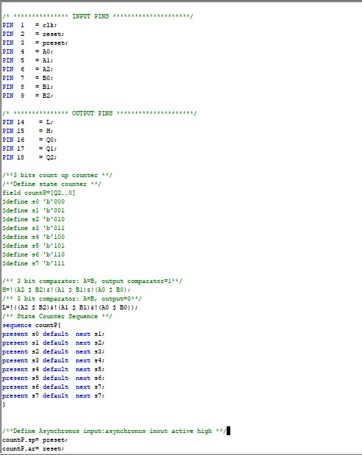

Comparator : A comparator is a combinational circuit that can be designed using XNOR gate. Figure 3 shows a 3 bit equally Comparator.

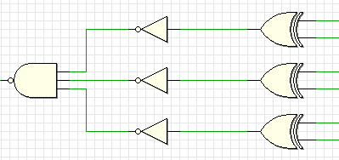

The circuit in Figure 3 can be translated to a WinCUPL code as follows :

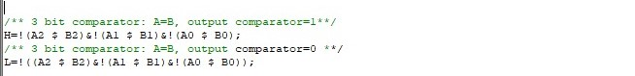

Multiplexer : Multiplexer is a device that allows digital information from several sources to be routed onto a single line for transmission over that line to a common destination. Figure 4 shows a Multiplexer 4 – 1.

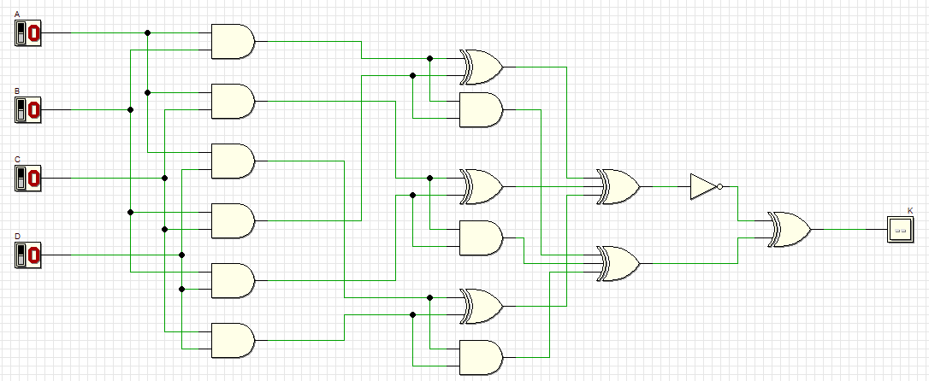

The full system enhancement is shown as below :

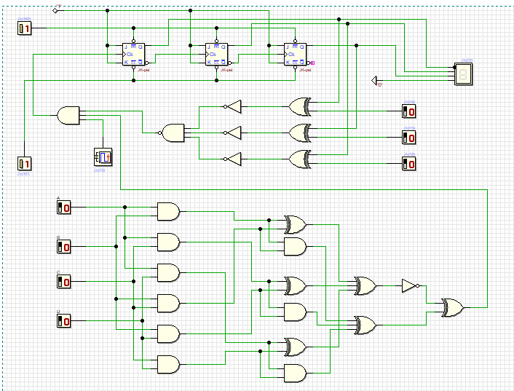

**CONCLUSION**

SUMMARY OF THE PROJECT

This project are made for the user to select a required size of paper to copy as it can facilitate their work. They just have to select the choice, which are A1, A2, A3 and A4. The counter will count the bit of paper’s size that has been selected while the comparator will compare it with the switch whether it has a same value or not. If the value is same, MUX will select the required size, else, the counter will stop operating.

REFLECTION

(Nik Amirah Firzanah)

This project is really tough for me as this is a challenge for a typical student. However, this project is a group project which is relatively easy with the fair and equitable distribution of work. When working in a group, misunderstanding must occur and this occurs in this group. For me who are weak in this subject, believe me or not, this project helps me better understand this subject and also with the help of my teammate Muhammad Ayman who really teaches and explains some things to me. With the guidance of our lecturer, Dr Raja Zahilah Raja Mohd Radzi which is an incentive to continue this mini project intensely. In addition to the friends around me who always provide assistance when needed. Honestly, I was less interested in this subject, but after doing this group work, I was interested in exploring this subject as it was more specific and in-depth about the machine which had attracted me.

(Muhd Ayman Mohyedin)

This project is a bit heavy for me. However, I continue with this project with my teammate, Nik Amirah. I'm also grateful for the help that our lecturers and friends have shared. Although this project is quite challenging for me, but we wisely handle it by sharing opinions and problems. All the work done is well organized although there is little misunderstanding. But that does not become a barrier to our task because everything can be overcome well. Through this project, I can understand the topics that are more in depth. this makes me more eager to continue this mini project. group work is sometimes quite challenging when there is no understanding and agreement or more simply less social in the group.

ACHIEVEMENTS, STRENGTHS AND WEAKNESSES

The achievement of this mini project is we are able to make the user select size of paper as they want. They can select size of paper whether A1, A2, A3 or A4. The strength is we can make any choice of various size of paper while the weakness is the size of paper is limited from A1 to A4 even paper has until A8.

**REFERENCES**

1. Digital Logic Book Fifth Edition, School of Computing, Faculty of Engineering, Universiti Teknologi Malaysia.
2. Dr. Raja Zahilah Raja Mohd Radzi, lecturer of Digital Logic
3. The Internet

**APPENDIX**



