

# Lab 4

Routing Protocol using Packet Tracer

**Name** : **CHIAM WOOI CHIN (A19EC0034)**

**Section: 09**

**Name : NG JING ER (A19EC0115)**

**Section: 09**

Checked By:

**Introduction**

You are given a Packet Tracer file with a network topology shown in Figure 1 below, which requires some work on IP addressing and routing protocol configuration. You must follow all the steps carefully and answer the given questions.

# 

Figure 1

# Task 1: IP addressing

**Step 1:** Fill in Table 1 (on next page) with the correct information. Note: The information may be found under the ***Config*** tab of each router (refer to Figure2).

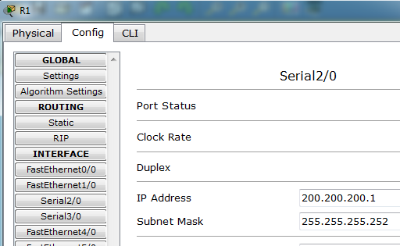

Figure 2

**Table 1**

|  |  |  |  |  |
| --- | --- | --- | --- | --- |
| **#** | **Device**  **Name** | **Interface** | **IP Address** | **Subnet Mask** |
| 1 | RTA | Se2/0 | 172.16.230.5 | 255.255.255.252 |
| 2 | Se3/0 | 172.16.230.1 | 255.255.255.252 |
| 3 | Fa0/0 | 172.16.224.255 | 255.255.254.0 |
| 4 | RTB | Se2/0 | **172.16.230.2** | **255.255.255.252** |
| 5 | Fa0/0 | **172.16.230.9** | **255.255.255.252** |
| 6 | Fa1/0 | **172.16.226.11** | **255.255.254.0** |
| 7 | RTC | Se2/0 | **172.16.230.6** | **255.255.255.252** |
| 8 | Se3/0 | **172.16.230.13** | **255.255.255.252** |
| 9 | Fa0/0 | **172.16.230.10** | **255.255.255.252** |
| 10 | Fa1/0 | **172.16.228.11** | **255.255.255.0** |
| 11 | RTD | Se2/0 | **172.16.230.14** | **255.255.255.252** |
| 12 | Fa0/0 | **172.16.229.222** | **255.255.255.0** |

**Step 2:** Based on the result and observation in **Step 1**, answer the following questions:

1. How many different subnets are there?  **8**
2. What is the network address of each of these subnets? (*Hint: Given the IP address and the subnet mask, you can calculate the network address using logical* ***AND*** *operation*). Complete Table 2 below.

Table 2

|  |  |  |  |
| --- | --- | --- | --- |
| **Subnet**  **#** | **Network Address** | **Broadcast Address** | **Range of usable addresses** |
| 1 | 172.16.224.0 | 172.16.225.255 | 172.16.224.1 - 172.16.225.254 |
| 2 | 172.16.230.0 | 172.16.230.3 | 172.16.230.1 - 172.16.230.2 |
| **3** | **172.16.230.4** | **172.16.230.7** | **172.16.230.5 – 172.16.230.6** |
| **4** | **172.16.226.0** | **172.16.227.255** | **172.16.226.1 – 172.16.227.254** |
| **5** | **172.16.230.8** | **172.16.230.11** | **172.16.230.9 – 172.16.230.10** |
| **6** | **172.16.230.12** | **172.16.230.15** | **172.16.230.13 – 172.16.230.14** |
| **7** | **172.16.228.0** | **172.16.228.255** | **172.16.228.1 – 172.16.228.254** |
| **8** | **172.16.229.0** | **172.16.229.255** | **172.16.229.1 – 172.16.229.254** |

1. Provided that all PC will use the last usable address in its subnet, fill in Table 3 below with the correct information.

Table 3

|  |  |  |  |  |
| --- | --- | --- | --- | --- |
| **#** | **Device**  **Name** | **IP Address** | **Subnet Mask** | **Default**  **Gateway** |
| 1 | PCA | 172.16.225.254 | 255.255.254.0 | 172.16.224.255 |
| 2 | PCB | **172.16.227.254** | **255.255.254.0** | **172.16.226.11** |
| 3 | PCC | **172.16.228.254** | **255.255.255.0** | **172.16.228.11** |
| 4 | PCD | **172.16.229.254** | **255.255.255.0** | **172.16.229.222** |

**Step 3:** Complete the IP addressing information on all the PCs in the topology. (Hint: Click on the PC, choose the ***Desktop*** tab, then click ***IP Configuration***).

**Step 4:** Open the routing table for each router. *(Hint: you can use the ‘magnifying glass’ icon* from the secondary toolbar*, then point & click to a router and choose ‘Routing Table’. See Figure 3 below.)*

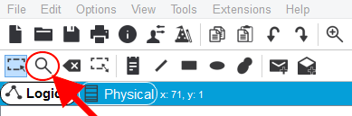

(a)

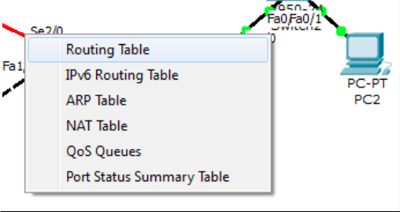

(b) Figure 3

**Step 5:** Copy the image of the routing table for each router. *(Hint: You can use Window's ‘Print Scrn’ command OR ‘Snipping Tool’ to copy / screenshot the image.)*

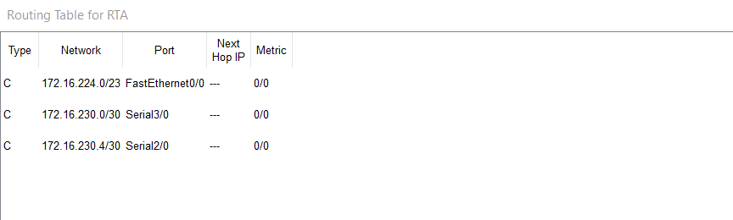

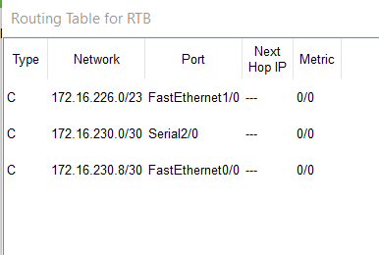

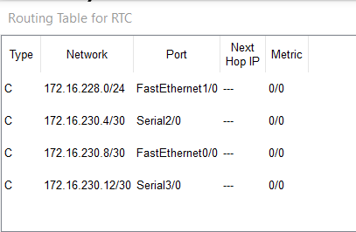

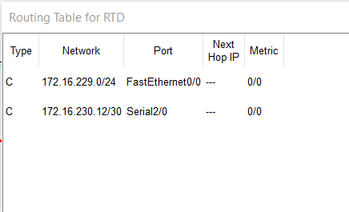

**Step 6:** Answer the questions below:

1. Do all the routers have the same information in its routing table?

**No, all the routers have the different information in its routing table.**

1. What is the difference that can be seen?

**Different network addresses and port**

1. Can all the PCs ping each other successfully? (Fill in the Table 4 below)

**Table 4**

|  |  |  |  |
| --- | --- | --- | --- |
| **#** | **Ping**  **between devices** | **Successful**  **☑** | **Unsuccessful**  **⮽** |
| 1 | PCA-PCB |  |  |
| 2 | PCA-PCC |  |  |
| 3 | PCA-PCD |  |  |
| 4 | PCB-PCC |  |  |
| 5 | PCB-PCD |  |  |
| 6 | PCC-PCD |  |  |

1. Reflection: what is the reason for your answer in (c)?

**All the ping results tested are successful after the ping command is run where the execute ping results screen display a short summary which shows that all the packets transmitted are successfully received (0% loss).**

# Task 2: Dynamic routing configuration – RIP

Dynamic routing allows the network to be more flexible to changes. It can help the routers adapt to the changes in the pathways without much intervention from network administrators.

In this part of the lab, you will learn how to configure RIP routing protocol, and see how changes happen in the routing tables.

**Step 1:** Choose Router RTA. Click the **CLI** tab. Copy the following text into the command line interface.

When asked this

just press ENTER

Destination filename [startup-config]? Building configuration...

[OK] RTA#

RTA>***enable*** RTA#***configure terminal***

Enter configuration commands, one per line. End with CNTL/Z. RTA(config)#***router rip***

RTA(config-router)#***version 2***

RTA(config-router)#***network 172.16.0.0*** RTA(config-router)#***no auto-summary*** RTA(config-router)#***exit*** RTA(config)#***exit***

RTA#

%SYS-5-CONFIG_I: Configured from console by console

RTA#***copy running-config startup-config***

**Task 1.1:**

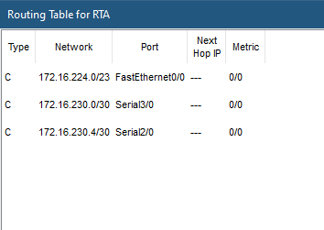(a) Copy (OR paste image / screenshot) of the RTA routing table here.

**Step 2:** Choose Router RTB. Click the **CLI** tab. Copy the following text into the command line interface.

When asked this

just press ENTER

RTB>***enable*** RTB#***configure terminal***

Enter configuration commands, one per line. End with CNTL/Z. RTB(config)#***router rip***

RTB(config-router)#***version 2***

RTB(config-router)#***network 172.16.0.0*** RTB(config-router)#***no auto-summary*** RTB(config-router)#***exit*** RTB(config)#***exit***

RTB#

%SYS-5-CONFIG_I: Configured from console by console

RTB#***copy running-config startup-config***

Destination filename [startup-config]? Building configuration...

[OK] RTB#

**Task 2.1:**

1. Copy (OR paste image / screenshot) of the RTA and RTB routing table below:

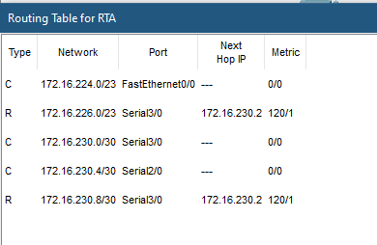

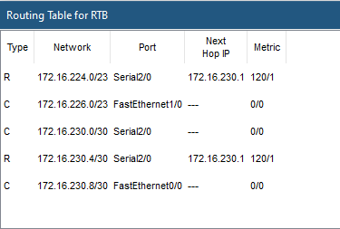

1. **Reflection:** what difference do you see between routing tables of RTA and RTB?

**Besides the directly connected network which automatically created in RTA, there is type R route source identifies that the router RTA was learned dynamically from router RTB using the RIP routing protocol to the destination network of router RTB 172.16.226.0/23 and 172.16.230.8/30 on port serial3/0 whereas the router RTB was learned dynamically from router RTA using the RIP routing protocol to the destination network of router RTA 172.16.224.0/23 and 172.16.230.430 on port serial2/0. Besides, there are also next hop IP and metric of the network address of RTB in routing table RTA and network address RTA in routing table RTB.**

**Step 3:** Copy the same configuration instructions to RTC and RTD ( as indicated in **Step 2**)

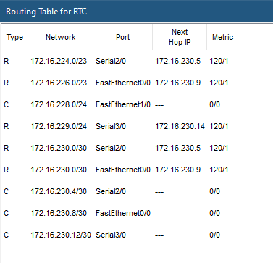

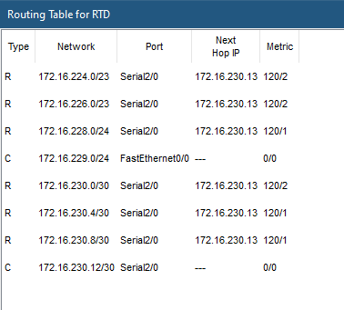

**Step 4:** Answer the questions below.

1. Do all the routers have the same information in its routing table?

**NO**

1. Write down routing table information (Next Hop IP, Metric) for RTC and RTD to the network 172.16.224.0/23

**Routing table information (Next Hop IP, Metric) for RTC to network 172.16.224.0/23 is 172.16.230.5 and 120/1 whereas Next Hop IP, Metric for RTD is 172.16.230.13 and 120/2.**

1. What is the difference that can be seen? Why is this?

**Besides the directly connected network type C which automatically created in each router whenever an interface is configured with an IP address and activated, there is additional different routing table information which are type R route source represent dynamic routing protocols, destination address, Next Hop IP and metric of other remote network in each router.**

**It is because the type R route source identifies that the router was learned dynamically from another router using the RIP routing protocol to the destination network address of the remote network on the port that connected to that router. The routers exchange routing information when there is a topology change. This exchange allows routers to automatically learn about new networks and also to find alternate paths when there is a link failure to a current network.**

1. Can all the PCs ping each other successfully? (Fill in the Table 5 below)

Table 5

|  |  |  |  |
| --- | --- | --- | --- |
| **#** | **Ping**  **between devices** | **Successful**  **R** | **Unsuccessful**  **S** |
| 1 | PCA-PCB |  |  |
| 2 | PCA-PCC |  |  |
| 3 | PCA-PCD |  |  |
| 4 | PCB-PCC |  |  |
| 5 | PCB-PCD |  |  |
| 6 | PCC-PCD |  |  |

1. Reflection: what is the reason for your answer in (d)?

**Based on the ping results, it shows that all the PCs ping successfully with each other. This is because the execute ping results screen shows that all the packets transmitted are successfully received where there is 0% loss of packet.**

**Step 5:** Switch **off** router RTA. (Hint: Click on the RTA router (i.e. using the 'Select' tool =>  ), on the **Physical**tab, click the **ON/OFF switch** to turn ON or OFF, as shown below:)

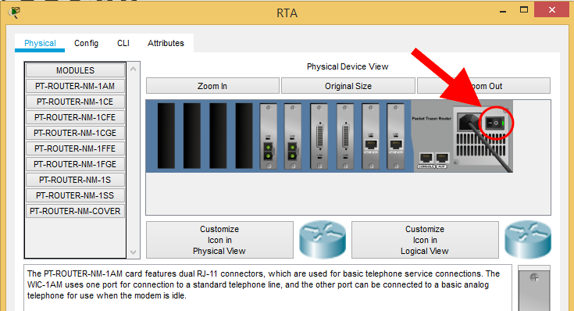

What are the changes noted in the routing tables?

**Ans: All the routing table information has disapeared.**

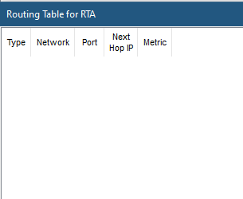

**Step 6:** Switch **on** router RTA. What are the changes noted in the routing tables?

**Ans: There is the directly connected network address (type C) which automatically created in router RTA whenever an interface is configured with an IP address and activated. Besides, there is additional different routing table information which are type R route source represent dynamic routing protocols identifies that the RTA was learned dynamically from RTB, RTC and RTD using the RIP routing protocol to the destination network address of the remote network of router RTB, RTC and RTD on the port that connected to router RTB, RTC and RTD, there is also the network address of each router that connected to RTA, Next Hop IP and metric of remote network in each router.**

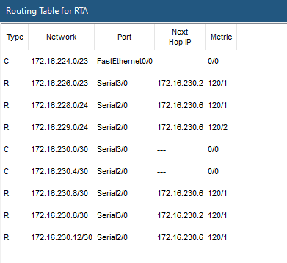

**Step 7: Reflection:** What have you learned in this task?

**Ans: From the task, I am able to know the process where a router can forward data via diffrent route or given destination. I have learnt how to enable and configure RIP routing in Cisco router in packet tracer and understand the changes happened in the routing table after execute the particular command.**

# Task 3: Dynamic routing configuration – OSPF

Make sure that you have all the routing tables on display on one side (as before). As you go through the steps, look at the changes happening in the routing tables.

**Step 1:** For allthe routers, click the **CLI** tab and copy the following text into the command line interface.

Router>***enable***

Router#***configure terminal***

Enter configuration commands, one per line. End with CNTL/Z.

Router(config)#***no router rip***

Router(config)#***exit*** Router#

%SYS-5-CONFIG_I: Configured from console by console

Router#***copy running-config startup-config***

Destination filename [startup-config]?

Building configuration...

[OK]

Router#

**Step 2:** Copy and paste the image of the routing table for each router below:

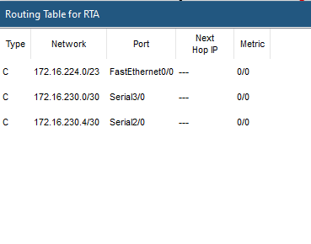

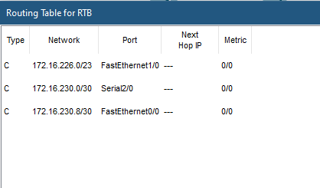

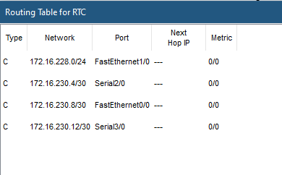

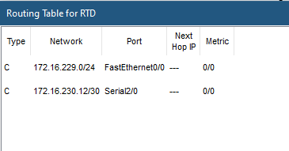

**Step 3:** For Router RTA, Click the **CLI** tab. Copy the following text into the command line interface.

RTA>***enable***

RTA# ***configure terminal***

Enter configuration commands, one per line. End with CNTL/Z. RTA(config)#***router ospf 1***

RTA(config-router)#***network 172.16.224.0 0.0.1.255 area 0***

RTA(config-router)#***network 172.16.230.0 0.0.0.3 area 0***

RTA(config-router)#***network 172.16.230.4 0.0.0.3 area 0***

RTA(config-router)#***end***

RTA#

%SYS-5-CONFIG_I: Configured from console by console

RTA# ***copy running-config startup-config***

Destination filename [startup-config]?

Building configuration... [OK]

RTA#

**Task 3.1:** Copy and paste the image of RTA’s routing table below:

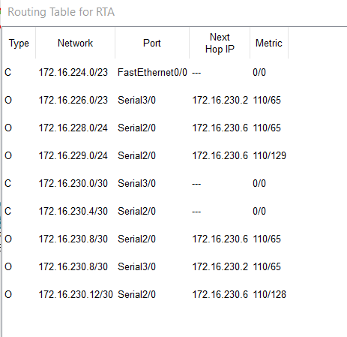

**Task 3.2:**

1. Does RTA have a path to ALL the different subnet?

**Yes, RTA have a path to all the different subnets**

1. Try pinging the different PCs and jot down your results. (Fill in the Table 6 below)

Table 6

|  |  |  |  |
| --- | --- | --- | --- |
| **#** | **Ping**  **between devices** | **Successful**  **R** | **Unsuccessful**  **S** |
| 1 | PCA-PCB |  |  |
| 2 | PCA-PCC |  |  |
| 3 | PCA-PCD |  |  |

**Step 4:** Configure the other routers with OSPF routing algorithm.

**Step 4.1:** For Router RTB, Click the **CLI** tab. Copy the following text into the command line interface.

RTA>***enable***

RTB# ***configure terminal***

Enter configuration commands, one per line. End with CNTL/Z. RTB(config)#***router ospf 1***

RTB(config-router)#***network 172.16.226.0 0.0.1.255 area 0***

RTB(config-router)#***network 172.16.230.0 0.0.0.3 area 0***

RTB(config-router)#***network 172.16.230.8 0.0.0.3 area 0***

RTB(config-router)#***end***

RTB#

%SYS-5-CONFIG_I: Configured from console by console

RTB# ***copy running-config startup-config***

Destination filename [startup-config]?

Building configuration...

[OK] RTB#

**Step 4.2:** For Router RTC, Click the **CLI** tab. Copy the following text into the command line interface.

RTC>***enable***

RTC# ***configure terminal***

Enter configuration commands, one per line. End with CNTL/Z. RTC(config)#***router ospf 1***

RTC(config-router)#***network 172.16.228.0 0.0.0.255 area 0***

RTC(config-router)#***network 172.16.230.4 0.0.0.3 area 0***

RTC(config-router)#***network 172.16.230.8 0.0.0.3 area 0***

RTC(config-router)#***network 172.16.230.12 0.0.0.3 area 0***

RTC(config-router)#***end***

RTC#

%SYS-5-CONFIG_I: Configured from console by console

RTC# ***copy running-config startup-config***

Destination filename [startup-config]?

Building configuration...

[OK] RTC#

**Step 4.3:** For Router RTD, Click the **CLI** tab. Copy the following text into the command line interface.

RTD>***enable***

RTD# ***configure terminal***

Enter configuration commands, one per line. End with CNTL/Z. RTD(config)#

RTD(config)#***router ospf 1***

RTD(config-router)#***network 172.16.229.0 0.0.0.255 area 0***

RTD(config-router)#***network 172.16.230.12 0.0.0.3 area 0***

RTD(config-router)#***end***

RTD#

%SYS-5-CONFIG_I: Configured from console by console

RTD# ***copy running-config startup-config***

Destination filename [startup-config]? Building configuration...

[OK] RTD#

**Step 5:** Copy the image of the routing table for each router and paste it here.

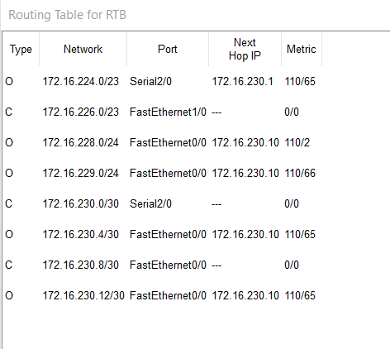

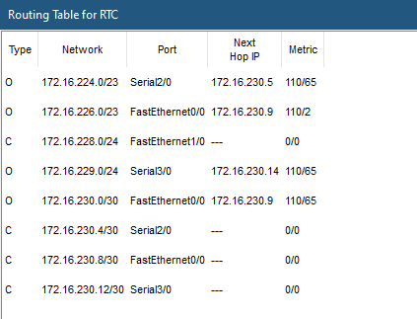

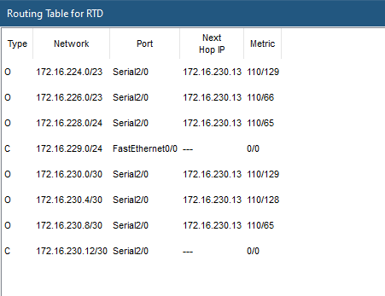

**Step 6:** Switch off router RTA. What are the changes noted in the routing tables?

**All the routing table information have disappered. There is nothing in routing table.**

**Step 7:** Switch on router RTA. Wait a few minutes. What are the changes noted in the routing tables?

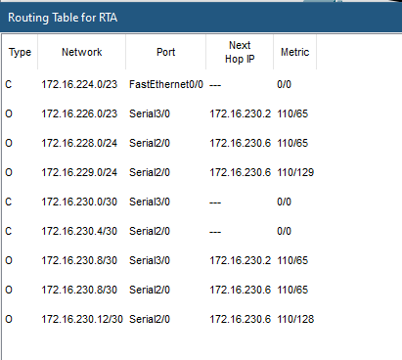

**Step 8: Reflection:** What have you learned in this task?

**Based on task 3, i have learnt to use CLI in Cisco to execute the configuration command. I have learnt how to configure OSPF Routing protocol in packet tracer and also some OSPF configuration commands. And the command executed will affect the results in the routing table.**