**IDENTIFYING THE PHILOSOPHY IN Ads**

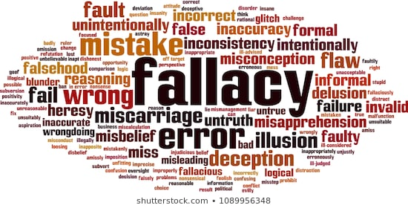

We will discuss about our 1st add which is Direct TV Ads. This Ads is a fallacy Ad. This Ads have fallacy of relevant. Because in this Ads argument whose premises are not logically relevant to the true or false conclusions.

This Ads use Scare tactic. So that people buy this cable. Everyone is Scare about their life. No one want too much hassle in their life. That’s why Direct TV use this philosophy to sell their product.

If we see if you have cable and which is not Direct TV that’s mean will be bitten by people. But in reality, this has very little do with whether you should choose cable over Direct TV.